Lab & Activities Week 03 Context Engineering II

Integrantes:
José Martínez-02220131016

Institución: Universidad de Santander
Pregrado: Ingeniería de Sistemas
Docente: Jorge Galvis
28 de Agosto 2026
Activity 1 · Warm-up Concept Quiz

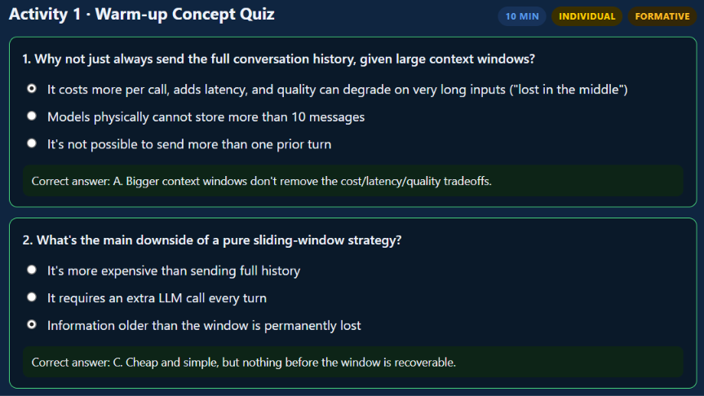
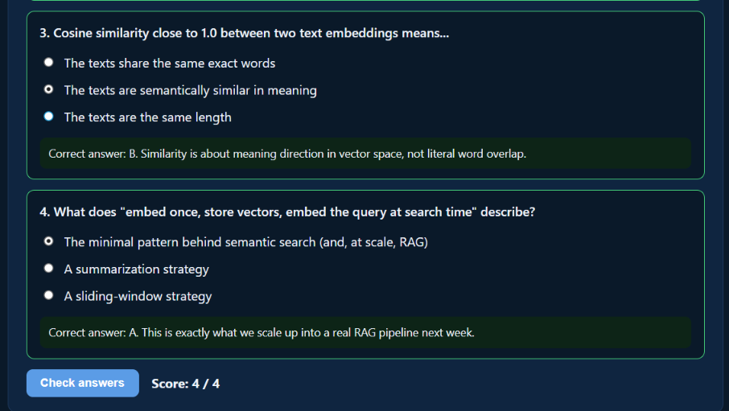
Activity 2 · Instructor-Led Live Coding
Follow along in week-03-context-engineering-ii.ipynb, sections 1-3: build a 10-turn synthetic conversation, apply sliding window vs. rolling summarization side by side, then generate embeddings and compute similarity between related and unrelated sentence pairs.
1. Sliding window vs. rolling summarization
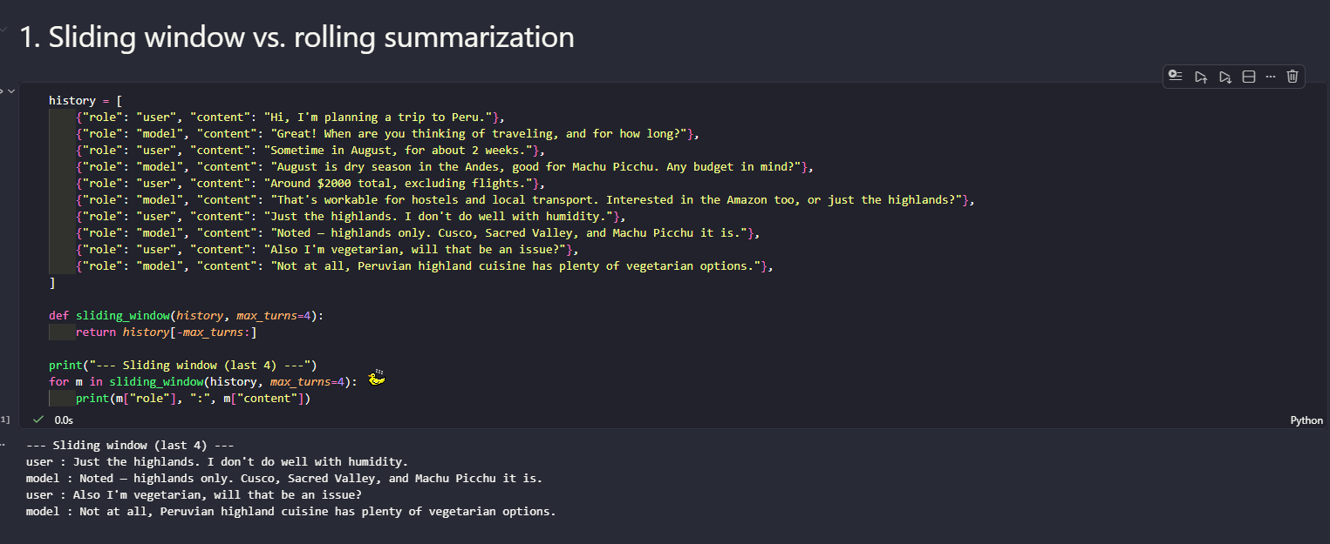
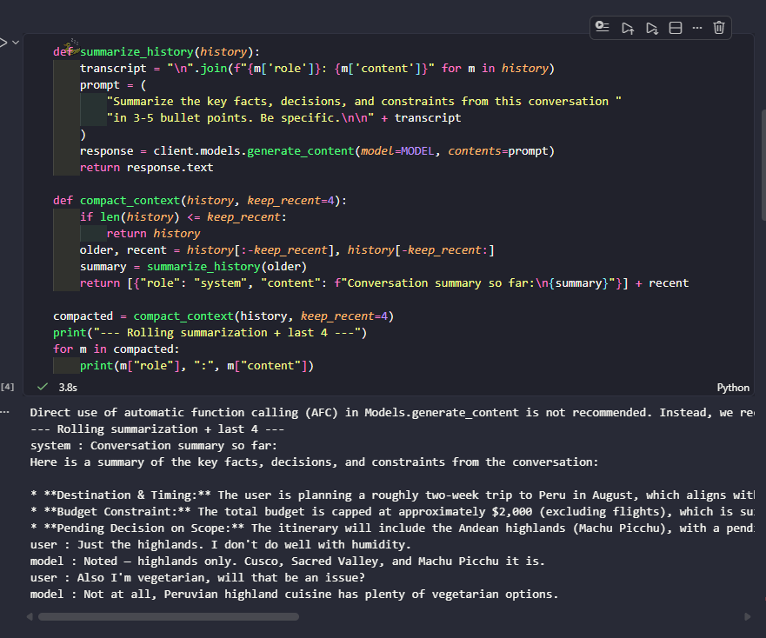

With max_turns=2 the sliding window still happens to catch the vegetarian line because it's one of the last two turns, but it already lost the budget, the dates, and "highlands only, no humidity" -- none of that survives a 2-turn window. The rolling summary keeps every one of those facts regardless of window size, because they get folded into the summary before being dropped. This is the actual tradeoff from quiz question 2: sliding window is cheaper (no extra LLM call) but anything older than the window is gone for good; summarization costs one extra call per compaction but nothing important must be lost.
2. Embeddings and cosine similarity
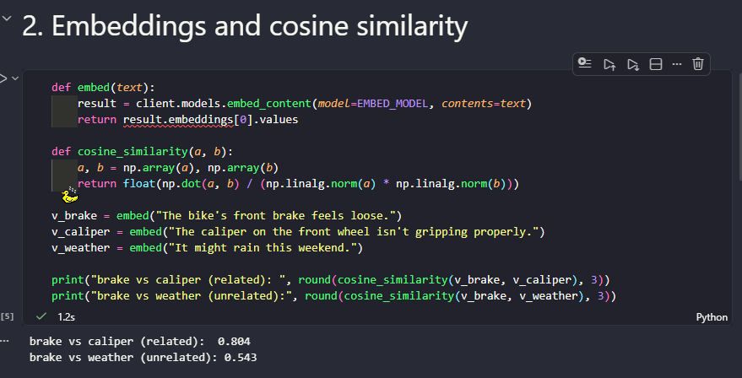
The related pair scores clearly higher (0.804 vs 0.543), confirming cosine similarity is doing its job. What surprised me is that the "unrelated" pair still isn't close to 0 -- 0.543 is not a low number. That's expected: both sentences are still short, plain English statements about everyday things, so they share some generic semantic space (register, sentence structure). What matters for semantic search is not the absolute number but the gap between related and unrelated pairs, and that gap is clearly there.
3. A minimal semantic search function
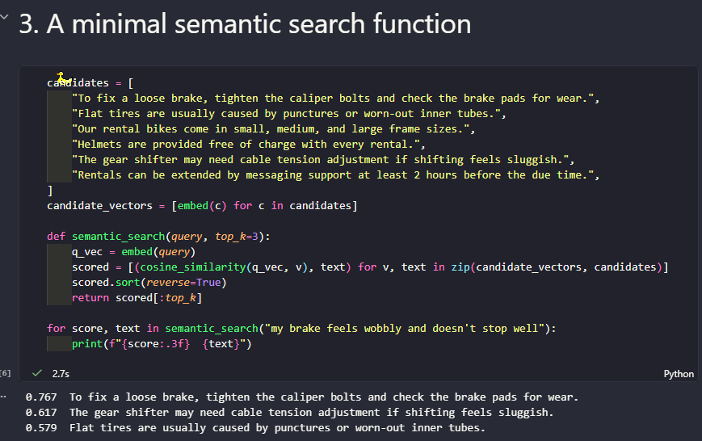
Exactly like the notebook's own note predicts: the top hit shares almost no literal words with the query ("wobbly" / "doesn't stop well" vs. "loose" / "caliper bolts"), yet it's clearly the right answer. This only works because the ranking is done in embedding space, not by keyword overlap -- this is the exact mechanic that gets scaled into full RAG next week.

Activity 3 · Group Workshop: Design a Memory Strategy
Scenario picked: (b) a semester-long tutoring assistant -- chosen because it's the same kind of assistant as my own Corte 1 project (a first-semester calculus tutor), so the design decision here feeds directly into Activity 6.

1. Strategy decision
A semester-long tutor cannot rely on a pure sliding window: a student may reference a concept covered weeks ago ("like you explained with the chain rule"), and losing that is a real quality cost -- the assistant would re-teach things or contradict earlier explanations, which erodes trust. But it also cannot keep the full semester transcript in every call: that's unbounded cost and most of it (small talk, already-solved exercises) is not worth re-sending. The design is a combination:
- Durable structured memory (a StudentProfile-style Pydantic model, reusing Week 2's schema-forcing) for facts that must survive forever: topics already mastered, recurring mistakes/misconceptions, current course unit, preferred explanation style.
- Sliding window for the live session: only the last 6-8 turns of the current problem-solving exchange are sent verbatim -- that's the only place where exact wording actually matters.
- Rolling summarization at the end of each session: the session's raw turns get folded into an update to the durable StudentProfile (e.g., append to topics_covered, add a new recurring mistake), then the raw transcript itself is discarded.
2. What's kept vs. dropped vs. summarized
- Kept forever (structured memory): topics mastered, recurring mistakes, current unit, preferred explanation style.
- Kept short-term (sliding window): the last 6-8 turns of the active problem.
- Summarized then discarded: everything else from a finished session, once its useful facts are folded into the structured memory.
- Dropped entirely: small talk, exact old phrasing, repeated confirmations ("got it", "thanks").
3. Defense against a "what if" challenge
Challenge: what if the student references something specific from 3 months ago that never made it into the structured summary? Answer: that's an acceptable, cheap failure mode -- the assistant asks a short clarifying question ("could you remind me which topic that was?") instead of trying to store the entire semester verbatim to cover a rare edge case. This mirrors quiz question 1 directly: persistent, structured facts belong in a dedicated memory store (like a system prompt for per-request data), not in an ever-growing raw history block.

Activity 4 · Individual Lab: Complete the Notebook
Note: cell as given uses asyncio.run(...) inside a helper function -- this throws "RuntimeError: asyncio.run() cannot be called from a running event loop" inside a Jupyter kernel, because the kernel already runs its own event loop (the same issue that came up with the ADK cell in Week 2). Fixed it the same way as last week: rewrote the helper as async def and used await/async for on the real async APIs (create_session, run_async) instead of wrapping sync calls in asyncio.run(), then called it with a top-level await (supported natively in Jupyter cells).

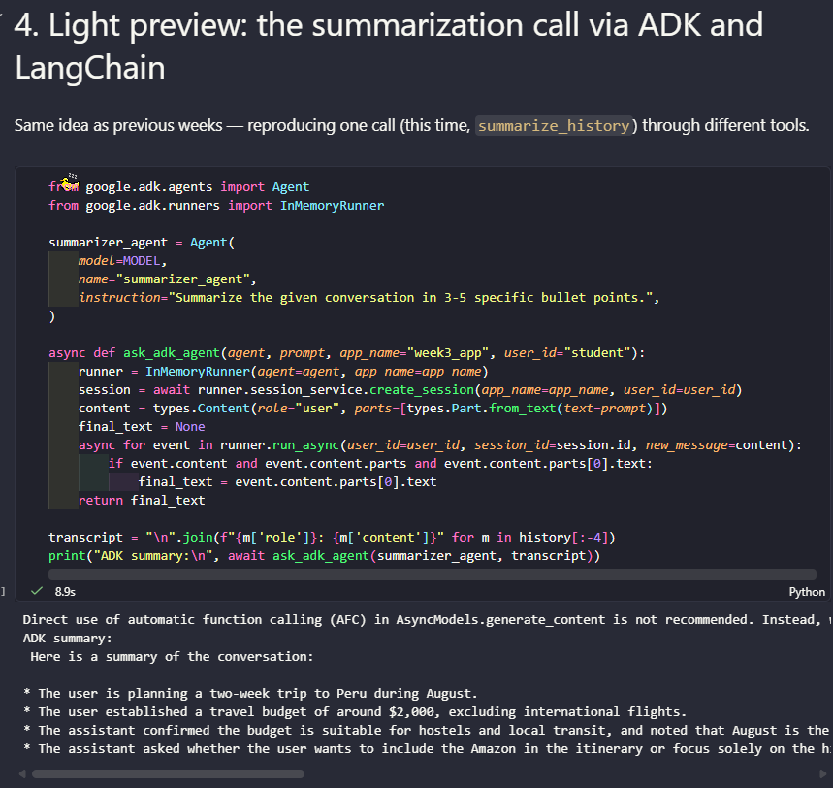
Same underlying facts recovered by both frameworks (destination, month, budget, the still-undecided Amazon question at that point in the transcript) -- only the wrapper format differs, same pattern observed with the raw SDK / ADK / LangChain comparison back in Week 2.

Exercise 1 -- Ranked semantic search with a threshold

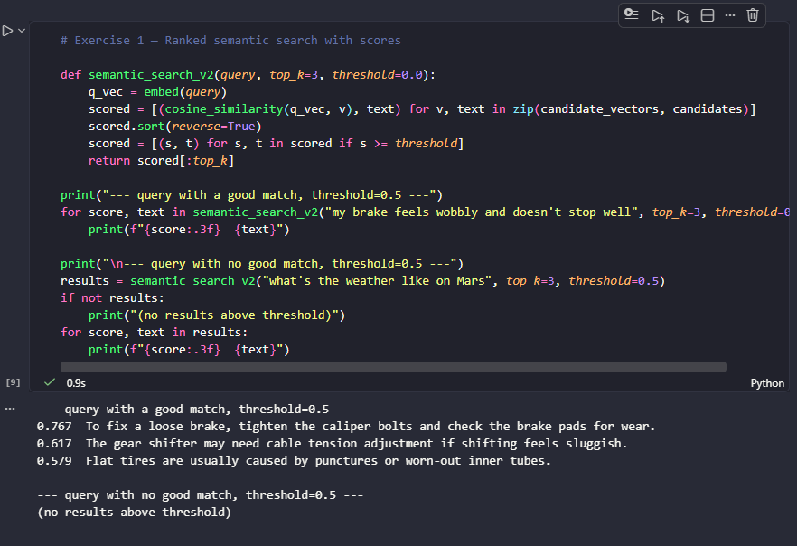
Tested with "what's the weather like on Mars", a query with no real match among the 6 candidates. At threshold=0.5 it correctly returns nothing. Dropping the threshold to 0.0 just to see the raw numbers shows the highest score for that query is only 0.491 -- below the cutoff, confirming the threshold is filtering out genuinely irrelevant results and not just being overly strict on a borderline case.
Exercise 2 -- Structured memory extraction
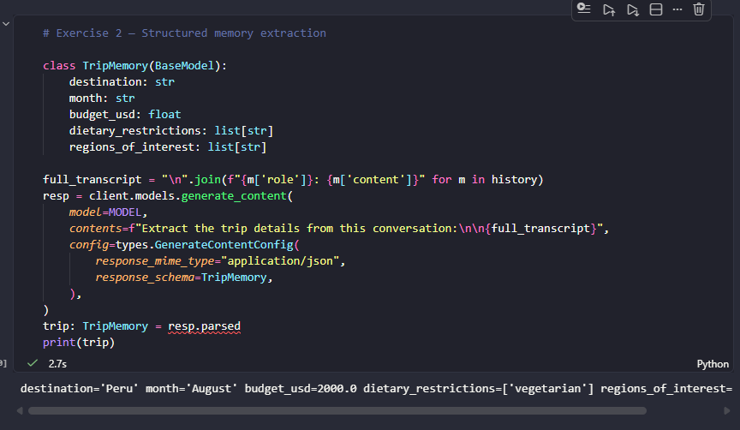
Every field came back correctly populated straight from the free-text conversation -- including regions_of_interest, which the model had to assemble from two different turns ("highlands only" plus the assistant's own earlier list of "Cusco, Sacred Valley, and Machu Picchu"). This is a cleaner fit for long-term memory than a paragraph summary: a paragraph has to be re-read and re-parsed by another LLM call every time, while a TripMemory instance can be stored and queried directly, the same argument made for the ResumeLine parser in Week 2.

Activity 6
For Corte 1, the assistant manages its conversation history through a sliding
window strategy. The system prompt is preserved at the head of every request,
while only the ten most recent complete exchanges are retained and older ones
are discarded on a first-in, first-out basis. A secondary budget of 12,000
characters bounds the history when individual exchanges are unusually long, and
any exchange still awaiting a response is kept intact. This approach was chosen
because tutoring sessions in integral calculus are short and typically centred
on a single exercise, so the immediate context governs the quality of the
response while exercises resolved several turns earlier contribute little.
Summarisation was discarded for the latency and cost introduced by its auxiliary
model calls, and full history for its inevitable overflow of the context window.
The knowledge base has been assembled in a data folder of eleven Markdown
documents covering indefinite integrals, integration techniques, definite
integrals and applications, drawn from OpenStax Calculus Volume 2 and course
notes, which will be chunked and embedded in the coming week.
Github Link: https://github.com/JulianGuardian/Cubik-Lite/pull/2

