Lab & Activities Week 04 Retrieval-Augmented Generation (RAG)

Integrantes:
José Martínez-02220131016

Institución: Universidad de Santander
Pregrado: Ingeniería de Sistemas
Docente: Jorge Galvis
28 de Agosto 2026
Activity 1 · Warm-up Concept Quiz
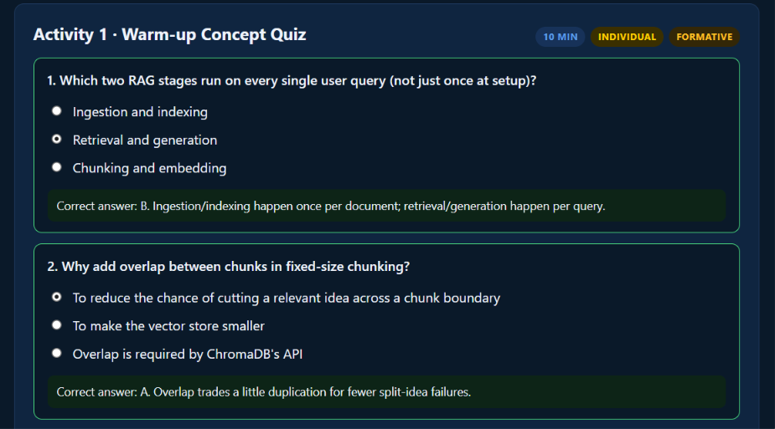
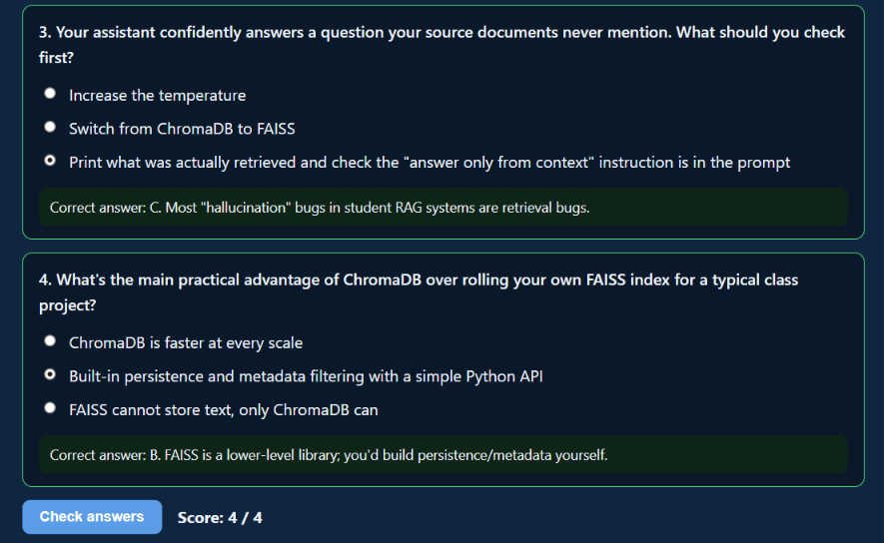
Activity 2 · Instructor-Led Live Coding
Follow along in week-04-rag.ipynb, sections 1-3: chunk a sample document, index it in both ChromaDB and FAISS, and run answer_with_rag live, including on a deliberately out-of-scope question, to see the "I don't have that information" behavior in action.
1. Chunking

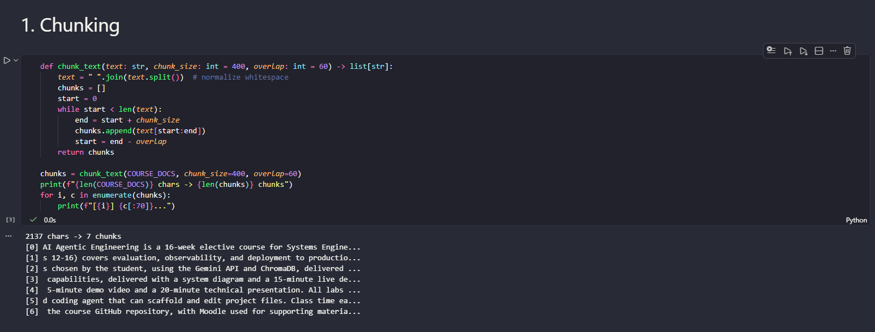
With chunk_size=400 and overlap=60, a 2137-character document becomes 7 chunks. Each chunk starts 340 characters after the previous one (400 - 60), so the last 60 characters of one chunk always repeat as the first 60 of the next -- exactly the mechanic behind quiz question 2.
2. Indexing with ChromaDB and FAISS
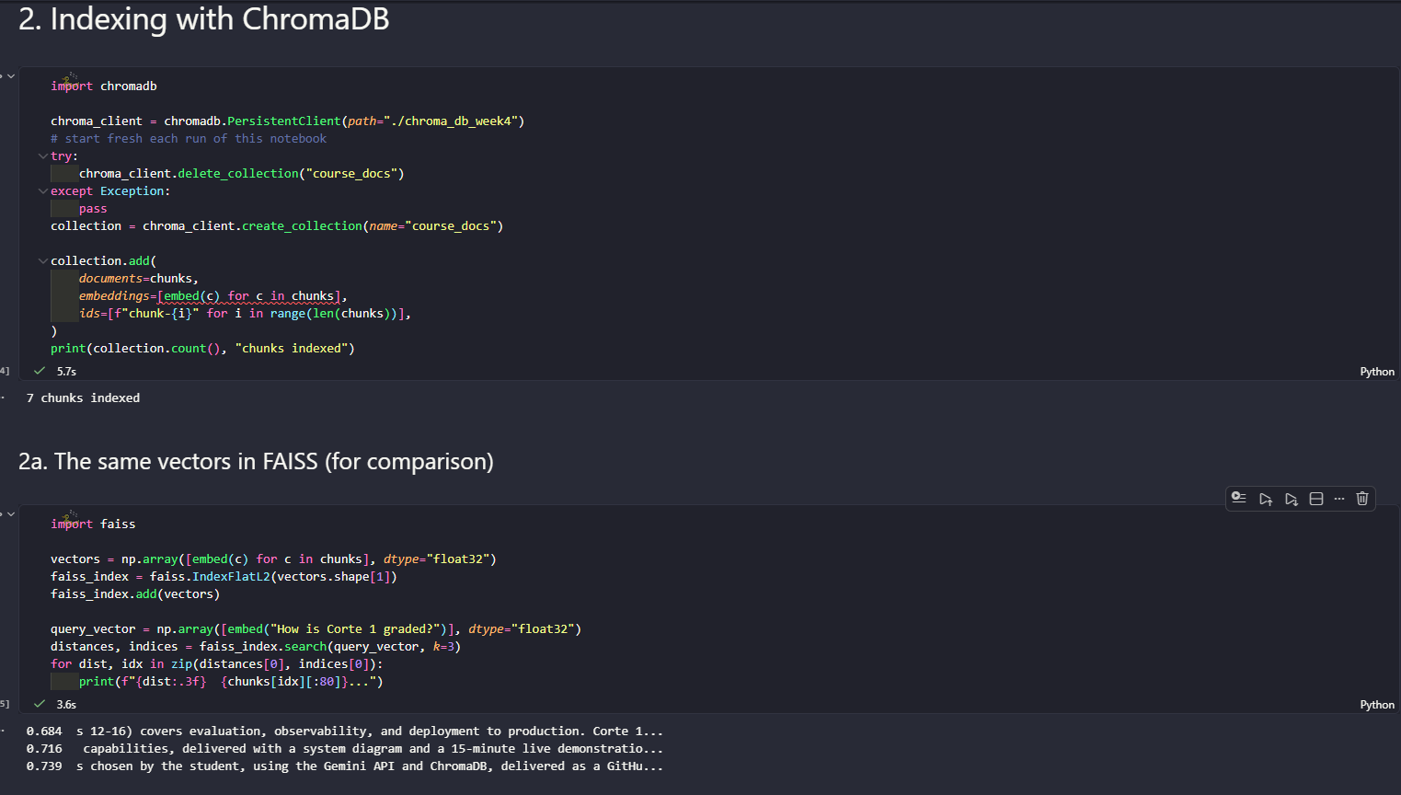
FAISS returns L2 distances (lower = closer), the opposite direction from the cosine similarity scores used in Week 3 (higher = closer) -- easy to misread if you're not paying attention to which metric a given library returns. ChromaDB's collection.count() confirms the same 7 chunks got indexed on that side too, and both retrieve the same top chunks for this query, since they're built from the exact same embeddings.
3. answer_with_rag

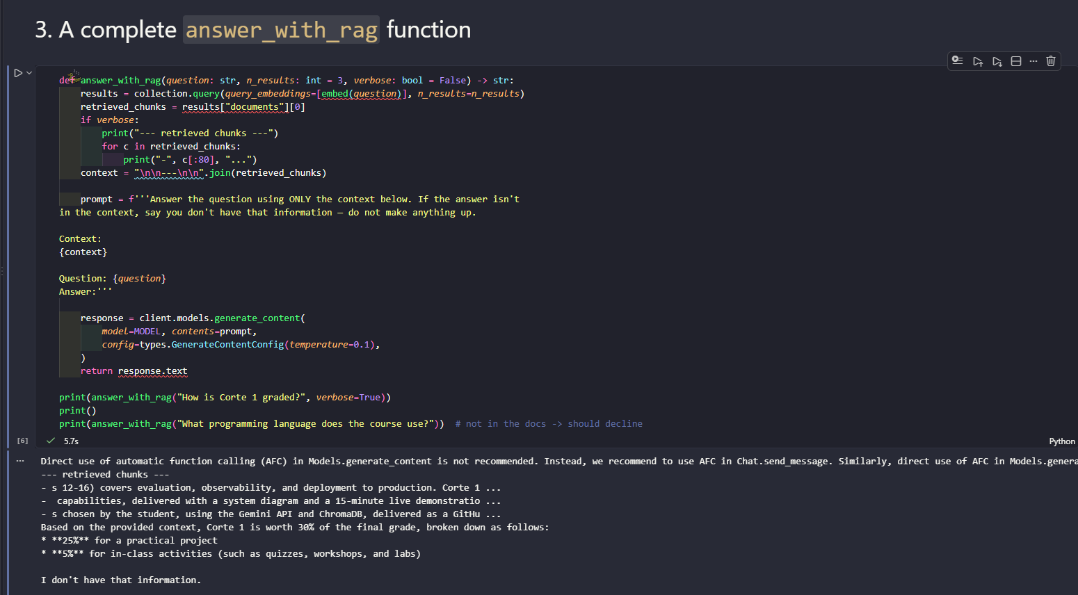
The in-scope question gets a grounded, detailed answer built only from the retrieved chunks. The out-of-scope question ("What programming language does the course use?", never stated anywhere in COURSE_DOCS) gets a clean decline instead of a guess -- exactly the behavior quiz question 3 is about: this only works because the prompt explicitly says "if the answer isn't in the context, say you don't have that information", not because the model is naturally cautious.

Activity 4 · Individual Lab: Complete the Notebook + Apply to Your Project
Sections 4: ADK tool / LangChain preview
Note: cell as given has the same asyncio.run(...)-inside-a-running-loop bug already fixed in Weeks 2 and 3 -- rewrote ask_adk_agent as async def, used await/async for on create_session and run_async, and called it with a top-level await.
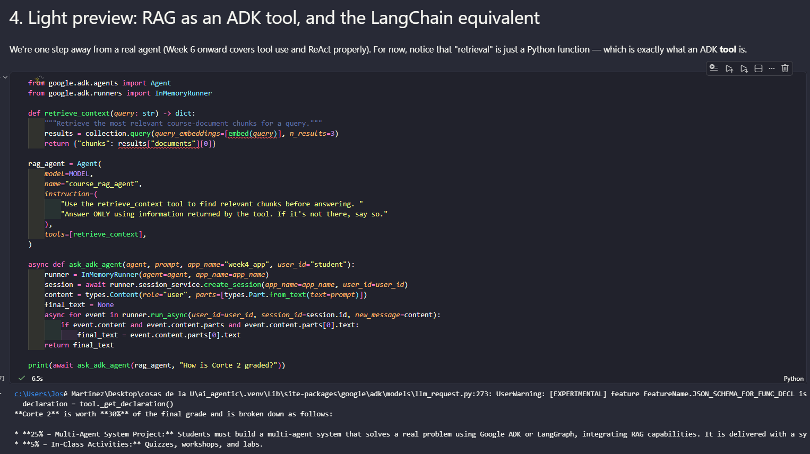
Same grounded-answer pattern as Activity 2, just reached through a tool call instead of a direct retrieval + prompt: the ADK agent decides on its own to call retrieve_context before answering, which is the same underlying mechanic as a RAG pipeline, framed as an agent tool -- exactly what the notebook's own note says is one step away from a real agent.
Own project documents (calculus tutoring assistant)
My Corte 1 project (from the Week 1 proposal) is a calculus tutoring assistant. Since gathering the real lecture notes/textbook chapters from Week 3 is still pending, I justo ask to the AI to give me a 3 short original placeholder notes (limits.txt, derivatives.txt, integrals.txt, in data/) covering the actual scope from my Week 2 system prompt, just so the pipeline could be exercised on real, domain-relevant text instead of the generic course-description sample. These are explicitly a stand-in and will be replaced once the real materials are gathered.
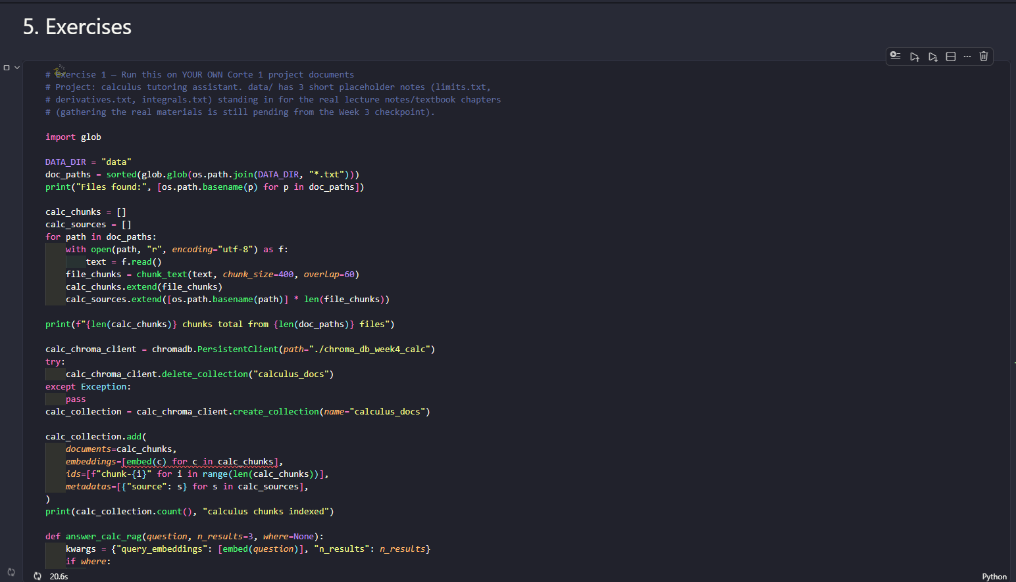
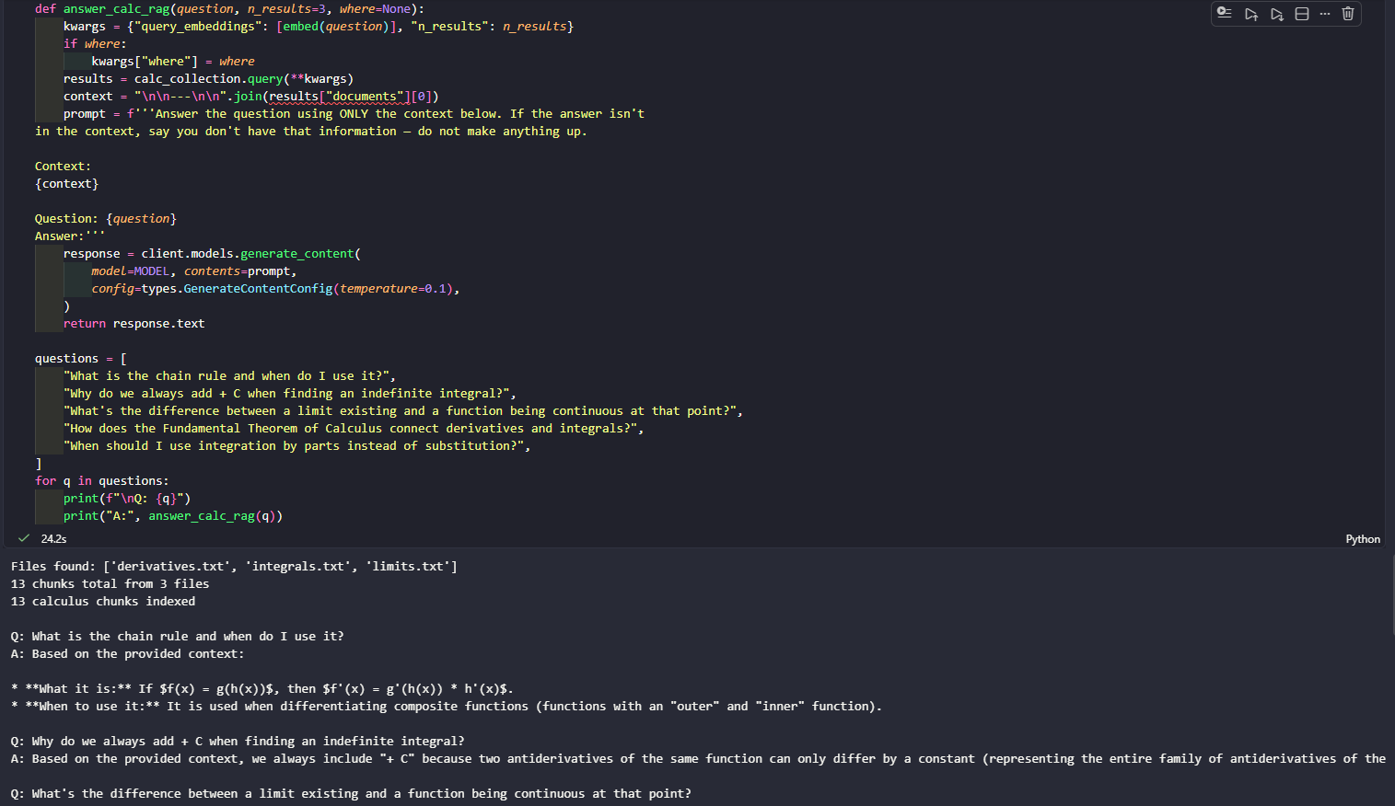
LLM Responses the answers like this:
Q: What is the chain rule and when do I use it?
A: Based on the provided context, the chain rule is the rule where if f(x) = g(h(x)), then f'(x) = g'(h(x)) * h'(x). You use it for composite functions.
Q: Why do we always add + C when finding an indefinite integral?
A: We always add "+ C" (an arbitrary constant of integration) because two antiderivatives of the same function can only differ by a constant, and the indefinite integral represents the entire family of antiderivatives of that function.
Q: What's the difference between a limit existing and a function being continuous at that point?
A: A limit existing at a point c only requires that both one-sided limits exist and are equal. A function being continuous at c is stricter: f(c) must be defined, the limit must exist, and the limit must equal f(c). The limit existing is only one of the three conditions for continuity.
Q: How does the Fundamental Theorem of Calculus connect derivatives and integrals?
A: If F is an antiderivative of f, the definite integral of f(x) dx from a to b equals F(b) - F(a) -- this makes it possible to evaluate definite integrals directly from an antiderivative instead of computing an area numerically.
Q: When should I use integration by parts instead of substitution?
A: Integration by parts is useful for products of functions (like x*e^x) and reverses the product rule, while substitution is used when the integrand contains a function and its derivative (reversing the chain rule). (The context didn't give further criteria beyond these two descriptions.)
All 5 answers are grounded correctly in the 3 placeholder documents, with no fabricated content -- a good sign the pipeline itself is sound and ready to point at the real course materials once they're gathered.
Exercise 2 -- metadata filtering
Re-indexed the same 13 chunks with metadatas=[{"source": ...}], then compared an unfiltered query against one restricted with where={"source": "integrals.txt"}.
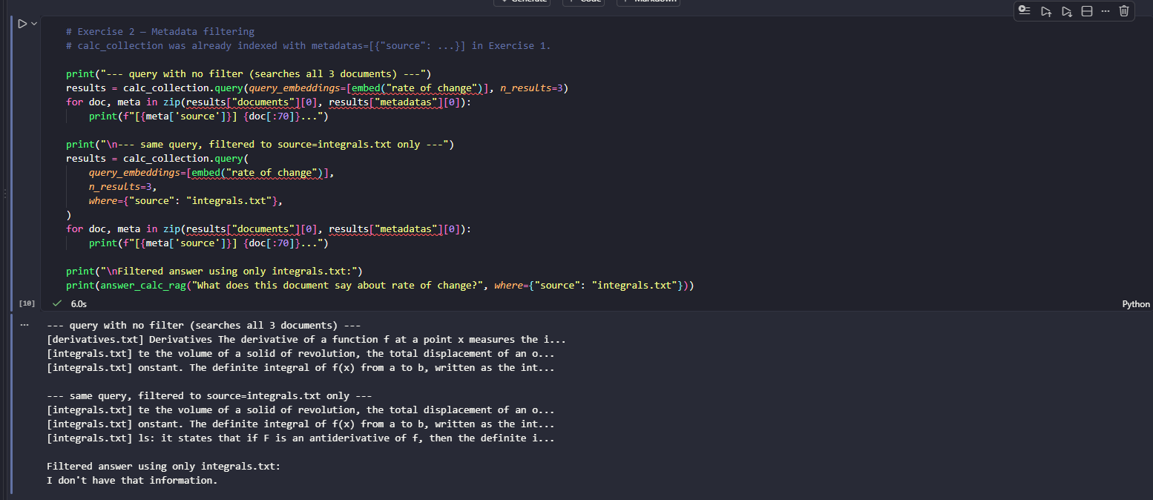
The unfiltered query for "rate of change" pulls from both derivatives.txt and integrals.txt, since rate of change is central to both. With the where filter locked to integrals.txt, only that document's chunks come back -- and asking directly "what does this document say about rate of change" against that filtered context correctly returns "I don't have that information", because integrals.txt talks about accumulation and area, not instantaneous rate of change (that concept lives in derivatives.txt, which the filter excluded). This is actually a good outcome: the filter is doing exactly what it should, and the system declines instead of stretching an adjacent but different document to answer something it doesn't actually say.
Activity 6 · Corte 1 Project: Delivery Checklist & Rubric

