<https://www.tytorobotics.com/blogs/articles/brushless-motor-manufacturers-for-evtol-and-aviation>

### magniX

magniX has become a household name for those following the development of the commercial electric aircraft industry. Through several fruitful partnerships, magniX motors have powered some of the most promising electric aircraft ever tested, including Harbour Air’s [electric Beaver seaplane](https://www.harbourair.com/harbour-air-magnix-and-h55-partner-for-the-worlds-first-certified-all-electric-commercial-airplane/) as well as the largest fully electric commercial aircraft to date, the [Cessna eCaravan](https://www.wingsmagazine.com/magnix-and-aerotec-fly-all-electric-cessna-grand-caravan/). Noting that in 2019 over 45% of commercial flights were less than 500 NM, magniX hopes to electrify these routes for improved environmental sustainability. Currently magniX lists two electric propulsion units on their website, the specs for the magni650 EPU are below.

Specifications:

* Max power: 640 kW
* Continuous torque: 3,020 Nm
* Max speed: 2,300 RPM
* Voltage: 800 V
* Peak efficiency: --
* Weight: 200 kg
* Known for: proven success in airworthy electric airplanes and seaplanes
* Location: Everett, USA
* Website: [www.magnix.aero/](https://www.magnix.aero/)

*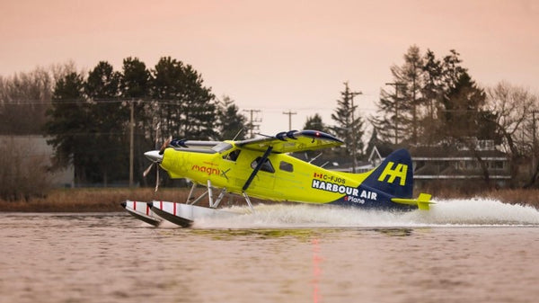Figure 1: Electric Beaver seaplane by magniX and Harbour Air (Photo from* [*Harbour Air*](https://www.harbourair.com/corporate-responsibility/goingelectric/)*)*

### H3X

A new and ambitious player on the scene, H3X is a U.S.-based company with aims to power large commercial aircraft like the Boeing 737. Their aspirations are certainly feasible as they have already developed an electric motor weighing only 15 kg with an unparalleled power density of 13 kW/kg. The [HPDM-250](https://www.h3x.tech/#motor) employs several innovations such as combining the electric motor and inverter into a single powerful unit, an optimized design contributing to the high power density. The performance characteristics for the HPDM-250 are outlined below.

Specifications:

* Max power: 250 kW
* Max torque: 120 Nm
* Max speed: 20,000 RPM
* Max voltage: 800 V
* Peak efficiency: 96.7%
* Weight: 15 kg
* Known for: superior power density
* Location: Minneapolis, USA
* Website: [www.h3x.tech/](https://www.h3x.tech/)

### EMRAX

The idea for EMRAX was born in 2005 when founder Roman Susnik flew Slovenia’s first flight in an electric aircraft. The flight ended in an emergency landing when the aircraft’s brushless motor failed, inspiring Susnik to develop a suitable motor himself. By 2008 a functional prototype was created and tested, and EMRAX had several requests for collaborations. Now in 2020, EMRAX engines are already used in a variety of [electric gliders and aircraft](https://emrax.com/references/aviation-aerospace/) and are also employed in Aquinea’s novel [all-electric helicopter](https://aquinea.fr/actualites-volta/). The motors possess a high power density and air-cooling, making them ideal for aviation applications. There are currently five ready-to-buy motors available from EMRAX with performance ranges summarized below.

Specifications:

* Max power range: 52 - 380 kW
* Max torque range: 90 - 1000 Nm
* Max speed range: 4,000 - 6,500 RPM
* Voltage range: 110 - 800 V
* Peak efficiency: up to 98%
* Weight range: 7 - 42 kg
* Known for: high power density and stacking option
* Location: Kamnik, Slovenia
* Website: [emrax.com/](https://emrax.com/)

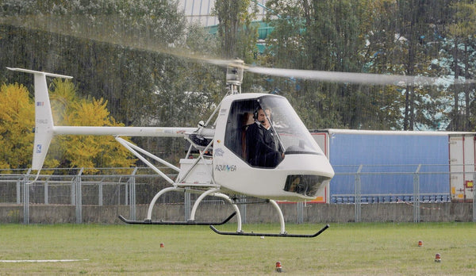

*Figure 2: Volta electric helicopter by EMRAX and Aquinea (Photo from* [*evtol.news*](https://evtol.news/aquinea-volta/)*)*

### Siemens

Founded over 170 years ago, Siemens has become an industrial giant with projects operating in many arenas. Their aerospace division is one such department, encompassing a range of specialities such as aerostructure production and power drive manufacturing. Despite the broad purview of the company, they have taken their place in the specific and highly competitive eVTOL industry. [CityAirbus](https://www.airbus.com/innovation/zero-emission/urban-air-mobility/cityairbus.html), Airbus Helicopter’s contribution to the eco-friendly air race, is powered by eight direct-drive 100 kW Siemens motors. With high caliber, proven electric motors, this manufacturer will certainly have a significant role in this up and coming industry. Information on their high-perfoming [SP200D](https://avinor.no/contentassets/c29b7a7ec1164e5d8f7500f8fef810cc/olaf-otto_siemens_oslo-22-march-2018_without-video.pdf) motor is found below.

Specifications:

* Max power: 204 kW
* Max torque: 1,500 Nm
* Max speed range: 1,300 RPM
* Voltage range: --
* Peak efficiency: --
* Weight range: 49 kg
* Known for: high efficiency, large motors
* Location: Munich, Germany (headquarters)
* Website: [www.siemens.com](http://new.siemens.com/global/en/products/drives/electric-motors.html)

### MGM COMPRO

With over 30 years of experience in the electronics industry, MGM COMPRO’s team is composed of ambitious and experienced engineers who are committed to electric propulsion. A quick glance at the News section of their website demonstrates that they are involved in many innovative projects including eVTOL vehicles, tilt-rotor aircraft, and personal flying machines. Already on the market are the [VELO self-launching gliders](https://www.gpgliders.com/offer/gp-14-e-se-velo) developed in partnership with GP Gliders and the [ΦNIX](http://pure-flight.eu/Pure-Plane.html) all-electric plane by the Pure Flight consortium. With their wealth of experience and diversity of projects on the go, it is doubtless that they will remain a key player in the electric aircraft industry. There are currently five classes of motors available on their website that are categorized based on power capability.

Specifications:

* Max power range: 5 - 80 kW
* Max torque range: 25 - 300 Nm
* Max speed range: 1,500 - 12,000 RPM
* Max voltage range: 63 - 800 V
* Peak efficiency: Up to 99%
* Weight range: 2.8 - 22 kg
* Known for: tailor-made, unique technical solutions
* Location: Zlin, Czechia
* Website: [www.mgm-compro.com/](https://www.mgm-compro.com/)

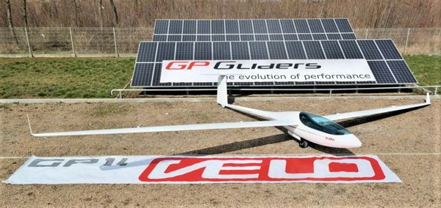

*Figure 3: VELO glider by MGM COMPRO and GP Gliders (Photo from* [*GP Gliders UK*](https://www.gpgliders.co.uk/model-range/gp14-velo/)*)*

### Safran

With a strong electrical engineering portfolio, it is no surprise that Safran has developed their own brushless motors for use in the aviation industry. Called ENGINeUS, the line of smart motors boast some unique features that differentiate them from other models, such as motor controller integration and a sealed design for use in harsh environments. The motors are already trusted by companies such as VoltAero, who are using it in their [six-seater Cassio](https://www.voltaero.aero/en/press-releases/cassio-flight-tests-with-safran-engineus-electric-motors/) electric plane. Safran also signed an agreement with Bye Aerospace to supply the motors for their [eFlyer 2 and eFlyer 4](https://byeaerospace.com/bye-aerospace-and-safran-announce-cooperation-agreement-to-equip-eflyer-all-electric-aircraft-with-engineus-electric-smart-motors/) aircraft. Between these partnerships, ENGINeUS will see use in air taxis, trainer planes and commuter aircraft. The performance characteristics for the recently developed [ENGINeUS 500](https://www.safran-group.com/products-services/engineustm) are outlined below.

Specifications:

* Max power: 500 kW
* Continuous torque: --
* Max speed: 2,200 RPM
* Voltage: --
* Peak efficiency: --
* Weight: --
* Known for: tolerance of harsh environments, integrated motor controller
* Location: Paris, France (headquarters)
* Website: [www.safran-electrical-power.com/](https://www.safran-electrical-power.com/electrical-systems/our-engineustm-electrical-motors)

**Further reading:** [**Comparing Drone Power System Designs**](https://www.tytorobotics.com/blogs/articles/analysis-and-modeling-of-uav-power-system-architectures)

*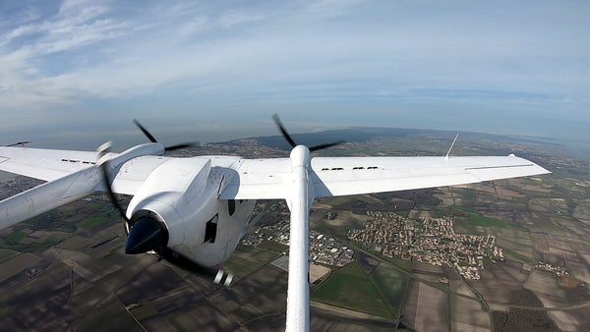Figure 4: Cassio 1 equipped with two ENGINeUS motors (Photo from* [*VoltAero*](https://www.voltaero.aero/en/press-releases/cassio-flight-tests-with-safran-engineus-electric-motors/)*)*

### T-Motor

T-Motor began and remains a drone-focused company, but their high-powered brushless motors are suitable for much more than quadcopters. Their U15L, XL and XXL models in particular are highly relevant for the manned aviation industry, producing up to 102 kg of thrust per motor. While no manned applications are advertised to date, their [YouTube channel](https://www.youtube.com/watch?v=sqkh6rEHdfI) highlights some of the larger UAVs and eVTOL vehicles that their motors can power. Only time will tell where this company will invest their R&D dollars next. Below are the performance ranges for their U15 line of motors.

Specifications:

* Max power range: 16 - 28 kW
* Max torque range: 6 - 56 Nm
* Max speed range: 2,439 - 3,134 RPM
* Voltage: 50 - 100 V
* Peak efficiency: --
* Weight range: 3.6 - 5.2 kg
* Known for: climate versatility, all-around performance
* Location: Nanchang, China
* Website: [uav-en.tmotor.com/](https://uav-en.tmotor.com/" \o "T-Motor website" \t "_blank)

### YASA

Incorporated in 2009, YASA specializes in motors for electric vehicles ranging from [sports cars](https://www.ferrari.com/en-US/auto/sf90-stradale) to [experimental aircraft](http://sustainableskies.org/espirit-of-st-louis-runs-at-oshkosh/). With their motors already powerful enough for manned flight, YASA seeks to power the all-electric and hybrid aircraft that will contribute to reducing global carbon emissions. They offer custom designed and off-the-shelf electric motors to meet the various needs of vehicle manufacturers. Their most ambitious collaboration to date is perhaps building ACCEL, the [world’s fastest electric aircraft](https://www.rolls-royce.com/innovation/key-demonstrators/accel.aspx#motors), in partnership with Rolls-Royce, a company working on several [electric aircraft projects](https://www.rolls-royce.com/innovation/propulsion.aspx). YASA currently has two off-the-shelf motors whose specs are summarized below.

Specifications:

* Power range: 160 - 200 kW
* Torque range: 370 - 790 Nm
* Max speed range: 3,250 - 8,000 RPM
* Voltage range: 350 - 700 V
* Peak efficiency: >95%
* Weight range: 24 - 37 kg
* Known for: smaller and lighter motors and controllers than competitors
* Location: Oxford, UK
* Website: [www.yasa.com/](https://www.yasa.com/)

*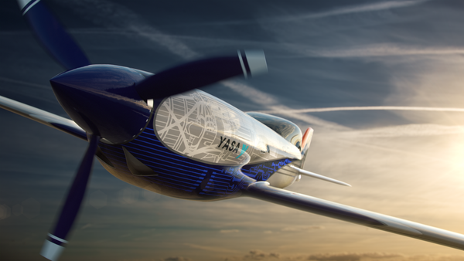Figure 5: ACCEL by YASA and Rolls-Royce (Photo from Rolls-Royce Flickr)*

### Turnigy

Having been around for just over 20 years, Turnigy prides themselves on keeping prices low for consumers through their ‘slick’ supply chain. They offer nine main models of motors, each suited to a unique function. While they are focused on the drone and RC industry, their motors do offer sufficient power for certain manned flights, such as manned multicopters and paramotors. They also offer their own pre-made [mini paramotor](https://www.youtube.com/watch?v=UuvIEy-fWfY&feature=youtu.be&t=6) (not built for passengers).

Specifications:

* Max power: 9.8 kW
* Max torque: --
* Max speed: 7,800
* Voltage: 19 - 52 V
* Peak efficiency: --
* Weight range: 2,500 g
* Known for: motors for a variety of uses
* Location: sold through Hobby King (Hong Kong, China)
* Website: [www.turnigy.com/](http://www.turnigy.com/)

### Thin Gap

Designed with both civilian and military uses in mind, Thin Gap motors are known for their toughness and high torque: weight ratio. This manufacturer also prides itself on its proprietary ironless stator and no cogging design, which allows for high power density, smoothness and efficiency. Looking to break into the VTOL industry, Thin Gap partnered with Aurora Flight Sciences to develop a [powerful fan system](https://www.thingap.com/wp-content/uploads/2013/10/ThinGap-Lift-Fans-Aerospace-Testing.pdf) for lifting heavy unmanned vehicles. The research contributed to the design of the [Aurora LightningStrike XV-24A](https://evtol.news/aurora-flight-sciences/), an electric Osprey-like project that has been discontinued. Below are the performance specs for their LSI 267-58 motor.

Specifications:

* Max power: 44 kW W
* Max torque: 191 Nm
* Max speed: 2,200 RPM
* Voltage: > 726 V
* Peak efficiency: --
* Weight: 4 kg
* Known for: ironless stator and no cogging design, high torque: weight ratio
* Location: Camarillo, USA
* Website: [www.thingap.com/](https://www.thingap.com/)

**Further reading:** [**Why You Should Measure Your Brushless Motor's Torque**](https://www.tytorobotics.com/blogs/articles/why-and-how-to-measure-torque-for-brushless-motors-on-drones)

*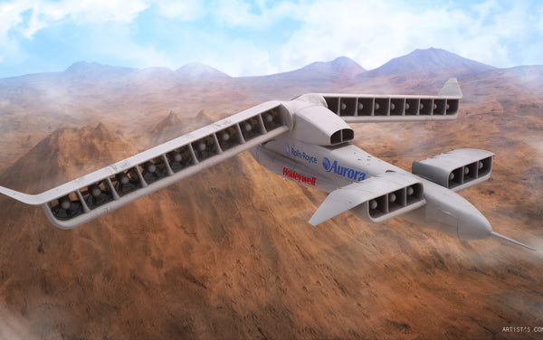Figure 6: The discontinued LightingStrike XV-24A (Image created by Moses Bunting)*

### KDE Direct

KDE Direct approaches manufacturing with the mission to power future-focused applications such as flights, satellites and space exploration. Their brushless motors are designed for longevity and zero-vibration operation, ideal for smooth flights and missions. While they are largely used in drones and UAVs, they also offer sufficient power to lift heavy lift drones. The performance range for KDE Direct’s brushless motor fleet is outlined below.

Specifications:

* Max continuous power range: 0.43 - 12.8 kW
* Max torque range: --
* Max speed range: --
* Voltage range: 7.4 - 69.6 V
* Peak efficiency: --
* Weight range: 24 - 700 g
* Known for: zero vibration operation
* Location: Bend, USA
* Website: [www.kdedirect.com/](https://www.kdedirect.com/)

### Pipistrel

Pipistrel can be called an expert in the electrical propulsion industry with already three different models of fully-electric aircraft available for purchase. Their [Velis Electro](https://www.pipistrel-aircraft.com/aircraft/electric-flight/velis-electro-easa-tc/) aircraft was actually the first ever electric-powered aeroplane to receive a type certificate from the EASA, paving the way for the innovative industry. They also offer electric [self-launching gliders](https://www.pipistrel-aircraft.com/aircraft/electric-flight/taurus-electro/) and hybrid general aviation style aircraft. Powering these aircraft is their E-811 liquid-cooled engine, capable of 49.2 kW of continuous power and rotation speed up to 2,500 RPM. Here’s a full summary of its basic characteristics.

Specifications:

* Max power: 57.6 kW
* Max torque: 220 Nm
* Max speed: 2,500 RPM
* Voltage range: 250 - 400 V
* Peak efficiency: --
* Weight: 22.7 kg
* Known for: the first electric engine certified for use in General Aviation by the EASA
* Location: Ajdovščina, Slovenia
* Website: [www.pipistrel-aircraft.com/](https://www.pipistrel-aircraft.com/)

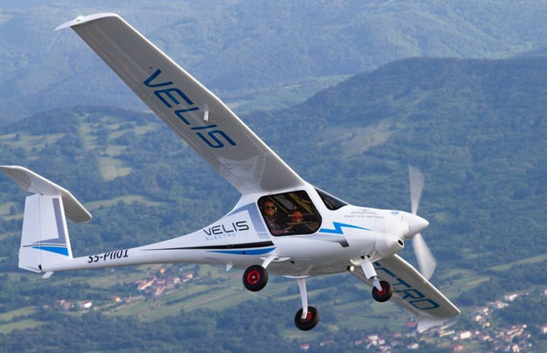

*Figure 7: The fully electric Velis Electro Aircraft (Photo from Pipistrel)*

### ****MAD Components****

The brushless motors created by MAD Components were "born for" heavy lift and manned drones, to put it in their words. Each rotor equipped with a MAD Components motor is designed to carry a payload up to 40 kg with a maximum thrust of up to 90 kgf per rotor. Designed for both commercial and recreational uses, you will see MAD motors in aircraft ranging from emergency rescue drones to paragliders. Below are the specs for their top performing motor, the [MAD TORQ M50C35 PRO EEE](https://mad-motor.com/product/mad-m50c35/?fbclid=IwAR2VJiB70OCFfbVmWdinpgYh9dCaftEglqxV9zP7lh4uC7uLzuLKAyZmgic).

* Max power: up to 21 kW
* Max torque: up to 67 Nm
* Max speed: --
* Max voltage: 100 V
* Peak efficiency: --
* Weight: up to 4.2 kg
* Known for: optimized cooling design, sturdy components
* Location: Warsaw, Poland
* Website: <https://mad-motor.com/>

### ePropelled

ePropelled is determined to shake up the brushless motor industry for eVTOL and aviation by developing solutions that meet the power-to-weight ratio needs of the trade. Their mandate specifically mentions the delivery of “propulsion systems for unmanned aerial vehicles (UAVs) and electric vertical takeoff and landing aircraft (eVTOL).” Their patented technology “produces a dramatically more energy-efficient method of electric propulsion that increases flight range and life expectancy of the battery pack”, allowing the manufacturer to save money on battery costs. Below are the specs for their largest motor, the [PM1200L](https://epropelled.com/pm/).

* Max power: up to 16 kW
* Max torque: up to 30 Nm
* Max speed: 8,000 RPM
* Max voltage: 72 V
* Peak efficiency: 94%
* Weight: up to 3.1 kg
* Known for: High power-to-weight ratio
* Location: Lowell, USA
* Website: <https://epropelled.com/>

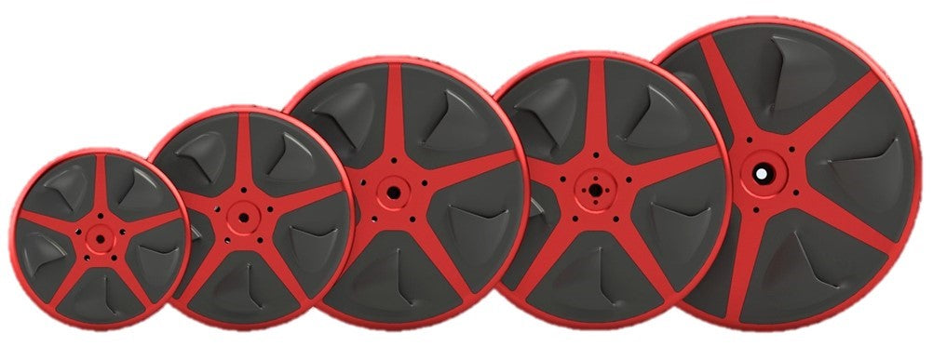

### Alva Industries

Alva Industries is a Norwegian motor manufacturer that was founded in 2016. Alva develops electric propulsion and traction systems for many functions, including cars, ships, airplanes, UAVs, and robotics. Their motors are based on a patented production method, FiberPrinting™, enabling virtually zero vibrations, precise positioning, extreme acceleration, high efficiency, and leading peak torque and peak power capabilities. The specs for their Series-X225 motor are below.

* Max power: 10 kW
* Max torque: 37 Nm
* Max speed: 4,000 RPM
* Max voltage: --
* Peak efficiency: 95.4%
* Weight: 2.8 kg
* Known for: High torque motors
* Location: Trondheim, Norway
* Website: <https://alvaindustries.com/>

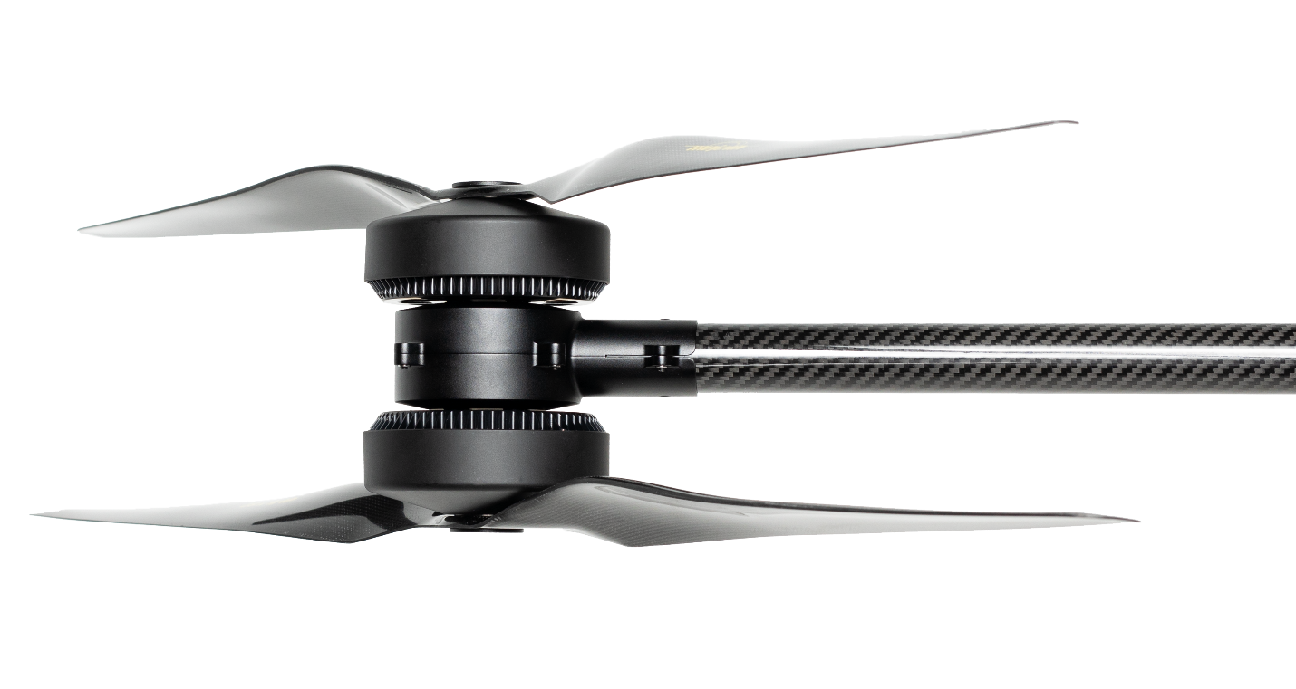

Figure 8: Coaxial propulsion system featuring two Alva motors

**Further reading:** [**How Brushless Motors Work and How to Test Them**](https://www.tytorobotics.com/blogs/articles/how-brushless-motors-work)

### Plettenberg

Plettenberg’s guiding principle is to achieve maximum efficiency at the lowest possible weight. They have several off the shelf electric motors available for purchase and they also do custom projects on request. According to their website, their standard solutions “offer efficiency levels of up to 95 % and power-to-weight ratios of up to 26 kW/kg.” Their [Nova 30](https://plettenberg-motoren.net/en/products/motor-solutions/motors) motor is the most powerful in their fleet, full specs below.

* Max power: 30 kW
* Max torque: up to 80 Nm
* Max speed: 7,000 RPM
* Max voltage: 140 V
* Peak efficiency: Up to 95%
* Weight: up to 6.5 kg
* Known for: High efficiency motors
* Location: Baunatal, Germany
* Website: <https://plettenberg-motoren.net/>

**Summary table (from highest to lowest max power)**

*Estimated values are italicized*

