Suggested by:
Product name: Doux Mousse DEF Texture Foam

Link to the product's website (if known):
Retail price: 15.99 USD

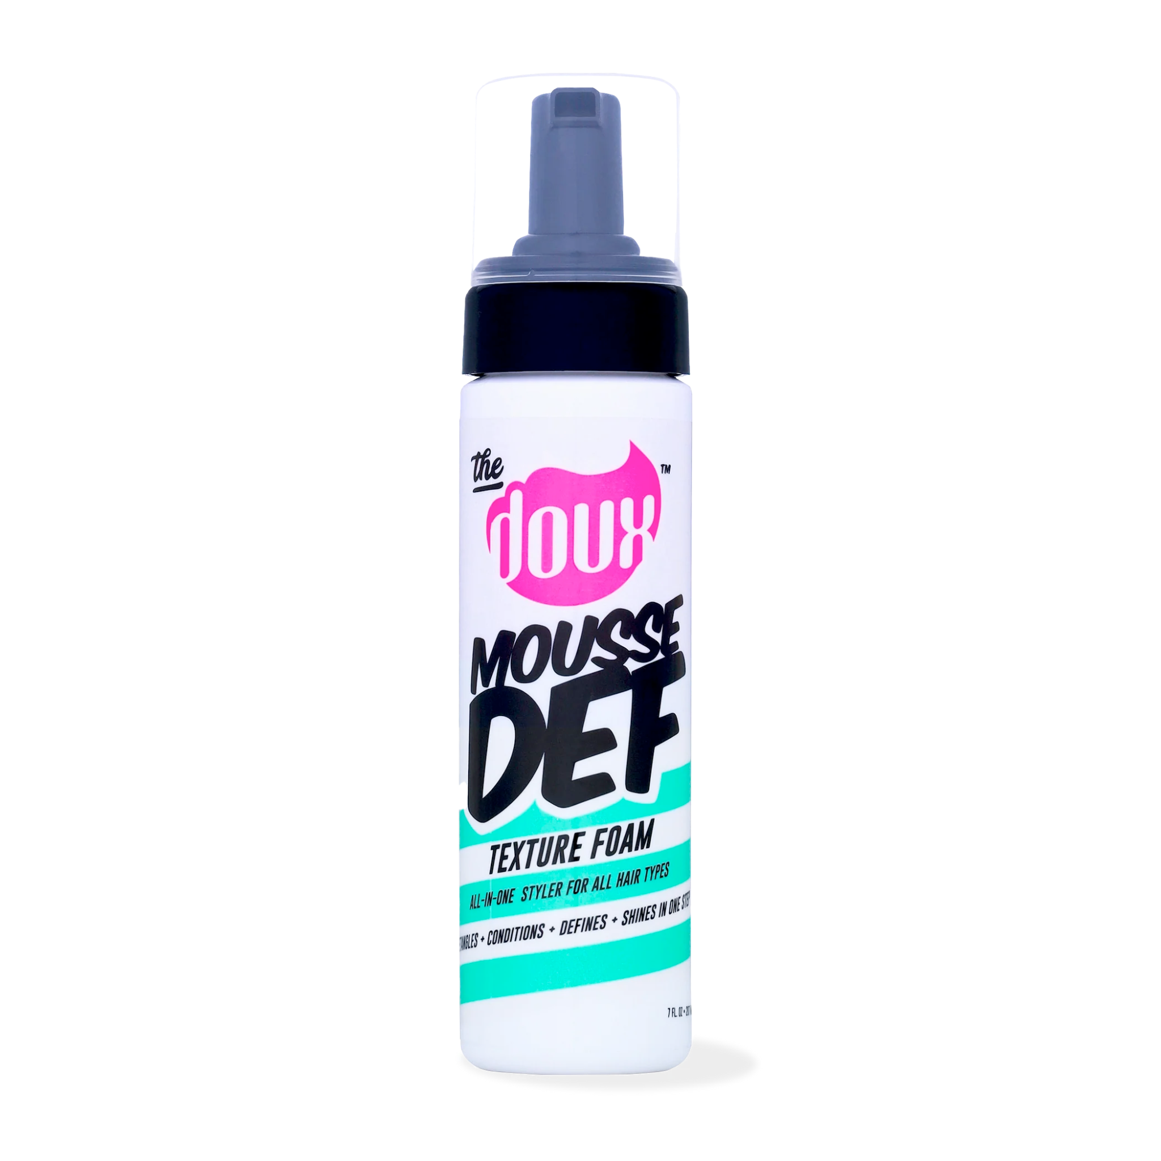
Image URL:

Product Analysis

Expanded research from extended sources

Active and Inactive Ingredients Safety and FDA Announcements

Formulation concerns

Efficacy on Black Hair and Skin

Is this a Black-owned business?

Is this product or the company that owns it certified cruelty-free by Leaping Bunny or PETA?
Is this product certified as vegan?

Tables

Active ingredients

Ingredients | EWG (data quality) | WIMJ (color) | SkinSafe | FDA Announcements

Inactive ingredients

Ingredients | EWG (data quality) | WIMJ (color) | SkinSafe | FDA Announcements

Ingredients group by INCI category

Category | Ingredients

Category per ingredient

Ingredients | Category

BONUS TRACK

Here’s a list of all the sources AI reviewed for the main analysis. Not all were highly relevant to the analysis, but I thought you might want to have a look at the kind of things it reviewed and see if there are any things to shortlist or remove entirely.

