Overview:

This project will implement a simple airport take-off time slot scheduler. Plane submit requests to take off at a certain time and tell the air traffic controller how long they will need the runway for. This program will process these requests and assign each plane a takeoff time.

Design:

The program will be written in Python. The program will take in input from the user in the form of a text file (.txt). The file will be passed in from standard in. The input file should be in the following format:

ID, Submission Time, Requested Start, Requested Duration

An example would be:

Delta 160, 0, 0, 4  
UAL 120, 0, 5, 4  
Delta 6, 2, 3, 6

The ID will be stored as a string and the other input values will be integers.

There will be a request class or data structure that will contain instance variables to store each of the input values. It will contain getter methods to retrieve these values but not setters as once a request is submitted it cannot be changed. The class diagram can be seen in Figure 1.

There will be a RequestProcess module that handles taking in and parsing the input. As the input is taken in, new request objects will be created. The objects will be stored in a priority queue. After all the input is taken in and stored, the priority queue will be processed and the program will print out the actual takeoff times to the console. The class diagram can be seen in Figure 2.

There will also be a Main module that drives the program. It will create a RequestProcess object and perform the necessary actions to support the functionality of the program. The class diagram can be seen in Figure 3.

Figures:

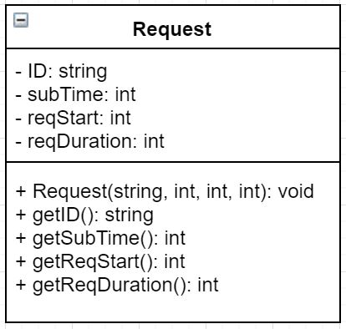

Figure 1

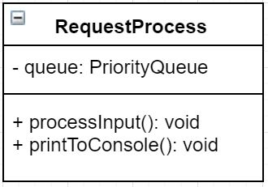

Figure 2

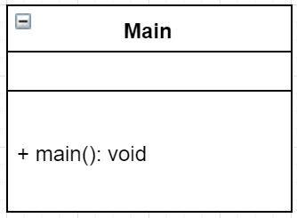

Figure 3

Change Log:

10/13/16 – 1:14PM – Initial SDD created