Results and analysis for DeepAR

Table of Contents
Script File: deepar-region-wise_optuna_local_linux_gpu_and_train_and_forecast.py 2
Trial #1: Include validation set in final training and include some tsfresh features. 2
Best Hyperparameters: 2
Results: 2
Evaluation Metrics: 2
Analysis: 2
Issues: 2
Recommendation for next trail: 3
Trial #2: 3
Best Hyperparameters: 3
Results: 3
Evaluation Metrics: 3
Analysis: 3
Issues: 3
Recommendation for next trail: 4

Author: Jose Peeterson

Dataset: New_BlueSG_clusters

Date: 23/4/2023

Model: DeepAR

Prediction type: Region-wise

Script File: deepar-region-wise_optuna_local_linux_gpu_and_train_and_forecast.py

Trial #1: Include validation set in final training and include some tsfresh features.

Tsfresh features are chosen from the result of best features from xgboost tweedie regression as shown below.

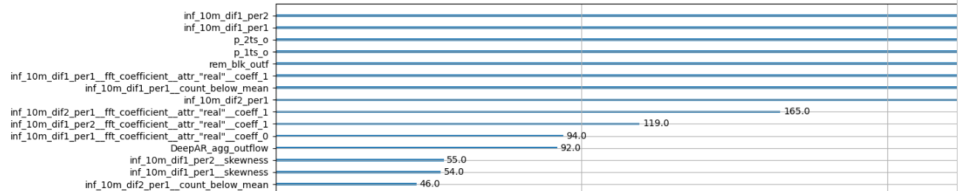

Region: Tampines
Check one region first.

Best Hyperparameters:

Results:

Evaluation Metrics:

Analysis:

Issues:

Recommendation for next trail:

Trial #2:

Best Hyperparameters:

Results:

Evaluation Metrics:

Analysis:

Issues:

Recommendation for next trail:

