Run Instructions for DeepAR

Dataset: New_BlueSG_clusters

Date: 21/3/2023

Model: DeepAR

Prediction type: Region-wise

Instructions:

1. Use “cluster_names_of_region.ipynb” file to identify which clusters belong to which regions by specifying region_name.

60 = minutes (1 hour) of aggregation, 0.5 = KiloMeter of aggregation.

Tampines clusters and stations:

160 | 160 | 160 | 161 | 162 | 162 | 162 | 163 | 164 | 165 | 165 | 165 | 165 | 166 | 166 | 166 | 167 | 168 | 168 | 169 | 169 | 169 | 169 | 170 | 170 | 170
85 | 157 | 295 | 27 | 86 | 180 | 201 | 386 | 39 | 130 | 184 | 293 | 350 | 45 | 144 | 383 | 321 | 67 | 312 | 55 | 169 | 311 | 313 | 79 | 158 | 211

2. Select all clusters‘ outflow of a particular region from “all_cluster_outflow_60_0.5.csv” and put into a file like “tampines_region_outflow.csv” shown below.

3. Select all clusters‘ inflow of a particular region from “all_cluster_inflow_60_0.5.csv” and put into a file like “tampines_region_inflow.csv” shown below.

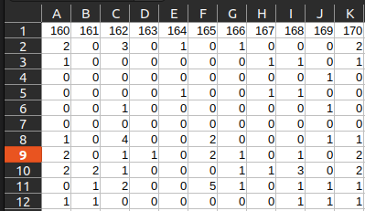

a. File: create_region_demand_inflow_data.ipynb

1. specify region_name = e.g. "tampines"

2. output files :

region_name+'_all_clstr_train_dem_data.csv’
region_name+'_all_clstr_val_dem_data.csv’
region_name+'_all_clstr_test_dem_data.csv’

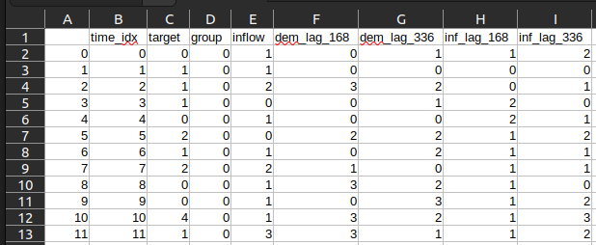

b. File: DeepAR_region-wise_optuna_local.ipynb
1. Run

c. File: DeepAR_region-wise_prediction.ipynb

1. use hyperparameters from optuna to train

