**MSc in Data Analytics (SB+) - Sept 2023 - 2023 - YR1**

Author: Jose Maria Rico Leal

e-mail: sba23021@student.cct.ie

Student ID: sba23021

GitHub Link: https://github.com/JoseRicoCct/CA2_Integrated_Assesment_MSc_Data_Analytics_CCT_Semester_1.git

Irish transport sector

## **Abstract**

*Empty*

**Abstract** 1

**1.** **Introduction** 3

**2.** **Programming** 4

2.1. Programming 4

2.2. Data Structures 4

2.3. Documentation 4

2.4. Testing and Optimisation 4

2.5. Data Manipulation 4

**3.** **Statistical Analysis** 4

3.1. Descriptive Statistics 4

*3.1.1.* *Dataset for Confidence Interval* 4

*3.1.2.* *Dataset for Hypothesis Test Two Populations* 5

*3.1.3.* *Dataset for ANOVA One-Way* 7

*3.1.4.* *Dataset for Chi-Squared Test* 8

*3.1.5.* *Dataset for Kruskal-Wallis* 9

*3.1.6.* *Dataset for U-Mann Whitney* 11

3.2. Confidence Interval 12

3.3. Inferential Statistics 14

*3.3.1.* *Parametric* 14

*3.3.1.1.* *T-test Two Populations* 14

*3.3.1.2.* *ANOVA One-Way* 16

*3.3.1.3.* *Chi-squared test* 18

*3.3.2.* *Non-parametric* 19

*3.3.2.1.* *Kruskal-Wallis* 19

*3.3.2.2.* *U-Mann Whitman* 21

3.4. Further Research and Challenges Faced 23

**4.** **ML** 24

4.1. Supervised Learning, GridSearchCV Hyperparameter Tunning. 25

4.2. Cross Validation and Feature Reduction. 26

4.3. Unsupervised Learning. 27

4.4. Sentiment Analysis. 27

4.5. Table and Conclusions 29

*4.5.1.* *Supervised Learning* 29

*4.5.2.* *Cross Validation and Feature Reduction* 32

*4.5.3.* *Unsupervised Learning* 34

**5.** **Data Preparation and Visualisation** 39

5.1. Data acquistion 39

5.2. EDA methodology 39

5.3. Visualisations 39

5.4. Dashboard 39

**6.** **Conclusion** 39

**7.** **References** 39

**8.** **Annex** 40

# **Introduction**

# **Programming**

# Programming

I organized the project into five Jupyter Notebooks:  
*CA2_ML_Code.ipynb*, *CA2_Programming_Code.ipynb*, *CA2_Statistics_Code.ipynb* and *CA2_Data_Visualisation.ipynb*. The project is programmatically explored using Python, emphasizing modularity and narrative-style programming.

# Data Structures

For this project I gathered and process data from:

CSV file:

Web API in CSV format:

Eurostat module:

Also, I explored gathering data from a:

Web API in JSON format:

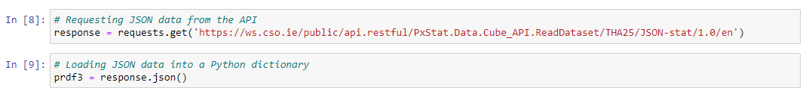

Entire parsing process is documented in *“CA2_Programming_Code_sba23021.ipynb”* from cell 8 to 17.

MySQL database:

As I could not an open MySQL database to connect, I will be demonstrating how to extract data from a local MySQL database. I created a table named *“tran_hv_psmod”* within a schema called *“eurostat”* and imported the previously fetched file from Eurostat, *“TRAN_HV_PSMOD.csv”*:

Once I had the records in the table, I was able to retrieve them using the Python package *“sqlalchemy”*:

Complete instructions on creating the table, pushing, and fetching records are provided in the annex.

# Documentation

# Testing and Optimisation

# Data Manipulation

# **Statistical Analysis**

# Descriptive Statistics

# *Dataset for Confidence Interval*

Dataset used is *“tii03-passenger-journeys-by-luas”.* We aim to estimate the range of potential values for the parameter *“LUAS average passenger number”.*Below are the descriptive statistics for the total LUAS passenger numbers (green and red lines) for the years 2019, 2020, 2021 and 2022:

We will be examining the mean values to establish the confidence intervals.  
It is interesting to note that both lines are quite balanced in terms of usage.

In Section 3.2, a detailed analysis of confidence intervals will be conducted for this dataset.

# *Dataset for Hypothesis Test Two Populations*

In this section we are comparing Ireland with some European countries, formulating hypothesis to assess if there are statistically significant differences in the *“percentage average passenger-kilometres based on type of transport (Bus, Car and Train”.* Since we will be using Ireland mean against other countries mean, this plot will assist us in constructing the hypothesis:

The dataset used is *“Modal split of inland passenger transport”* withthe Eurostat code *“TRAN_HV_PSMOD”.*

# *Dataset for ANOVA One-Way*

Using Irish airports as a reference, an ANOVA will be conducted to test whether there are any statistically significant differences in the means compared to other European airports. The dataset used is *“Air passenger transport by main airports in each reporting country”* with the Eurostat code *“AVIA_PAOA”.*

In the first scenario Dublin Airport is considered, and below a graph of the subset of airports selected for this case:

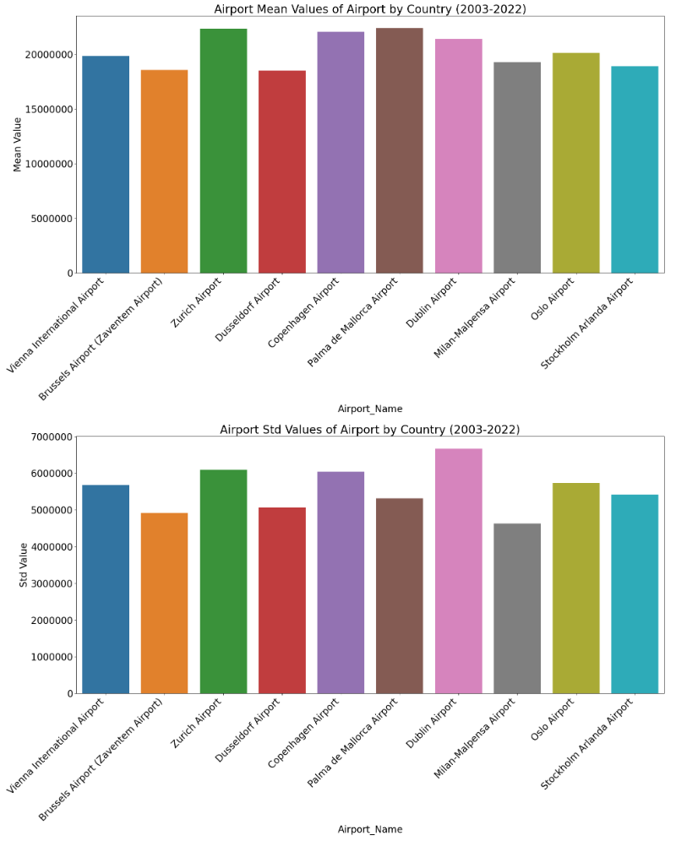

In the second scenario, Shannon Airport is considered, and below is a graph showing the subset of airports selected for this case:

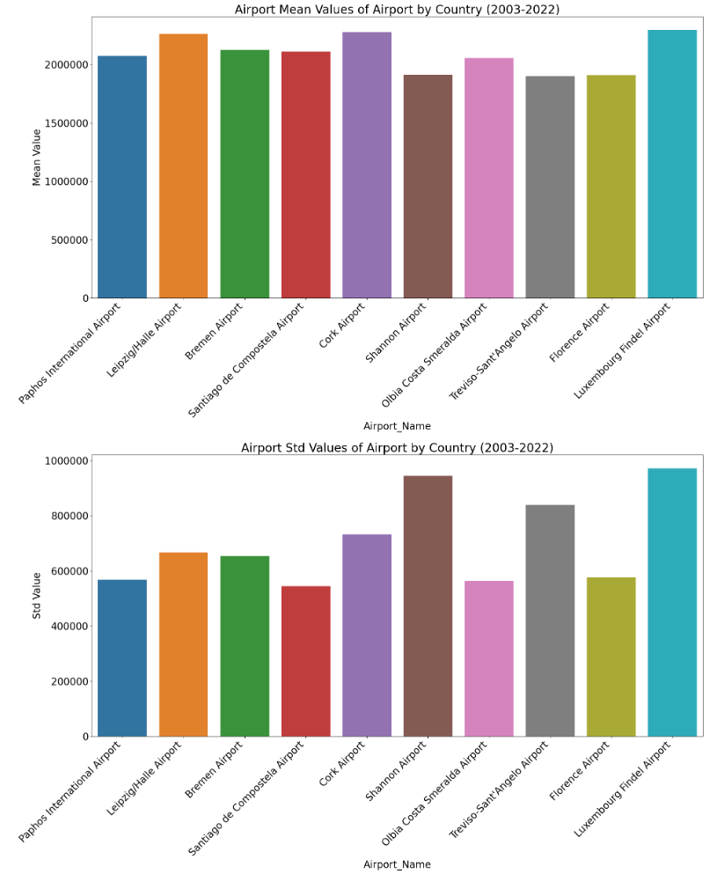

# *Dataset for Chi-Squared Test*

This test will be performed to examine the association between the categorical variable *“Motor_energy_type”* for Ireland and Austria. The dataset used is *“New passenger cars by type of motor energy”* with the Eurostat code *“road_eqr_carpda”.*

This model is highly sensitive to the frequency of the variables. I have presented two cases: one where we reject H0, and the second one where I manually changed values to accept H0. I will now illustrate how the categorical variable numbers will look for each case, with further analysis to follow in *“3.3.1.3. Chi-squared test”.*

Scenario 1: Rejecting H0.

Scenario 2: Accepting H0.

# *Dataset for Kruskal-Wallis*

For this test, I utilized the same dataset as for ANOVA. Some of the airports violated the assumptions of normality required for ANOVA. The advantage of using the Kruskal-Wallis test is that it does not require normality to perform the test. I will present two scenarios: one to accept H0 and another to reject H0.

Scenario 1: Accepting H0.

Scenario 2: Rejecting H0.

# *Dataset for U-Mann Whitney*

I used a new dataset for this test, *“Passengers transported (Railway transport)”,* with the Eurostat code *“rail_pa_total”* because the data did not follow a normal distribution. This choice allowed me to demonstrate the test's capability to handle non-normally distributed data.

Scenario 1: Accepting H0.

Scenario 1: Rejecting H0.

# Confidence Interval

The task is to determine the weekly LUAS average for the total number of passengers in the years 2019, 2020, 2021, and 2022. It is important to note that both LUAS lines (red and green) are in scope. The analysis will be conducted with a 90% confidence level, and here are the results:

E.g. At a 90% confidence level, for 2019 the weekly LUAS number of passengers average is between 453K and 472K. Subsequently the same formulation for the rest of the years.

Plotting the confidence intervals:

After performing confidence intervals, the next natural step is to verify if the weekly averages are the same for both the red and green LUAS lines. We will use a t-test.

Hypothesis:

H0: μ green line = μ red line.  
H1: μ green line != μ red line.

Results:

At a 5% significance level, we accept the Null Hypothesis; there is not enough evidence to conclude that the weekly mean values for the LUAS green line are different from those of the red line.

# Inferential Statistics

# *Parametric*

# *T-test Two Populations*

To perform this test, we will compare Ireland with three different countries, each having a distinct transportation method. The first scenario involves comparing Ireland with Slovenia for cars, the second compares Ireland with Denmark for buses, and the third compares Ireland with Slovenia again, but this time for trains.

Hypothesis:

H0: μ Ireland = μ EU Country.

H1: μ Ireland != μ EU Country.

Results:

Since the p-value is greater than alpha, we accept the null hypothesis (H0). There is not enough evidence to conclude that there is a significant difference between the percentage average of passenger-kilometres for the BUS vehicle in Ireland and Slovenia.

As the p-value is less than alpha, we reject the null hypothesis (H0), providing sufficient evidence to conclude a significant difference in the percentage average of passenger-kilometres for the Car vehicle between Ireland and Denmark.

As the p-value is less than alpha, we reject the null hypothesis (H0), indicating sufficient evidence to conclude a significant difference in the percentage average of passenger-kilometres for the Train vehicle between Ireland and Slovenia.

# *ANOVA One-Way*

In the first scenario, we examine Dublin, Zurich, and Copenhagen airports to verify whether the yearly average passenger numbers for the period from 2003 to 2022 are the same or not.

To perform ANOVA, we need both Shapiro-Wilk and Levene tests to have p-values greater than 5% alpha.

Now we can perform ANOVA:

H0: μ IE_EIDW = μ CH_LSZH = μ DK_EKCH.

H1: there are at least 2 μ that are different one to another.

Result p-value = 0.889

There is no reason to reject the Null Hypothesis; therefore, we can conclude that, with a 5% alpha, the mean of annual passengers carried (2003-2022) for Dublin, Zurich and Copenhagen airports is quite similar.

Second scenario: Shannon, Billund, and Treviso airports. We want to verify if the yearly average passenger numbers for the period 2003 to 2022 are the same or not.

Shapiro-Wilk and Levene tests:

ANOVA hypothesis:

H0: μ IE_EINN= μ IT_LIPH= μ DK_EKBI.

H1: there are at least 2 μ that are different one to another.

Result p-value = 0.04

We fail to accept the Null Hypothesis; therefore, we can state that with a 5% alpha the mean of annual passengers carried (2003-2022) for Shannon, Treviso-Sant'Angelo and Billund airports is different.

# *Chi-squared test*

First Scenario:

Hypothesis:

H0: There is no significant difference between the observed and expected frequencies. Ireland and Austria are independent with no association or relationship.

H1: There is a significant difference between the observed and expected frequencies, indicating a non-independent relationship between Ireland and Austria

Result p-value = 1.64e-14, we fail to accept H0.

In the second scenario, I manually adjusted values for Austria to align frequencies more closely with those of Ireland; this model is highly sensitive to substantial differences between categorical variables.

After applying the Chi-Square test, we obtained a p-value of 0.59, leading us to accept H0

# *Non-parametric*

# *Kruskal-Wallis*

Scenario 1:

We do not have normality for our samples:

Hypothesis:

H0: μ IE_EIKN= μ FR_LFBP= μ SE_ESGP.

H1: there are at least 2 μ that are different one to another.

Result, p-value = 0.23511.

We accept H0; the means of annual passengers carried (2003-2022) for Ireland West Knock, Pau Pyrenees, and Goteborg airports are quite similar.

Scenario 2:

We do not have normality for our samples:

Hypothesis:

H0: μ IE_EIKY= μ DE_EDSB= μ PL_EPRZ.

H1: there are at least 2 μ that are different one to another.

Result, p-value = 8.48e-08

We fail to accept H0; the means of annual passengers carried (2003-2022) for Kerry, Karlsruhe/Baden, and Rzeszow-Jasionka airports are different.

# *U-Mann Whitman*

Scenario 1:

Checking normality:

Hypothesis:

H0: μ Ireland = μ Croatia.

H1: μ Ireland != μ Croatia.

Result p-value = 0.3068

As the p-value is greater than alpha, we accept H0, indicating that there is no significant difference between the average number of train passengers in Ireland and Croatia.

Scenario 2:

Checking normality:

Hypothesis:

H0: μ Ireland = μ Slovakia.

H1: μ Ireland != μ Slovakia.

Result p-value = 3.45e-06

We reject H0 as p-value is lower than alpha, there is a significant difference between the average number of train passengers between Ireland and Slovakia.

# Further Research and Challenges Faced

The tests I have conducted above reveal interesting findings:

*“Number of public transport journeys at highest level since the beginning of the pandemic”* (BreakingNews.ie, 2022), based on the confidence intervals, we can confirm that the number of passengers is recovering:

*“Paris Charles De Gaulle recorded the highest number of air passengers”* (ec.europa.eu, n.d.). *“Dublin Airport Was EU’s 11th Largest Airport in 2018”* (DublinAirport, n.d.):

Analising means in the ANOVA section we can see that those headings are highly correlated with *“FR_LFPG”* and *“IE_EIDW”.*

The challenges faced included gathering the data and establishing the scenarios to perform the tests.

# **ML**

The methodology for ML part can be seen as follows:

# Supervised Learning, GridSearchCV Hyperparameter Tunning.

The choice of the dataset *“TRAN_HV_PSMOD”* and the selection of supervised ML models (Decision Tree, Random Forest, K-Nearest Neighbours, and Support Vector Machine) are purely matters of modelling. After numerous attempts, this combination has proven effective.

We will be modelling the dataset to see how models react having these classes:

I paired Ireland with Hungary because it showed the best performance association for selected ML models, here are the results:

Overall model is performing well however for Gamma = 0.0001, models seem to be overfitted as this score is lower compared to Gamma 0.01 and 0.001:

To address the issue of overfitting, I enriched the dataset by quarterly weighting yearly values:

The results are as follows:

Now we have a better fit, with higher scores observed at Gamma = 0.0001.

# Cross Validation and Feature Reduction.

Ireland will be our target variable for each transportation method. In the first attempt with yearly data, we obtained the following results:

After quarterly enrichment, increasing the number of rows from 32 to 128, we obtained the following results:

Linear regression estimation has performed much better with enriched data.

# Unsupervised Learning.

Dataset it is split into each mode of transportation having Ireland as a reference.

First attempt with quarterly data we get the following results:

To improve the results, we are going to enhance the dataset by breaking down each year into monthly values. The results are as follows:

*KMeans* and *PCA* have performed better with more data.

# Sentiment Analysis.

We are going to conduct sentiment analysis using Ryanair reviews and a set of tweets related to USA airlines. Results:

*Tweets* dataset is larger than *Ryanair* one that explains more correctly classified inputs:

Ryanair figure X

USA Airlines

Model accuracy for *Ryanair* is 73% and 75% for *USA Airlines.* ROC results as it follows:

*USA Airlines* seem to be classifying bad inputs better, while the other two are closer to each other. Let us test the classifier by adding reviews:

Result:

*Ryanair's* sentiment analysis performs well even though it has fewer inputs than *USA Airlines.* This difference could be attributed to the collection of reviews from *Tripadvisor,* where I ensured capturing opinions across good, bad, and neutral categories.

# Table and Conclusions

# *Supervised Learning*

Let us compare each model after enriching the dataset.

Decision Trees CM:

Random Forrest:

KNN:

GridSearchCV CM:

Gamma Accuracy:

Accuracy Table:

By adding more values, models have performed better, with the exception of RF. However, we solved overfitting in the hyperparameter tuning phase, achieving higher accuracy at a lower level of gamma.

# *Cross Validation and Feature Reduction*

Same approach as we followed previously, we increased dataset row count by breaking down years into quarters, here the results:

Summary table:

Optimal feature selection and improved accuracy after enriching the dataset, undoubtedly, this method requires a larger dataset to perform well.

# *Unsupervised Learning*

PCA Variance:

PCA Scatter Plot:

PCA Heatmap:

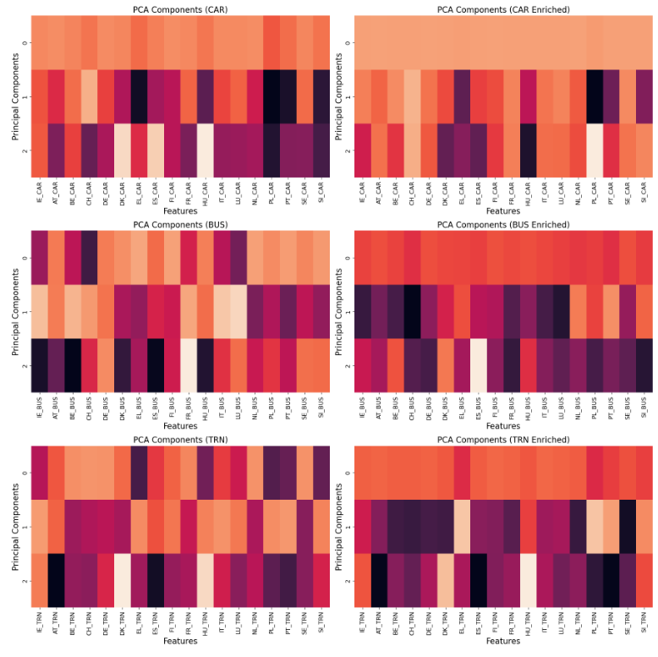

Elbow Method:

Silhouette Score:

Tables PCA and Silhouette Score:

After enriching the data, the first principal component explains almost 97% of the variability for the CAR and BUS datasets, while the TRN dataset exhibits 76.86% variability on the first component. This demonstrates a clear improvement.  
The silhouette score has improved, indicating that the clusters are now closer to being well-defined (closer to +1). Additionally, all plots demonstrate a clear improvement after enlarging the dataset.

# **Data Preparation and Visualisation**

# Data acquistion

# EDA methodology

# Visualisations

# Dashboard

# **Conclusion**

# **References**

Statistics:

BreakingNews.ie. (2022). *Number of public transport journeys at highest level since the beginning of the pandemic.* [online] Available at: https://www.breakingnews.ie/ireland/number-of-public-transport-journeys-at-highest-level-since-the-beginning-of-the-pandemic-1304260.html [Accessed 11 Dec. 2023].

ec.europa.eu. (n.d.). *Air transport statistics.* [online] Available at: https://ec.europa.eu/eurostat/statistics-explained/index.php?title=Air_transport_statistics#:~:text=In%202022%2C%20820%20million%20people%20in%20the%20EU%20travelled%20by%20air.&text=In%202022%2C%20Paris%20Charles%20De [Accessed 11 Dec. 2023].

DublinAirport. (n.d.). *Dublin Airport Was EU’s 11th Largest Airport in 2018*. [online] Available at: https://www.dublinairport.com/latest-news/2019/05/31/dublin-airport-was-eu-s-11th-largest-airport-in-2018.

DublinAirport. (n.d.). *Dublin Airport Was EU’s 11th Largest Airport in 2018*. [online] Available at: <https://www.dublinairport.com/latest-news/2019/05/31/dublin-airport-was-eu-s-11th-largest-airport-in-2018>.

# **Annex**