Social Injustice Social Injustice Social Injustice Social Injustice Social Injustice

& the African-American & the African-American & the African-American & the African-American & the African-American

Experience Experience Experience Experience Experience


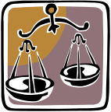

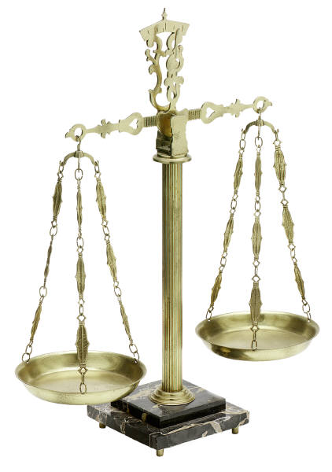

A library orientation and A library orientation and A library orientation and A library orientation and A library orientation and
book club unit book club unit book club unit book club unit book club unit

- based on multi-cultural - based on multi-cultural - based on multi-cultural - based on multi-cultural - based on multi-cultural
Themes themes themes themes themes

Includes handouts, Includes handouts, Includes handouts, Includes handouts, Includes handouts,
bookmarks, and bookmarks, and bookmarks, and bookmarks, and bookmarks, and Powerpoint lessons for: Powerpoint lessons for: Powerpoint lessons for: Powerpoint lessons for: Powerpoint lessons for:

• a freshman library • a freshman library • a freshman library • a freshman library • a freshman library
orientation that parallels orientation that parallels orientation that parallels orientation that parallels orientation that parallels
To Kill a Mockingbird To Kill a Mockingbird To Kill a Mockingbird To Kill a Mockingbird To Kill a Mockingbird


• 6 book club lessons • 6 book club lessons • 6 book club lessons • 6 book club lessons • 6 book club lessons
that are aligned to CA that are aligned to CA that are aligned to CA that are aligned to CA that are aligned to CA
English/Language Arts English/Language Arts English/Language Arts English/Language Arts English/Language Arts
Standards and are ready Standards and are ready Standards and are ready Standards and are ready Standards and are ready
for teachers to use for teachers to use for teachers to use for teachers to use for teachers to use

On the web: On the web: On the web: On the web: On the web:
http://www.santasusana.org/ http://www.santasusana.org/ http://www.santasusana.org/ http://www.santasusana.org/ http://www.santasusana.org/
Click on Student Info Click on Student Info Click on Student Info Click on Student Info Click on Student Info
Click on Library Click on Library Click on Library Click on Library Click on Library
Click on Librarian’s Corner Click on Librarian’s Corner Click on Librarian’s Corner Click on Librarian’s Corner Click on Librarian’s Corner


