To: Prof. Geoffrey Buhl
From: Jose de Jesus Rodriguez Rivas
Date: January 23, 2019
Subject: Introduction

Summary: This memo is to tell a little bit about myself and why I am in this class.

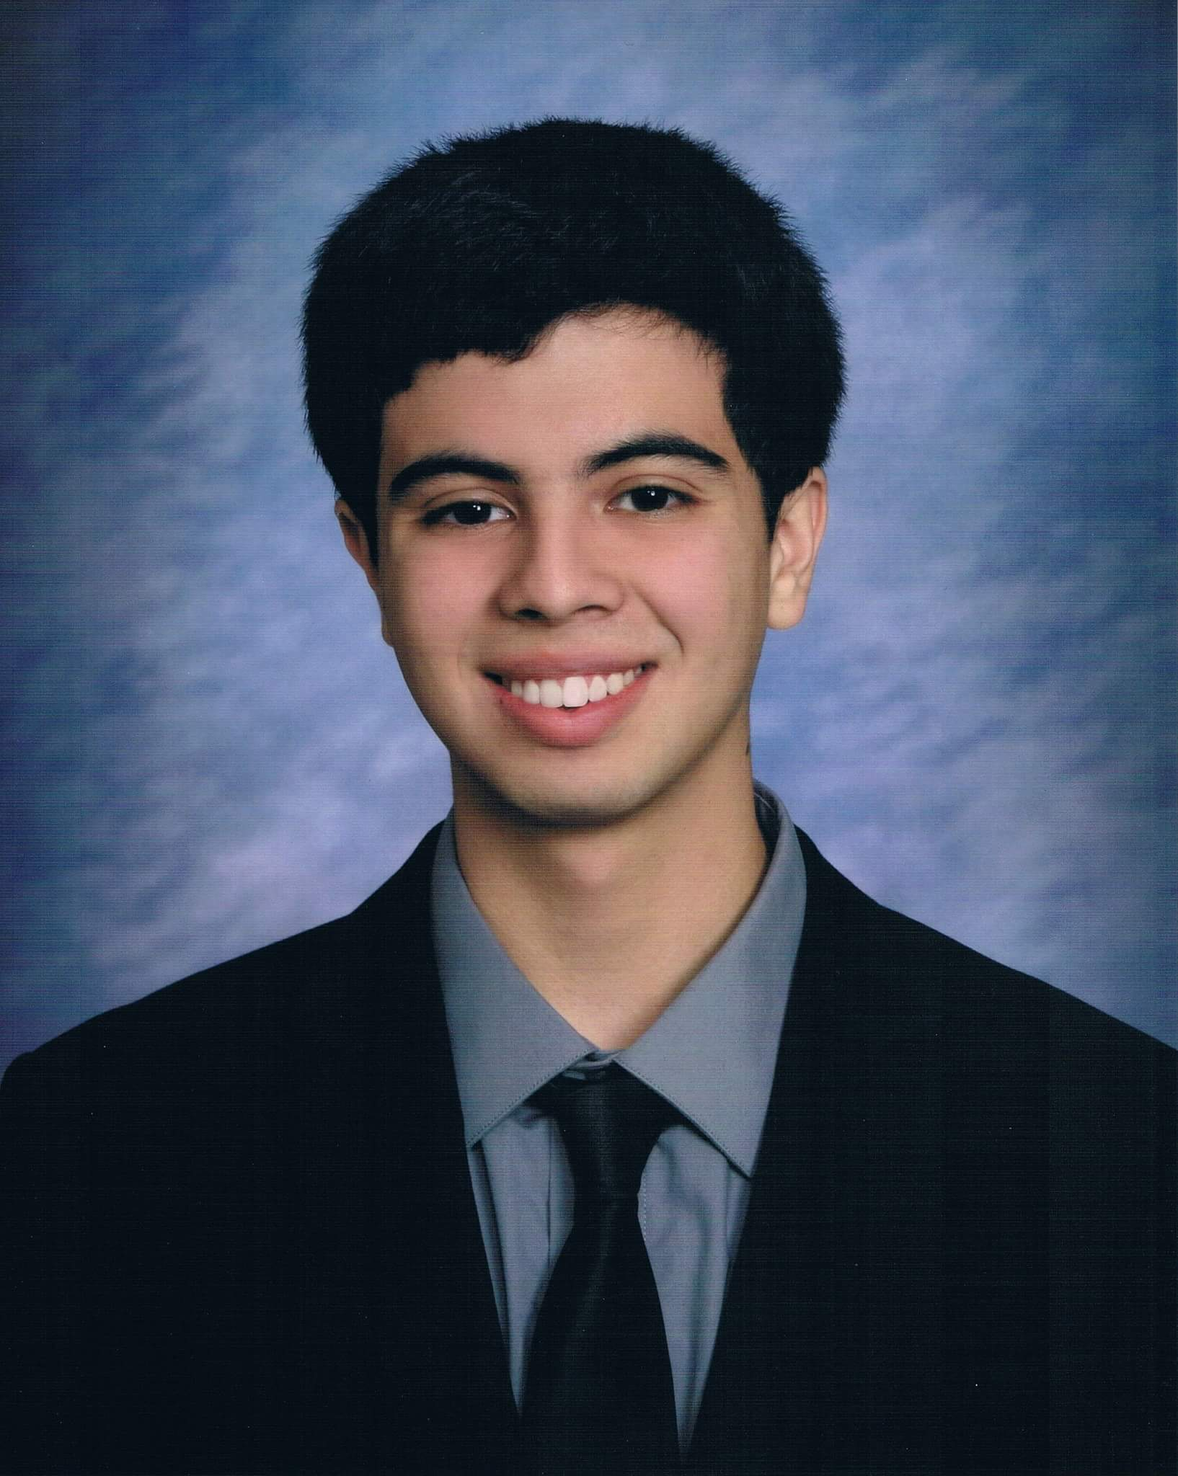
I am currently in my second year at Channel Islands, I am pursuing a Computer Science major with minors in Mathematics and Game Design. I came directly to Channel Islands from my high school named Santa Susana High School, which is a public magnet school for technology and performing arts. I have selected the Computer Science major because I want to be a game developer for my career.

My main rationale for taking this course is mainly that it is required to take for my major. I’m not sure what kind of projects the course will entail so I don’t know if I have the background experience that will help, however, I did well in both Calculus II and Logic so I hope the skills from those classes will carry over.

Cordially,

Jose de Jesus Rodriguez Rivas
Student in Computer Science
CSU Channel Islands

