WHITEWATER RAFTING SITE PLAN

LOGO

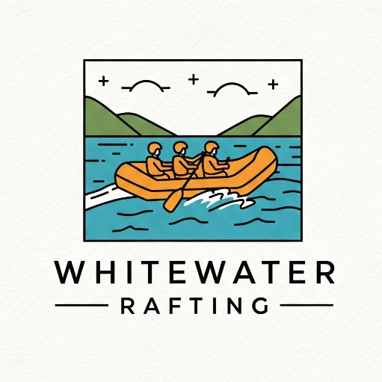

COLORS

Primary: 316039

Secondary: 134074

Accent1-color: 47cb8f

Accent2-color: 68d8d6

URL color pallet: <https://coolors.co/316039-134074-47cb8f-68d8d6>

FONTS

Heading-font: Bad Script

Text-font: Funnel Sans