RCOMP

Project Report



Teacher: Bertil Marques (BPM)
Network Architecture Planed by:
- João Fernandes - 1141114
- José Barros - 1151117
- José Rodrigues - 1150710
- Tiago Vilaça - 1140412

Table of Contents
Introduction 3
Client Specifications 4
Fase One: 4
Subjet in consideration 5
Cost: 5
Space Usage: 5
Maintenance: 6
Usability: 6
Others: 6
Firewall System 6
UPS Infrastructure 6
In case of energy drop, UPS systems (see Illustration 18: UPS “Uninterruptible power supply” Rack ) will protect the network and servers. In necessary to guarantee that some essential services will remain active, for the client and business. 6
Redundancy 6
Redundancy will secure online services to the company in case of malfunction in one of the nodes. 7
The example above (see Illustration 2: Example from cisco with alternative routes) show the secure approach. If router 1 is down, router 2 will secure the path to the switch as a second way. 7
WLAN Security practices 7
Network Traffic 8
Development 9
Blueprint at scale of implantation of buildings 9
Outdoor campus 10
Building One 11
Ground Level 11
First Level 14
Second Level 16
Building Two 18
Ground Level 18
First Level 21
Material 24
CAT 6 24
Material List 24
Material Usage 29
General Network View 30
IPV4 Address Used 31
Conclusion 32

Introduction

This work was carried out within the scope of the curricular unit of Computer Networks
(RCOMP). Its purpose was to plan a structured network for a company headquarters.
The project was drawn taking into account the schematic plans provided. The planning consisted of
Development of a structured cabling project (respecting the standards taught),
In the definition of level 2 and level 3 equipment used in the definition of addressing and
Static IPv4 routing and simulation presentation using Cisco software
Packet Tracer.

Client Specifications

Fase One:

Structured cabling system project, including outlets and cross-connects deployment plan, cable pathways plan and hardware inventories. All calculations and technical decisions justifications should be included.

Subjet in consideration

Cost:

The balance between material cost, work hours, benefit are taken in consideration to give to the client the ideal product/service available according with is needs.

Space Usage:

In the Development (9) area each decision int the space is documented.
Is taken in consideration:
- Security
The way that cabling is engineered contributes to the architecture of the working place. Public places should never have in the floor cable lines, they are a safety hazard. Entrances and exits should not be affected by the network architecture.
Warning signs in factory’s or exit signs should not be covered by wiring closet’s or other network hardware, putting in line lives of employees in case of accident.
- Energy Consumption
Cobber lines, switches, routers, and others heat up and waste energy. Power pics could harm/put offline the company services.
- Ethernet Sockets
Each Room area is needed to calculate the number of Ethernet sockets for each room. The default number of sockets in 10 m² is two.
For security reasons and considering the future growth of the company is good practice to increase the number of sockets in the room.

The extra sockets to make secure the network in case of work/employees overflow in the area is calculated by:
Illustration 1: Formula to calculate the number of sockets needed in determined area
In this project the extra safety sockets is 5.

Maintenance:

- Humid areas like bathrooms were avoided (for ex: WC)
- Elevator Shafts avoided, because of low access
- Most network devices are in isolated network wiring closet's

Usability:

- Stability

- Speed

Others:
To maximize informational security and improve the work flow of the company some points should taken in consideration.

Firewall System
Filtering processes in the network are needed to secure the network. Guaranteeing an save work envelopment for the employers and clients.

UPS Infrastructure

In case of energy drop, UPS systems (see Illustration 22: UPS “Uninterruptible power supply” Rack ) will protect the network and servers. In necessary to guarantee that some essential services will remain active, for the client and business.

Redundancy

If a route in the network is offline there always should be an alternative route to the nodes.
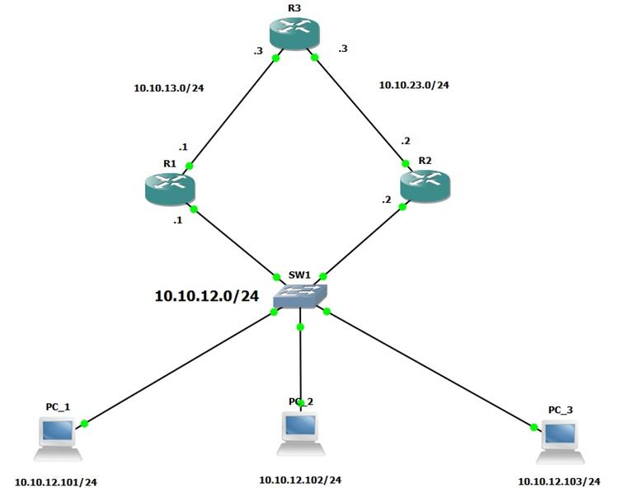Illustration 2: Example from cisco with alternative routes

Redundancy will secure online services to the company in case of malfunction in one of the nodes.

The example above (see Illustration 2: Example from cisco with alternative routes) show the secure approach. If router 1 is down, router 2 will secure the path to the switch as a second way.

WLAN Security practices

Wireless LAN are one of the most difficult areas to secure on company infrastructure. There is no physical barrier to unwanted access to the WLAN signal in public/common area of the company.
Internal Users should have different type of access from guest users (for example in the exposition hall where costumers/investors are common to appear).
If possible, security protocols should be implemented to the maximum extend. WPA2 enterprise (and not Personal version) utilizes 802.1x authentication of the IEEE security specification, it requires an single user account to validate access. Guest could have an WPA2 protocol (only needed password), and employees should have an separated network that relies on WPA2 protocols.

Network Traffic

In a company various network packets of different protocols are constantly traded and altered in the system. Sometimes overflow in the network is created, giving a slow connection or even more serious packet loss.
Protocols to reduce the signal noise in the system will be needed in the future.
The existence of proxy in the internet network relative to the Web connection will be advised, for security reasons and to ensure filtration in the network of:
- Malicious packages
- Unnecessary heavy packages (filtration of add for example)
- Blocked domains by the company

Development

Blueprint at scale of implantation of buildings

To mark the network cabling and cable tray is needed a system to identify each element.
Below on Illustration 3 the color scheme is shown:
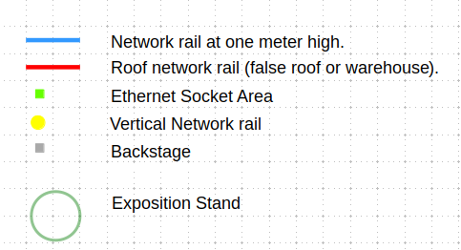Illustration 3: Network Diagram Labels
Blue rail (this color ) represents network rail/tray (see Illustration 20: Network Cable Trays) at a meter height. Inside of the cable tray there are UTP copper cables(see Illustration 16: CAT6 UTP copper cable), providing the ability to the network packets be able to be transmitted.

Green rail (this color ) represents network rail/tray (see Illustration 20: Network Cable Trays) at a meter height with Ethernet sockets (see Illustration 19: Ethernet CAT6 Socket) allowing the different network devices connect using an RJ45 adapter (see Illustration 17: RJ 45 CAT 6 Crimp Connector). Inside of the cable tray there are UTP copper cable (see Illustration 16: CAT6 UTP copper cable), providing the ability to the network packets be able to be transmitted.

Red rail (this color ) represents network rail/tray (see Illustration 20: Network Cable Trays) in a . Inside of the cable tray there are UTP copper cables cable (see Illustration 16: CAT6 UTP copper cable), providing the ability to the network packets be able to be transmitted.

Grey rectangles (this color ) represents Network backstage’s also known as wire closets (see Illustration 21: Wiring closets - Able to store: switchs, routers, UPS, server racks, etc) will very certainly contain layer 2 or higher network devices.

Outdoor campus

ISP support is provided by a external company. The dark blue line in Illustration 4: Outdoor Campus represents the cable used in the network.

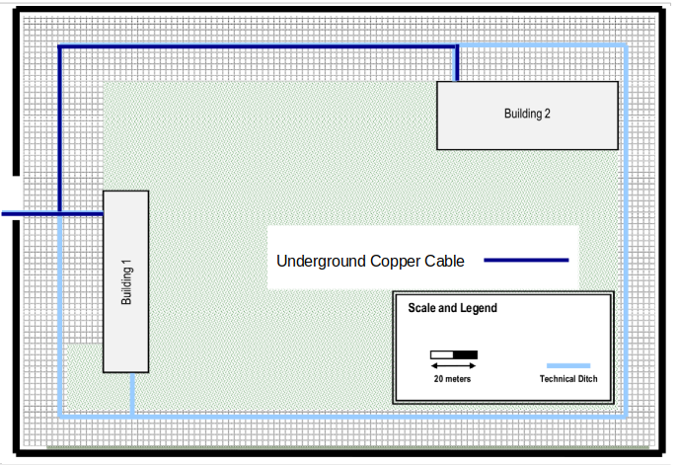Illustration 4: Outdoor Campus

Building One

Ground Level

The ground floor contains a principal entrance at the left of room 0.7, and a secondary entrance below of room 0.1.
In the principal entrance a reception desk will be available (see Illustration 5) inside of the desk will be available extra Ethernet sockets and other network devices, guaranteeing that those devices aren't visible to the public.

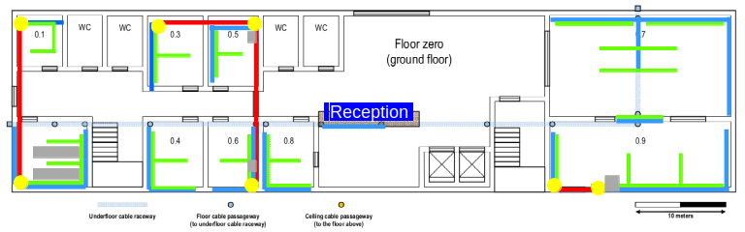Illustration 5: Building 1, Ground Level
Room dimensions and type of usage is defined in Illustration 6.
The calculus of the number of Ethernet sockets are provided by the formula: Illustration 1: Formula to calculate the number of sockets needed in determined area.
Room 0.2 contains two big wire closets, providing enough space for the needed routers, switches, server rack and UPS needed.
Example:
The room 0.5 has 42,9 m², so the number of sockets needed are 8.

But it should be increased by 5 because of the possibility of more employees in that area. So that room should have 13 sockets.

Illustration 6: Building 1, ground floor room dimensions and purpose/usage
The amount of Ethernet sockets are provided in the following table:
Illustration 7: Number of ethernet sockets needed by each room

First Level
The first level of the building 1, has a very simple schematic, where we have a few offices rooms (1,3,4,5) and some telephony rooms (6,8). The most important points on this floor are the rooms 7,8 and 12.
Both 7 and 9 rooms will be used as a presentation room. In our prespective, room 7 is reserved for partners/investors presentations, while the room 9 will have a similar function but for company employees. Those rooms will have full wi-fi coverage since thats the most pratical way to support those rooms.
Last but not least, room 12 will serve as a meeting room for the company bosses, where they can discuss the current company status and abord new ideas.

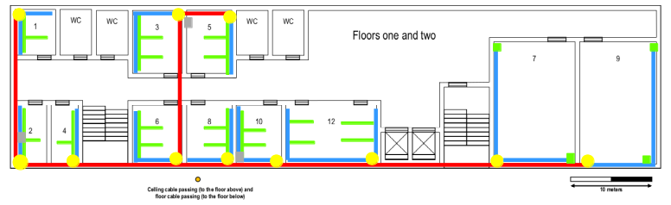Illustration 8: Building 1, First Level
Illustration 9: Room area, objective of room and number of ethernet sockets needed

Second Level
The second level will be very similiar to the first level. There will be a few more telephony rooms in detriment of the offices (6,7,8,9), while the remaining simple rooms will still be offices. Room 12 will maintain is function as a meeting room, while rooms 7 and 9 will now swap functions.
Previously they were presentations rooms but now we will use this rooms in this floor as telephony rooms. As you can see in the illustration, there are Ethernet sockets along the room. Those will be placed along the tables, that are used for the telephony employees.

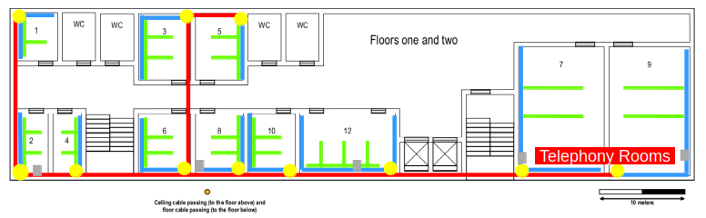Illustration 10: Building 1, Second Level
Illustration 11: Room area, objective of room and number of ethernet sockets needed

Building Two

Ground Level
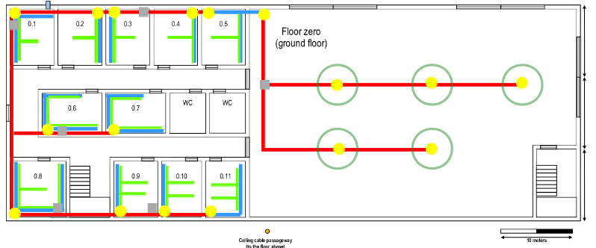Illustration 12: Building 2, Ground Level
The ground floor of the building 2 has a simple structure, which we can divide in two different areas. On the left half, the area is reserved to office rooms and telephony rooms. On the right half, the area is reserved to an Exhibition center.
In the left area, the office rooms (1,2,3,4,5 and 6) and the telephony rooms(7,8,9,10,11), all have multiple Ethernet sockets, as seen on Illustration 9.
In the right area, the exhibition center area, there are no Ethernet sockets available, but there are multiple wiring closets, which may be important in the area network for some exhibitions that may occur there.

Illustration 13: Room area, objective of room and number of ethernet sockets needed

First Level

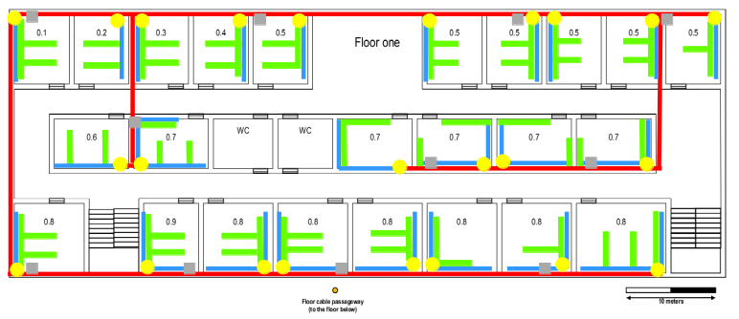Illustration 14: Building 2, First Level
The first level is very similar to the ground level. The left half is similar to the ground floor second half. The right half is basically a copy of the left half, with some changes on the room occupation.
On the left half, the office rooms (1,2,3,4,11,12,17,18) and the telephony rooms (5, 19,20) all contain multiple Ethernet sockets, in order to make the building connected. The same happens on the right half, where the telephony rooms (6,7,8,9,10,19,20,21,22,13), the office rooms (13,14,15,16) and the presentation/formation room (24).
As we can see in illustration 10, Ethernet sockets will be used in every room. The rooms with the number 1,5,7,10,12,14,17,18,20 and 23 will be equipped with wiring closets.

Illustration 15: Room area, objective of room and number of ethernet sockets needed

Material
A vast array of materials have been used in then network presented in the blueprints.
The connections in the blueprints (see Illustration 3: Network Diagram Labels), the red, green, yellow traces represents UTP cable (see Illustration 16: CAT6 UTP copper cable) inside of cable trays (see Illustration 20: Network Cable Trays).
In case of the yellow lines, they are vertical lines, is exactly the same as the green and blue plans, but with a vertical layout.
The green traces, represents cable trays with the possibility of installing sockets(see Illustration 19: Ethernet CAT6 Socket) accordingly with the room needs. When possible the rule should be 3 meters between each pair of sockets, for better space usage, and preventing material wear.

CAT 6
Every cable (see Illustration 16: CAT6 UTP copper cable), sockets, crimps etc will be Category 6 (CAT6). That decision was made by the team, because cat 6 offers various advantages:
- Compatible with CAT 5 and 3
- Prevents network cross-talk (caused by network coupling between nodes)
- Prevents signal noise
Downsides:
- More expensive than lower category’s.

For this type of cable the maximum allowed length without signal loss. Considering that because of patch panels connections contains normal signal loss, the real usable length should be 90 meters.
Except the 10Gb Base-T cable used in the servers and routers, they cant exceed the 50 meters mark.

Material List

A list of materials are provided by the following photos down:

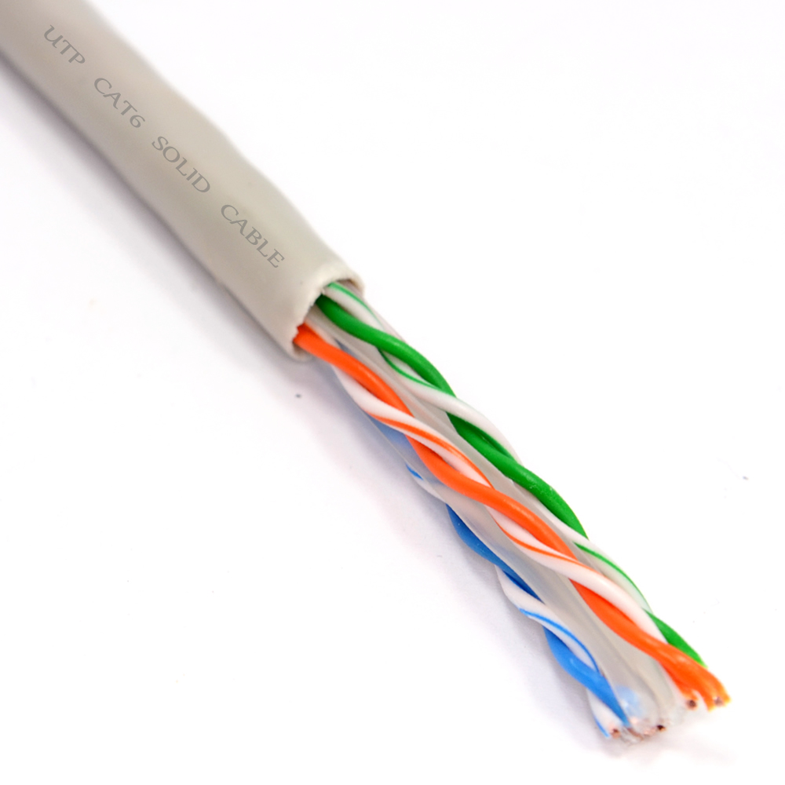Illustration 16: CAT6 UTP copper cable

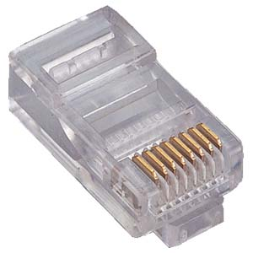Illustration 17: RJ 45 CAT 6 Crimp Connector
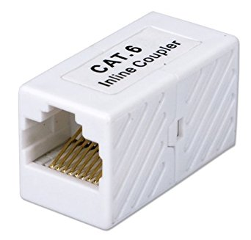Illustration 18: CAT6 RJ45 Female Coupler
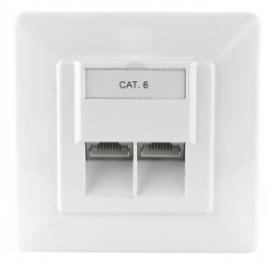Illustration 19: Ethernet CAT6 Socket
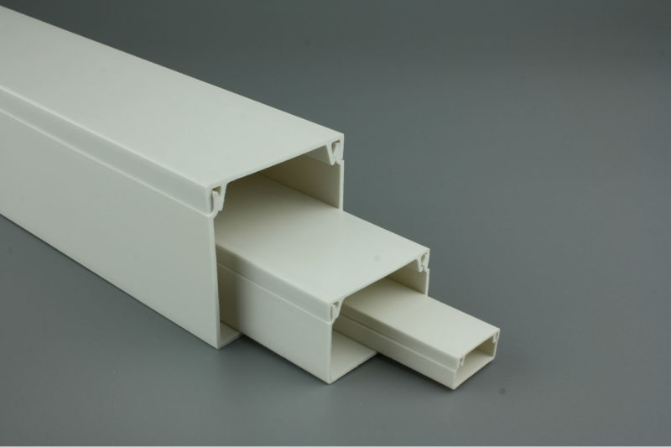Illustration 20: Network Cable Trays
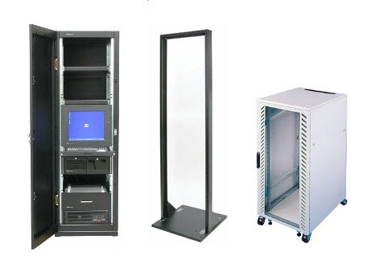Illustration 21: Wiring closets - Able to store: switchs, routers, UPS, server racks, etc
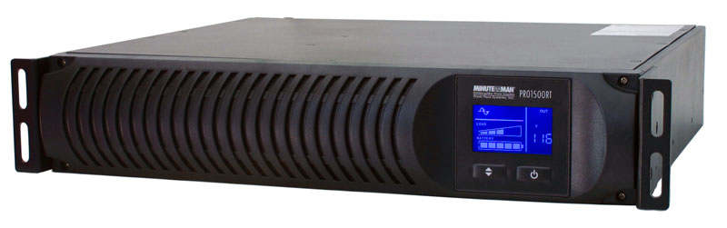Illustration 22: UPS “Uninterruptible power supply” Rack

Material Usage

Material usage was calculated accordingly with the space needed, amount of clients in each room, the area and length of material used.

The following table show the material usage for the present iteration of the project.
Illustration 23: Material usage

Cost

The following table show the cost of the materials. An equilibrium between price and quality was taken in consideration. Take in consideration that the elevated volume of purchase may alter the material cost, into a lower price.

Illustration 24: Material cost used in project

General Network View

This area will show the layer two and tree devices, clientes and protocols used in the network.

In the blueprints the are where will be avaible routers and switches will be the wire closets that will cointain layer 2,3 devices.

IPV4 Address Used

The proper rules of IPV4 addressing were taken in consideration.
The addresses and IP masks were chosen by the number of nodes (size needed in the table) needed and shown in the project proposal given.
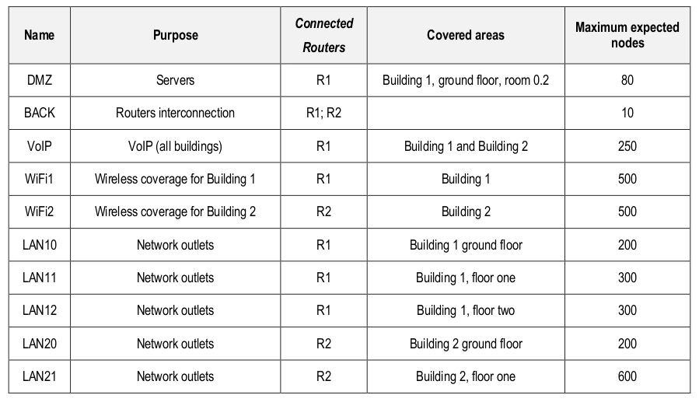Illustration 25: Number of nodes for each LAN
Illustration 26: IPV4 addressing table

Conclusion

With the elaboration of this project, it was possible to deepen the knowledge
Classes, which were applied during the projection of the structured cabling and in the configuration
Of the networks used. Thus, it was not only possible to verify the existing size and complexity
In a network involving multiple buildings with different plants and with different requirements
Imposed by the users in the configuration of the networks, but it was also possible to quantify the materials used to carry out a project of this magnitude.

