RCOMP

Project Report



Teacher: Bertil Marques (BPM)
Network Architecture Planed by:
- João Fernandes - 1141114
- José Barros - 1151117
- José Rodrigues - 1150710
- Tiago Vilaça - 1140412

Table of Contents
Introduction 4
Client Specifications 5
Fase One: 5
Subject in consideration 6
Cost: 6
Space Usage: 6
Maintenance: 7
Usability: 7
Others: 7
Firewall System 7
UPS Infrastructure 7
Redundancy 7
WLAN Security practices 8
Network Traffic 9
Development 10
Blueprint at scale of implantation of buildings 10
Outdoor campus 11
Building One 12
Ground Level 12
First Level 15
Second Level 17
Building Two 19
Ground Level 19
First Level 21
Material 24
CAT 6 24
Layer 2 Devices 24
Access 25
Trunk 25
Layer 3 Devices 27
Access Point 27
Material List 29
Material Usage 35
Cost 36
General Network View 37
Building 1) 37
Building 2) 37
Outdoor Building Connection) 37
System Password 39
Legal Notice 40
All Layer 2 Devices 41
Building 1) 41
Building 2) 42
Position of Layer 2 and 3 Devices 44
Building 1) 44
Building 2) 46
IPV4 Subnetting 48
Vlans 49
Network Blueprint 53
Building 1) 54
Building 2) 55
Network Protocols 56
VTP 56
SPT 59
SSH, Telnet, etc 60
Conclusion 61

Introduction

This work was carried out within the scope of the curricular unit of Computer Networks
(RCOMP). The purpose was to plan a structured network for a company headquarters.
The project was drawn taking into account the schematic plans provided. The planning consisted on the development of a structured cabling project (respecting the standards taught),
In the definition of level 2 and level 3 equipment used in the definition of addressing and
Static IPv4 routing and simulation presentation using Cisco software Packet Tracer.

Client Specifications

Fase One:

Structured cabling system project, including outlets and cross-connects deployment plan, cable pathways plan and hardware inventories. All calculations and technical decisions justifications should be included.

Fase Two:

Required layer two and layer three devices specification (inventories). Layer two devices configuration. Including VLANs and access-points 2.4 GHz band channels.
Layer two Packet Tracer Student simulation. Including required VLANs, VTP and STP.

Subject in consideration

Cost:

The balance between material cost, work hours, benefit are taken in consideration to give to the client the ideal product/service available according with his needs.

Space Usage:

In the Development (10) area each decision into the space is documented.
Is taken in consideration:
- Security
The way that cabling is engineered contributes to the architecture of the working place. Public places should never have in the floor cable lines, they are a safety hazard. Entrances and exits should not be affected by the network architecture.
Warning signs in factory’s or exit signs should not be covered by wiring closet’s or other network hardware, putting in line lives of employees in case of accident.
- Energy Consumption
Cobber lines, switches, routers, and others heat up and waste energy. Power pics could harm/put offline the company services.
- Ethernet Sockets
Each Room area is needed to calculate the number of Ethernet sockets for each room. The default number of sockets in 10 m² is two.
For security reasons and considering the future growth of the company is good practice to increase the number of sockets in the room.

The extra sockets to make secure the network in case of work/employees overflow in the area is calculated by:
Illustration 1: Formula to calculate the number of sockets needed in determined area
In this project the extra safety sockets is 5.

Maintenance:

- Humid areas like bathrooms were avoided (for ex: WC)
- Elevator Shafts avoided, because of low access
- Most network devices are in isolated network wiring closet's

Usability:

- Stability

- Speed

Others:
To maximize informational security and improve the work flow of the company some points should taken in consideration.

Firewall System
Filtering processes in the network are needed to secure the network. Guaranteeing an save work envelopment for the employers and clients.

UPS Infrastructure
In case of energy drop, UPS systems (see Illustration 30: UPS “Uninterruptible power supply” Rack ) will protect the network and servers. In necessary to guarantee that some essential services will remain active, for the client and business.

Redundancy
If a route in the network is offline there always should be an alternative route to the nodes.
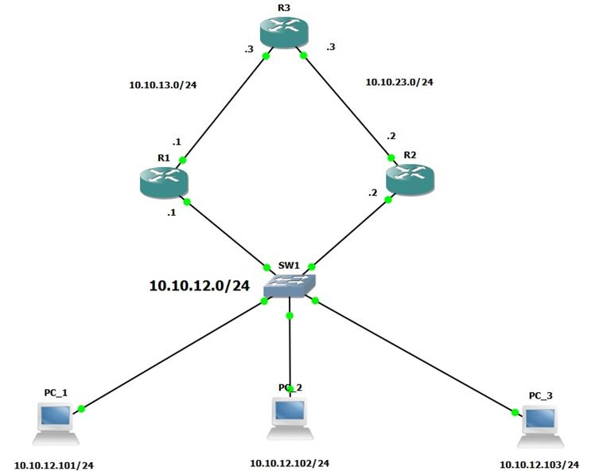Illustration 2: Example from cisco with alternative routes
Redundancy will secure online services to the company in case of malfunction in one of the nodes.
The example above (see Illustration 2: Example from cisco with alternative routes) show the secure approach. If router 1 is down, router 2 will secure the path to the switch as a second way.

WLAN Security practices

Wireless LAN are one of the most difficult areas to secure on company infrastructure. There is no physical barrier to unwanted access to the WLAN signal in public/common area of the company.
Internal Users should have different type of access from guest users (for example in the exposition hall where costumers/investors are common to appear).
If possible, security protocols should be implemented to the maximum extend. WPA2 enterprise (and not Personal version) utilizes 802.1x authentication of the IEEE security specification, it requires an single user account to validate access. Guest could have an WPA2 protocol (only needed password), and employees should have an separated network that relies on WPA2 protocols.

Network Traffic

In a company various network packets of different protocols are constantly traded and altered in the system. Sometimes overflow in the network is created, giving a slow connection or even more serious packet loss.
Protocols to reduce the signal noise in the system will be needed in the future.
The existence of proxy in the internet network relative to the Web connection will be advised, for security reasons and to ensure filtration in the network of:
- Malicious packages
- Unnecessary heavy packages (filtration of add for example)
- Blocked domains by the company

Development

Blueprint at scale of implantation of buildings

To mark the network cabling and cable tray is needed a system to identify each element.
Below on Illustration 3 the color scheme is shown:
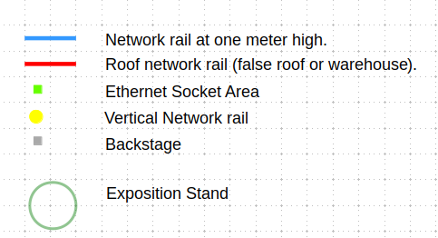Illustration 3: Network Diagram Labels
Blue rail (this color ) represents network rail/tray (see Illustration 29: Network Cable Trays) at a meter height. Inside of the cable tray there are UTP copper cables(see Illustration 25: CAT6 UTP copper cable), providing the ability to the network packets be able to be transmitted.

Green rail (this color ) represents network rail/tray (see Illustration 29: Network Cable Trays) at a meter height with Ethernet sockets (see Illustration 27: Ethernet CAT6 Socket) allowing the different network devices connect using an RJ45 adapter (see Illustration 26: RJ 45 CAT 6 Crimp Connector). Inside of the cable tray there are UTP copper cable (see Illustration 25: CAT6 UTP copper cable), providing the ability to the network packets be able to be transmitted.

Red rail (this color ) represents network rail/tray (see Illustration 29: Network Cable Trays) in the air. Inside of the cable tray there are UTP copper cables cable (see Illustration 25: CAT6 UTP copper cable), providing the ability to the network packets be able to be transmitted.

Grey rectangles (this color ) represents Network backstage’s also known as wire closets (see Illustration 28: Wiring closets - Able to store: switchs, routers, UPS, server racks, etc) will very certainly contain layer 2 or higher network devices.

Outdoor campus

ISP support is provided by a external company. The dark blue line in Illustration 4: Outdoor Campus represents the cable used in the network.

For redundancy reasons the entrances cable of the building are duplicated, so ISP cable is entering in two cables, if the first fails there is the second. The fiber optic cable is also used to connect the building LAN’s. They are also duplicated to increase redundancy.

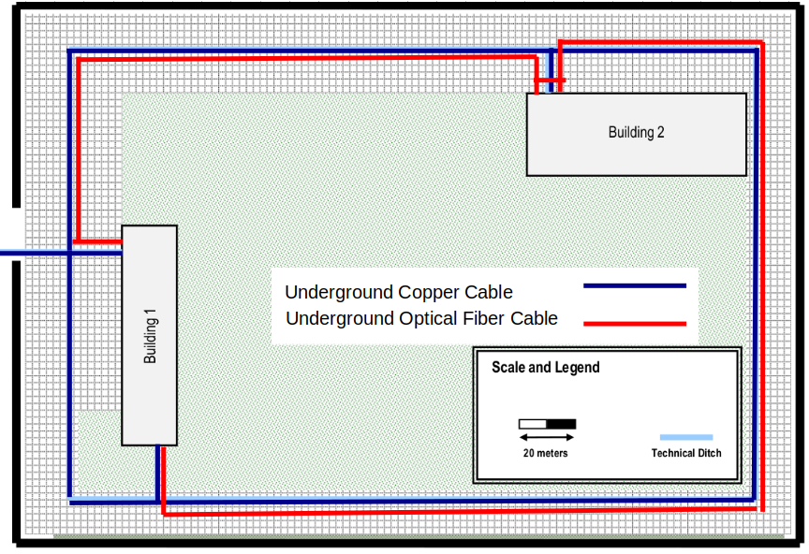Illustration 4: Outdoor Campus

Building One

Ground Level

The ground floor contains a principal entrance at the left of room 0.7, and a secondary entrance below of room 0.1.
In the principal entrance a reception desk will be available (see Illustration 5) inside of the desk will be available extra Ethernet sockets and other network devices, guaranteeing that those devices aren't visible to the public.

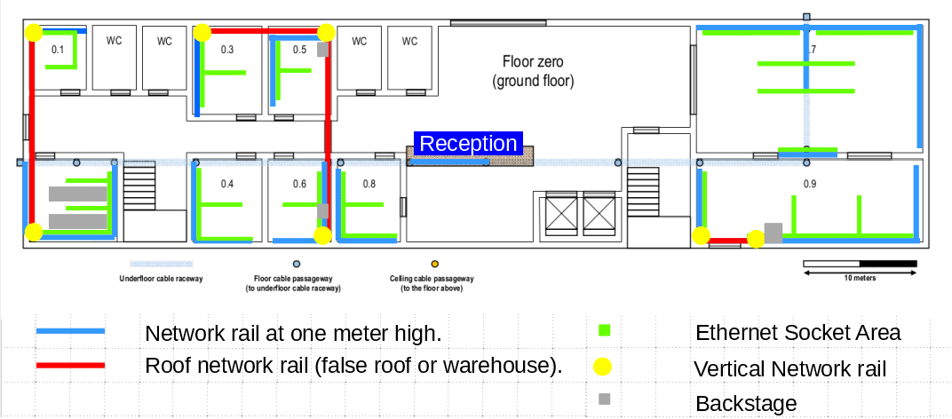Illustration 5: Building 1, Ground Level
Room dimensions and type of usage is defined in Illustration 6.
The calculus of the number of Ethernet sockets are provided by the formula: Illustration 1: Formula to calculate the number of sockets needed in determined area.
Room 0.2 contains two big wire closets, providing enough space for the needed routers, switches, server rack and UPS needed.
Example:
The room 0.5 has 42,9 m², so the number of sockets needed are 9.

But it should be increased by 5 because of the possibility of more employees in that area. So that room should have 14 sockets.

Illustration 6: Building 1, ground floor room dimensions and purpose/usage
The amount of Ethernet sockets are provided in the following table:
Illustration 7: Number of ethernet sockets needed by each room

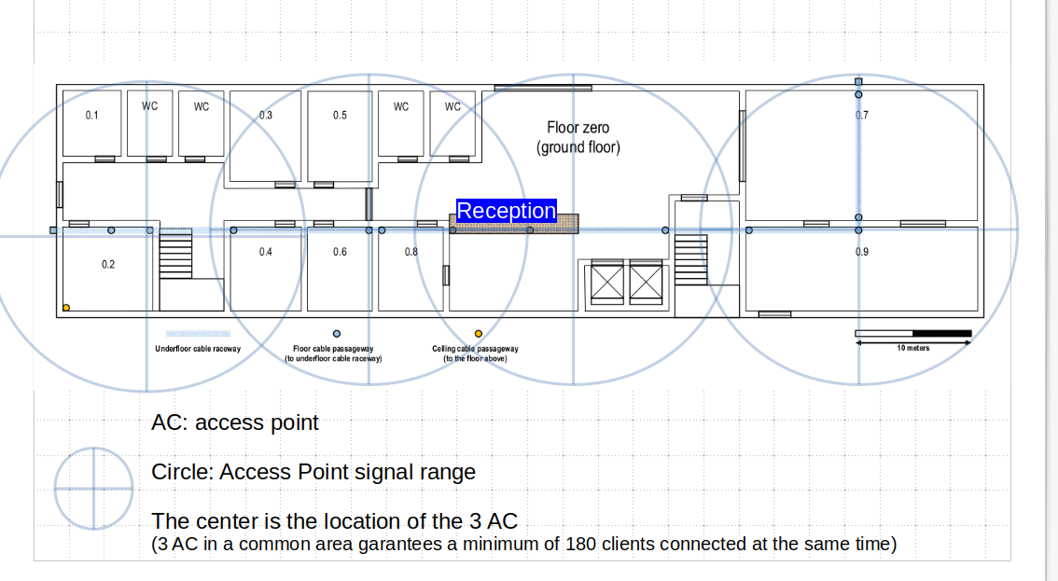Illustration 8: Building 1, Ground Level AC position

First Level

The first level of the building 1, has a very simple schematic, where we have a few offices rooms (1,3,4,5) and some telephony rooms (6,8). The most important points on this floor are the rooms 7,8 and 12.
Both 7 and 9 rooms will be used as a presentation room. In our prespective, room 7 is reserved for partners/investors presentations, while the room 9 will have a similar function but for company employees. Those rooms will have full wi-fi coverage since thats the most pratical way to support those rooms.
Last but not least, room 12 will serve as a meeting room for the company bosses, where they can discuss the current company status and abord new ideas.

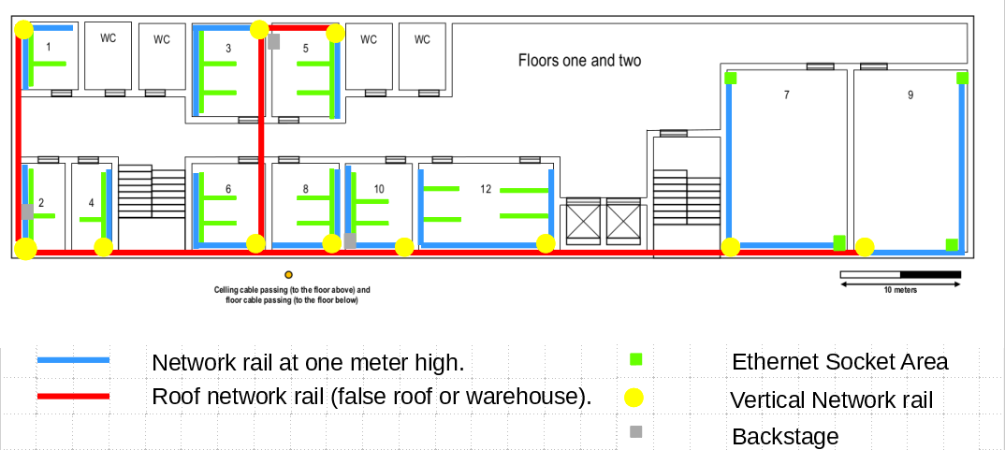Illustration 9: Building 1, First Level
Illustration 10: Room area, objective of room and number of ethernet sockets needed

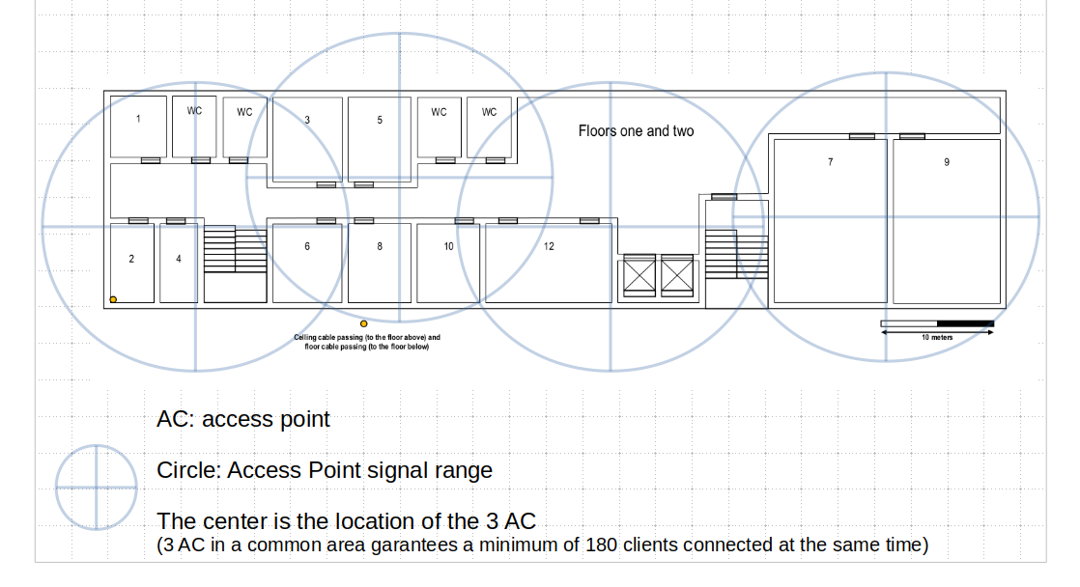Illustration 11: Building 1, First Level AC position

Second Level
The second level will be very similiar to the first level. There will be a few more telephony rooms in detriment of the offices (6,7,8,9), while the remaining simple rooms will still be offices. Room 12 will maintain is function as a meeting room, while rooms 7 and 9 will now swap functions.
Previously they were presentations rooms but now we will use this rooms in this floor as telephony rooms. As you can see in the illustration, there are Ethernet sockets along the room. Those will be placed along the tables, that are used for the telephony employees.

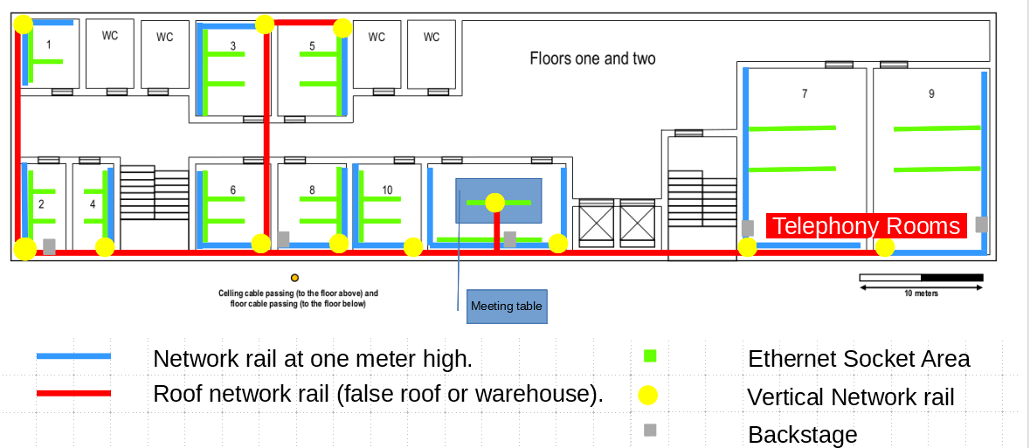Illustration 12: Building 1, Second Level
Illustration 13: Room area, objective of room and number of ethernet sockets needed

Illustration 14: Building 1, Second Level AC position

Building Two

Ground Level

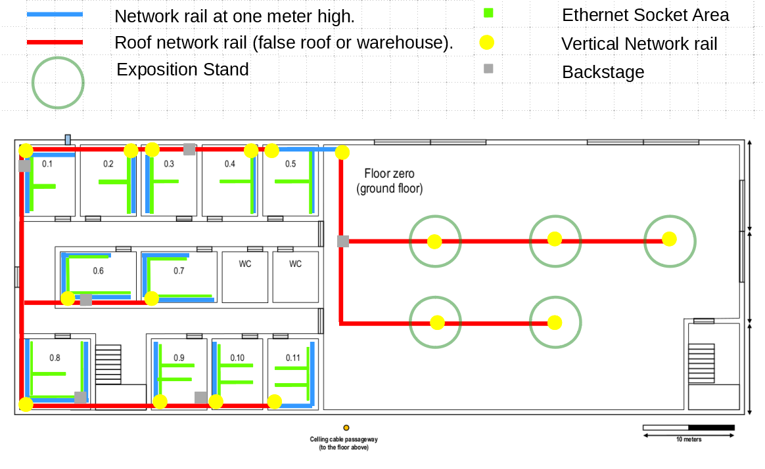Illustration 15: Building 2, Ground Level
The ground floor of the building 2 has a simple structure, which we can divide in two different areas. On the left half, the area is reserved to office rooms and telephony rooms. On the right half, the area is reserved to an Exhibition center.
In the left area, the office rooms (1,2,3,4,5 and 6) and the telephony rooms(7,8,9,10,11), all have multiple Ethernet sockets, as seen on Illustration 9.
In the right area, the exhibition center area, there are no Ethernet sockets available, but there are multiple wiring closets, which may be important in the area network for some exhibitions that may occur there.
Illustration 16: Room area, objective of room and number of ethernet sockets needed
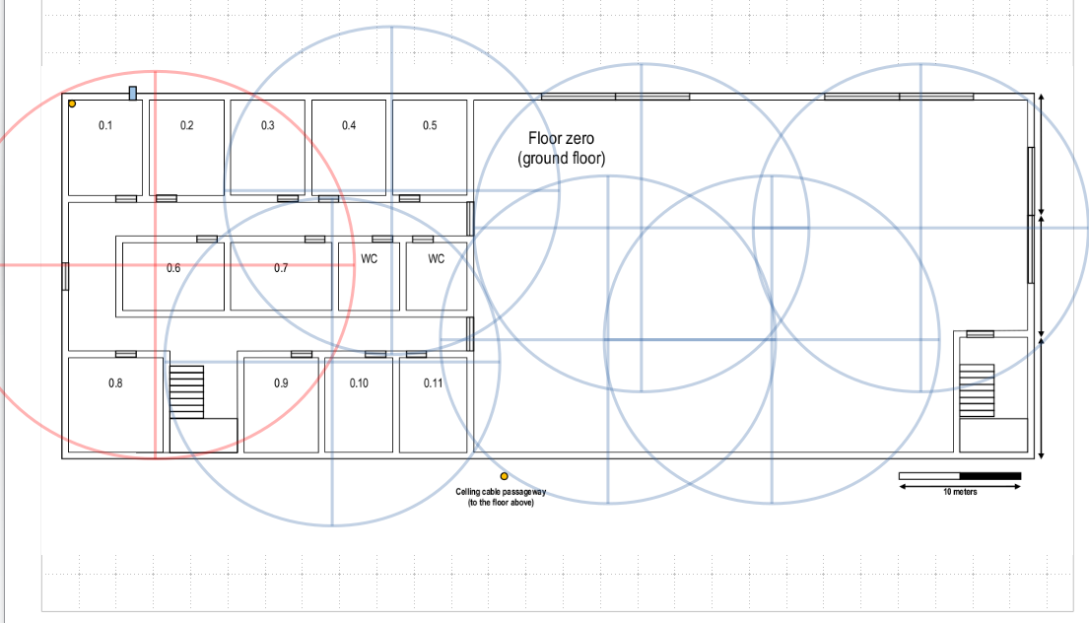Illustration 17: Building 2, Ground Level AC position (red signal means that int that area strong signal will be implemented )

First Level
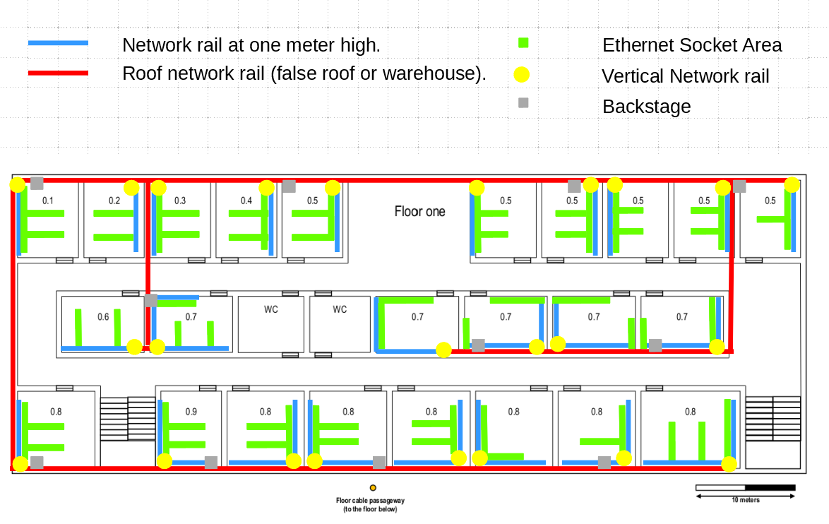Illustration 18: Building 2, First Level

The first level is very similar to the ground level. The left half is similar to the ground floor second half. The right half is basically a copy of the left half, with some changes on the room occupation.
On the left half, the office rooms (1,2,3,4,11,12,17,18) and the telephony rooms (5, 19,20) all contain multiple Ethernet sockets, in order to make the building connected. The same happens on the right half, where the telephony rooms (6,7,8,9,10,19,20,21,22,13), the office rooms (13,14,15,16) and the presentation/formation room (24).
As we can see in illustration 10, Ethernet sockets will be used in every room. The rooms with the number 1,5,7,10,12,14,17,18,20 and 23 will be equipped with wiring closets.

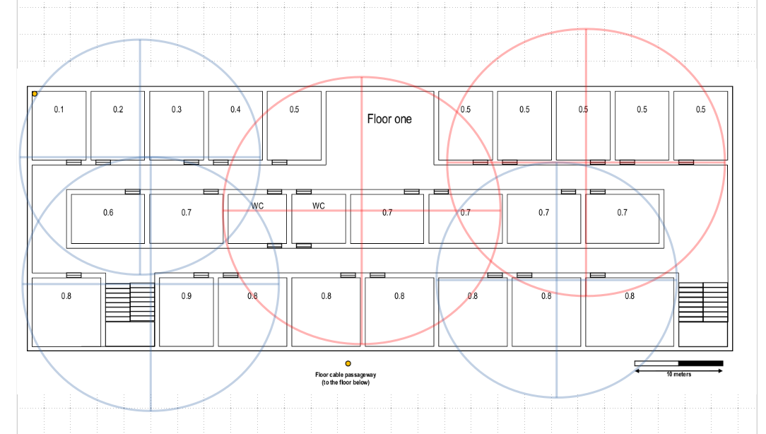Illustration 19: Building 2, Ground Level AC position (red signal means that int that area strong signal will be implemented )

Illustration 20: Room area, objective of room and number of ethernet sockets needed

Material

A vast array of materials have been used in then network presented in the blueprints.
The connections in the blueprints (see Illustration 3: Network Diagram Labels), the red, green, yellow traces represents UTP cable (see Illustration 25: CAT6 UTP copper cable) inside of cable trays (see Illustration 29: Network Cable Trays).
In case of the yellow lines, they are vertical lines, is exactly the same as the green and blue plans, but with a vertical layout.
The green traces, represents cable trays with the possibility of installing sockets(see Illustration 27: Ethernet CAT6 Socket) accordingly with the room needs. When possible the rule should be 3 meters between each pair of sockets, for better space usage, and preventing material wear.

CAT 6
Every cable (see Illustration 25: CAT6 UTP copper cable), sockets, crimps etc will be Category 6 (CAT6). That decision was made by the team, because cat 6 offers various advantages:
- Compatible with CAT 5 and 3
- Prevents network cross-talk (caused by network coupling between nodes)
- Prevents signal noise
Downsides:
- More expensive than lower category’s.

For this type of cable the maximum allowed length without signal loss. Considering that because of patch panels connections contains normal signal loss, the real usable length should be 90 meters.
Except the 10Gb Base-T cable used in the servers and routers, they cant exceed the 50 meters mark.

Layer 2 Devices

Layer two devices were implemented in the network to enable the use of VLAN’s inside the buildings.
The device used in the project is a 24 ports (see Illustration 32: Cisco Switch (layer two device) model "Cisco Catalyst 2960-24T").
There are two ways to connect switches. Mode:

Access
Used between a client (example computer), that connection permits the specification of the VLAN that connects to that PC.
Ex: (see the illustration Example of layer two devices connected to each other, and to terminals (Computers) that will be used for this example)
PC A and B will have respectably the IP 10.0.160.2 and 10.0.160.2, in the VLAN table that is the Vlan 21 (see Illustration 52: List of Virtual LAN's, name, address mask and network address).
So the switch port that connects to the computers are: FastEthernet 0/2 and 3.
The proper configuration of the network will be that the port 2 and 3, will connect in mode access referent of the Vlan 21.
In following the table is available the command that enables access mode
Switch Comand:
int range fa0/2-3
switchport mode access
switchport access vlan 21
switchport port-security maximum 2
switchport port-security mac-address sticky
switchport port-security violation shutdown
switchport nonegotiate
no shutdown

Trunk
Used between an layer two device to a layer 2 or layer 3 device. Example: Switch to switch or router to switch (or vice versa).

Ex: (see the illustration Example of layer two devices connected to each other, and to terminals (Computers) that will be used for this example)
Both switches are connected by the FastEthernet 0/1 and 0/9 (see Illustration 52: List of Virtual LAN's, name, address mask and network address).
The proper configuration of the network will be that the port 1 of the top switch and 0 in the bottom switch, will connect in mode trunk referent of all VLAN’s in the network.
In following the table is available the command that enables access mode
Switch Comand:
int fa0/1
switchport mode trunk
switchport nonegotiate
no shutdown
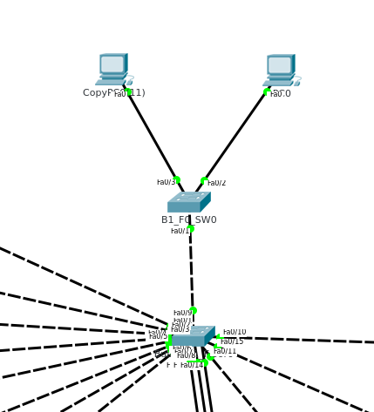Illustration 21: Example of layer two devices connected to each other, and to terminals (Computers)

Layer 3 Devices

Two routers will be used with the objective of implementation of DHCP protocol and a VOIP system.
The router used is a CISCO router model “2911” (see Cisco 2911 Integrated Services Router (layer 3 device)).

Access Point

A AC is a device that supports WLAN implementation, the model used is a CISCO “WAP561” (see Access Point from Cisco model "WAP561").
The wireless network will use an type 802.12ac (created and maintained by IEEE) in a 2.4 GHz band.
The 2.4 GHz band is divided into 14 channels (4 principal individual channels, the 14 overlaps so only 4 are really usable) spaced 5 MHz apart, beginning with channel 1, which is centered on 2.412 GHz. This network will use all the channels available and supported by the Access Point from Cisco model "WAP561".
It was chosen because it supports WPA2 protocol Enterprise version, that is the most secure way of WLAN encryption and login system.
The range of the signal is 25 meters radius, but with the wall’s and copper wires intersecting the signal, we considered that each router haves 15 meters radius of strong WIFI signal.
Each AC supports 60-80 clients connected at the same time. To guarantee that the WIFI signal will always be on in high demanding periods (with a lot of clients connections),in each common are there are going to be installed 3 AC at a time, giving the support for 180-240 clients connected at the same time in each common area (see AC conectivity example).
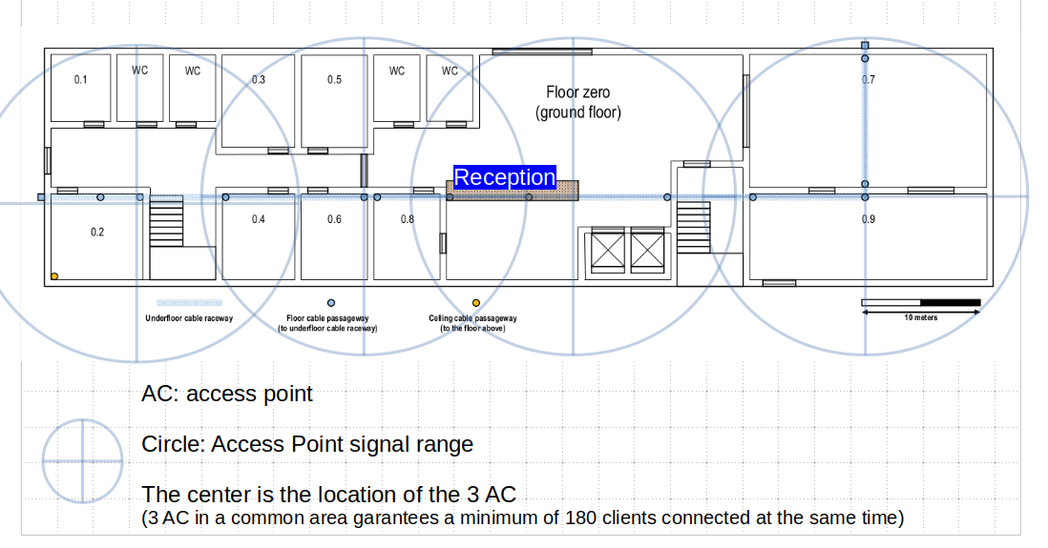Illustration 22: AC conectivity example

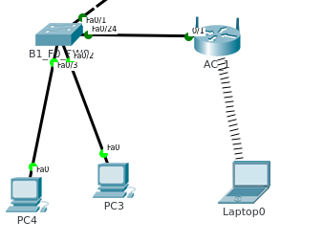Illustration 23: Access Point example. Connected to a switch using the vlan "wifi", and a laptop connected to that Vlan using the AC
Create a connection in the AC is very simple:
- In the switch connect in mode access to the port adjacent to the AC.
EX: See Access Point example. Connected to a switch using the vlan "wifi", and a laptop connected to that Vlan using the AC illustration.
The wifi network vlan is the number 5 in the building 1 (see List of Virtual LAN's, name, address mask and network address).
Command in switch:
enable
conf t
int fast 0/24
switchport mode access
switchport vlan 5

- Enable the WLAN in the AC CLI.
- Connect an laptop that supports 2.4 Ghtz and 802.11c connectivity
The laptop will automatically connect to the nearest/strongest signal.

Access Poin Chanel’s

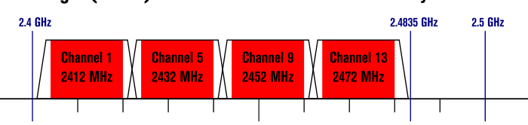Illustration 24: List of access point chanel's in 2.4 GHz and 802.12ac IEEE.

Material List

A list of materials are provided by the following photos down:

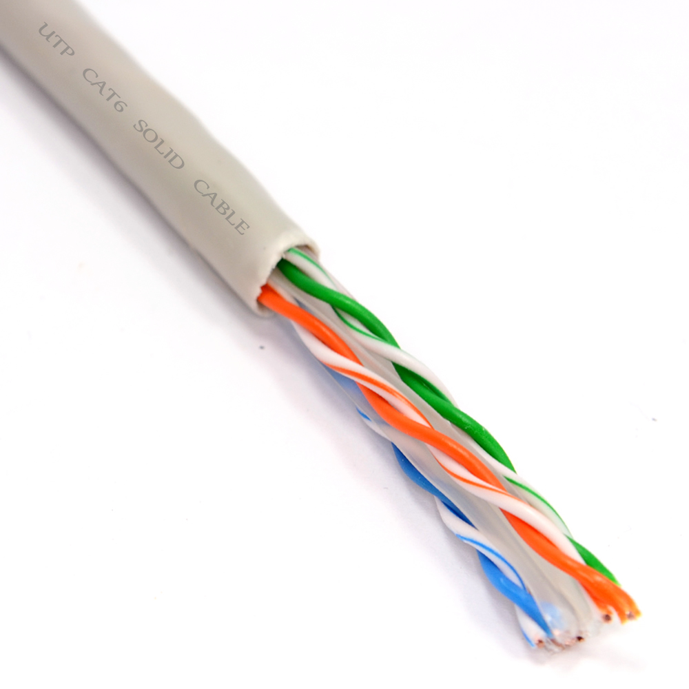Illustration 25: CAT6 UTP copper cable

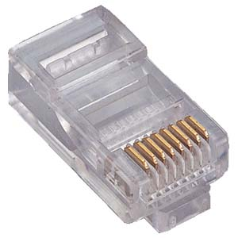Illustration 26: RJ 45 CAT 6 Crimp Connector

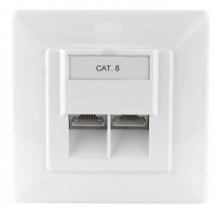Illustration 27: Ethernet CAT6 Socket

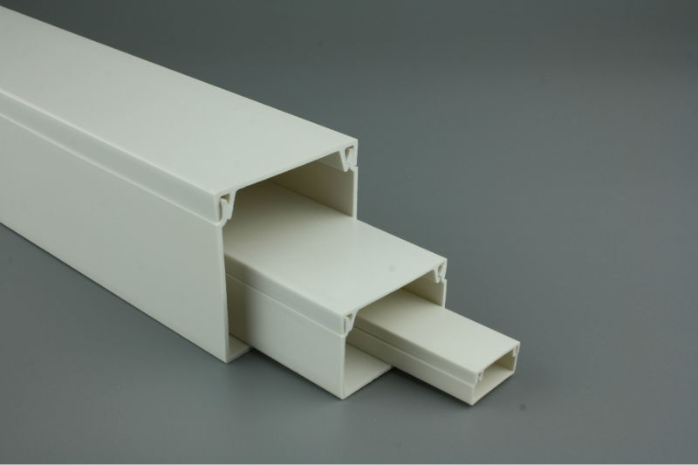Illustration 29: Network Cable Trays
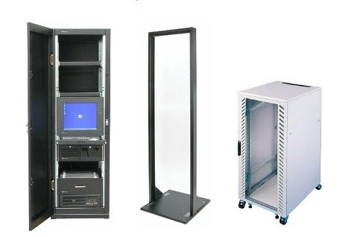Illustration 28: Wiring closets - Able to store: switchs, routers, UPS, server racks, etc

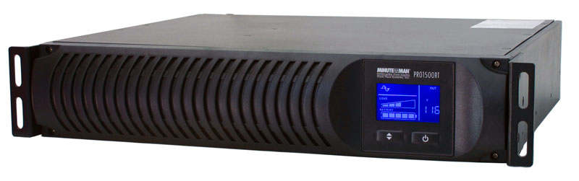Illustration 30: UPS “Uninterruptible power supply” Rack

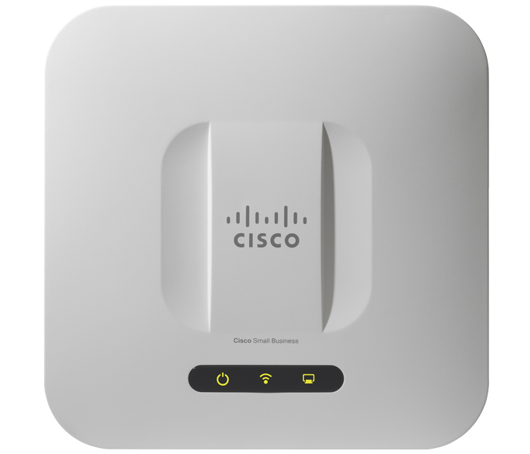Illustration 31: Access Point from Cisco model "WAP561"

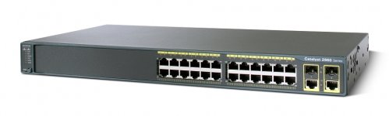Illustration 32: Cisco Switch (layer two device) model "Cisco Catalyst 2960-24T"

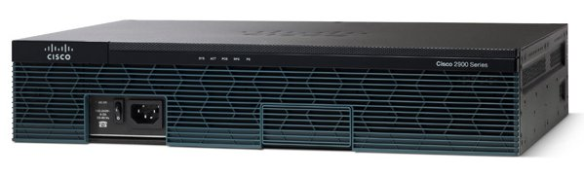Illustration 33: Cisco 2911 Integrated Services Router (layer 3 device)

Material Usage

Material usage was calculated accordingly with the space needed, amount of clients in each room, the area and length of material used.

The following table show the material usage for the present iteration of the project.
Illustration 34: Material usage
Illustration 35: Material use: layer 2 and 3

Cost

The following table show the cost of the materials. An equilibrium between price and quality was taken in consideration. Take in consideration that the elevated volume of purchase may alter the material cost, into a lower price.

Illustration 36: Material cost used in project

General Network View

This area will show the layer 2 and 3 devices, clients and protocols used in the network.

In the blueprints the are where will be available routers and switches will be the wire closets that will contain layer 2,3 devices.

Building 1)

The building will have a router for ISP connection, and future features just like DHCP protocol.
Each floor will have a backbone switch responsible for managing the connections in that floor.
Floor | Backbone switch name
Ground | Building1_Floor0
First | Building1_Floor1
Second | Building1_Floor2

Building 2)

Floor | Switch name
Ground | BackBone_Floor1
First | BackBone_Floor1

Outdoor Building Connection)

Connecting the two buildings will be used fiber optics fiber. For that is needed an switch that transfers the data from the optical fiber to copper wire.
Is used and generic witch with available sockets for the extra module “PT-SWITCH-NM-1FFE” (see Grafic example in packet tracer simulator of the "PT-SWITCH-NM-1FFE" module).
This module is able to connect fiber optics compatible switch to other “normal” switch’s that uses FastEthernet or GigaEthernet.
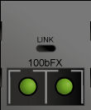Illustration 37: Grafic example in packet tracer simulator of the "PT-SWITCH-NM-1FFE" module

Building | Name
One | FiberTransmuter_B1
Two | FiberTransmuter_B2

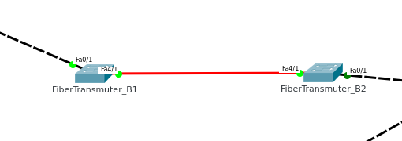Illustration 38: Connection between buildings using fiber optics and compatible layer 2 devices
The reason of using fiber optics wire to connect the network between buildings is the distance between each other. In the blueprints the distance of wire (see Outdoor Campus) is approximately 170-180 meters in the most direct route and approximately 240 meters in the less direct route.
The cable signal is lost in copper wire is about 200 meters, and considering that the copper line isn't is ideal condition's (ex: rectilinear line, no radio noise in the air, temperature variations, etc) the signal may be lost in 160 meters or even less depending in the time of year and ground type on the outside.
Fiber optic wire is “immune” to the outdoor difficulties experienced by the copper wire so is ideal in the outside.
In very tall buildings fiber optics is also used on the vertical wiring. In this project case that wont be needed considering the height of the build.
Max Floor Height: | Building 1 | Building 2
6 meters (the real height is less [4-5 meters] but, the calculations are made to the “worst case scenario”) | 3 floors | 2 floors
Total Height | 18 meters | 12 meters

If the buildings height are less than 180-200 meters there is no need for fiber optics in the vertical way. So in this project case there is no need.

System Password

Every Switch and Router will be encrypted using the password “isep” for security reasons.
Take in consideration that the command “service password-encryption” is activated, so if the password is lost, there is no possibility of administrating the devices.

Legal Notice

Legally may be necessary to create an warning to trespassers in the network, explaining that they may not access the network without the correct credentials, and attempts to break the system security is illegal (except for individuals/company that are authorized).
See the banner created for the project in Illustration 39: Banner Motd: Legal Notice of the terms in the usage of the network.

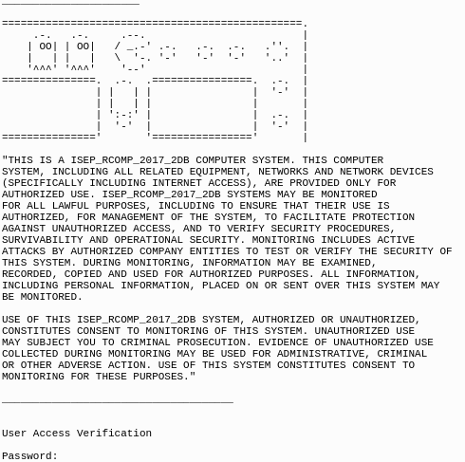Illustration 39: Banner Motd: Legal Notice of the terms in the usage of the network

All Layer 2 Devices

Building 1)

Illustration 40: Table of all layer 2 devices in the ground floor of the Building 1

Illustration 41: Table of all layer 2 devices in the first floor of the Building 1

Illustration 42: Table of all layer 2 devices in the second floor of the Building 1

Building 2)

Illustration 43: Table of all layer 2 devices in the ground floor of the Building 2

Illustration 44: Table of all layer 2 devices in the first floor of the Building 2

Position of Layer 2 and 3 Devices

The following tables are going to show the room were the layer 2,3 devices and AC’s are going to be positioned. Layer 2,3 devices will always be stored in wire closets (see Wiring closets - Able to store: switchs, routers, UPS, server racks, etc), access point
(see Access Point from Cisco model "WAP561") will be stored in the fake ceiling (it will be only visible in building 2, ground floor, exposition center [room with biggest open area]).

Building 1)

Illustration 45: Building 1, grounf floor, layer 2,3 devices by room

Illustration 46: Building 1, first floor, layer 2,3 devices by room

Illustration 47: Building 1, second floor, layer 2,3 devices by room

Building 2)

Illustration 48: Building 2, ground floor, layer 2,3 devices by room

Illustration 49: Building 2, first floor, layer 2,3 devices by room

IPV4 Subnetting

Illustration 50: Adressing table for each LAN

Vlans

VLAN’s placement were planned by the LAN grid provided in the project proposal (see Project proposal).
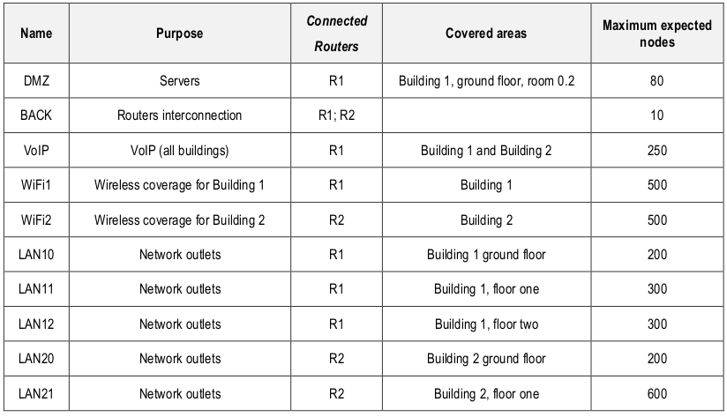Illustration 51: Project proposal

Illustration 52: List of Virtual LAN's, name, address mask and network address
In building 1 there will be available the VLAN’s (see Building 1, avaible vlans for that switch):
- DMZ
- Back
- Voip
- Wifi1
- LAN 10
- LAN 11
- LAN 12

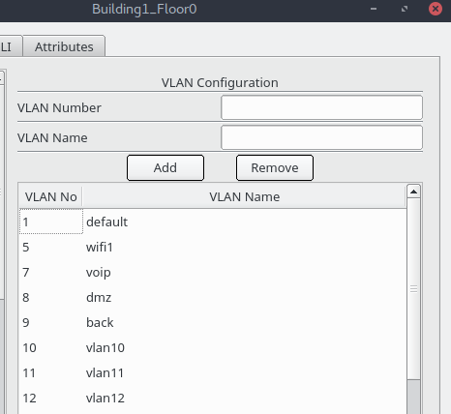Illustration 53: Building 1, avaible vlans for that switch
In building 2 there will be available the VLAN’s (see Building 2, avaible vlan's in switch):
- DMZ
- Back
- Voip
- Wifi1
- LAN 20
- LAN 21

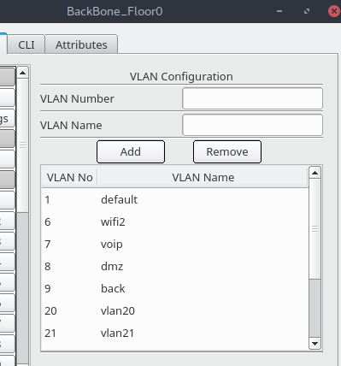Illustration 54: Building 2, avaible vlan's in switch
Creation of vlan:

In switch
Enable
conf t
vlan 5
name wifi
exit
interface vlan 5
ip address 10.0.XXX.YY 255.255.AAA.BBB

Network Blueprint

The packet tracer project that simulates the network was created in similar conditions that in real life. The number of layer 2 and 3 is the real amount. The only difference to real life is the amount of clients (PC’s) and the amount of access points (there is created a few to test the network).

The amount of switches and routers in the simulation are the real number for the future installation because while they are configuration the command line history is saved in documents. When the simulation works fine, when the engineer's and network technicians installs the real life network, they will simple resort to the documentation used and tested in the simulation and copy the configuration commands to the terminal/console.

Building 1)
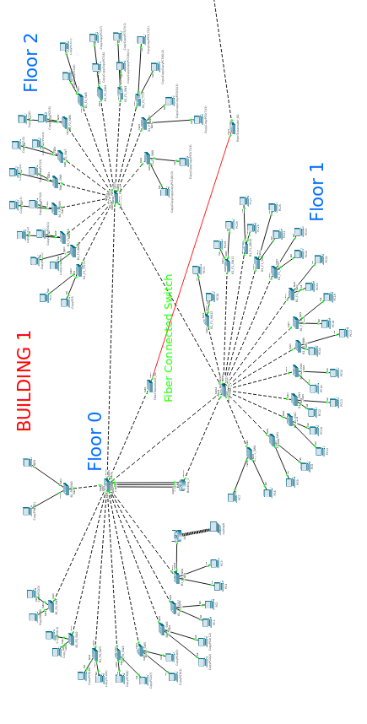Illustration 55: Building 1 , network blueprint

Building 2)

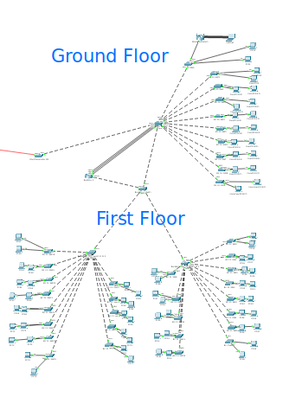Illustration 56: Building 2 , network blueprint

Network Protocols

Various protocols are implemented in the network to ensure the well management of the same.

VTP
To facilitate the implementation of the network the VTP protocol enables the possibility of syncing the VLAN information (id, name, ipv4 address)
There are two type of VTP: SERVER (the one o implements the Vlan’s), CLIENT (the one’s that copy’s the server’s implementations).

In a domain there is only one server (if that switches crashes on simple command will enable the next one as a server [“vtp mode server”])

The steps are:

- Create a domain
For each network there is only one domain (ex: “building 1”).
The command to create/join a domains in a switch is:
In the switch
Enable
conf t
vtp domain building_1

- Select a switch as server
In the network the switch that is used as server is always the one that haves 3 connections to the router (see Switch is a VTP server. This is the one in the floor 0 near the router, so is chosen to be the VTP server), is the direct switch next to the router in floor 0.
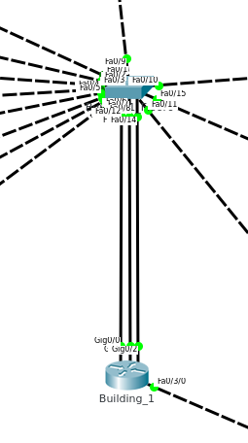Illustration 57: Switch is a VTP server. This is the one in the floor 0 near the router, so is chosen to be the VTP server

In the switch
Enable
conf t
vtp domain building_1 //it needs to be in a domains
vtp mode server

- Select all the other as clients
All the other switches are clients, that will receive the Vlan configuration.

In the switch
Enable
conf t
vtp domain building_1 //it needs to be in a domains
vtp mode client

SPT
Spanning Tree protocol.

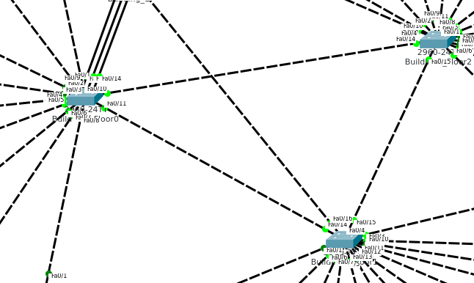Illustration 58: Example of the network, were network path cicles may be detected. Needed STP protocol enable.
Command used in switch to correct the work in the protocol:
no spanning-tree vlan 1

SSH, Telnet, etc
One of the primary reason of security breaches are bad configuration in ports and no encryption.

Comands to resolve varius security riscs
enable secret isep
line con 0
logging synchronous
password isep
login
exit
line vty 0 4
password isep
login
exit
service password-encryption

Conclusion

With the elaboration of this project, it was possible to strenght our knowledge in the current subject that we learned throughout the classes, which were applied during the projection of the structured cabling and in the configuration of the networks used.
It was possible to verify the existing size and complexity in a network involving multiple buildings with different plants and with different requirements imposed by the users in the configuration of the networks, but it was also possible to quantify the materials used to carry out a project of this magnitude.

