RCOMP

Project Report



Teacher: Bertil Marques (BPM)
Network Architecture Planed by:
- João Fernandes - 1141114
- José Barros - 1151117
- José Rodrigues - 1150710
- Tiago Vilaça - 1140412

Table of Contents
Introduction 3
Client Specifications 4
Subject in consideration 5
Speed: 5
Space Usage: 5
Maintenance: 5
Usability: 5
Development 6
Program structure: 6
Program modes: 7
Server: 7
Client: 8
Client and server: 8
Peer-to-peer: 9
UDP protocol 11
TCP protocol 14
Client file request: 14
Server send file: 15
Threaded paradigm 16
Legal Notice 17
Conclusion 18

Introduction

This work was carried out within the scope of the curricular unit of Computer Networks (RCOMP). The purpose was to develop a peer-to-peer application (either in C or Java language). The project was developed taking into account that the application main objective is to provide download access to local files between several instances of the application.

Client Specifications

This project consists of developing a network application, either in C or Java language. It’s a peer-to-peer network application, this means it’s a single application, but several instances of it will communicate with each other.
The application main objective is providing download access to some local files. Once it starts it will periodically announce to the network a list of local filenames it is willing to serve.
Other application instances, will listen for these announcements, and build a list of available filenames on the network. The application’s user may then select one available file to be downloaded.

Subject in consideration

Speed:

Space Usage:

Maintenance:

The program created is developed in a modular fashion with good programming practices. Improving the possibility of new features.

Usability:

The user can execute the program in every directory, when it haves read/write permission.
It can execute by to different ways:
- Terminal
Command: java jar FileTransfer.jar
- Double click

The jar program will create the “shared” and “download” folder in the same directory if they aren’t created preciously.

Development

Program structure:
.
├── client
│ ├── ClientInterface.java
│ └── Client.java
├── controller
│ ├── ClientController.java
│ ├── PeerToPeerController.java
│ └── ServerController.java
├── filetransfer
│ └── FileTransfer.java
├── list
│ ├── ClientLogList.java
│ ├── FileList.java
│ └── TcpFileList.java
├── networkElements
│ ├── Address.java
│ ├── ConnectionUDP.java
│ ├── FileConnectionTCP.java
│ ├── IpProtocol.java
│ └── TextConnectionTCP.java
├── peerToPeer
│ ├── ClientForPeerToPeer.java
│ ├── PeerToPeer.java
│ └── TcpFiles.java
├── server
│ ├── ClientLog.java
│ ├── Server.java
│ └── udp
│ └── AnnouncementUDP.java
├── ui
│ ├── ArranqueUi.java
│ ├── ClientMenuUI.java
│ ├── LogFileShowUI.java
│ ├── PeerToPeerMenuUI.java
│ ├── ServerMenuUI.java
│ ├── SettingsUI.form
└── utils
├── ByteSizeFormat.java
├── FileChooser.java
├── Settings.java
└── Utils.java

10 directories, 36 classes

Program modes:
This application contains various modes:
- Server mode
- Client mode
- Peer to peer
The peer-to-peer consists in an integration between server and client mode. Basically a peer-to-peer application depends on creating a server to share files and announcements, and depends in a client to receive.

Server:

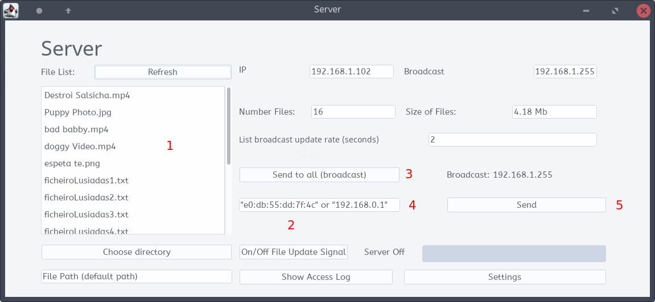Illustration 1: Server UI
Point:
- Files in shared folder of the sender.
- On/Off button to stop or start to send UDP announcements.
- “Send to all”. Changes the text area (number 4) to the broadcast Ip of the network.
- Area were user can insert the ip to send UDP (when pressed button number 3 it will change to broadcast IP).
- “Send Button”. Validates the text inserted in button 4, and alters the destination IP of the UDP packages.

Usage order: The normal usage is: Set to broadcast, send button to confirm, turn on server. 3 →5→2

Client:

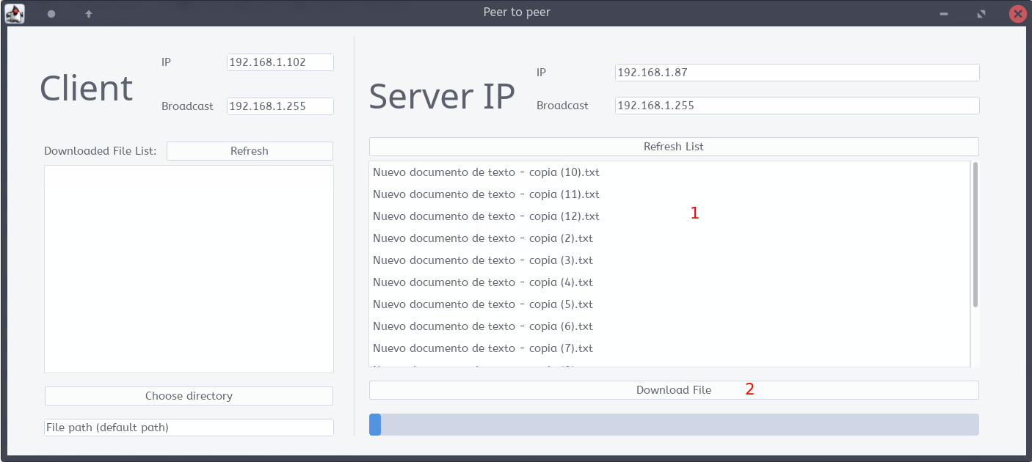Illustration 2: Client UI
Point:
- File list that exists in server received by UDP protocol. (to select more than one file use control + mouse select the files).
- Button to download. The selected files in the list number 1.
Illustration 3: An announcement is sent every 30 seconds

Client and server:

The server module is responsible to send UDP announcements of the files, and open a TCP port for each client (it could use a single TCP for everything, but if various clients are connecting at the same time and requesting downloads that can take some time to download, is better to open various threads and the same number of TCP ports for each connection, improving speed and supporting more than one client each time).
The client module is responsible to receive the UDP announcements from the other server in the network, then send a TCP request to the default TCP port of the server, with it own IP, port to receive file, and the files that each one want.
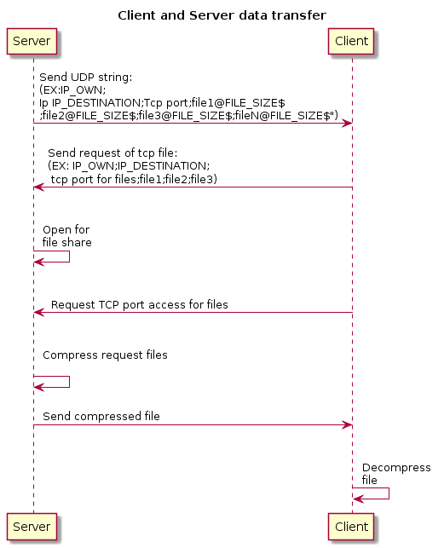Illustration 4: Server and Client data transfer

Peer-to-peer:

Peer-to-peer is an instance of the program that is able to send and receive UDPs and files.
Basically the peer-to-peer instance uses the client module and the server module at same time.
It is able to store all the filenames of each server, and sort it by TCP port for each server. When the user requests a file to download, the peer-to-peer instance will send the file request only to the server with that TCP port.

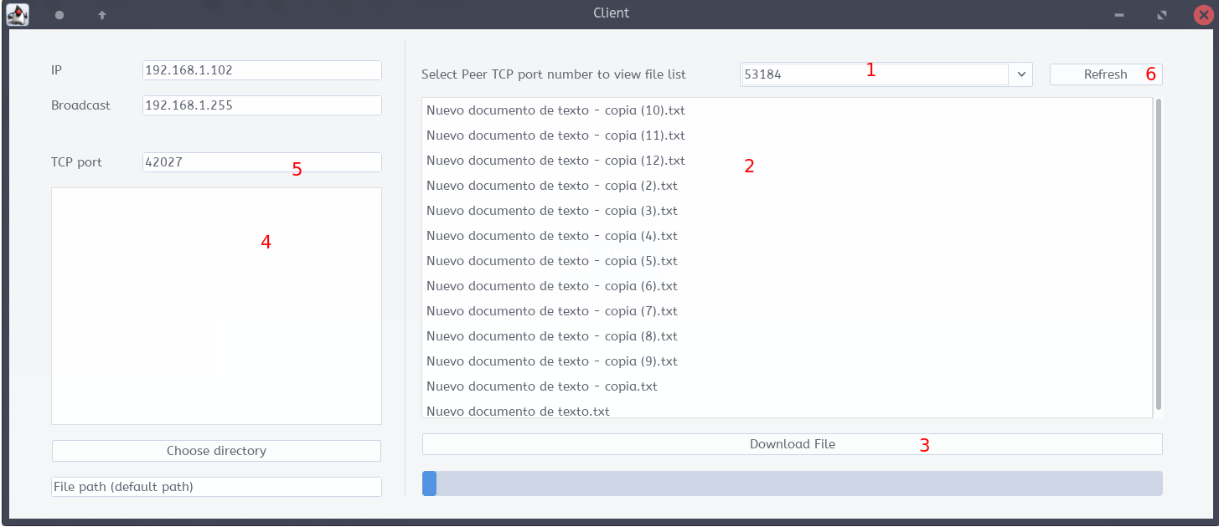Illustration 5: Peer to peer UI
Point:
- Combobox to select one of the connected servers (identified by their TCP port, is own TCP port is not shown in the list).
- List of files available from that selected server.
- Button to download. The selected files in the list number 1.
- Files that exist in the peer-to-peer instance. And is also shared to other peer to peer.
- Information about the own TCP port of is own server.
- Force refresh from the server list.

UDP protocol
The classes responsible by UDP connections are:
- AnnouncementUDP.java
- ConnectionUDP.java

The nomenclature of the UDP message is:

IP of machine | Ip destination | TCP port of server to receive request | Filename 1 | Size in bytes of file 1 | Filename 2 | Size in bytes of file 2 | Filename N | Size in bytes of file N

EX: were the server with the ip 192.168.1.102 is sending the UDP announcement to the broadcast ip (192.168.1.255) of the network, and the TCP port number of the server to listen requests is 45629.

With the files:

Filename | File size in bytes
Video.mp4 | 410224
Puppy Photo.jpg | 171402
bad babby.mp4 | 2149320
doggy Video.mp4 | 1073391
espeta te.png | 540616

192.168.1.102;192.168.1.255;45629;Video.mp4@410224$;Puppy Photo.jpg@171402$;bad babby.mp4@2149320$;doggy Video.mp4@1073391$;espeta te.png@540616$;

The separators used in the string that is send are:
; | The general separator that separates the Ips, Tcp port, and all the files
@ | First separator for the file size in bytes. | babby.mp4@2149320$
$ | First separator for the file size in bytes | babby.mp4@2149320$

When an UDP string is to big for the UDP protocol the message is divided in a special way. Is created a new TCP port that will be responsible for the rest of the files that doesn't fit in the previews UDP.

UDP size limitation solution.
Original UDP  (image that this message does not fit in one UDP announcement and that only fits in 3 UDP annoucements) | 192.168.1.102;192.168.1.255;45629;Video.mp4@410224$;Puppy Photo.jpg@171402$;bad babby.mp4@2149320$;doggy Video.mp4@1073391$;espeta te.png@540616$;espeta te.png@540616$;espeta te.png@540616$;espetate.png@540616$;aroba.png@540616$;aaaaa.png@540616$;arobaddddddpng@540616$;12345675432345.png@540616$;
Divided UDP
1º | 192.168.1.102;192.168.1.255;45629;Video.mp4@410224$;Puppy Photo.jpg@171402$;bad babby.mp4@2149320$;doggy Video.mp4@1073391$;
2º | 192.168.1.102;192.168.1.255;66666;espeta te.png@540616$;espeta te.png@540616$;espeta te.png@540616$;espetate.png@540616$;aroba.png@540616$;aaaaa.png@540616$;
3º | 192.168.1.102;192.168.1.255;21212;arobaddddddpng@540616$;12345675432345.png@540616$;
In this example is created 3 different UDP requests with different TCP port listener in the server, that is made to ensure that there is no data collision and data lost in the server, also each TCP listener is created in a thread that ensures faster reaction speed.

In java environment when a socket is created with the value at 0, is generated by the machine. The server generates the TCP port using that algorithm:
EX: ServerSocket s = new ServerSocket(0). It will create a new TCP connection with an port selected by the OS.

TCP protocol
The classes responsible by TCP connections are:
- FileConnectionTCP.java
- TextConnectionTCP.java

Client file request:
The client TCP file request sent by the client module is quite similar to the UDP protocol sent by the server module.

IP of machine | Ip destination | TCP port of client to receive files | Filename 1 | Filename 2 | Filename N

EX: were the client with the ip 192.168.1.102 is sending the TCP announcement to the broadcast ip (192.168.1.255) of the network, and the TCP port number of the client to receive file is 10023

With the files:

Filename
Video.mp4
Puppy Photo.jpg
bad babby.mp4
doggy Video.mp4
espeta te.png

192.168.1.102;192.168.1.255;45629;Video.mp4;Puppy Photo.jpg;bad babby.mp4;doggy Video.mp4;espeta te.png;

The client is the one to “decide” the TCP port used for file transfer.
In java environment when a socket is created with the value at 0, is generated by the machine. But it can take time to work, to improve program speed the client is going to create the TCP using an faster algorithm.

That is calculated by the sum of each octet of the client IP (unique) plus 9999 (every known protocol used uses TCP ports under the value 2000, so above 9999 is not used).
EX:
IP: 192.168.1.102

TCP port of client: 192+168+1+102+9999 = 10462

When a TCP port is already used in the network the generated TCP port is altered the algorithm new ServerSocket(0).
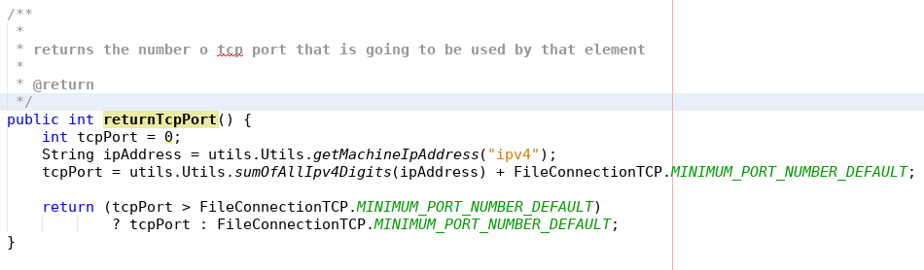Illustration 6: Code to generate TCP port

Server send file:

When a file download request is received the server will process the TCP request (see 7 Illustration 1: Server UI1414), then compress the files requested and then send the file.
The zipped file will be named: ".zipped.file.java.nao.mexer.rcomp.temporario.dropbox.fanado.zip".
It will sent, and always removed when zip file isn't needed.
The compressed file haves the advantage to make the file transfer faster.

Threaded paradigm
All the UDP and TCP listeners, file downloads modules are created used threads.
The listeners are created using “infinite” cycles, so is needed threads (equivalent to forks) for the program to work.

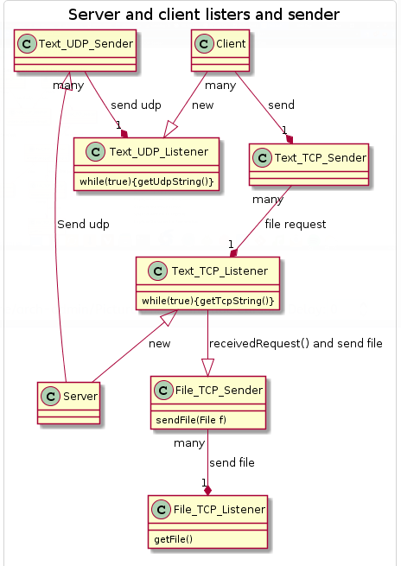Illustration 7: Thread graphical visualization

Legal Notice

Legally may be necessary to create an warning to trespassers in the network, explaining that they may not access the network without the correct credentials, and attempts to break the system security is illegal (except for individuals/company that are authorized).

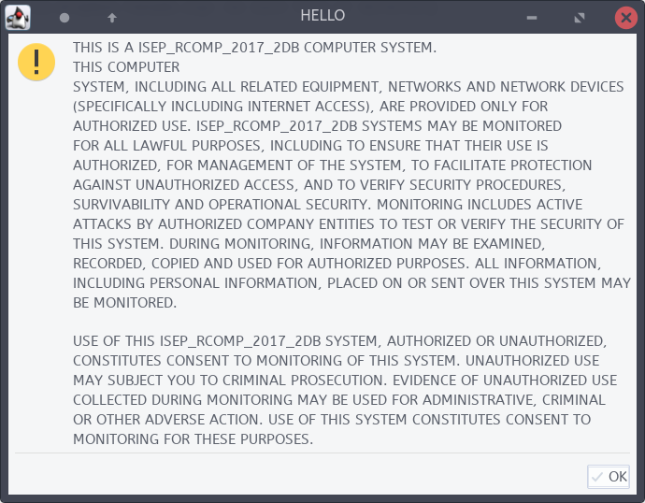Illustration 8: Legal notice

Extra Features
The project proposal requested these extra features:
Some additional, non-mandatory, features to be taken into account on
project assessment (additional value factors):
- Overcome the limit on the filenames list size due to the UDP datagram size limit. Suggestion: split it into several datagrams.
- Strategies to overcome the broadcast domain confinement. Suggestion: create a list of remote nodes (unicast addresses) and send announcements not only to the local broadcast address, but also to each remote node.

The team considers that all the extra features requested were explicated.

Overcome the limit on the filenames list size

See UDP size limitation solution. were is explained the solution created to the problem given.

Strategies to overcome the broadcast domain confinement
The UDP protocol is able to send to unicast addresses protocol (see 1Illustration 2Illustration 2, the client is able to send to unique address).
Also every TCP connection does not use broadcast addresses.

Conclusion

With the elaboration of this project, it was possible to strengthen our knowledge in the current subject that we learned throughout the classes, which were applied during the development of the peer-to-peer application (developed in Java language). In the end, it was a good project for us to understand how complex a bigger peer-to-peer application (e.g Dropbox) has to be implemented, and how it works.

