Hive Project

The first thing to do into cloudera is to créate the .CSV file with the order

$ vi /tmp/ejemplo.CSV

;

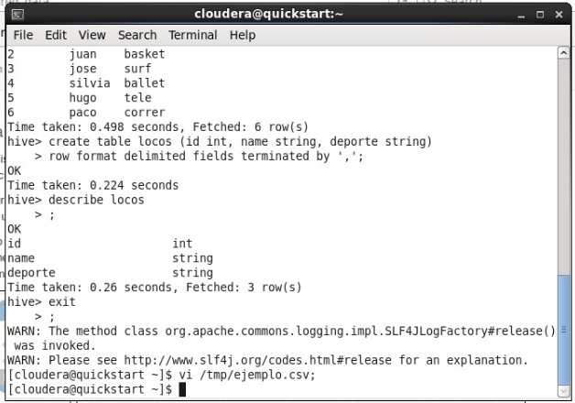

The file is going to be called “ejemplo.CSV”

A screen displays and I wrote.

1, pamela, box

2, juan, basket

3, jose, surf

4, silvia, ballet

5, caeli, youtube

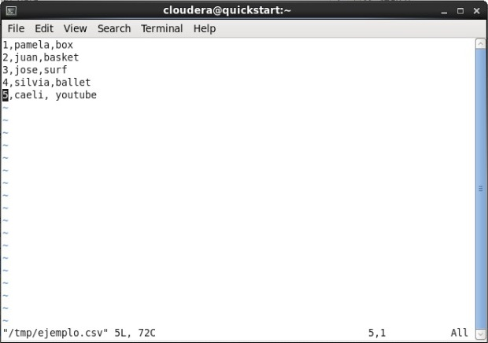

This is a text file that contains an id number, a name and the sport they like for each person

After that I wrote the order in cloudera:

$ hdfs dfs –put ejemplo.csv

;

And then I wrote $hdfs dfs –ls, to show the files in the hdfs, with this order I can see the files

After that I write the word **hive** in the terminal

When the system gets me into hive I created a table with the next order:

Create table gente ( id int, name string, deporte string)

Row format delimited fields terminated by ‘,’

;

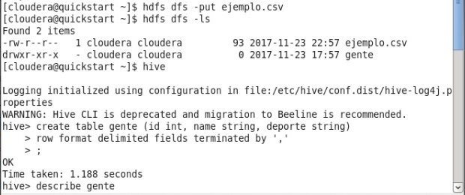

Then the only thing I have to do is to insert the data from the CSV file already in the hdfs into the table create with:

Load data local inpath ‘ejemplo.csv’ overwrite into table gente

;

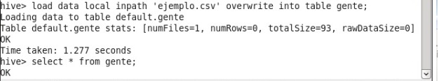

With this The data has been uploaded into that table, now to certify this I just need to write a query like

Select * from gente

;

