This is for Part A

To validate my sql I entered with:

-mysql –u retail_dba –p cloudera

Then I entered queries:

Show databases;

Use retail_db;

Show tables;

Select * from departments; (This was part of a tutorial)

Then we need to get out of mysql using “exit”

To list the tables using sqoop

sqoop list-tables \  
--connect jdbc:mysql://quickstart:3306/retail_db \  
--username root \  
--password cloudera

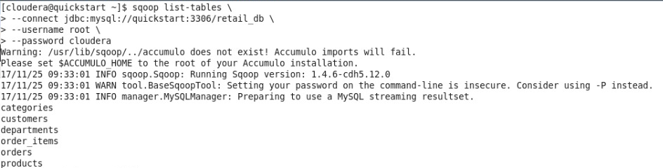

Part B:

This part is to create a database:

Connect to database using: **mysql -u root -pcloudera**

create database using : **create database HR_db;**

Declare database to HR_db using: **use HR_db**

Create tables:

**create table Employee( \**

**primary key (id),**

**id varchar(8),**

**name varchar(30),**

**salary float,**

**designation varchar(20)**

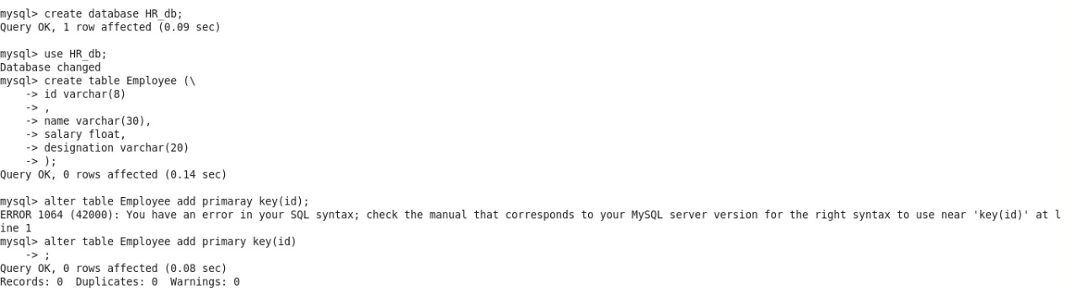**);**

Now we insert values into that table with:

**insert into Employee values("0001","marcos", 10, "Software Engineer");**

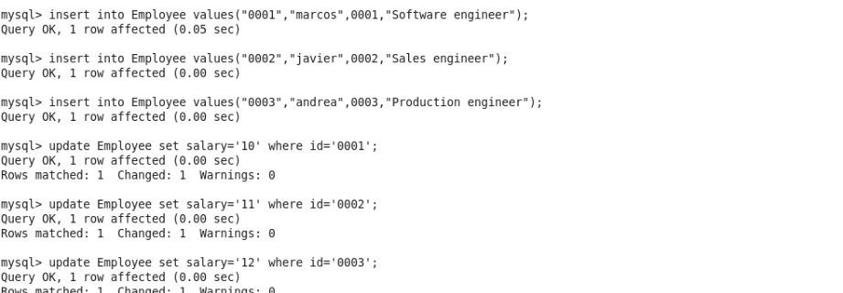**I repeated this procedure**

**To eval connection with sqoop command use:**

**sqoop eval --connect jdbc:mysql://quickstart:3306/HR_db --username root --password cloudera --query "select * from Employee"**

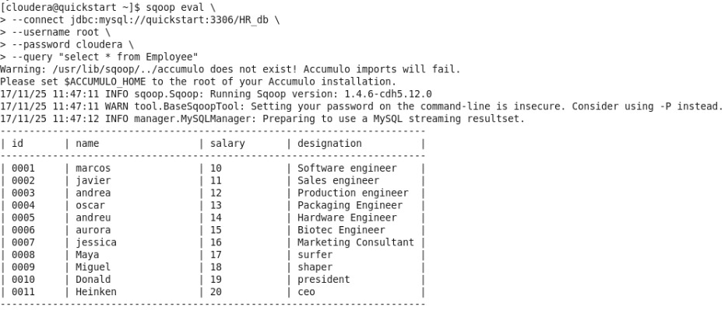

I´m using this command to import tables, using 8 mappers in avro file format to Hive:

**sqoop import --connect jdbc:mysql://quickstart:3306/HR_db --table Employee --username root  
--password cloudera -m 8 --create-hive-table  
--hive-table Employee --as-avrodatafile --target-dir /user/imported/Employee**