Jose Torres Jr
02/19/2026

Project 2

Schema of tableA:
(ID, title, release_year, genre, director, runtime_minutes, imdb_rating, rotten_tomatoes_score)

Schema of tableB:
(ID, title, release_year, genre, director, runtime_minutes, imdb_rating, rotten_tomatoes_score)
Both tables were verified to share the same schema. No structural transformation was required.

S value:
S = {ID, title, release_year, genre, director, runtime_minutes, imdb_rating, rotten_tomatoes_score}
Attribute 1 Director:
Missing values: 149 out of 200 (74.5%) of records are missing director’s information.
Type:
Textual (string identifier)
Outliers:
No textual anomalies observed, but high missing rate is major data quality issue.
Format Issues:
Director names appear consistently in string format.
Synonyms:
Not applicable for IDs
Data quality problems:
URL encoding artifacts
Inconsistent formatting (film vs person vs list entries)

Attribute 2: Title
Missing values: 0/1001 (0%) values are missing. While the title attribute is rarely null, there are several entries that contain invalid values such as actor names or list pages, which function as missing values from semantic perspective.

Type:
Textual (string identifier)
Text length analysis:
Average length: moderate.
Minimum short titles: 3-5 characters
Maximum: long descriptive titles (>40 characters)
Outliers:
Some entries contain:
Actor names
List pages
Non-film entites
Synonyms:
Not applicable.
Sprinkled data:
Sometimes actor names or metadata appear inside title field instead of proper attributes.
Other data quality problems:
Mixed entity types ( films, actors, lists).
Attribute 3: release_year:
Missing values: 0/1001 (0%) are missing.
Type: Numeric(integer)
Outliers: Years tied to non-film entries.
Unrealistic values (future or incorrect)
Format: Some values stored as strings require numeric conversion.
Synonyms: Not applicable
Sprinkled data: Sometimes year appears inside title field.
Other data quality problems: non-film entities still have year values.

Attribute 4: genre:
All values = “Horror”
Missing: 0/1001 (0%) are missing.
Synonyms: No strong genre synonyms were observed in this dataset, as most entries consistently use the label Horror.
Outliers: Genre attached to non-film records.
Sprinkled data: Genre information does not appear to be heavily sprinkled across other attributes.
Type: Categorical
Format issues: Consistent format.
Synonyms: None observed.
Sprinkled data: No major sprinkling.
Other data quality problems: Genre applied to actor/list entries semantic noise.
Attribute 5: director:
Missing values: 746/1001 (74.5%) are missing.
Type: Textual
Outliers: No major textual outliers.
Synonyms: Not applicable.
Data Quality Problems
Large missing rate major quality issue.
Possible fixes:
External lookup
Fill with Unknown
Attribute 6: runtime_minutes:
Missing values: 75.2/1001 (75.2%) missing
Type: Numeric
Outliers: Runtime values above 200 minutes may be considered outliers.
Possible fixes: Fill with median runtime and remove non-film rows.

Attribute 7: imdb_rating:
Missing values: 1001/1001 (100%) missing.
Type: Numeric
Use: Currently unusable.
Possible fixes: External API enrichment and dropping attribute.
Attribute 8: rotten_tomatoes_score:
Missing value: 1001/1001 (100%) missing
Type: Numeric
Use: Currently unusable
Possible fixes: External API enrichment and dropping attribute.

Major Data quality Issues:
Table A contains:
Film entries
Person entries
List entries
Entity level matching is inconsistent

Histograms

Two histograms were created to analyze the distribution of release_year and runtime_minutes across both tables.

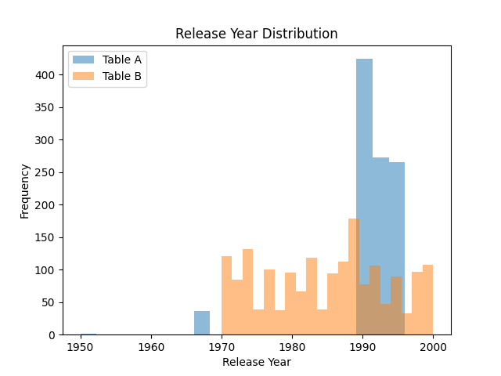

The release_year histogram shows that most films fall within expected decades, with Table B showing a broader distribution.
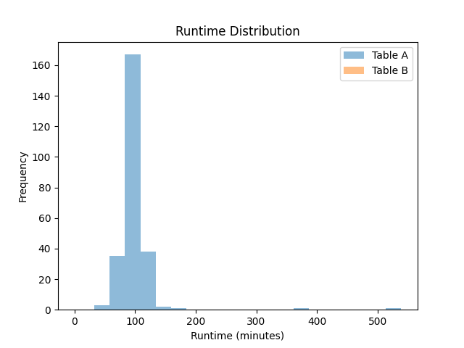

The runtime histogram reveals that most films fall within typical runtime ranges (60-120 minutes), though a few extreme values appear, which may represent anomalies or data entry issues.

Software Tools Used

The following tools were used to explore, clean, and analyze the datasets:
- Python: Primary language for data analysis and cleaning.
- Pandas: used for loading CSV files, handling missing values, and computing statistics.
- Matplotlib: Used to generate histograms for detecting outliers and distributions.
- VS Code: Development environment for writing and running scripts.
- Microsoft Word: Used to prepare the written report.

