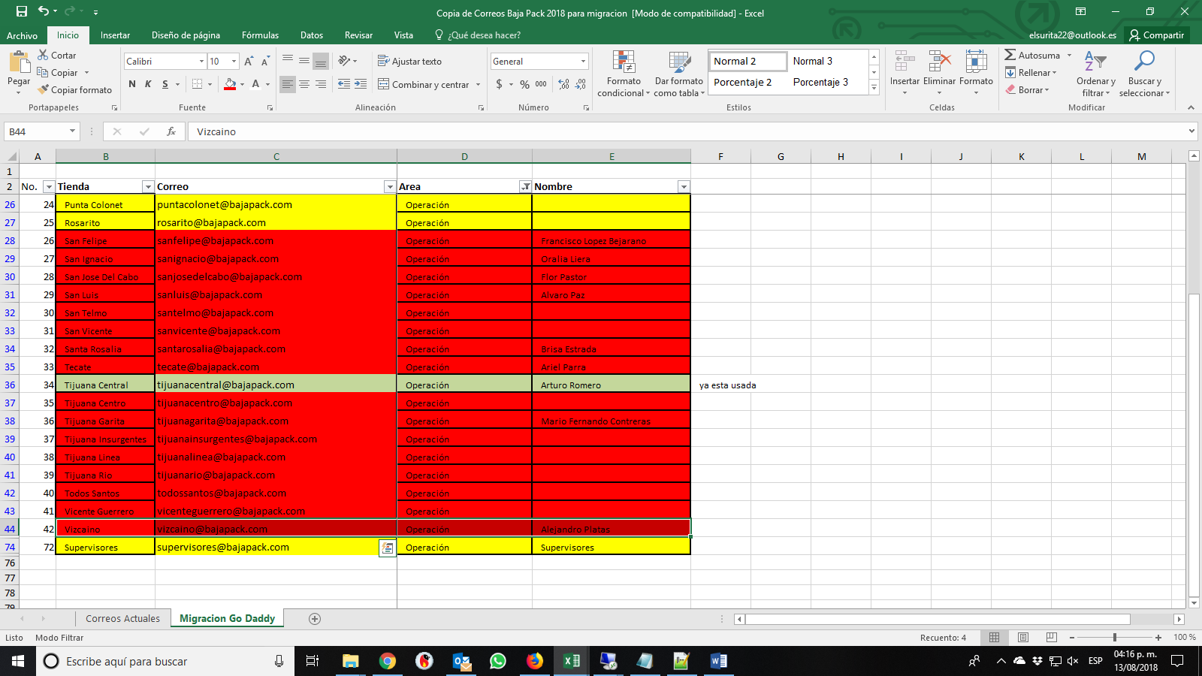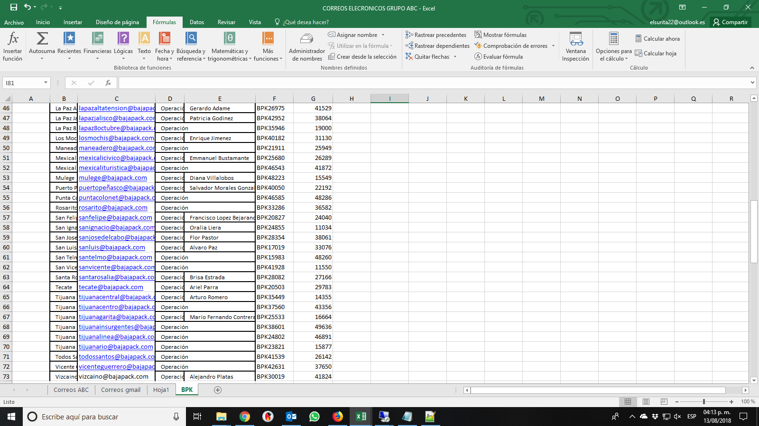

|  |
| --- |
|  |
| [admbpk@bajapack.com](https://wcc.godaddy.com/) |  | [Inicia](https://wcc.godaddy.com/) |  |  |
|  | [aligeraldo@bajapack.com](https://wcc.godaddy.com/) |  |  |  |  |
|  | [almacen@bajapack.com](https://wcc.godaddy.com/) |  |  |  |  |
|  | [arios@bajapack.com](https://wcc.godaddy.com/) |  |  |  |  |
|  | [asesorcallcenter1@bajapack.com](https://wcc.godaddy.com/) |  |  |  |  |
|  | [asesorcallcenter2@bajapack.com](https://wcc.godaddy.com/) |  |  |  |  |
|  | [asesorcallcenter3@bajapack.com](https://wcc.godaddy.com/) |  |  |  |  |
|  | [asesorcallcenter4@bajapack.com](https://wcc.godaddy.com/) |  |  |  |  |
|  | [asesorcallcenter5@bajapack.com](https://wcc.godaddy.com/) |  |  |  |  |
|  | [asesorcallcenter6@bajapack.com](https://wcc.godaddy.com/) |  |  |  |  |
|  | [atapiz@bajapack.com](https://wcc.godaddy.com/) |  |  |  |  |
|  | [barriles@bajapack.com](https://wcc.godaddy.com/) |  |  |  |  |
|  | [cabosanlucas@bajapack.com](https://wcc.godaddy.com/) |  |  |  |  |
|  | [call.center@bajapack.com](https://wcc.godaddy.com/) |  |  |  |  |
|  | [camalu@bajapack.com](https://wcc.godaddy.com/) |  |  |  |  |
|  | [constitucion@bajapack.com](https://wcc.godaddy.com/) |  |  |  |  |
|  | [cuidadinsurgentes@bajapack.com](https://wcc.godaddy.com/) |  |  |  |  |
|  | [culiacan@bajapack.com](https://wcc.godaddy.com/) |  |  |  |  |
|  | [dbalboa@bajapack.com](https://wcc.godaddy.com/) |  |  |  |  |
|  | [dgarciav@bajapack.com](https://wcc.godaddy.com/) |  |  |  |  |
|  | [ecruz@bajapack.com](https://wcc.godaddy.com/) |  |  |  |  |
|  | [elrosario@bajapack.com](https://wcc.godaddy.com/) |  |  |  |  |
|  | [embarquesmalecon@bajapack.com](https://wcc.godaddy.com/) |  |  |  |  |
|  | [ensenada@bajapack.com](https://wcc.godaddy.com/) |  |  |  |  |
|  | [gsandoval@bajapack.com](https://wcc.godaddy.com/) |  |  |  |  |
|  | [guerreronegro@bajapack.com](https://wcc.godaddy.com/) |  |  |  |  |
|  | [gvelazquez@bajapack.com](https://wcc.godaddy.com/) |  |  |  |  |
|  | [info@bajapack.com](https://wcc.godaddy.com/) |  |  |  |  |
|  | [jbarrera@bajapack.com](https://wcc.godaddy.com/) |  |  |  |  |
|  | [jerodriguez@bajapack.com](https://wcc.godaddy.com/) |  |  |  |  |
|  | [jgonzalez@bajapack.com](https://wcc.godaddy.com/) |  |  |  |  |
|  | [jhurtado@bajapack.com](https://wcc.godaddy.com/) |  |  |  |  |
|  | [jmendoza@bajapack.com](https://wcc.godaddy.com/) |  |  |  |  |
|  | [jsoto@bajapack.com](https://wcc.godaddy.com/) |  |  |  |  |
|  | [krodriguez@bajapack.com](https://wcc.godaddy.com/) |  |  |  |  |
|  | [lapaz5defebrero@bajapack.com](https://wcc.godaddy.com/) |  |  |  |  |
|  | [lapaz5mayo@bajapack.com](https://wcc.godaddy.com/) |  |  |  |  |
|  | [lapaz8octubre@bajapack.com](https://wcc.godaddy.com/) |  |  |  |  |
|  | [lapazaltatension@bajapack.com](https://wcc.godaddy.com/) |  |  |  |  |
|  | [lapazjalisco@bajapack.com](https://wcc.godaddy.com/) |  |  |  |  |
|  | [lazarocardenas@bajapack.com](https://wcc.godaddy.com/) |  |  |  |  |
|  | [losmochis@bajapack.com](https://wcc.godaddy.com/) |  |  |  |  |
|  | [maneadero@bajapack.com](https://wcc.godaddy.com/) |  |  |  |  |
|  | [mbeltran@bajapack.com](https://wcc.godaddy.com/) |  |  |  |  |
|  | [mesadecontrol@bajapack.com](https://wcc.godaddy.com/) |  |  |  |  |
|  | [mexicalicivico@bajapack.com](https://wcc.godaddy.com/) |  |  |  |  |
|  | [mexicalituristica@bajapack.com](https://wcc.godaddy.com/) |  |  |  |  |
|  | [mulege@bajapack.com](https://wcc.godaddy.com/) |  |  |  |  |
|  | [ncarrillo@bajapack.com](https://wcc.godaddy.com/) |  |  |  |  |
|  | [psoto@bajapack.com](https://wcc.godaddy.com/) |  |  |  |  |
|  | [puntacolonet@bajapack.com](https://wcc.godaddy.com/) |  |  |  |  |
|  | [rosarito@bajapack.com](https://wcc.godaddy.com/) |  |  |  |  |
|  | [sanfelipe@bajapack.com](https://wcc.godaddy.com/) |  |  |  |  |
|  | [sanignacio@bajapack.com](https://wcc.godaddy.com/) |  |  |  |  |
|  | [sanjosedelcabo@bajapack.com](https://wcc.godaddy.com/) |  |  |  |  |
|  | [sanluis@bajapack.com](https://wcc.godaddy.com/) | Cuenta de correo con verificación pendiente |  |  |  |
|  | [santarosalia@bajapack.com](https://wcc.godaddy.com/) | Cuenta de correo con verificación pendiente |  |  |  |
|  | [santelmo@bajapack.com](https://wcc.godaddy.com/) | Cuenta de correo con verificación pendiente |  |  |  |
|  | [sanvicente@bajapack.com](https://wcc.godaddy.com/) | Cuenta de correo con verificación pendiente |  |  |  |
|  | [sistema@bajapack.com](https://wcc.godaddy.com/) |  |  |  |  |
|  | [supervisores@bajapack.com](https://wcc.godaddy.com/) |  |  |  |  |
|  | [tecate@bajapack.com](https://wcc.godaddy.com/) | Cuenta de correo con verificación pendiente |  |  |  |
|  | [tijuanacentral@bajapack.com](https://wcc.godaddy.com/) | Cuenta de correo con verificación pendiente |  |  |  |
|  | [tijuanacentro@bajapack.com](https://wcc.godaddy.com/) | Cuenta de correo con verificación pendiente |  |  |  |
|  | [tijuanagarita@bajapack.com](https://wcc.godaddy.com/) | Cuenta de correo con verificación pendiente |  |  |  |
|  | [tijuanainsurgentes@bajapack.com](https://wcc.godaddy.com/) | Cuenta de correo con verificación pendiente |  |  |  |
|  | [tijuanalinea@bajapack.com](https://wcc.godaddy.com/) | Cuenta de correo con verificación pendiente |  |  |  |
|  | [tijuanario@bajapack.com](https://wcc.godaddy.com/) | Cuenta de correo con verificación pendiente |  |  |  |
|  | [todossantos@bajapack.com](https://wcc.godaddy.com/) | Cuenta de correo con verificación pendiente |  |  |  |
|  | [vicenteguerrero@bajapack.com](https://wcc.godaddy.com/) | Cuenta de correo con verificación pendiente |  |  |  |
|  | [vizcaino@bajapack.com](https://wcc.godaddy.com/) | Cuenta de correo con verificación pendiente |  |  |  |
|  | [puertopeñasco@bajapack.com](https://wcc.godaddy.com/) |  |  |  |  |