20487D_MOD01_LAK

# Module 1: Overview of Service and Cloud Technologies

# Lab: Exploring the Work Environment

**Exercise 1: Creating an ASP.NET Core Project**

**Task 1: Create a new ASP.NET Core project**

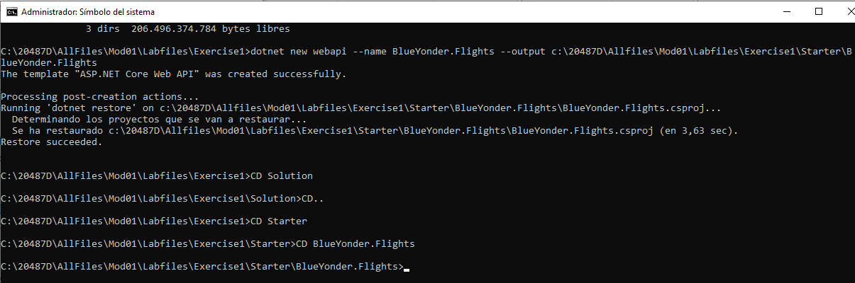

### Exercise 2: Creating a Simple Entity Framework Model

#### Task 1: Create a new POCO entity

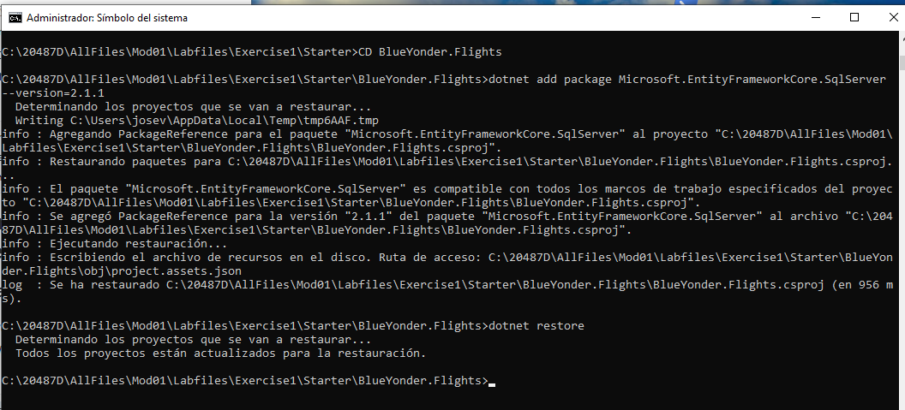

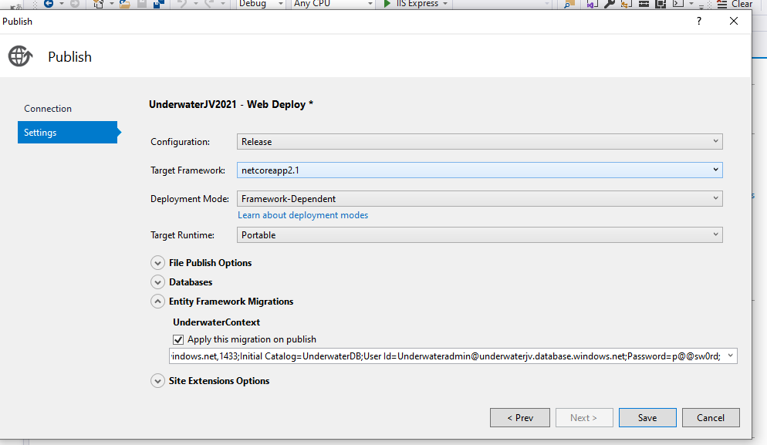

### Exercise 4: Deploying the Web Application to Azure

#### Task 1: Create an Azure Web App and an SQL database

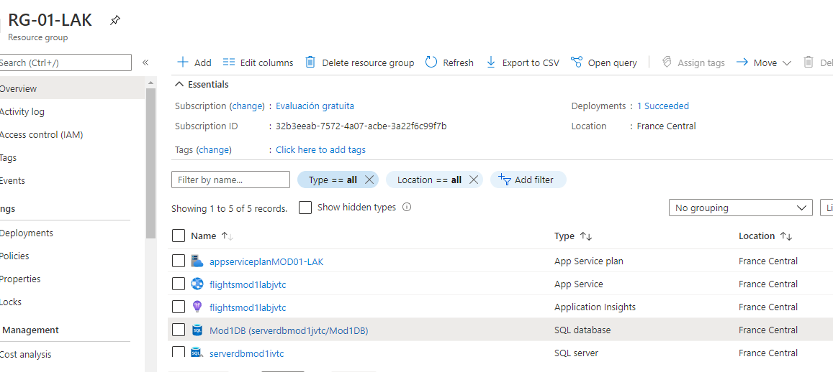

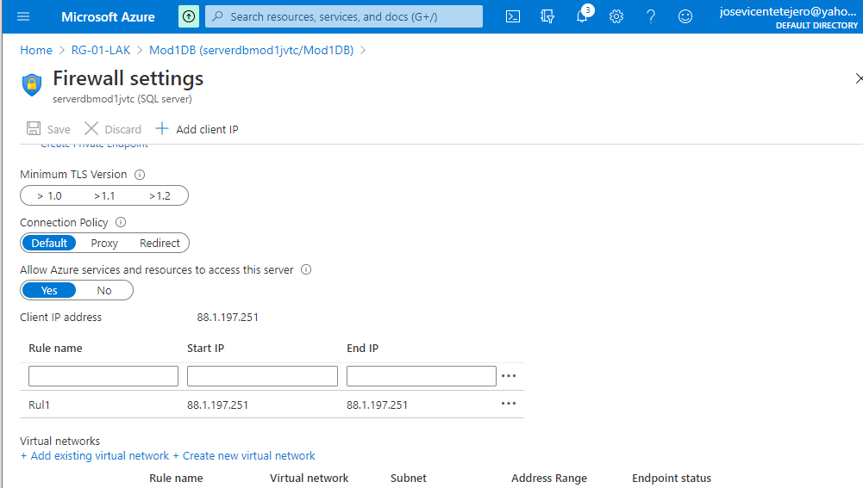

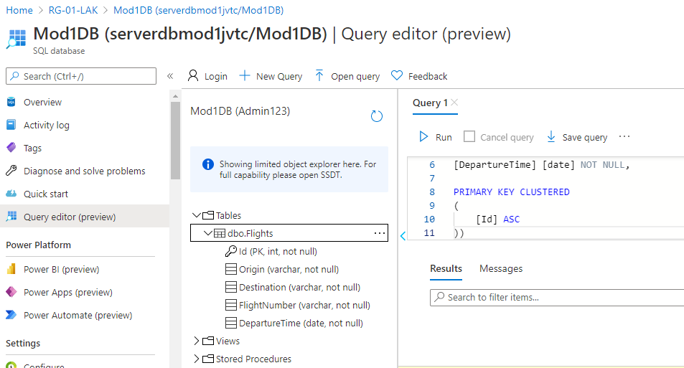

Task 2: Deploy the web application to the Azure Web App

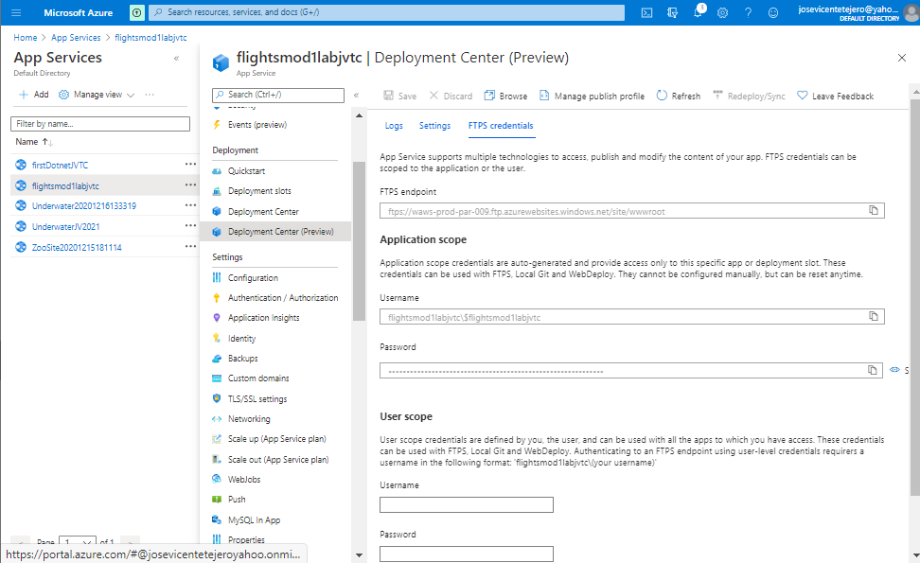

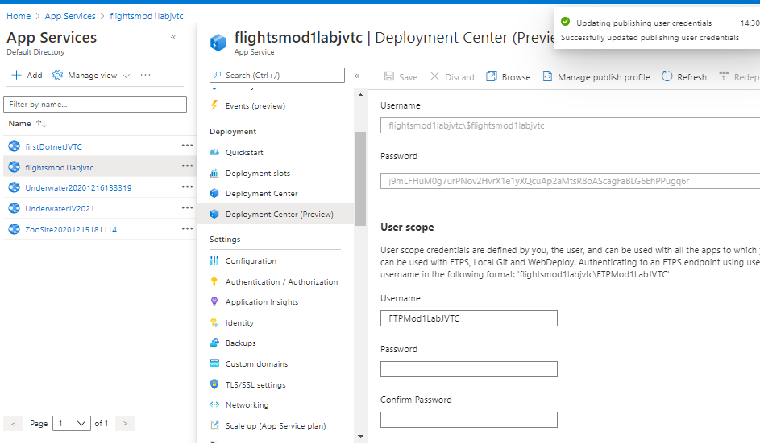

Al ejecutar:

$postParams = "{'origin': 'Germany',

'destination': 'France',

'flightNumber': 'GF7625',

'departureTime': '0001-01-01T00:00:00'}"

Invoke-WebRequest -Uri http://flightsmod1labjvtc.azurewebsites.net/api/flights -ContentType "application/json" -Method POST -Body $postParams

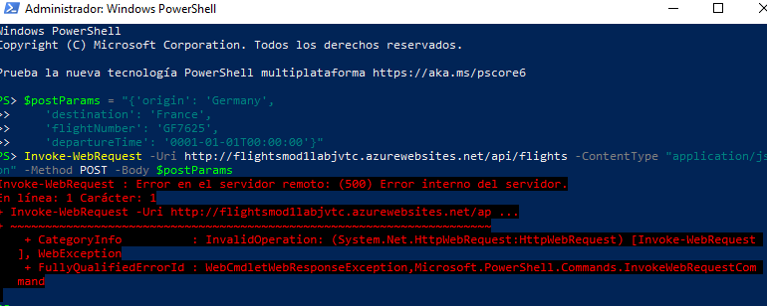

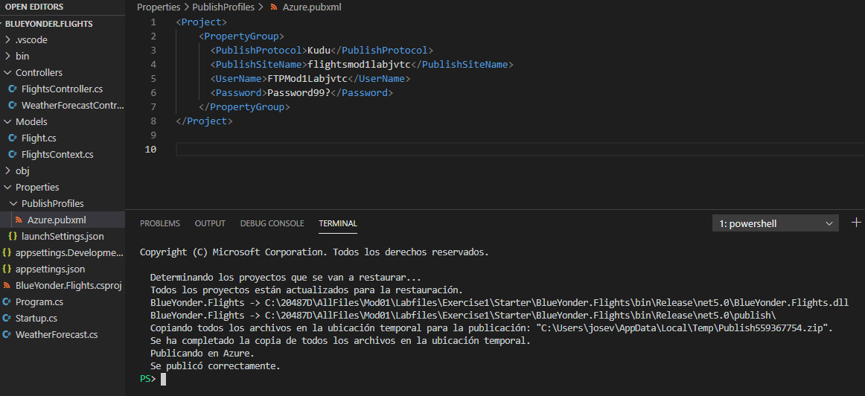

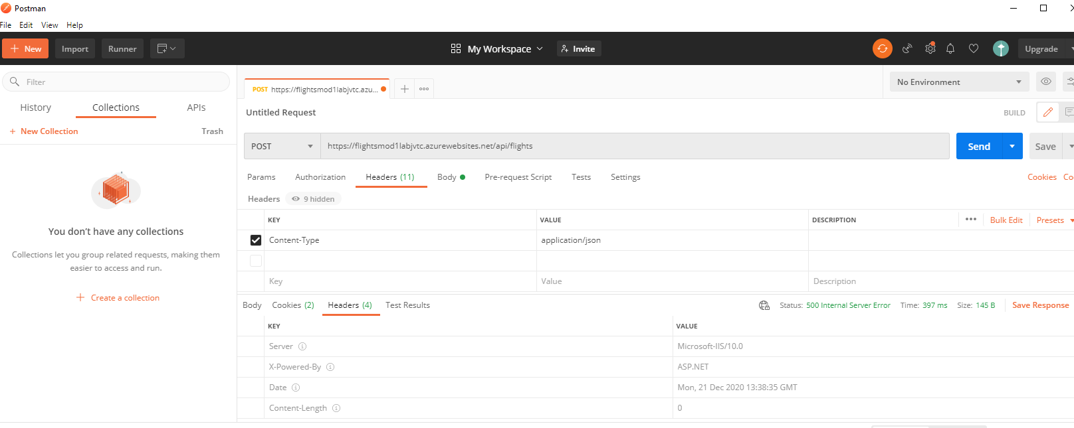

Como el comando Invoque no funciona, añadimos los registros directamente en la base de datos.

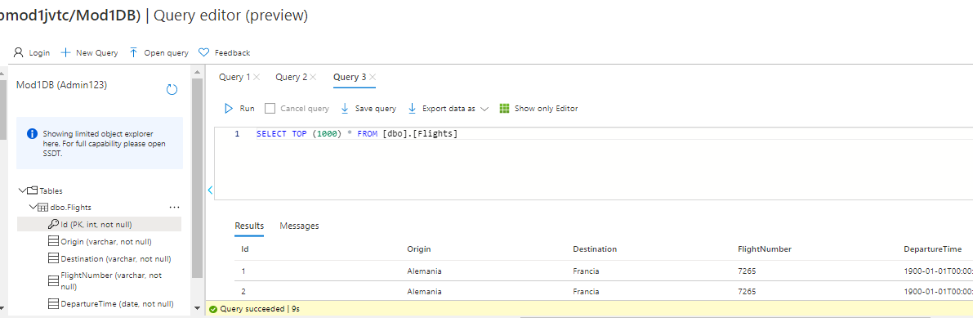

Comprobamos que funciona correctamente.

