20487D_MOD02_DEMO

**Lesson 2: Creating an Entity Data Model**

**Demonstration: Creating an Entity Type, DbContext, and DbInitializer**

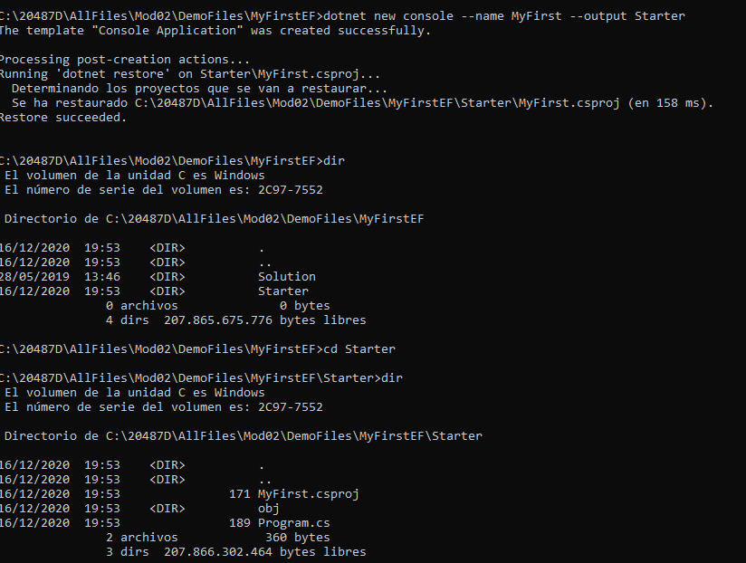

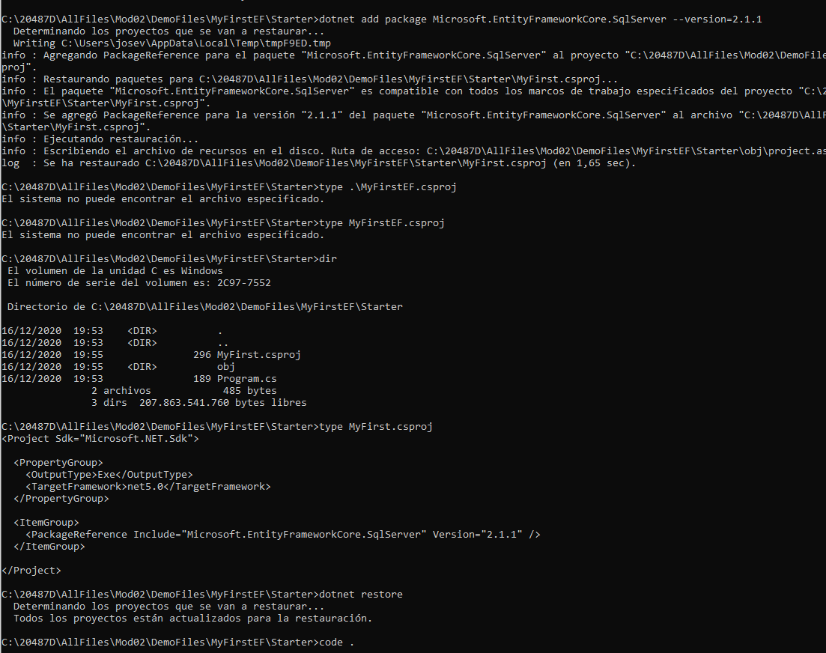

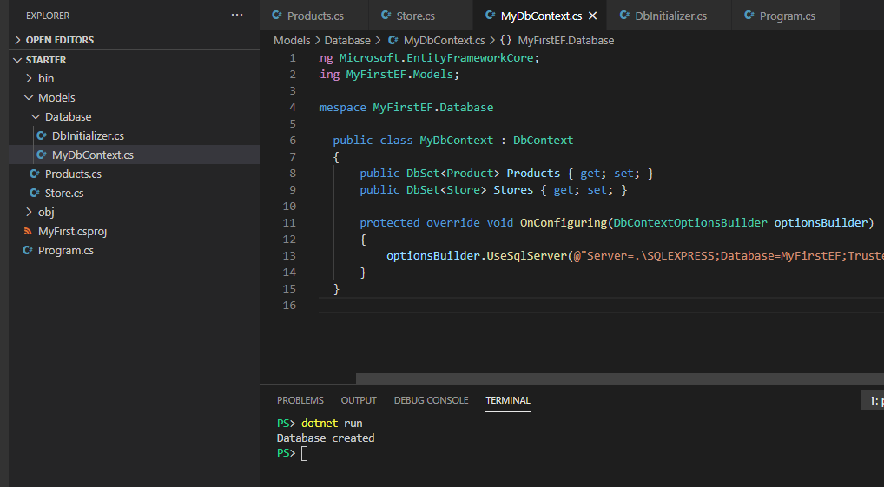

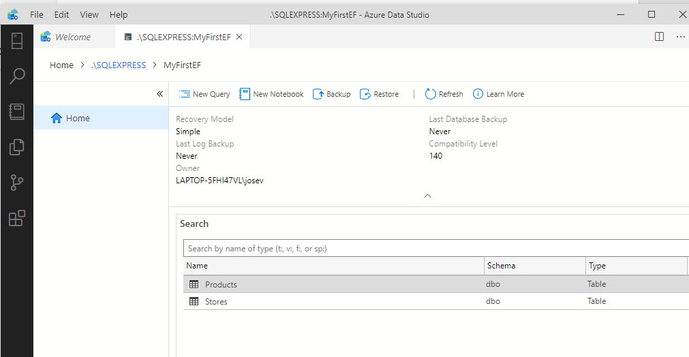

# Lesson 3: Querying Data

### Demonstration: Using Language-Integrated Query (LINQ) to Entities

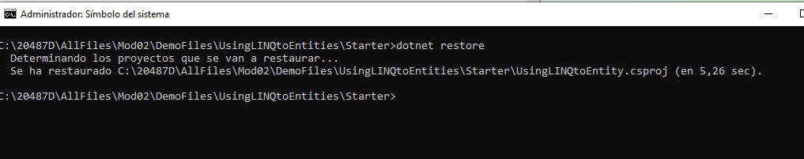

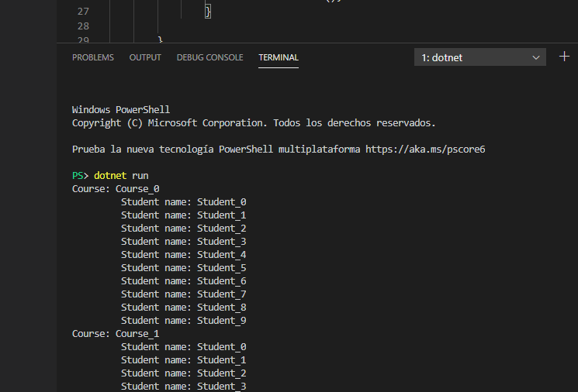

Demonstration 2: Running Stored Procedures with Entity Framework

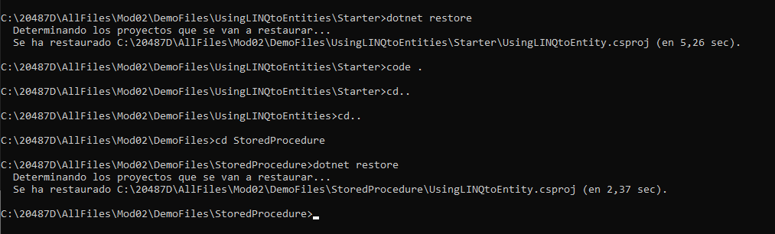

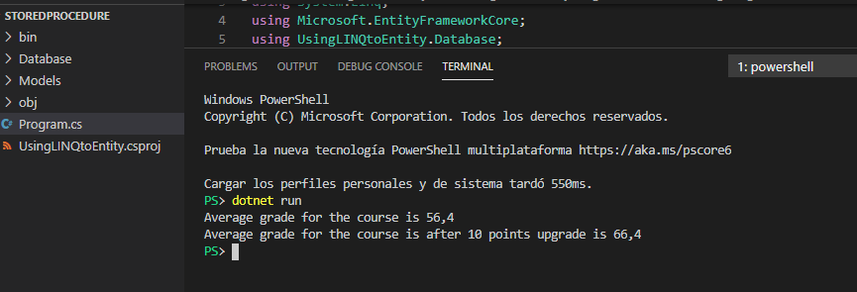

# Lesson 4: Manipulating Data

### Demonstration: CRUD Operations in Entity Framework

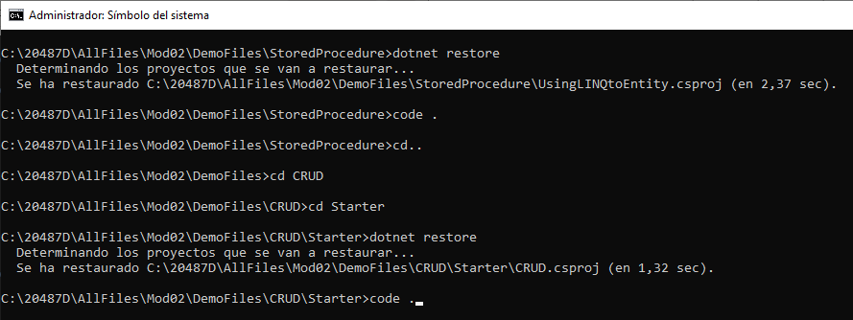

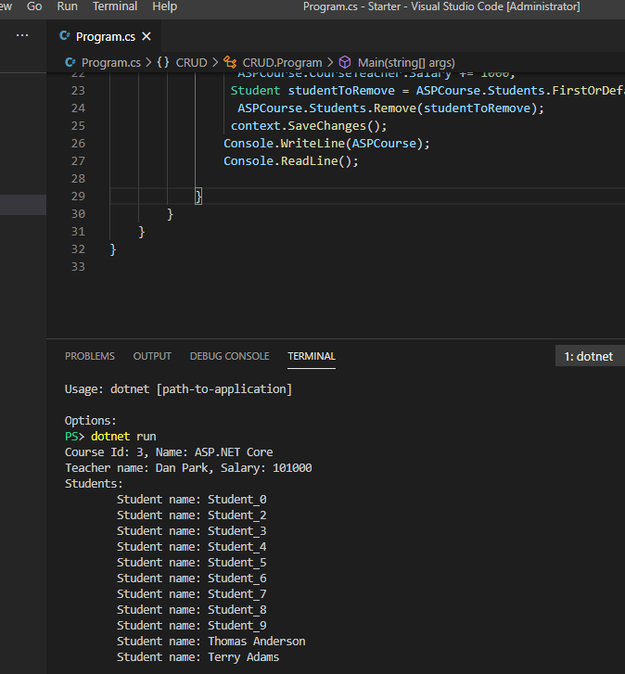

**Demonstration: Using Entity Framework with In-Memory Database**

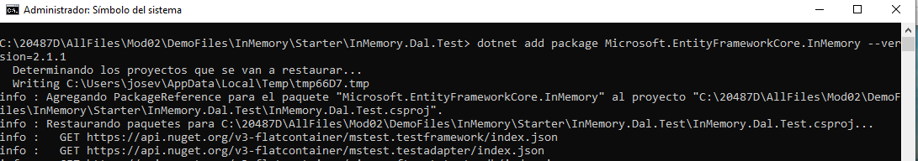

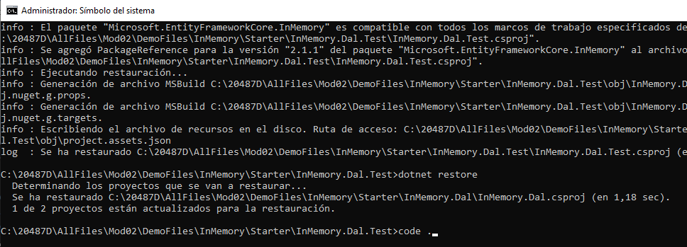

El resultado es el siguiente:

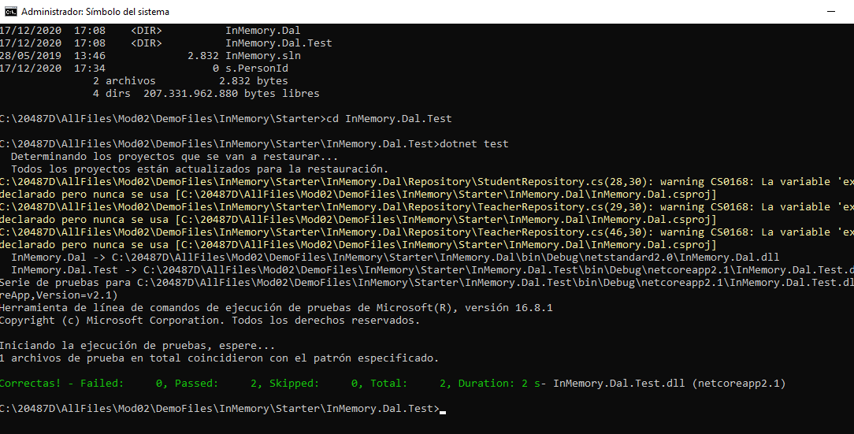

### Demonstration: Using Entity Framework with SQLite

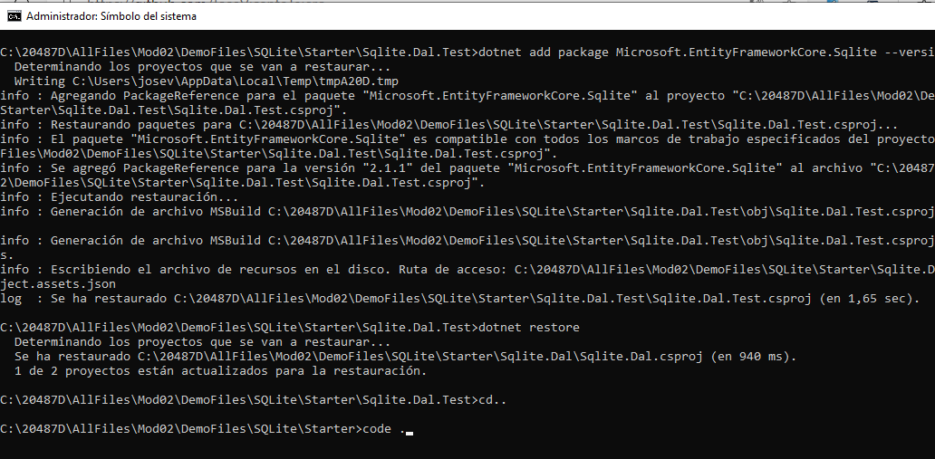

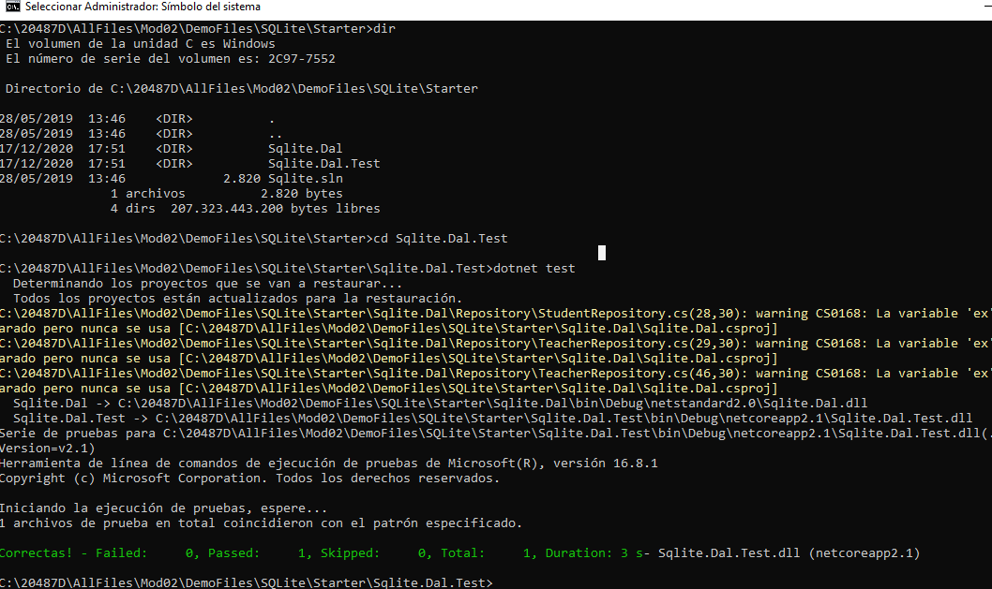

Resultado:

