20487D_MOD02_LAK

# Module 2: Querying and Manipulating Data Using Entity Framework

# Lab: Creating a Data Access Layer using Entity Framework

### Exercise 1: Creating a Data Model

#### Task 1: Create a class library for the data model

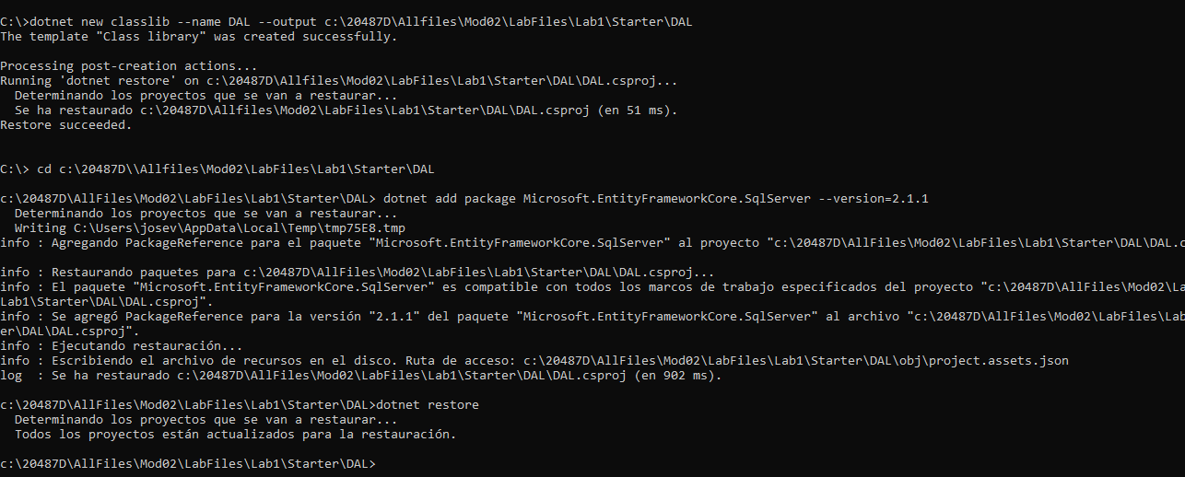

### Exercise 2: Query your database

#### Task 1: Create a database initializer with dummy data

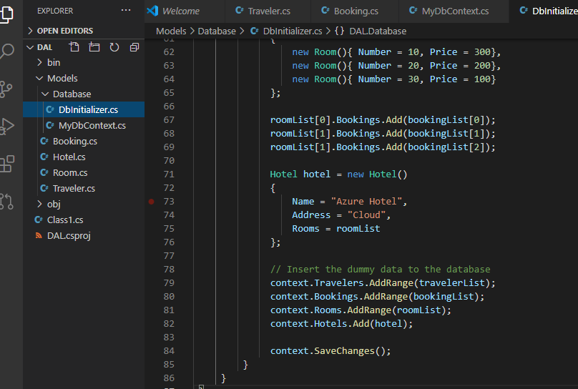

Task 2: Write a language-integrated query (LINQ) query to query the data

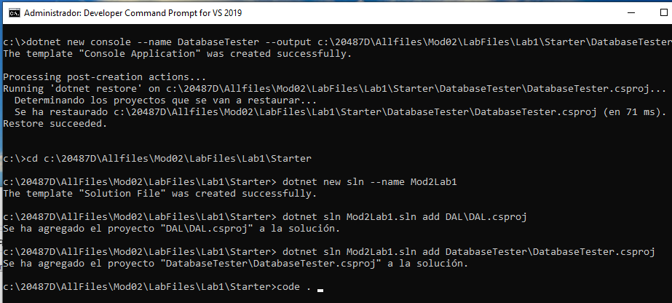

Resultado de Exercise 2, Task 2

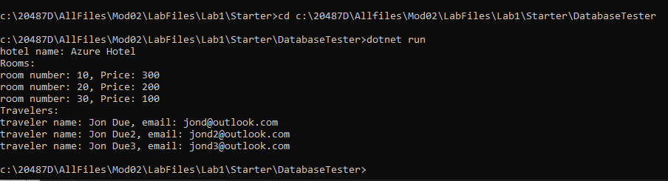

**Lab: Manipulating Data**

**Exercise 1: Create repository methods**

### Exercise 2: Test the model using SQL Server and SQLite

#### Task 1: Create test code with transactions

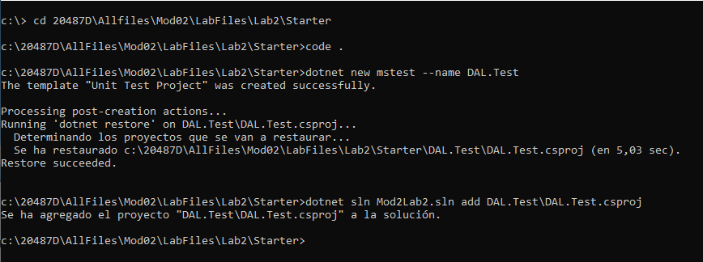

Resultado:

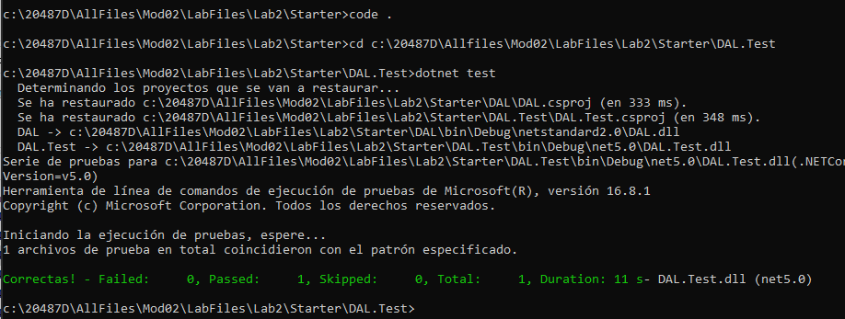

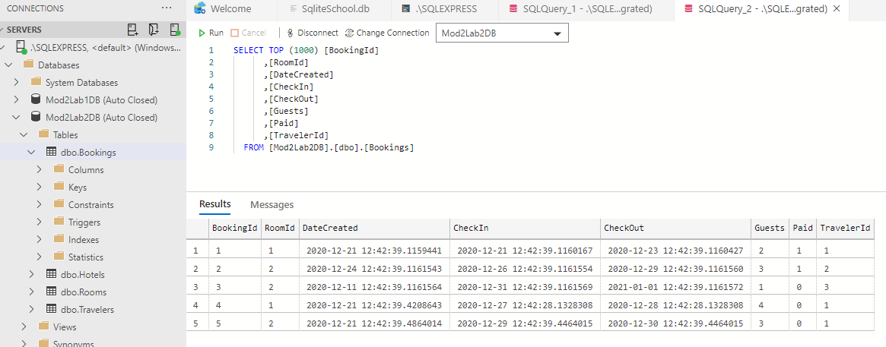

#### Task 3: Replace the SQL Server provider with SQLite

