20487D_MOD03_DEMO

# Lesson 2: Creating an ASP.NET Core Web API

### Demonstration: Creating Your First ASP.NET Core Web API

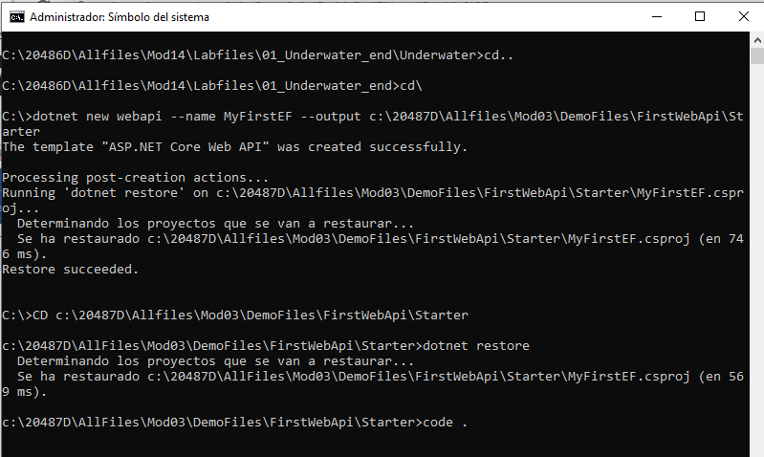

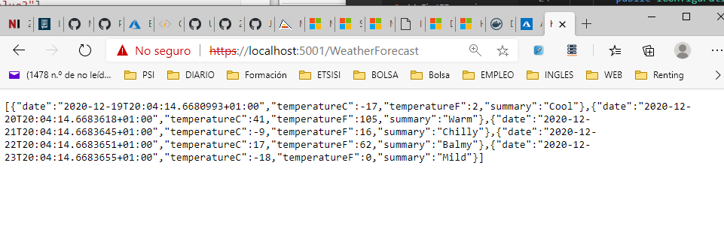

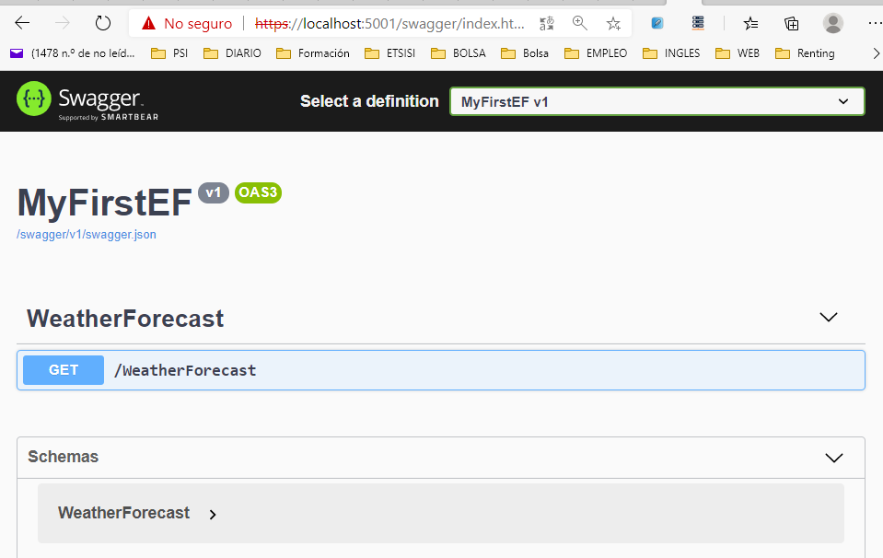

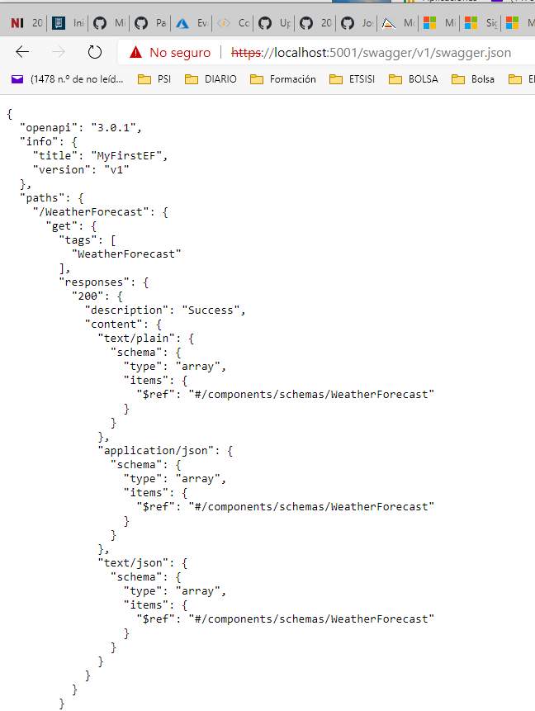

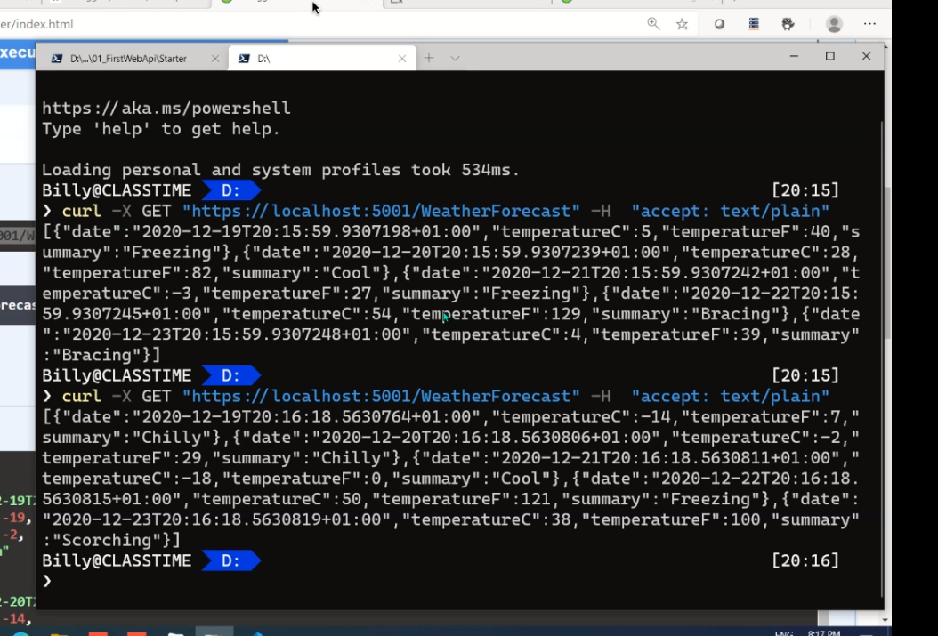

# Lesson 3: Consuming ASP.NET Core Web APIs**

### **Demonstration: Consuming Services by Using JavaScript**

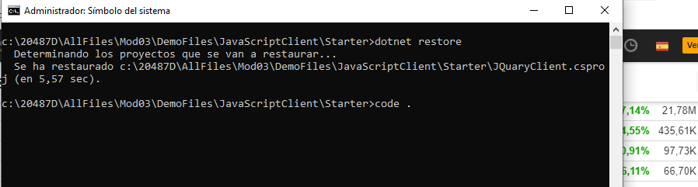

El resultado:

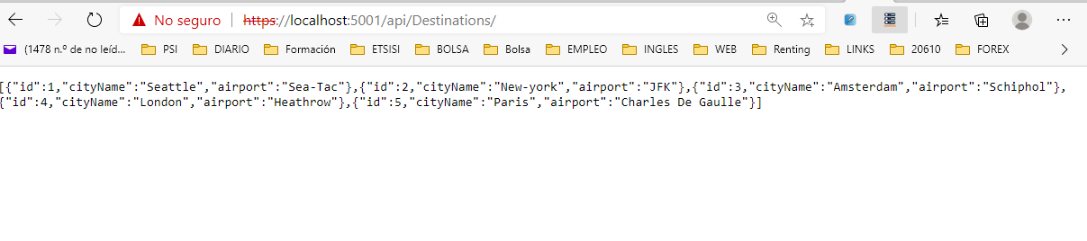

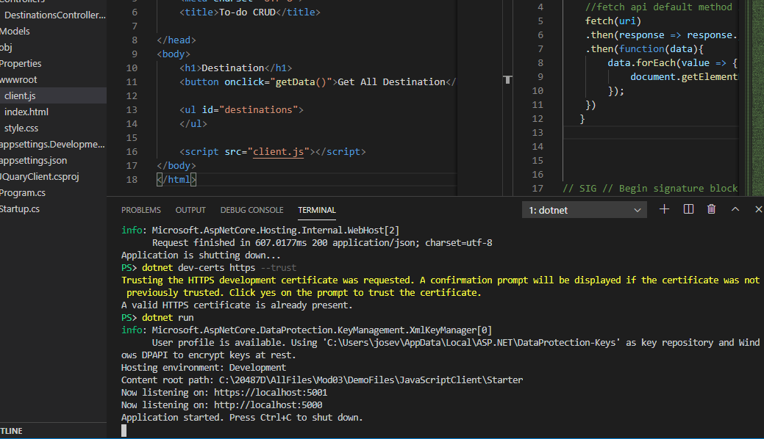

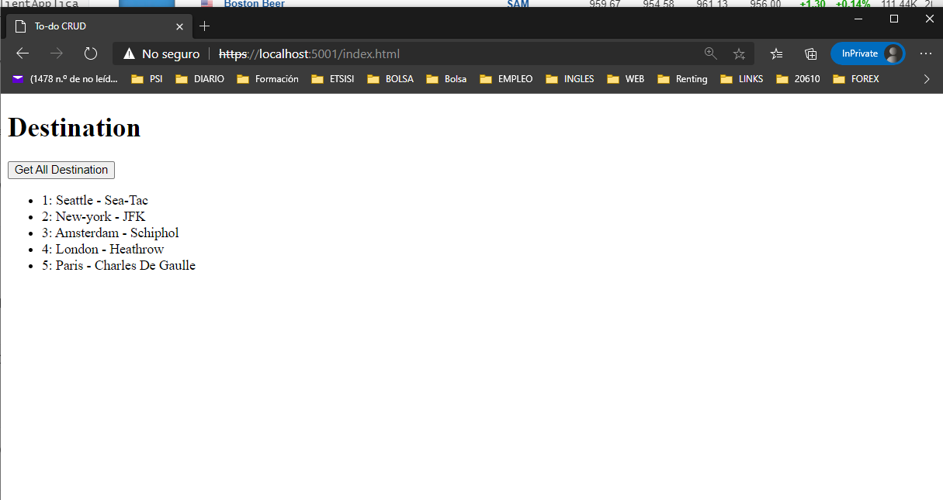

**Demonstration: Consuming Services by Using HttpClient**

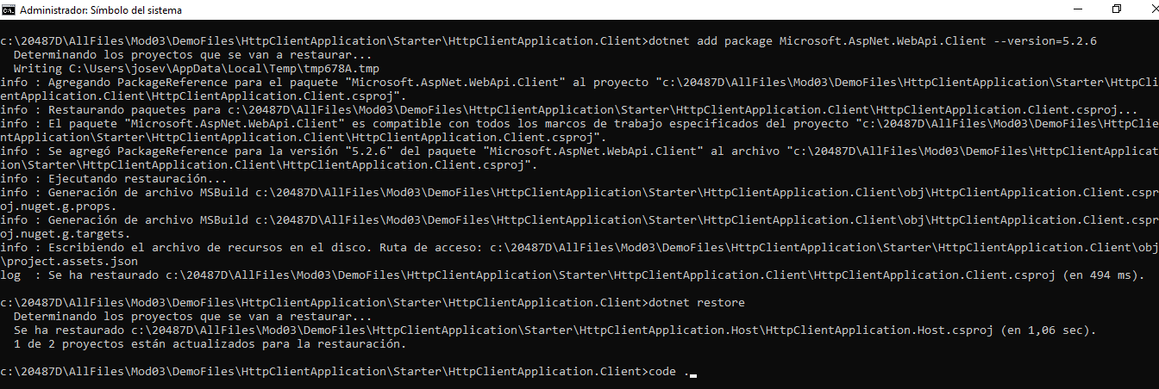

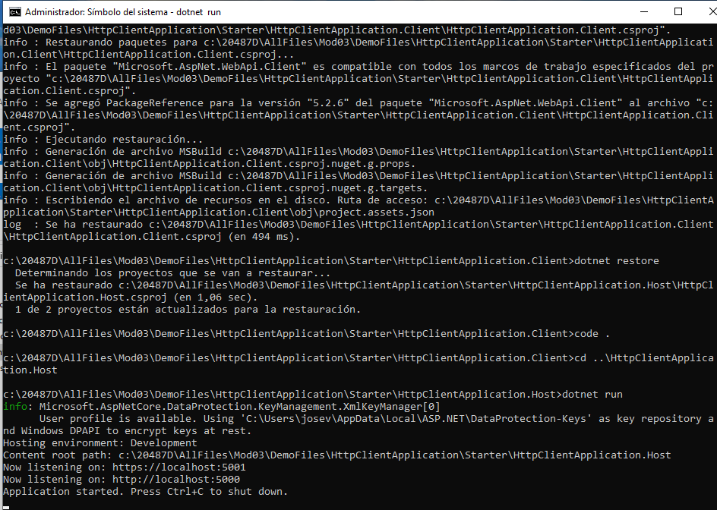

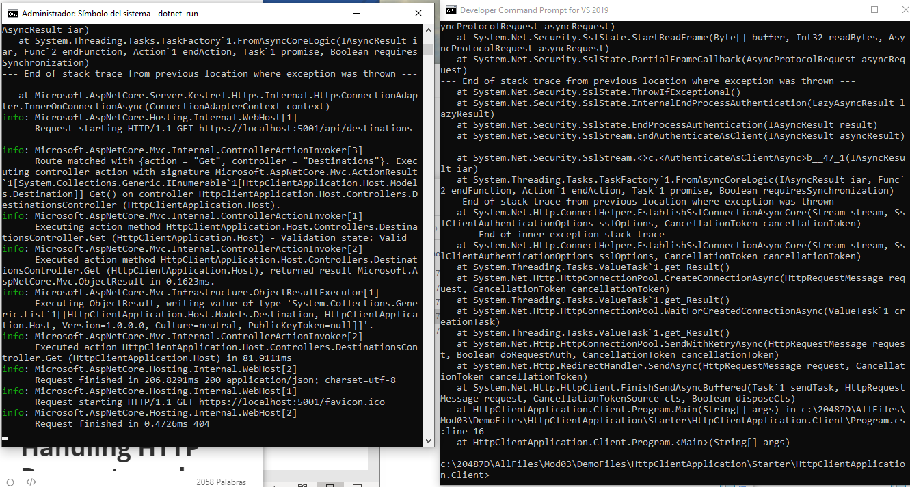

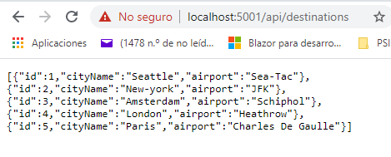

**# Lesson 4: Handling HTTP Requests and Responses**

**### Demonstration: Throwing Exceptions**

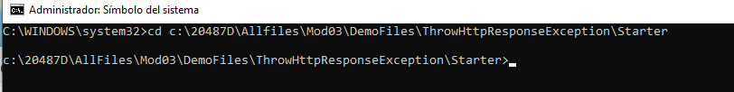

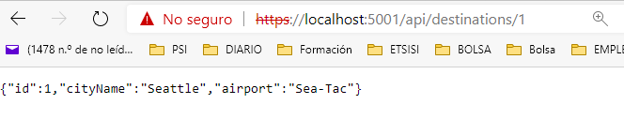

Induciendo error al poner Id 0:

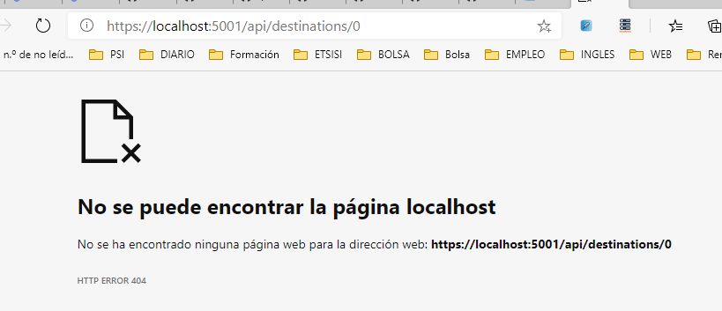

**# Lesson 5: Automatically Generating HTTP Requests and Responses**

**### Demonstration: Testing HTTP requests with Swagger**

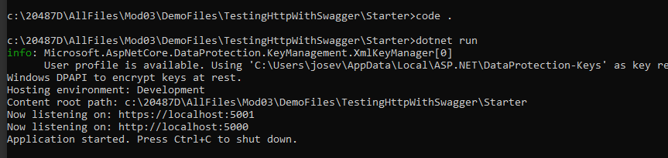

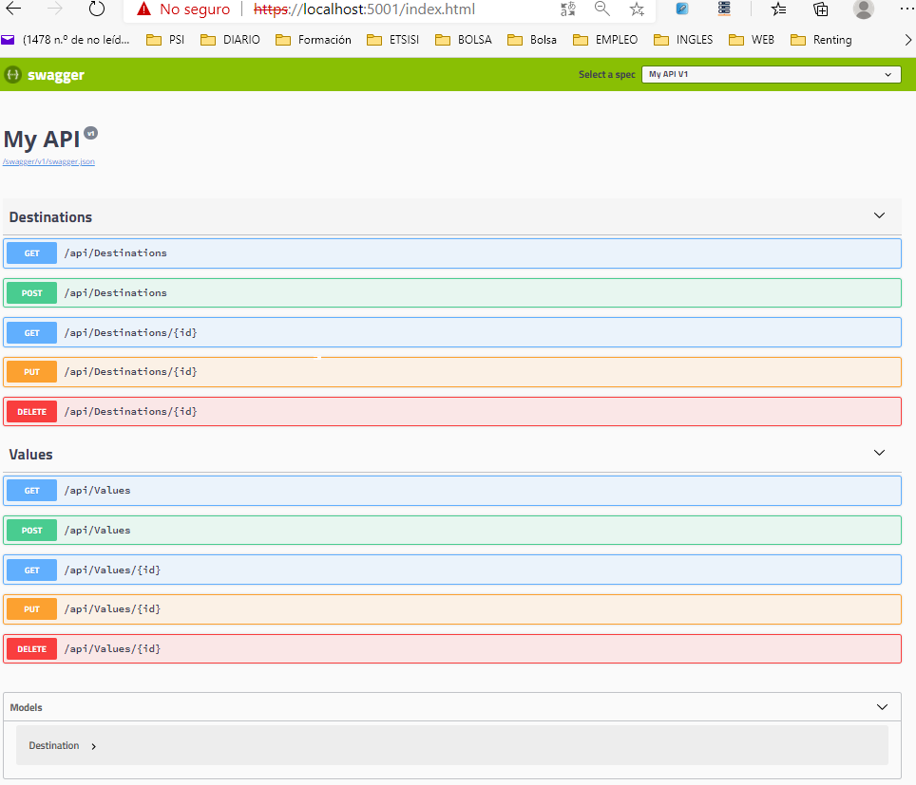

**Demonstration: Generating C# HTTP Clients by Using AutoRest**

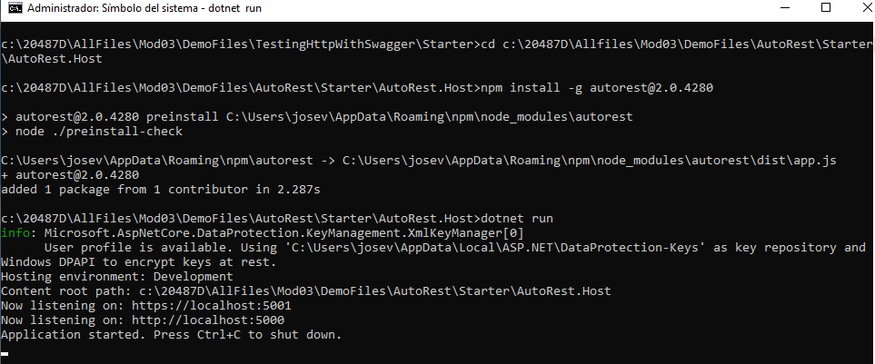

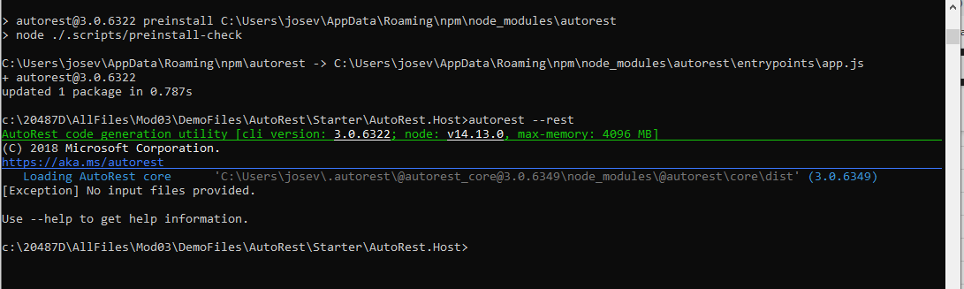

Instalamos la última versión de autorest y le damos autorest --rest

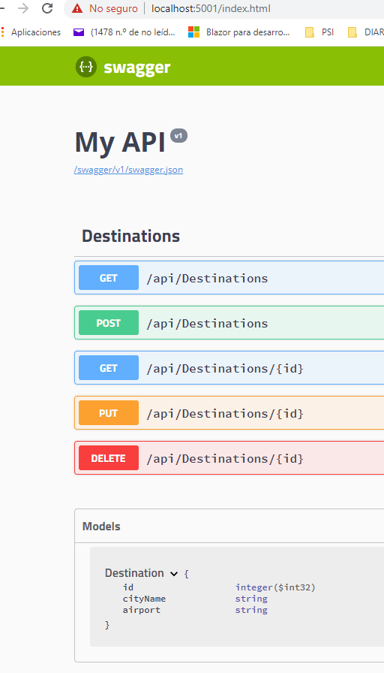

**A**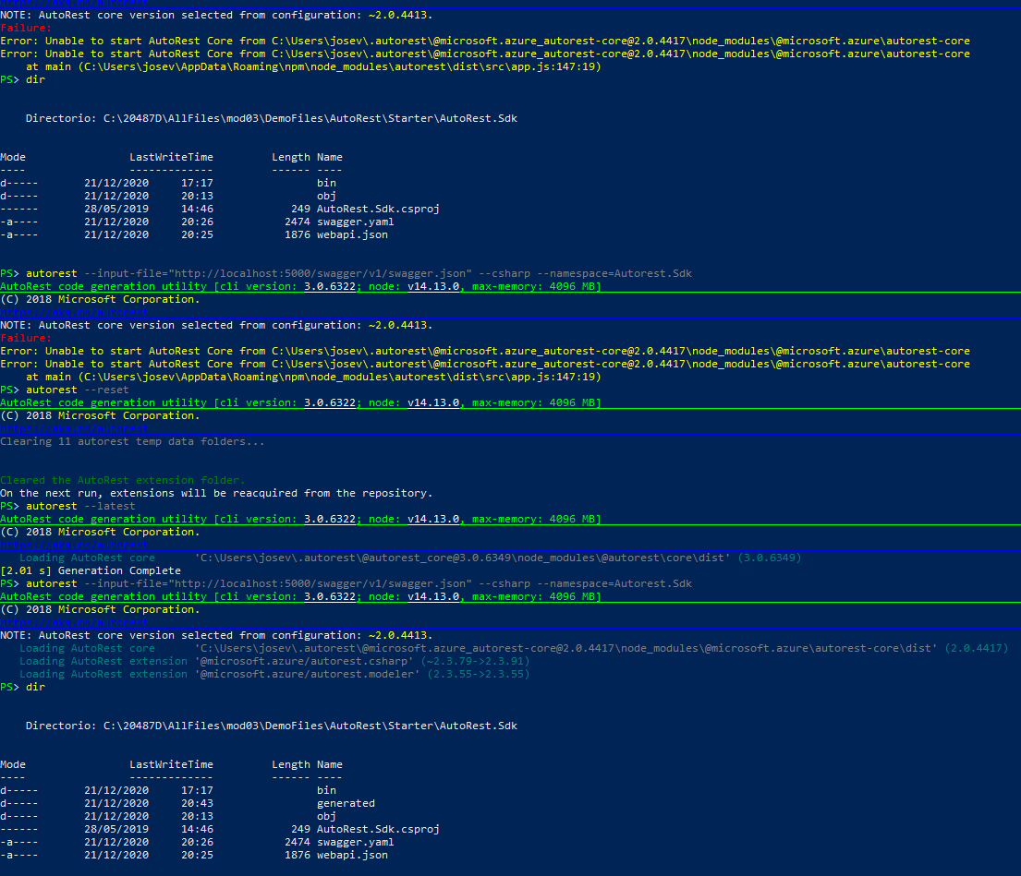

A partir del fichero json:

<https://localhost:5001/swagger/v1/swagger.json>

Se obtiene el .jaml o directamente:

Alternativa al yaml

autorest -Input http://localhost:5000/swagger/v1/swagger.json -CodeGenerator CSharp -Namespace AutoRest.Sdk

o con yaml:

autorest --input-file="http://localhost:5000/swagger/v1/swagger.json" --csharp --output --namespace=Autorest.sdk

Finalmente se obtiene generated.

