20487_MOD05_DEMO

**Module 5: Hosting Services On-Premises and in Azure**

**Lesson 1: Hosting Services On-Premises**

**Demonstration: Hosting Services On-Premises by using Windows Services with Kestrel (RunAsService)**

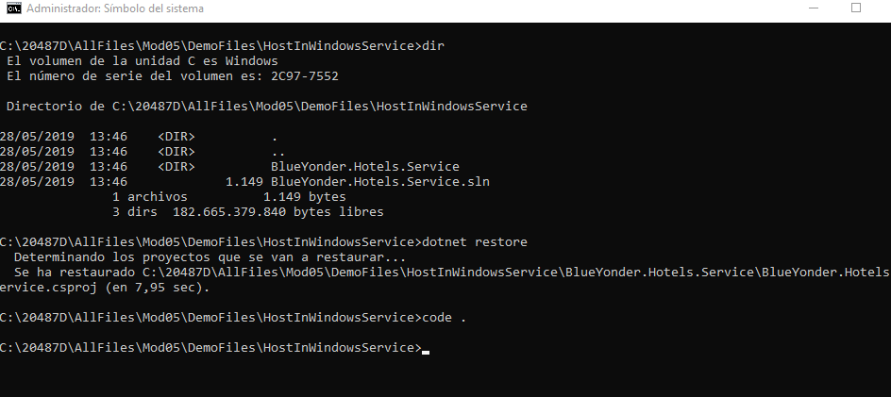

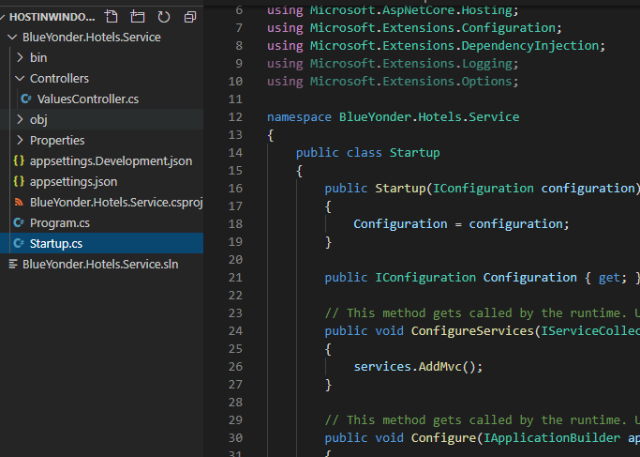

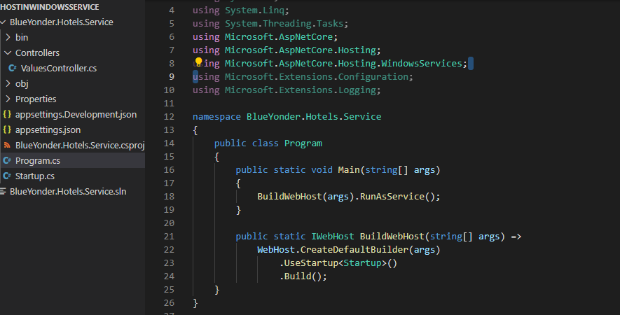

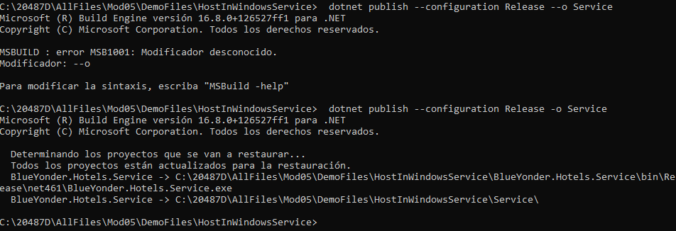

Creamos el servicio:

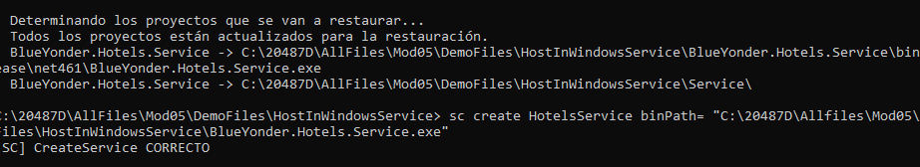

Lo arrancamos:

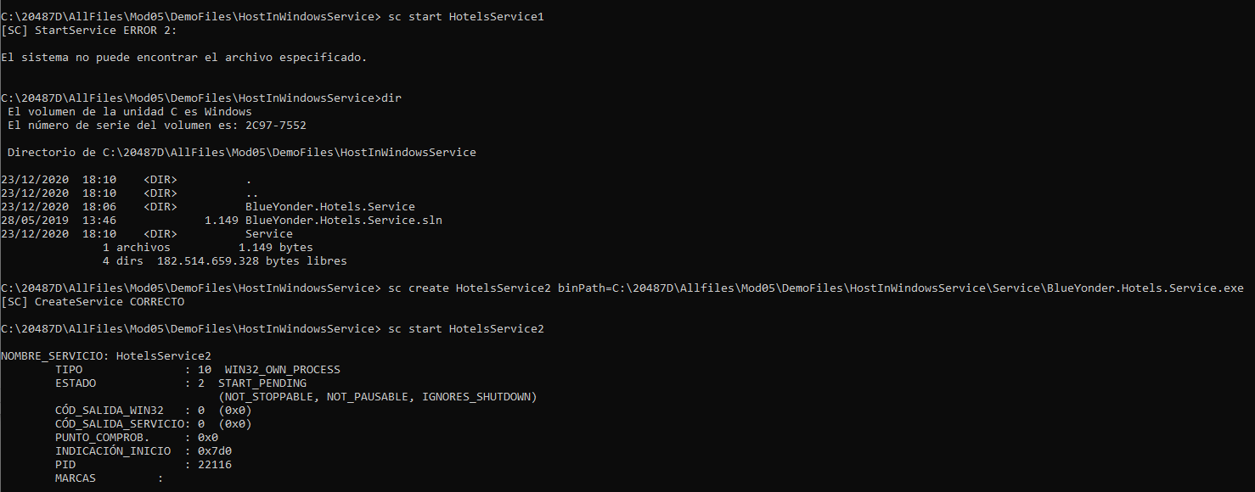

Comprobamos que funciona el servicio:

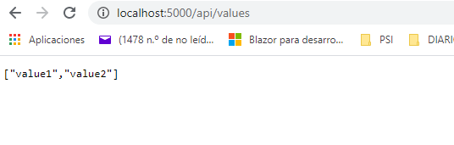

Paramos el servicio:

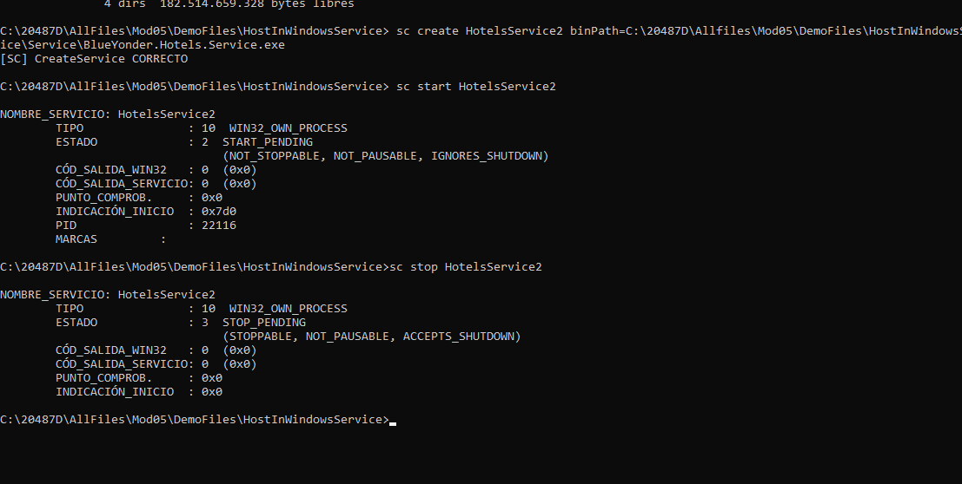

Los borramos:

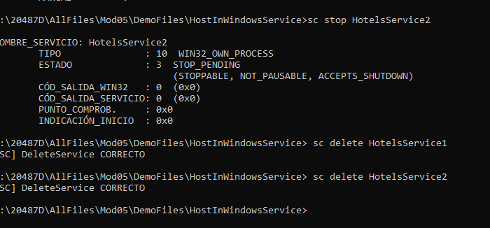

### Demonstration: Hosting ASP.NET Core Services in IIS

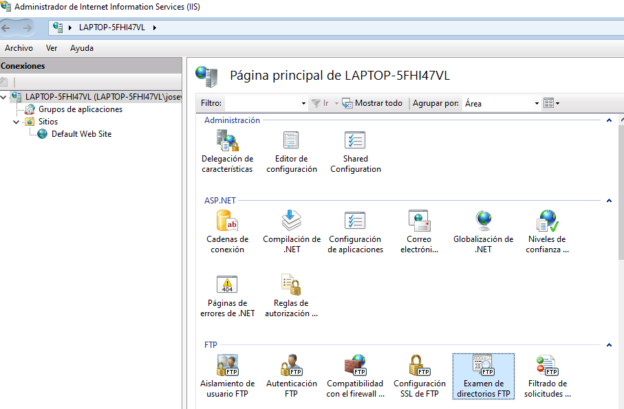

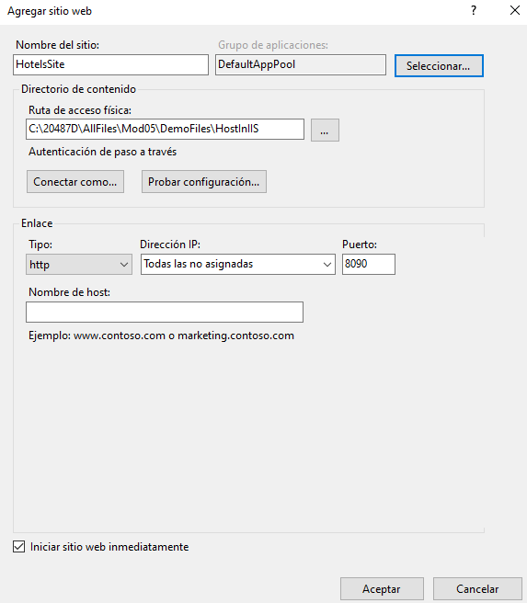

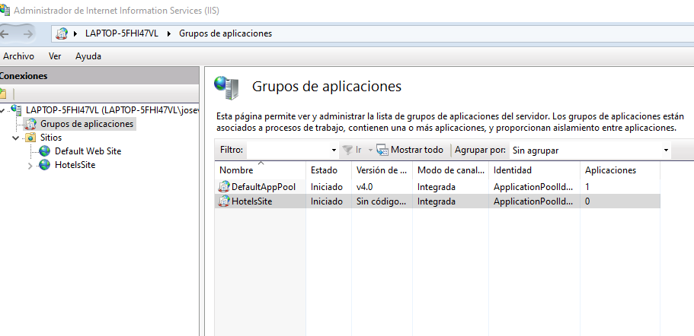

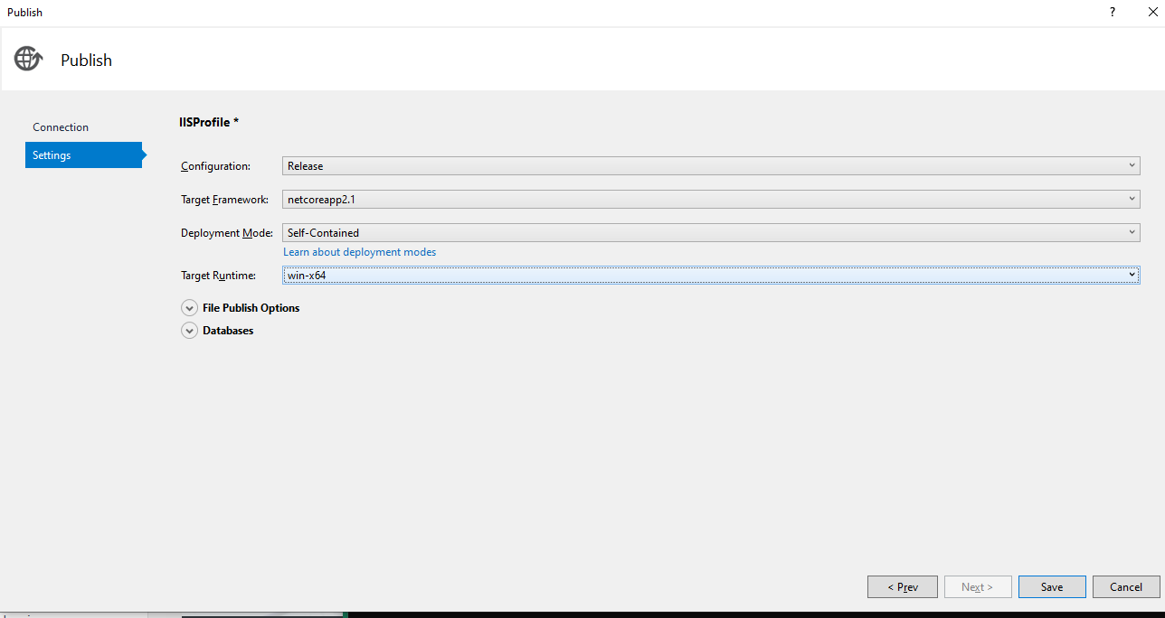

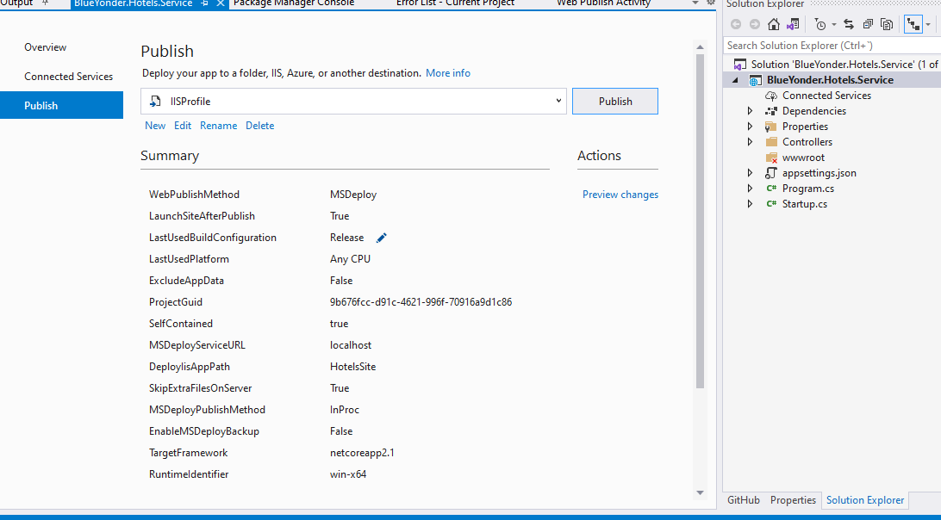

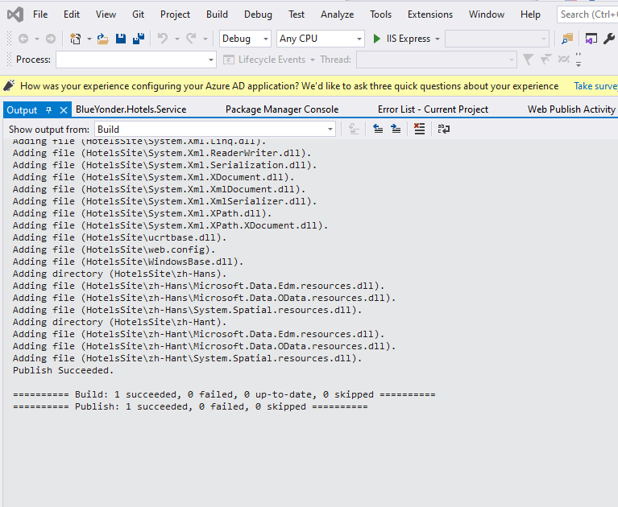

Pulsamos en “Examinar sitio web”

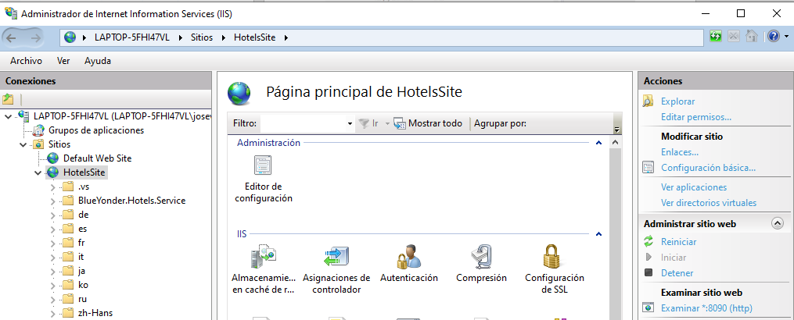

Añadimos ruta:

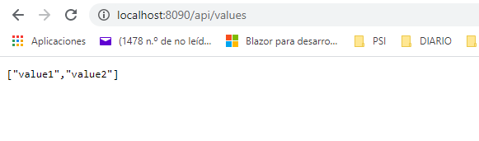

# Lesson 2: Hosting Services in Web Apps Feature of Azure App Service

### Demonstration: Hosting ASP.NET Core Web APIs in Web Apps

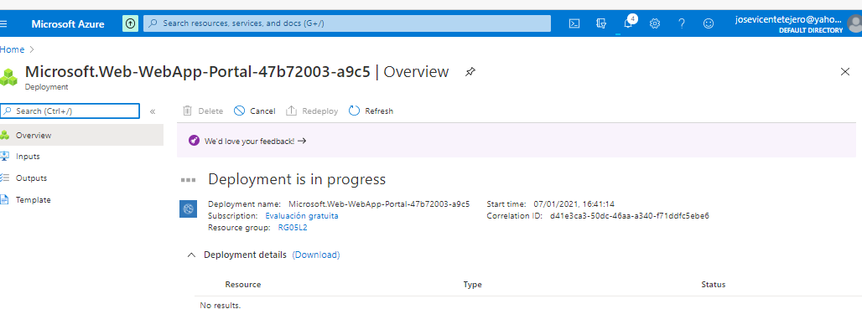

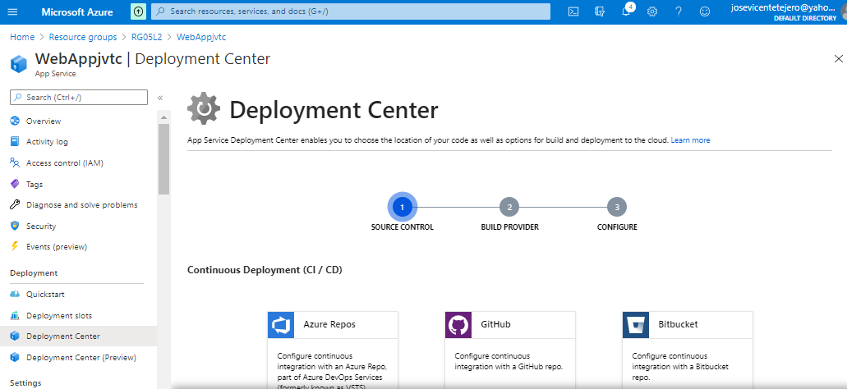

FTPMod1LabJVTC

Password55_?

Hay que tomar datos de la pestaña App Credentials.

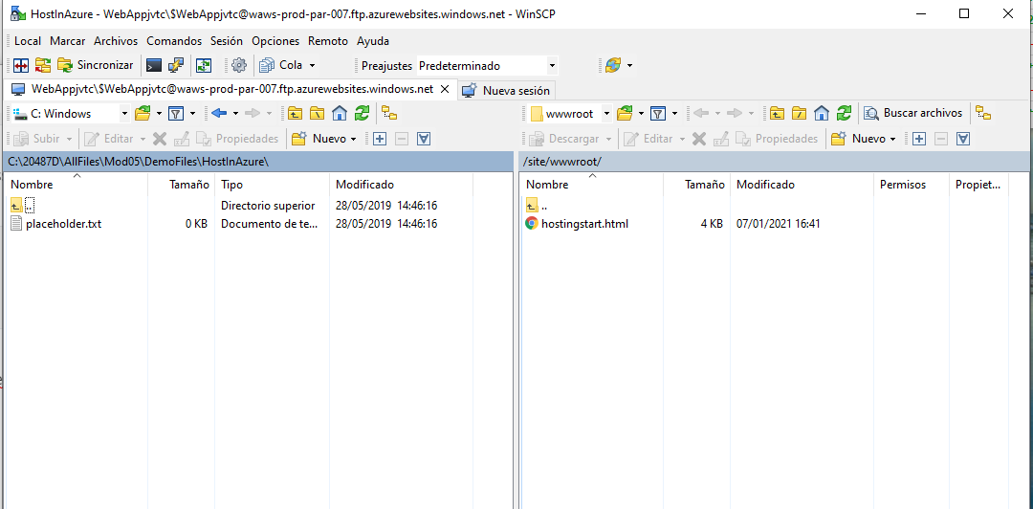

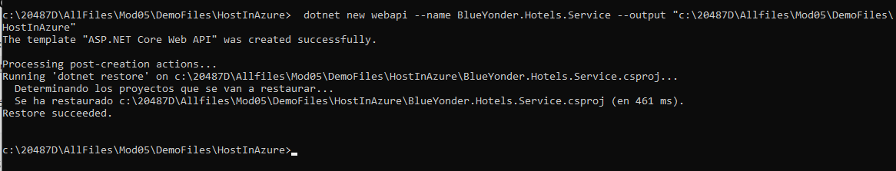

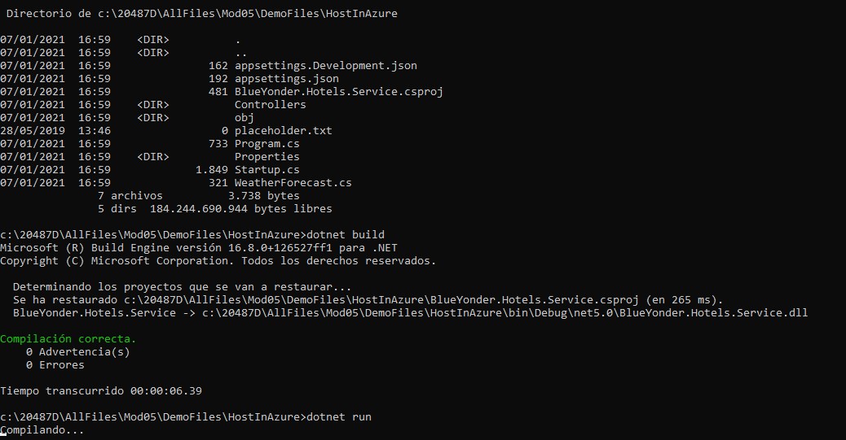

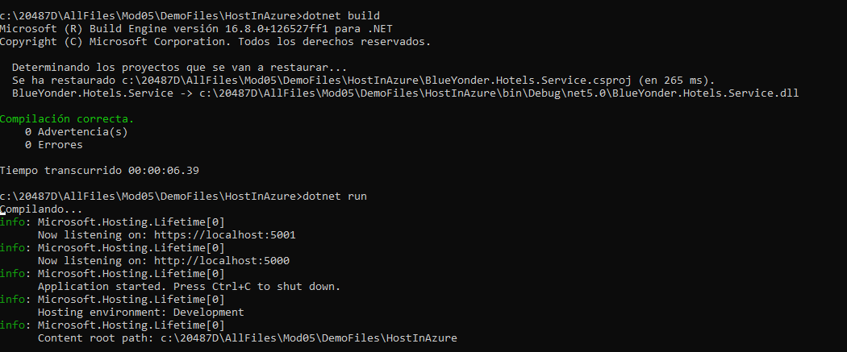

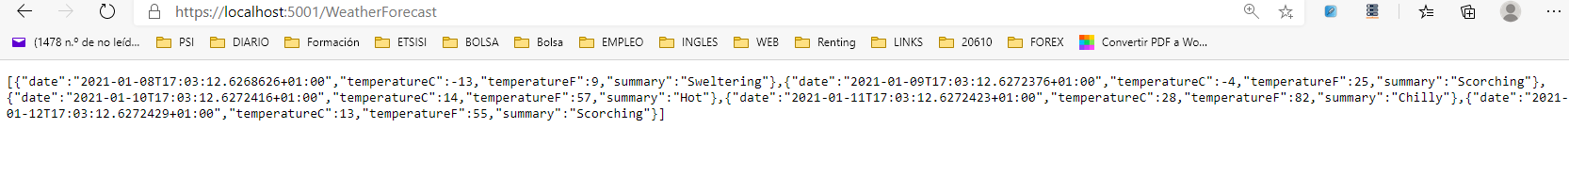

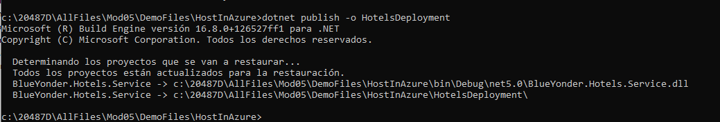

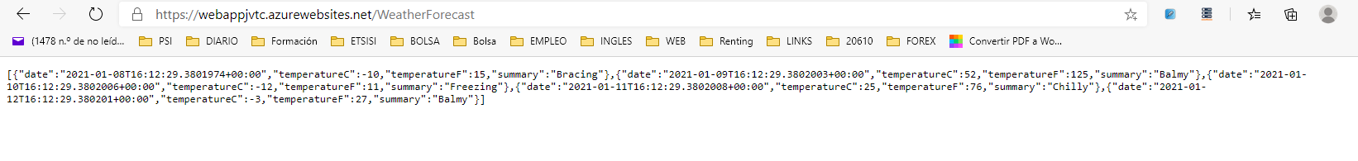

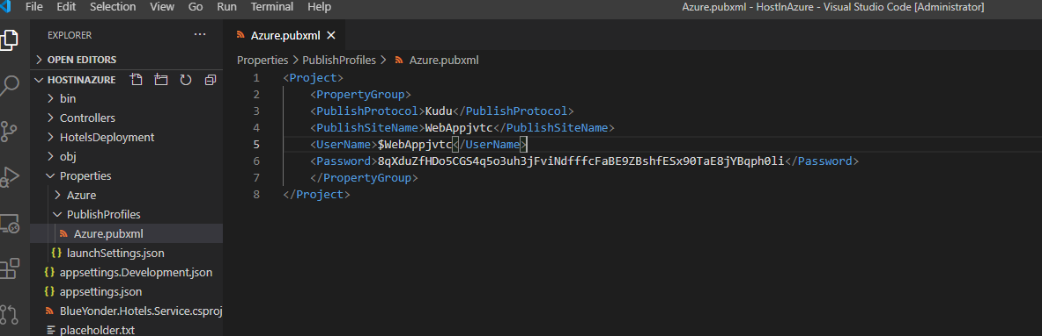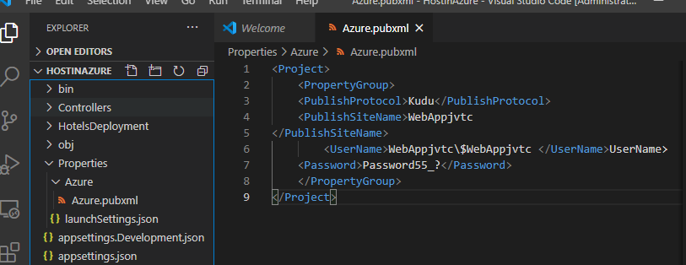

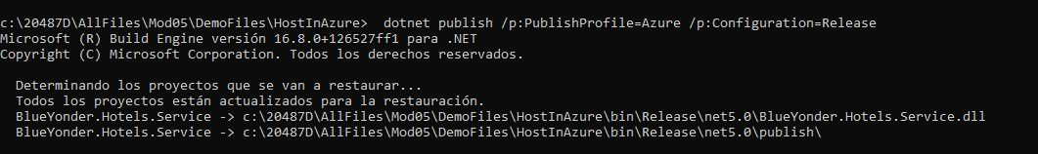

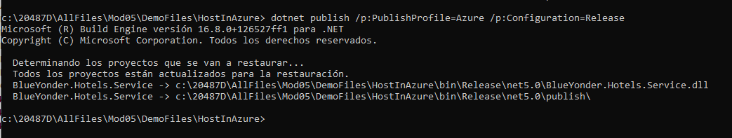

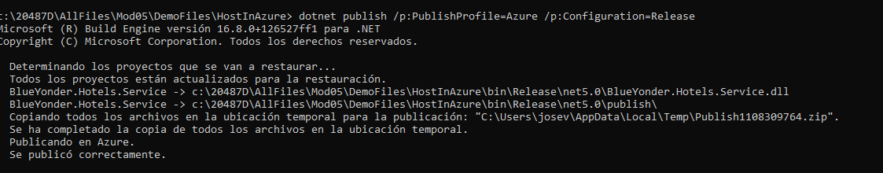

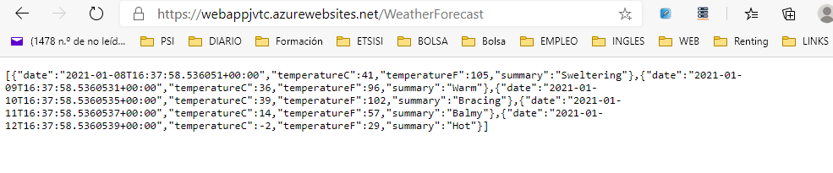

# Lesson 3: Packaging Services in Containers

### Demonstration: Creating an empty ASP.NET Core Docker container

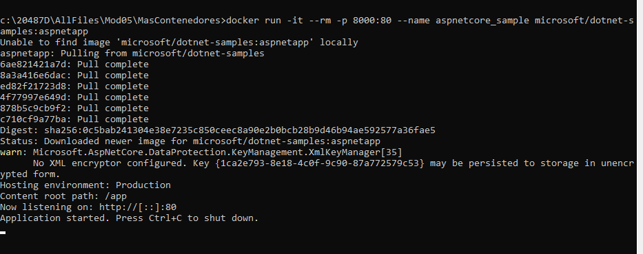

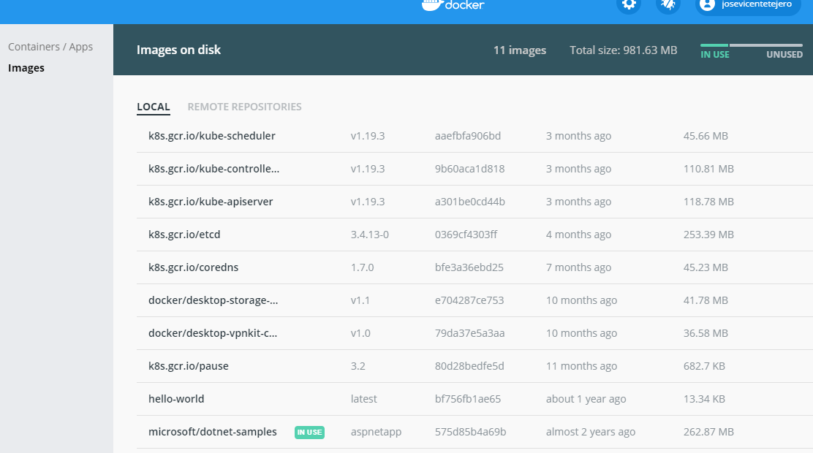

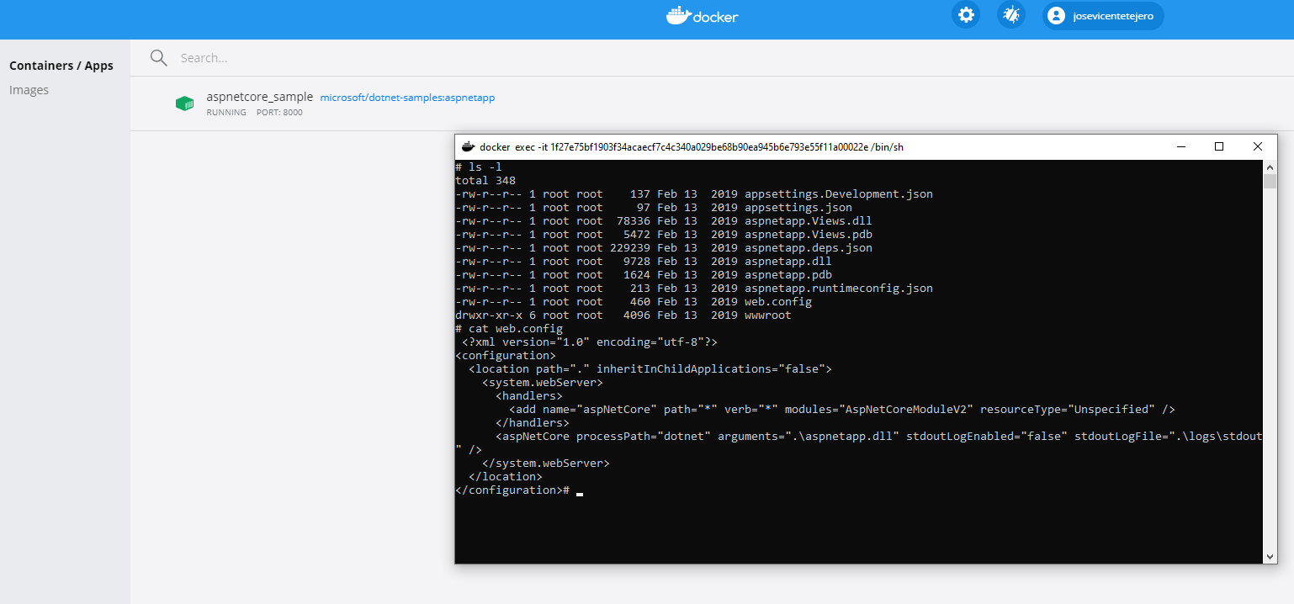

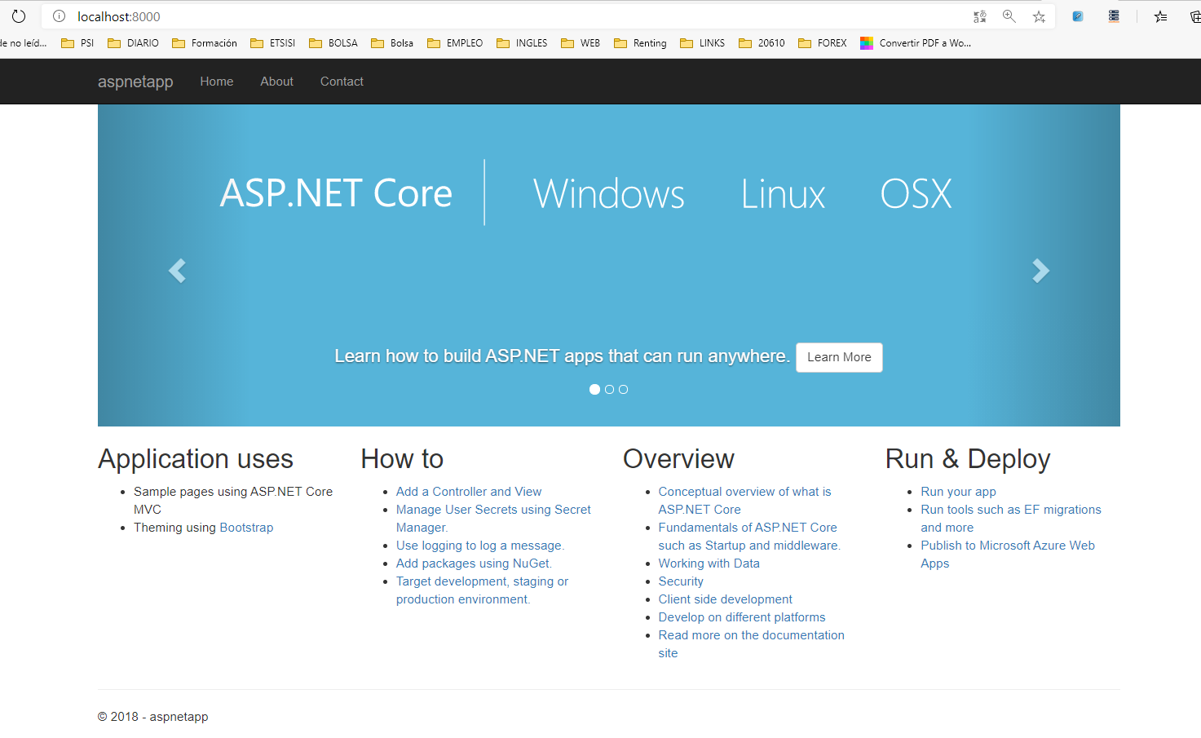

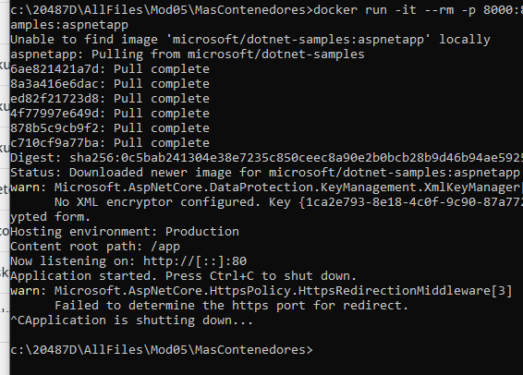

### Demonstration: Publishing into a Container

### 

### 

### docker build -t hotels_services -f .\Host_In_Docker\Dockerfile .

### Para ejecutar el fichero dockerfile creado en Visual code

### 

### Es la imagen creada:

### 

### 

### 

### 

### 

### 

### 

### 

### El resultado_

### 

### # Lesson 4: Implementing Serverless Services

### ### Demonstration: HTTP-triggered Azure Function

### 

### 

### 

### 

### 

### 

### 

### Demonstration: Developing, Testing, and Publishing an Azure Function from CLI

### 

### 

### 

### 

### 

### 

### 

### 

### 

### 