Module 8: Monitoring and Diagnostics

# Lesson 1: Logging in ASP.NET Core

### Demonstration: Recording logs to the Console and EventSource providers

#### Demonstration Steps

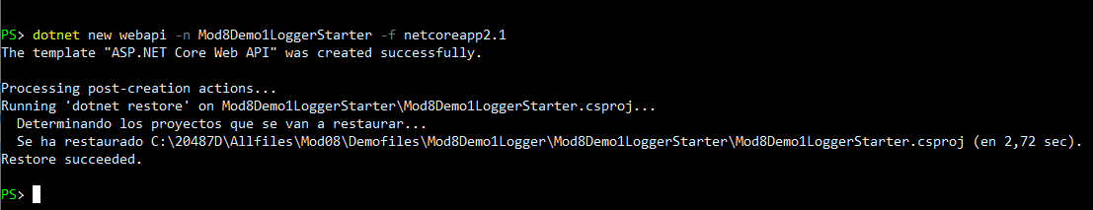

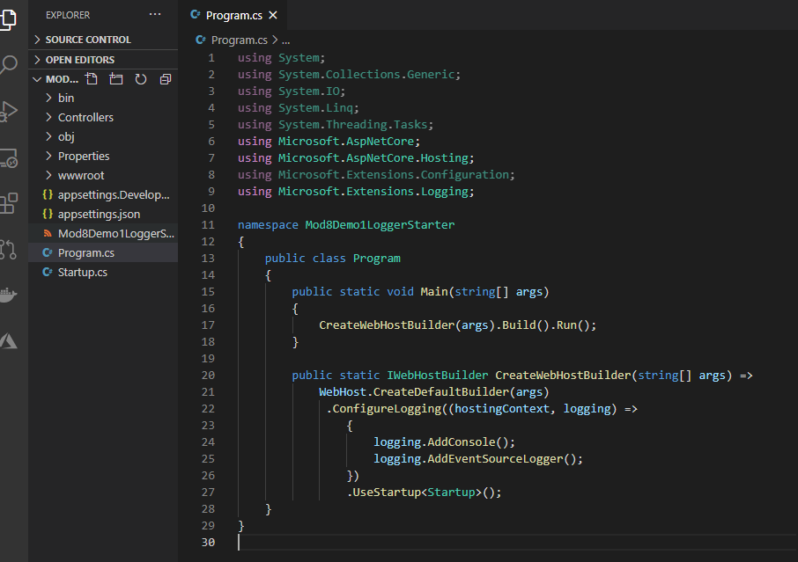

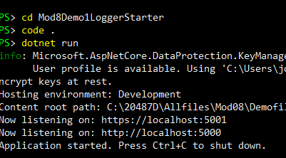

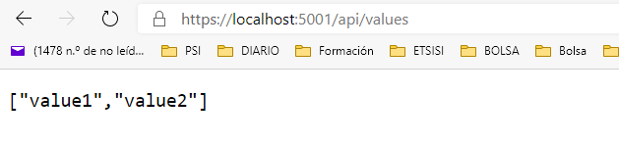

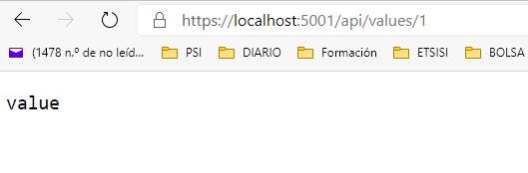

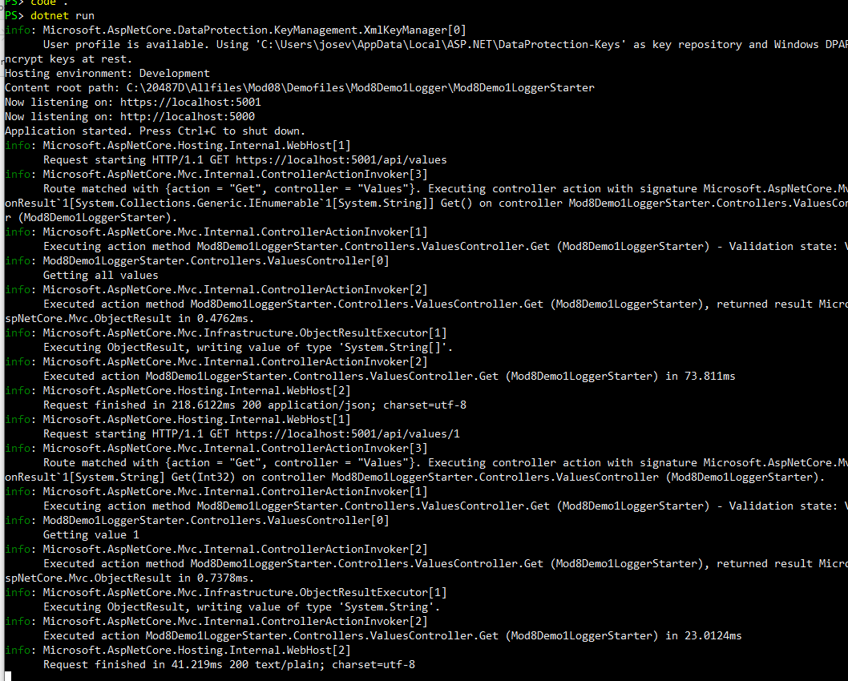

**Demonstration: Using Serilog**

**Demonstration Steps**