Notes_Chapter1

Exercises 1.4:

1. N-Tier Architecture:

User <----> Client <----> Middleware <----> Database
^------> Search API
Client: Web browser
Middleware: Django application
Database: SQLite3 Database engine
Search API: Search API

2. Wireframes:
<copied from ebook>

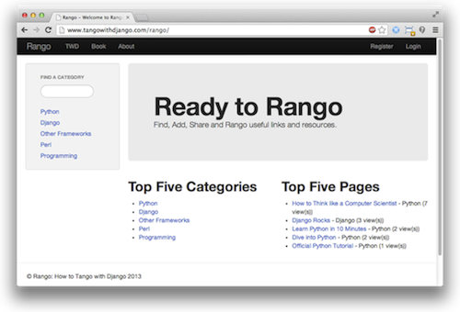
The index page with a categories search bar on the left, also showing the top five pages and top five categories.
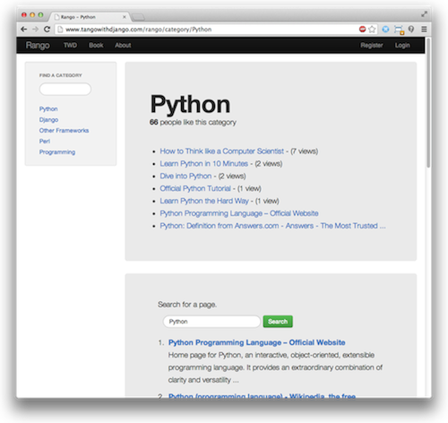
The category page showing the pages in the category (along with the number of views). Below, a search for Python has been conducted, with the results shown underneath.

3.URL Mapping:

/rango : main page
/rango/about : about page
/rango/category/<category_name>/ : category page (each category has its page/pages)

4. E-R Diagram:

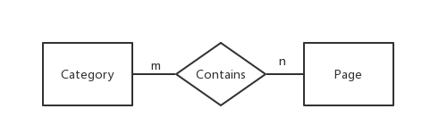

It is a m:n relationship
Category model:

Field Type
name CharField
views IntegerField
Likes IntegerField

Page Model:

Field Type
category ForeignKey
title CharField
url URLField
views INtegerField

