YEEAP | AI PROJECT IMPLEMENTATION
REAL ESTATE HOUSE
SALE PRICE PREDICTION
Using Machine Learning Regression
GROUP PROJECT IMPLEMENTATION REPORT
Group 23 | YEEAP AI Project Implementation
Google Colab • Ames Housing Dataset • Regression

October 23, 2026
Scope notice: this prototype estimates historical Ames, Iowa sale prices in USD. It is not a professional appraisal and is not validated for other geographic markets.

Executive summary
This project implements the Group 23 Module 4 proposal as a beginner-friendly Google Colab notebook. It covers data preparation, exploratory data analysis, a Linear Regression baseline, comparison with Random Forest and Gradient Boosting, regression evaluation, residual review, model saving, and end-to-end testing.
The uploaded CSV contains 2,930 rows and 82 columns. After excluding the target SalePrice and two identifier fields (Order and PID), 79 predictors remain. Random Forest produced the best validation performance: RMSE $20,124.77, MAE $14,347.72, and R² 0.9255. On a separate held-out test set of 586 records, it achieved RMSE $26,285.70, MAE $15,516.53, and R² 0.9138.
Important currency note: the Ames dataset records SalePrice in U.S. dollars (USD) [2]. The example in the proposal that refers to birr should not be applied to this particular dataset. The prototype is for historical Ames data and is not validated for Ethiopia or another market.

1. Refine the problem
Problem statement: estimate the expected sale price of a residential property from recorded characteristics such as neighborhood, overall quality, living area, lot size, year built, rooms, basement, and garage details. Manual valuation can be time-consuming and may not consistently capture relationships among many features.
Target users include real estate agents, sellers, buyers, property companies, investors, and teams conducting preliminary property-related analysis. The output is a numeric estimate in USD. The intended use is decision support, comparison, and discussion, not a guaranteed price or a legal valuation.

2. Define the AI solution
- Task type: supervised regression, because SalePrice is a continuous numeric target.
- Baseline: Linear Regression, used as an interpretable benchmark.
- Alternatives: Random Forest Regressor and Gradient Boosting Regressor, which can capture nonlinear relationships and interactions.
- Selection: lowest validation RMSE, with a separate held-out test set reserved for final evaluation.
Implementation uses Python, pandas, NumPy, Matplotlib, scikit-learn, and joblib. The complete notebook includes explanatory markdown and runnable code.

3. Prepare the data
Data item | Observed value
Dataset file | ames-housing.csv
Rows / original columns | 2,930 / 82
Target / missing target values | SalePrice / 0
Exact duplicate rows | 0
Predictors after identifier exclusion | 79
Numeric / categorical predictors | 36 / 43
Training pool / held-out test rows | 2,344 / 586

Order and PID are excluded because they are identifiers rather than regular property characteristics. The train/test split uses random_state=42; the training pool is further split into training and validation subsets, approximately 64% / 16% / 20% overall.

Data quality and preprocessing
Missing values are common in optional fields. Examples include Pool.QC (2,917 missing), Misc.Feature (2,824), Alley (2,732), Fence (2,358), Mas.Vnr.Type (1,775), and Fireplace.Qu (1,422). Numeric missing values are imputed with the training median; categorical missing values are filled with a Missing label. Categorical values are one-hot encoded with handle_unknown="ignore", and numeric features are standardized. All preprocessing is inside the fitted model pipeline to reduce data leakage.
Extreme prices are not automatically removed because some may represent genuine high-value properties; their prediction errors are reviewed instead.

4. Explore the data
SalePrice has mean $180,796.06, median $160,000, minimum $12,789, maximum $755,000, and skewness about 1.74. The right tail means a smaller number of expensive houses may contribute disproportionately to RMSE. Numeric correlations show association, not causation, and do not capture every categorical or nonlinear relationship.
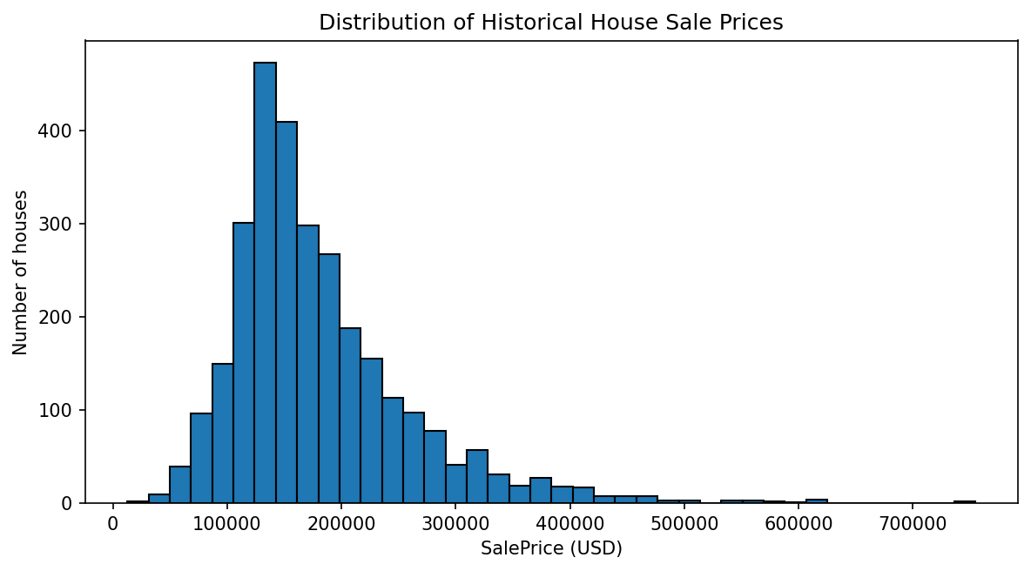 | 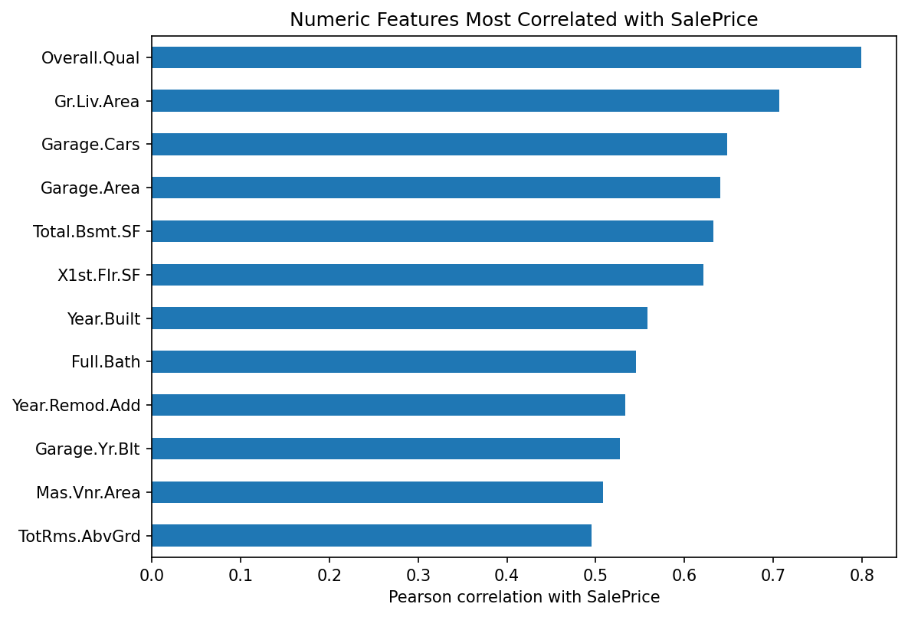
Figure 1. SalePrice distribution (left) and numeric features most correlated with SalePrice (right), generated from the supplied CSV.
The strongest numeric associations with sale price are Overall.Qual (r = 0.7993), Gr.Liv.Area (0.7068), Garage.Cars (0.6479), Garage.Area (0.6404), Total.Bsmt.SF (0.6323), and X1st.Flr.SF (0.6217). These correlations are descriptive associations, not causal effects.

5. Build a baseline model
Linear Regression was trained first to provide a reference point. On the validation subset, it achieved RMSE $20,862.58, MAE $15,485.94, and R² 0.9200.

6. Improve and compare models
Random Forest and Gradient Boosting were compared with the same validation subset. A dedicated validation set was used for model choice; the test data was not used to select the model.
Model | Validation RMSE (USD) | Validation MAE (USD) | Validation R²
Random Forest | $20,124.77 | $14,347.72 | 0.9255
Linear Regression | $20,862.58 | $15,485.94 | 0.9200
Gradient Boosting | $20,971.00 | $15,241.81 | 0.9192

Random Forest was selected because it had the lowest validation RMSE. Compared with the Linear Regression baseline, its validation RMSE was approximately 3.5% lower and its validation MAE approximately 7.3% lower. This is an observed improvement on this split; it does not prove the selected algorithm will always perform best.

7. Final held-out evaluation
Random Forest was refitted on the entire 80% training pool and evaluated once on the separate 20% test set of 586 properties.
Test metric | Measured result | Interpretation
RMSE | $26,285.70 | Penalizes large errors more strongly; error scale is tens of thousands of USD.
MAE | $15,516.53 | Average absolute difference between predictions and actual sale prices.
R² | 0.9138 | About 91.4% of test-set price variation explained relative to a mean-only reference.

The test RMSE is higher than the validation RMSE, showing that performance depends on the sampled records. These metrics support a course prototype but do not guarantee an accurate estimate for an individual property.

Error analysis
The notebook plots actual versus predicted prices and residuals (prediction minus actual). Points far from the diagonal line or residuals far from zero identify errors that merit review. In a follow-up iteration, errors should be compared across price bands and neighborhoods, with special attention to expensive and unusual properties.
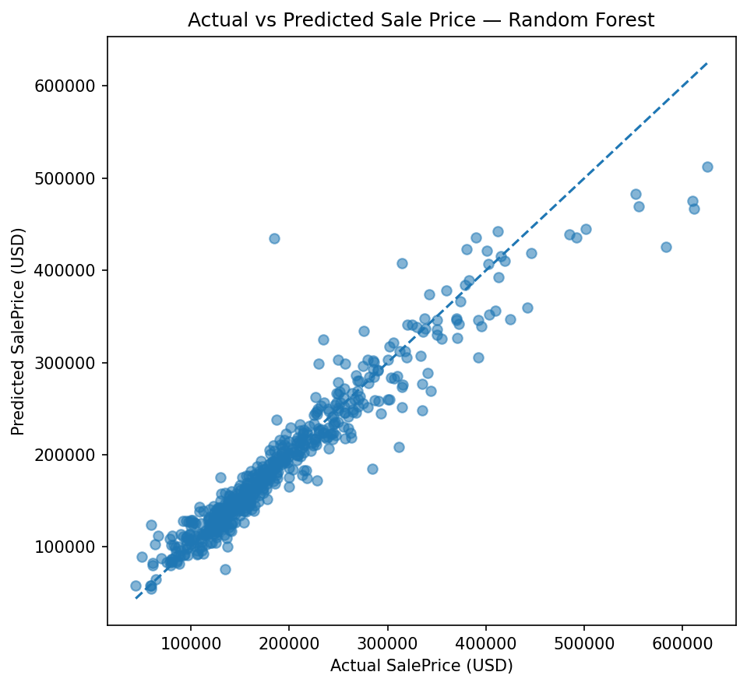 | 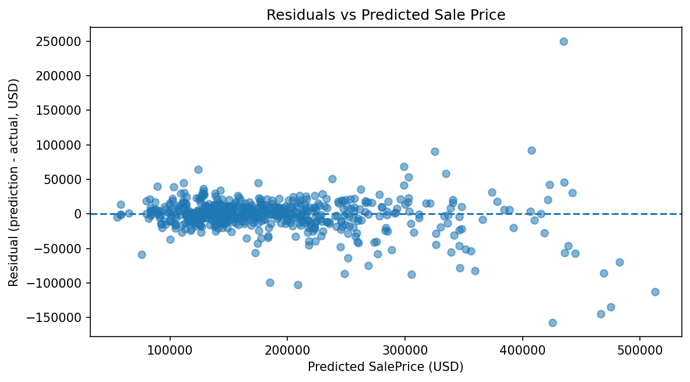
Figure 2. Actual-versus-predicted sale prices (left) and residuals versus predicted sale price (right) for the held-out test set.

8. Test the complete solution
The notebook provides a predict_house_price() function. It validates feature names, rejects negative values for selected non-negative measurements, treats omitted features as missing, and applies the same preprocessing/model pipeline used in training.
Test case | Expected behavior | Result
Complete held-out property | Return a finite positive estimate | PASS
Partial property details | Impute omitted fields; return estimate | PASS
Unseen neighborhood category | Do not crash on unseen category | PASS
Negative lot area | Reject invalid negative measurement | PASS

The sample partial-input case (NAmes neighborhood, 1,500 sq ft living area, 8,000 sq ft lot, quality 6, year built 1990, three bedrooms, two full bathrooms, and a two-car garage) produced approximately $171,625 USD. This is only a model-generated example, not a market quotation.
The notebook saves the full pipeline and metadata to ames_housing_model.joblib and exports validation metrics, test predictions, workflow test results, JSON summaries, and charts into project_outputs/.

9. Limitations and responsible use
- Geographic representativeness: the dataset describes Ames, Iowa. Results are not validated for Ethiopia or another market.
- Historical transactions: current property markets may differ from the years represented in the data.
- Individual prediction uncertainty: a strong aggregate R² does not guarantee an accurate estimate for a specific home.
- Missing data: imputation is practical but may hide differences in data collection or the meaning of missing values.
- Evaluation scope: one fixed split is suitable for a prototype; repeated cross-validation and external validation are recommended.
- Fairness and transparency: review errors by neighborhood and property group, explain the estimate, and maintain human review.
- Currency and appraisal: keep predictions labeled USD when using this dataset. Currency conversion alone would not make this model suitable for Ethiopia. Do not present output as a guaranteed price, legal appraisal, mortgage decision, or investment advice.

10. Conclusion and future work
The notebook completes the eight-stage assignment workflow and demonstrates prediction on complete, partial, and category-unseen inputs. Random Forest was the best of the three candidates on validation RMSE and obtained test R² 0.9138 on the supplied split. Further work should add cross-validation and hyperparameter tuning, compare error patterns across neighborhoods and price ranges, provide uncertainty estimates and feature explanations, and validate on current locally representative data before any real-world deployment.

Group members and contributions
The Module 4 proposal lists six original members and assigns technical roles using generic Member 1–5 labels. Addisu Melkie Tafere is included in the updated Module 6 group information for GitHub/deployment documentation. The mapping below is proposed and must be checked against actual participation; update it if needed and remove anyone who did not contribute. The proposal names the group leader as Dereje Zerfie, while the roster gives Dereje Zerfie Tadesse.
Member | Contribution / responsibility
Tamirat Aboye Demeke | Problem framing, target users, stakeholder needs, and project scope.
Behailu Feleke Tabor | CSV/schema review, data quality, missing values, and preprocessing.
Dereje Zerfie Tadesse (group leader listed as Dereje Zerfie) | Baseline and candidate regression models, validation metrics, evaluation, and coordination.
Bekele Molla | Prediction form, input validation, model integration, and demonstration workflow.
Yoseph Tesfaye Tafesse | Functional tests, invalid/unseen input checks, reproducibility, and setup instructions.
Beamlak Tessema | Report, charts, limitations, responsible-use review, and presentation support.
Addisu Melkie Tafere | GitHub repository organization, browser publishing instructions, and Streamlit deployment verification plan.

References
1. Group 23. Real Estate House Sale Price Prediction Using Machine Learning. YEEAP AI Project Proposal, Module 4, submitted September 30, 2026 (uploaded proposal PDF).
2. CMU Statistics & Data Science Data Repository. House prices in Ames, Iowa. https://cmustatistics.github.io/data-repository/money/ames-housing.html
3. Kaggle. House Prices: Advanced Regression Techniques. https://www.kaggle.com/competitions/house-prices-advanced-regression-techniques
4. Scikit-learn documentation. https://scikit-learn.org/stable/

