# Role of Central Banks in Managing Economic Stability

Josef Ďarmek

Prof. Fayyaz

Banking & Finance

07/11/2024

The central banks play an important role in the operation of economic stability through the management of interest rates and monetary policies, where they have to ensure that the financial market is very well regulated. Central bank actions have a lot of impact on commercial banks and the inflation targets, usually around 2%-3%.

Interest rates are strong tools that help manage the economy. Since interest rates go down, the cost of lending goes low, making it an encouragement for business investments and consumer spending. This is registered as economic growth.

In effect, when the economy is on an overdrive, raising interest rates increases borrowing costs, cools an overheating economy, and serves to regulate inflation. For instance, during the 2008 global financial crisis, the U.S. Federal Reserve and all central banks around the world lowered interest rates to almost zero levels with a view to stimulating economic activity; in doing so, they successfully averted deeper recessions. Central banks raised their interest rates to very high levels in the 1970s with a view to controlling the high level of inflation then, in an effort to stop the spending that was fueling the economic expansion and pumping up the inflation rate.

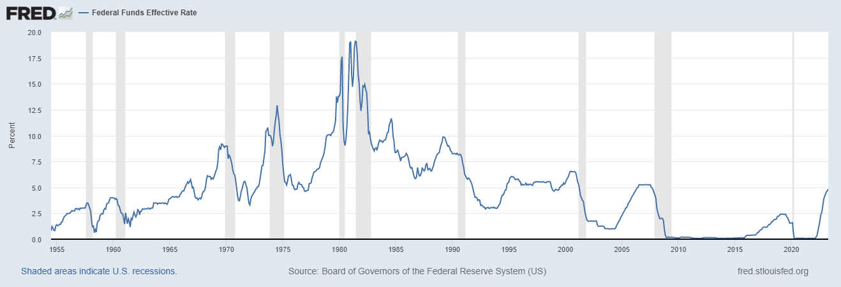

*Source: Fred*

Monetary policy can be defined as the act of controlling the money supply by the central bank in the economy to achieve certain macroeconomic goals, mainly to reduce inflation, create employment, and stabilize the economy. The major instruments include open market operations, discount rates, and reserve requirements. Open market operations are geared towards either buying or selling government securities for the purpose of influencing the quantity of money made available for lending. For instance, if securities are bought, more reserves will enter into the system. It encourages lending and investment. However, with the sale of securities, the opposite is achieved. The reserves are shuffled and removed to curb lending and spending.

The discount rate is the rate of interest to commercial banks, charged by central banks, and passed on to the clients. Moreover, the reserve requirement states the threshold of reserves that the bank should have at any point. In this regard, reserves control the ability of commercial banks to extend loans.

Quantitative easing is a modern monetary policy tool in the event of financial crises.

QE means that when traditional monetary policies are found to be ineffective, then central banks start buying long-term securities, often bonds, in order to get liquidity in the market. That will subsequently result in lowering interest rates and pushing up investments. The responsibility of ensuring overall stability and responsibility in terms of financial regulation and supervision should be with a central bank. Central banks are the policy rule makers and framers of guidelines to ensure safe operations of financial institutions. This most of the time secures the interests of consumers and public confidence in the financial system.

For example, since the post-financial crisis of 2007-08, the central banks and regulators have brought in the Basel III norms to enhance robustness in bank capital requirements and better risk management. Central banks, operating through their monetary policy and regulation, have significant control over commercial banks. Given that the benchmark interest rates are generally determined by central banks, these rates of lending and borrowing charged by commercial banks have an indirect influence on the terms of credit, consumer spending, and business investment. The prudential regulatory powers of central banks entail the responsibility of monitoring the commercial banks to run it in good and sound banking practice. Stress tests make the banks better able to withstand adverse economic environments and so properly can identify weaknesses as well as other vulnerabilities in order to ensure that the necessary levels of capital will be available.

Furthermore, central banks become the very last resort of lenders who provide liquidity to commercial banks at times of financial crises. This role could be seen in the 2008 financial crises when central banks across the globe created emergency funds to avert possible meltdown. Central banks therefore work to see to it that there is a stable level of inflation through the strategy of inflation targeting which gives implicit targets for desired inflation and executes the wanted levels of monetary policy. Still, the central banks are struggling with other factors in determining the desirable point with regard to controlling inflation, such as global commodity prices, exchange rate volatility, and geopolitical factors. However, the central banks target to control inflation within an appropriate range in order to maintain both economic stability and public purchasing power.

Take for example the European Central Bank's objective of maintaining "below but close to 2% over the medium term" of inflation. The ECB performs this through the use of multiple instruments, such as management of key interest rates, QE bond buying, and policy guidance.

In summary, central banks are very essential in controlling economies through strategic interest rate regulation, monetary policies, and enforcement. Regulating commercial banks ensures system stability and safety while managing inflation targets underlines the complexity of economic management.