Metronome

Contents

Feasibility study 1

Analysis 1

Stakeholders 1

Research 2

Essential features 2

Limitations 2

Design 2

Implementation 3

Testing 3

Installation 3

Evaluation 3

Maintenance 4

# Feasibility study

I would like to make a web based metronome. A metronome is a tool that plays notes at a certain number of beats per minute evenly spaced to help musicians keep time.

I know that this problem is solvable because the problem (working out how fast to make beepy sounds) can be solved in a finite number of steps. The main calculation is converting a BPM (e.g. 60 beats per minute) to the delay (in milliseconds) between each beep. This is computationally simple using a theoretical approach.

The budget is limited (£0) and we have 2 weeks to complete the project.

# Analysis

## Stakeholders

Joel is a 6 year old boy who’s just started drumming. He wants a simple to use metronome app that he can use on his android tablet to drum along to each day.

## Research

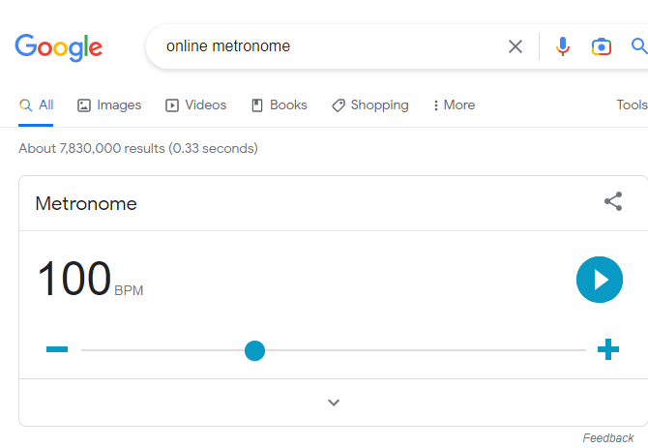

[https://www.google.com/search?q=online+metronome](https://www.google.com/search?q=online+metronome8&safe=active&ssui=on)

Google has a built in metronome. It’s free and really easy to use. It has a nice visual pulsing feature so you don’t need audio enabled. However, it doesn’t indicate how far through each measure you are like a traditional metronome.

## Essential features

My solution must allow you set the BPM and start / stop the beat. On each beat it should make an audible tick and give a visual indication in case someone can’t hear the tick.

The solution must work on any web enabled device with a clear, touchscreen friendly interface.

There should be limited text so it’s suitable for small children.

There should be buttons to allow you to increase or decrease the BPM by 5 without starting / stopping the beat.

It should be freely accessible online.

## Limitations

There is insufficient time to add additional features but these could be added later. My solution will not allow you to compare your playing to the beat to see how in time you are. There will be no feature to log in and track your progress. It would be great if there was a feature to change the BPM automatically over time but this is not essential as development time is limited.

There is no requirement to make a native android or apple app: the metronome will be purely web based in order to make it freely available to as many people as possible.

### Table

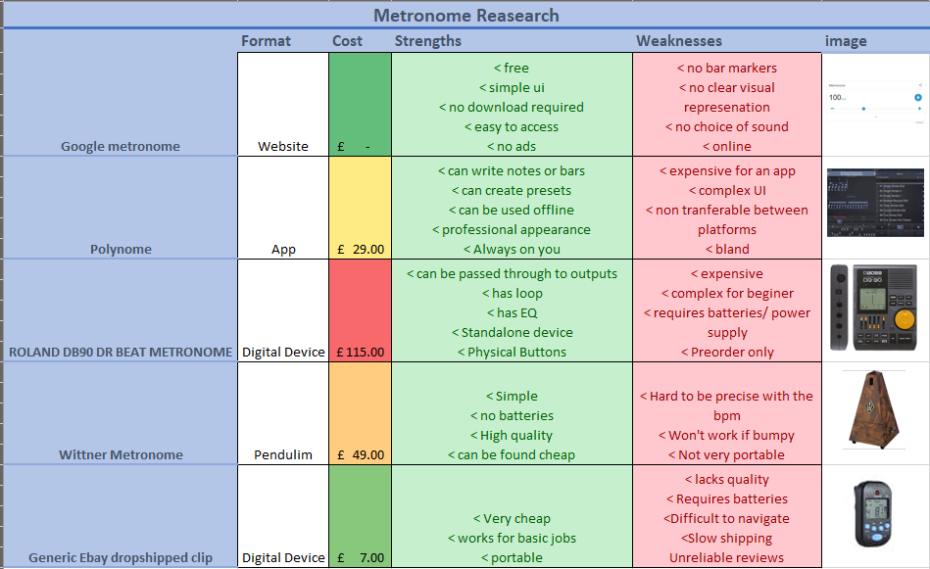

## Hardware and software requirements

For development, I need to be able to use Visual Studio 2017 which requires:

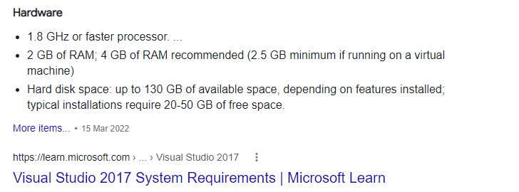

<https://learn.microsoft.com/en-us/visualstudio/releases/2017/vs2017-system-requirements-vs>

For the stakeholders to run the metronome they need a web enabled device running a modern browser (e.g. chrome)

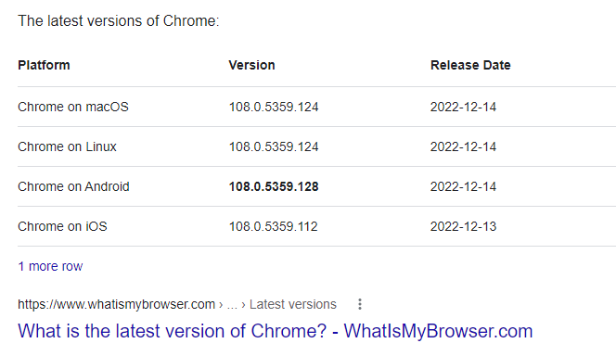

<https://www.whatismybrowser.com/guides/the-latest-version/chrome>

This is so that all the features of css / javascript / HTML5 work as expected.

My stakeholder has a Samsung Galaxy Tab A7 32 GB Wi-Fi Android Tablet - Dark Grey (UK Version)

|  |  |
| --- | --- |
| **Screen size:** | 10.4” diagonal  1200x2000 224ppi density |
| **OS:** | Android 12 |
| **Storage:** | 32Gb |
| **RAM:** | 4Gb |

## Success Criteria

|  |  |  |
| --- | --- | --- |
| Number | Criteria | Justification |
| 1 | Must be accessible on a android 12 device in Chrome connected to the internet | The stakeholder has an android 12 device with a reliable WiFi connection. Any updates to the app can be automatically rolled out to the users |
| 2 | User can set the BPM | The stakeholder wants to practice between 50BPM and 120BPM |
| 3 | Any invalid BPM will be automatically corrected to the closest sensible value between 50-120BPM | The stakeholder wants to focus on drumming and might accidentally type in invalid data |
| 4 | The user should be able to increase the BPM by 5 using a touch button | The stakeholder wants to be able to practice drumming at different speeds as they become more proficient |
| 5 | The user should be able to decrease the BPM by 5 using a touch button |
| 6 | There should be a start and stop button that toggles when you press it | The user should be able to control the metronome with their finger with a really simple UI |
| 7 | When the metronome starts there should be an audible beep | The stakeholder wants to drum along to a click sound in headphones |
| 8 | When the metronome starts there should be a visual indication showing whenever it would ‘tick’ | Sometimes the metronome would be used with the sound turned off. |
| 9 | There should be a high contrast mode button which toggles a black and white colour scheme with a larger text | Sometimes the metronome will be on a small screen a reasonable distance from the drummer and they need to see it at a glance without misreading any of the numbers |

# Design

## Algorithms

The user should be able to enter the BPM score (beats per minute). The browser needs to know how long to pause between each tick in milliseconds. This can be done using the following algorithm.

BPM = user input

Interval = 1 * 60 * 1,000/BPM

## Usability features

Normal mode:

50

Start

High contrast mode:

50

Start

The high contrast option should be all black and white with larger text so that it can be visible from a distance on small screens with a high (224) DPI. It will also be usable by people who are partially sighted or colour blind.

The decrease button is on the left because western audiences associate reading from left to right so a smaller number would be on the left of a number line.

The largest UI components are the BPM editable text box and the start / stop button because…

### Variable and validation

|  |  |  |  |
| --- | --- | --- | --- |
| Variable | Data type | Validation | Justification |
| BPM | Int | Range check (between 50 and 120) | The BPM should be anything from just less than one to two beats per second |
| BPMUserInput | Str | TypeCheck and PresenceCheck | The BPM should be an int between 50 and 120 |
| IntervalMS | Int | Make sure it’s rounded to 0 decimal places | The browser needs an interval between ticks in millisecond as a whole number |
| HighConstrastMode | Bool | Checkbox can be ticked or not ticked | Toggle between contrast and normal |
| IsPlaying | Bool | Either true or false | Metronome can either be playing or paused. |

### Testing

|  |  |  |  |  |
| --- | --- | --- | --- | --- |
| **Test number** | **Description** | **Success Criteria** | **Test data** | **Expected result** |
| 1a | Basic web page | 1 | Page load | A web page with a title and text box to enter BPM and two buttons to increase/ decrease the BPM; displays in chrome |
| 2 | BPM | 2 | 120 | Valid data is excepted |
| 3 | BPM | 2 | “” | BPM to be set to 50 |
| 4 | BPM | 2 | 30 | BPM to be set to 50 |
| 5 | BPM | 3 | 130 | BPM to be set to 120 |
| 6 | BPM | 3 | Potato | BPM to be set to 50 |
| 7 | Increasing BPM | 4 | BPM set to 60, press increase | BPM increase up to 65 |
| 8 | Increasing BPM | 4 | BPM set to 120, press increase | Stay at 120 |
| 9 | Increasing BPM | 4 | BPM set to 119,  Press increase | BPM set to 120 |
| 10 | decreasing BPM | 5 | BPM set to 70, press decrease | BPM decrease to 65 |
| 11 | decreasing BPM | 5 | BPM set to 50, press decrease | BPM stay at 50 |
| 12 | decreasing BPM | 5 | BPM set to 52, press decrease | BPM set to 50 |
| 13 | Start | 6 | Start pressed | Should start |
| 14 | Stop | 6 | Start pressed, stop pressed | Start then stop |
| 15 | Start | 6 | Start pressed twice | Should carry on |
| 16 | Stop | 6 | Stop pressed | Stay stopped |
| 17 | Beep on start | 7 | Start pressed | When start is pressed should beep |
| 18 | Indicator | 8 | Start pressed | Indication should start moving in beat |
| 19 | Indicator | 8 | Start pressed, Stop pressed | Should start indicating before stopping |
| 20 | Contrast mode | 9 | contrast button pressed | Switch to high contrast |
| 20 | Toggle | 9 | Contrast button pressed twice | Should toggled back and forth between high contrast mode |

### Post development testing

# Implementation

Lorem ipsum dolor sit amet, consectetuer adipiscing elit. Maecenas porttitor congue massa. Fusce posuere, magna sed pulvinar ultricies, purus lectus malesuada libero, sit amet commodo magna eros quis urna.

Nunc viverra imperdiet enim. Fusce est. Vivamus a tellus.

Pellentesque habitant morbi tristique senectus et netus et malesuada fames ac turpis egestas. Proin pharetra nonummy pede. Mauris et orci.

Aenean nec lorem. In porttitor. Donec laoreet nonummy augue.

Suspendisse dui purus, scelerisque at, vulputate vitae, pretium mattis, nunc. Mauris eget neque at sem venenatis eleifend. Ut nonummy.

# Testing

Lorem ipsum dolor sit amet, consectetuer adipiscing elit. Maecenas porttitor congue massa. Fusce posuere, magna sed pulvinar ultricies, purus lectus malesuada libero, sit amet commodo magna eros quis urna.

Nunc viverra imperdiet enim. Fusce est. Vivamus a tellus.

Pellentesque habitant morbi tristique senectus et netus et malesuada fames ac turpis egestas. Proin pharetra nonummy pede. Mauris et orci.

Aenean nec lorem. In porttitor. Donec laoreet nonummy augue.

Suspendisse dui purus, scelerisque at, vulputate vitae, pretium mattis, nunc. Mauris eget neque at sem venenatis eleifend. Ut nonummy.

# Installation

Lorem ipsum dolor sit amet, consectetuer adipiscing elit. Maecenas porttitor congue massa. Fusce posuere, magna sed pulvinar ultricies, purus lectus malesuada libero, sit amet commodo magna eros quis urna.

Nunc viverra imperdiet enim. Fusce est. Vivamus a tellus.

Pellentesque habitant morbi tristique senectus et netus et malesuada fames ac turpis egestas. Proin pharetra nonummy pede. Mauris et orci.

Aenean nec lorem. In porttitor. Donec laoreet nonummy augue.

Suspendisse dui purus, scelerisque at, vulputate vitae, pretium mattis, nunc. Mauris eget neque at sem venenatis eleifend. Ut nonummy.

# Evaluation

Lorem ipsum dolor sit amet, consectetuer adipiscing elit. Maecenas porttitor congue massa. Fusce posuere, magna sed pulvinar ultricies, purus lectus malesuada libero, sit amet commodo magna eros quis urna.

Nunc viverra imperdiet enim. Fusce est. Vivamus a tellus.

Pellentesque habitant morbi tristique senectus et netus et malesuada fames ac turpis egestas. Proin pharetra nonummy pede. Mauris et orci.

Aenean nec lorem. In porttitor. Donec laoreet nonummy augue.

Suspendisse dui purus, scelerisque at, vulputate vitae, pretium mattis, nunc. Mauris eget neque at sem venenatis eleifend. Ut nonummy.

# Maintenance

Lorem ipsum dolor sit amet, consectetuer adipiscing elit. Maecenas porttitor congue massa. Fusce posuere, magna sed pulvinar ultricies, purus lectus malesuada libero, sit amet commodo magna eros quis urna.

Nunc viverra imperdiet enim. Fusce est. Vivamus a tellus.

Pellentesque habitant morbi tristique senectus et netus et malesuada fames ac turpis egestas. Proin pharetra nonummy pede. Mauris et orci.

Aenean nec lorem. In porttitor. Donec laoreet nonummy augue.

Suspendisse dui purus, scelerisque at, vulputate vitae, pretium mattis, nunc. Mauris eget neque at sem venenatis eleifend. Ut nonummy.