dados

Autogenerated data summary from dataMaid

2022-10-08 21:12:35

# Data report overview

The dataset examined has the following dimensions:

| Feature | Result |
| --- | --- |
| Number of observations | 517 |
| Number of variables | 13 |

### Checks performed

The following variable checks were performed, depending on the data type of each variable:

|  | character | factor | labelled | haven labelled | numeric | integer | logical | Date |
| --- | --- | --- | --- | --- | --- | --- | --- | --- |
| Identify miscoded missing values | × | × | × | × | × | × |  | × |
| Identify prefixed and suffixed whitespace | × | × | × | × |  |  |  |  |
| Identify levels with < 6 obs. | × | × | × | × |  |  |  |  |
| Identify case issues | × | × | × | × |  |  |  |  |
| Identify misclassified numeric or integer variables | × | × | × | × |  |  |  |  |
| Identify outliers |  |  |  |  | × | × |  | × |

Please note that all numerical values in the following have been rounded to 2 decimals.

# Summary table

|  | Variable class | # unique values | Missing observations | Any problems? |
| --- | --- | --- | --- | --- |
| X | integer | 9 | 0.00 % |  |
| Y | integer | 7 | 0.00 % | × |
| month | character | 12 | 0.00 % | × |
| day | character | 7 | 0.00 % |  |
| FFMC | numeric | 106 | 0.00 % | × |
| DMC | numeric | 215 | 0.00 % | × |
| DC | numeric | 219 | 0.00 % | × |
| ISI | numeric | 119 | 0.00 % | × |
| temp | numeric | 192 | 0.00 % | × |
| RH | integer | 75 | 0.00 % | × |
| wind | numeric | 21 | 0.00 % | × |
| rain | numeric | 7 | 0.00 % | × |
| area | numeric | 251 | 0.00 % | × |

# Variable list

## X

| Feature | Result |
| --- | --- |
| Variable type | integer |
| Number of missing obs. | 0 (0 %) |
| Number of unique values | 9 |
| Median | 4 |
| 1st and 3rd quartiles | 3; 7 |
| Min. and max. | 1; 9 |

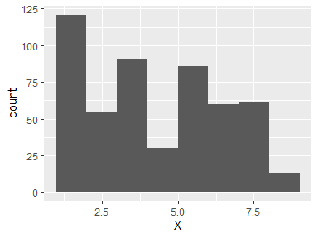

## Y

| Feature | Result |
| --- | --- |
| Variable type | integer |
| Number of missing obs. | 0 (0 %) |
| Number of unique values | 7 |
| Median | 4 |
| 1st and 3rd quartiles | 4; 5 |
| Min. and max. | 2; 9 |

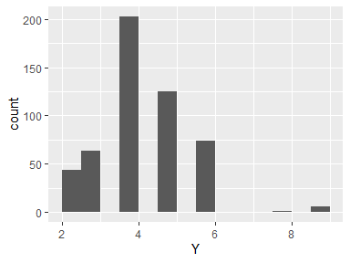

* Note that the following possible outlier values were detected: "2", "3".

## month

| Feature | Result |
| --- | --- |
| Variable type | character |
| Number of missing obs. | 0 (0 %) |
| Number of unique values | 12 |
| Mode | “aug” |

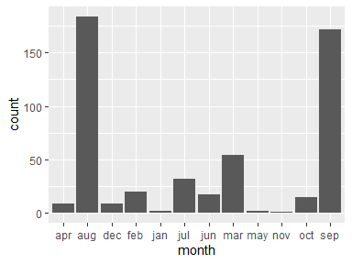

* Note that the following levels have at most five observations: "jan", "may", "nov".

## day

| Feature | Result |
| --- | --- |
| Variable type | character |
| Number of missing obs. | 0 (0 %) |
| Number of unique values | 7 |
| Mode | “sun” |

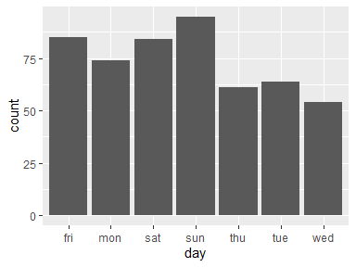

## FFMC

| Feature | Result |
| --- | --- |
| Variable type | numeric |
| Number of missing obs. | 0 (0 %) |
| Number of unique values | 106 |
| Median | 91.6 |
| 1st and 3rd quartiles | 90.2; 92.9 |
| Min. and max. | 18.7; 96.2 |

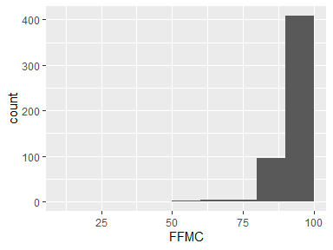

* Note that the following possible outlier values were detected: "18.7", "50.4", "53.4", "63.5", "68.2", …, "95.8", "95.9", "96", "96.1", "96.2" (13 values omitted).

## DMC

| Feature | Result |
| --- | --- |
| Variable type | numeric |
| Number of missing obs. | 0 (0 %) |
| Number of unique values | 215 |
| Median | 108.3 |
| 1st and 3rd quartiles | 68.6; 142.4 |
| Min. and max. | 1.1; 291.3 |

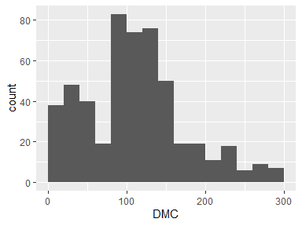

* Note that the following possible outlier values were detected: "263.1", "266.2", "269.8", "273.8", "276.3", "284.9", "287.2", "290", "291.3".

## DC

| Feature | Result |
| --- | --- |
| Variable type | numeric |
| Number of missing obs. | 0 (0 %) |
| Number of unique values | 219 |
| Median | 664.2 |
| 1st and 3rd quartiles | 437.7; 713.9 |
| Min. and max. | 7.9; 860.6 |

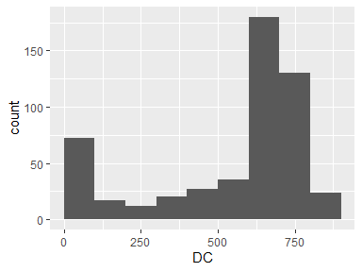

* Note that the following possible outlier values were detected: "750.5", "751.5", "752.6", "753.8", "758.1", …, "825.1", "844", "849.3", "855.3", "860.6" (15 values omitted).

## ISI

| Feature | Result |
| --- | --- |
| Variable type | numeric |
| Number of missing obs. | 0 (0 %) |
| Number of unique values | 119 |
| Median | 8.4 |
| 1st and 3rd quartiles | 6.5; 10.8 |
| Min. and max. | 0; 56.1 |

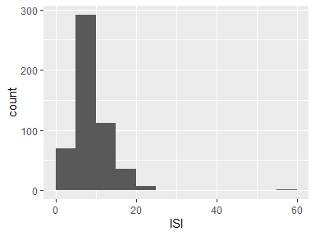

* Note that the following possible outlier values were detected: "0", "0.4", "0.7", "0.8", "1.1", …, "2.8", "21.3", "22.6", "22.7", "56.1" (9 values omitted).

## temp

| Feature | Result |
| --- | --- |
| Variable type | numeric |
| Number of missing obs. | 0 (0 %) |
| Number of unique values | 192 |
| Median | 19.3 |
| 1st and 3rd quartiles | 15.5; 22.8 |
| Min. and max. | 2.2; 33.3 |

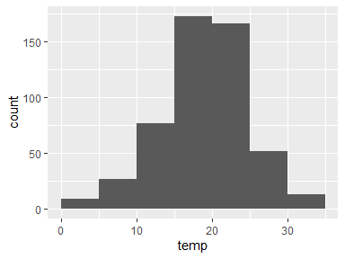

* Note that the following possible outlier values were detected: "32.3", "32.4", "32.6", "33.1", "33.3".

## RH

| Feature | Result |
| --- | --- |
| Variable type | integer |
| Number of missing obs. | 0 (0 %) |
| Number of unique values | 75 |
| Median | 42 |
| 1st and 3rd quartiles | 33; 53 |
| Min. and max. | 15; 100 |

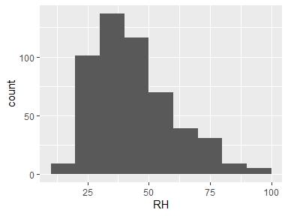

* Note that the following possible outlier values were detected: "15", "100".

## wind

| Feature | Result |
| --- | --- |
| Variable type | numeric |
| Number of missing obs. | 0 (0 %) |
| Number of unique values | 21 |
| Median | 4 |
| 1st and 3rd quartiles | 2.7; 4.9 |
| Min. and max. | 0.4; 9.4 |

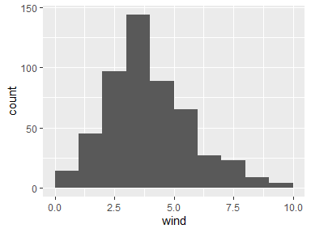

* Note that the following possible outlier values were detected: "8.5", "8.9", "9.4".

## rain

| Feature | Result |
| --- | --- |
| Variable type | numeric |
| Number of missing obs. | 0 (0 %) |
| Number of unique values | 7 |
| Median | 0 |
| 1st and 3rd quartiles | 0; 0 |
| Min. and max. | 0; 6.4 |

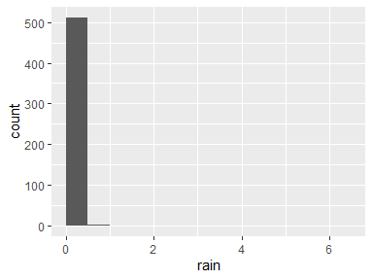

* Note that the following possible outlier values were detected: "0.2", "0.4", "0.8", "1", "1.4", "6.4".

## area

| Feature | Result |
| --- | --- |
| Variable type | numeric |
| Number of missing obs. | 0 (0 %) |
| Number of unique values | 251 |
| Median | 0.52 |
| 1st and 3rd quartiles | 0; 6.57 |
| Min. and max. | 0; 1090.84 |

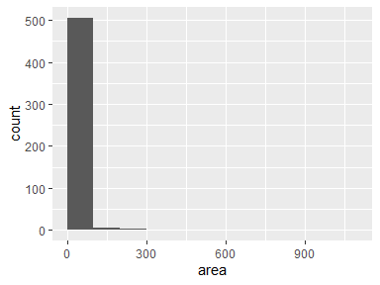

* Note that the following possible outlier values were detected: "154.88", "174.63", "185.76", "196.48", "200.94", "212.88", "278.53", "746.28", "1090.84".

Report generation information:

* Created by: JosefersonBarreto (username: joseferson).
* Report creation time: sáb out 08 2022 21:12:36
* Report was run from directory: C:/Users/joseferson/Documents/joseferson barreto/projeto_MLG
* dataMaid v1.4.1 [Pkg: 2021-10-08 from CRAN (R 4.2.0)]
* R version 4.2.0 (2022-04-22 ucrt).
* Platform: x86_64-w64-mingw32/x64 (64-bit)(Windows 10 x64 (build 19044)).
* Function call: dataMaid::makeDataReport(data = dados, output = "word")