关于时序数据库方面的书籍目前较少

1.InfluxDB原理与实战

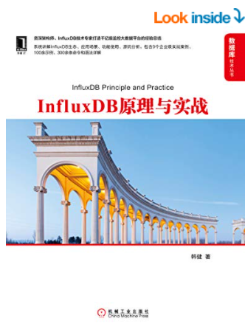

视频：

2. [IoTDB _ 搜索结果_哔哩哔哩_Bilibili](https://search.bilibili.com/all?keyword=IoTDB&from_source=webtop_search&spm_id_from=333.1007)

3. [20210629直播回放丨新TSDB存储引擎架构与特性_哔哩哔哩_bilibili](https://www.bilibili.com/video/BV1V54y1p7vX?from=search&seid=2289661546719690676&spm_id_from=333.337.0.0)

4. [#25 OpenTSDB 时序数据引擎介绍 【 Go 夜读 】_哔哩哔哩_bilibili](https://www.bilibili.com/video/BV1ht411873N?from=search&seid=2289661546719690676&spm_id_from=333.337.0.0)

5. [[阿里云]时序时空数据库tsdb基础入门_哔哩哔哩_bilibili](https://www.bilibili.com/video/BV1cE411q77N?from=search&seid=2289661546719690676&spm_id_from=333.337.0.0)