**Chapter I**

**INTRODUCTION**

The term "archiving" refers to the process of saving and keeping any important data that can be safely maintained for an extended period of time. It typically consists papers that, depending on the contents of a file, an organization may or may not use again. An institution, such as a school, must adapt to this type of data preservation when it comes to various documents that must be kept. It will reduce their work in keeping files from a manual to an automated way with the help of software or a filing system.

Web-based file management is a system that will make the instructor’s work in file sorting and submitting required papers much easier. This system will include a well-organized repository for faculty member reports that the institution will have access to. Security will be enhanced because the files will be kept in a single storage place that School of Computer Studies faculty members will be allowed. The traditional way of submitting files will be unnecessary because of this proposed system.

Valuable files might be stored in an unstructured manner if there is no secured filing system in place. Since there is no proper storage for the documents, incidents such as office clutter and file loss will occur. As a result of these events, the enhancement of document storage must be implemented through an online file management system that will serve as a virtual cabinet for the important files submitted by faculty members.

Due to the hard copies submitted by faculty members, there will be a bulk copy of reports in the cabinets. Because the papers are not properly disposed of, they will occasionally become an addition to the filing cabinet. Reports and other activities will be tough to locate since manually searching through a large collection of documents to find a specific paper would be challenging.

As a response of the challenges, a feasible solution could be to create a system entitled “Web-based File Management System for School of Computer Studies”. Unlike existing versions, the suggested system will filter the files stored in it and make it easier to locate them. Despite these challenges, frequent maintenance and monitoring of the system will keep it functional for a long time.

**Objectives of the Study**

The general objective of the study is to develop a system entitled “Web-Based File Management System for School of Computer Studies” that will help reduce the department's workload allowing them to improve the school's filing strategy.

Specifically, the study aims to:

1. design and develop the system called “Web-based File Management System for School of Computer Studies” that is capable of:
   1. ensuring the security of important documents and files;
   2. saving space by reducing office clutter;
   3. organizing and sorting of the essential documents submitted by faculty members;
   4. monitoring of the reports submitted by the Faculty Members;
   5. providing and managing accounts for the different type of users; and
   6. generating reports such as semestral grades, schedules, and many others for the printed copy of documents.
2. test the system through unit, integration, performance, system and acceptance testing;
3. evaluate the system if it conforms with the ISO 9126 standards; and
4. prepare an implementation plan for the deployment of the system.

**Scope and Limitations of the Study**

The study focuses on the development of the web-based file management system for the School of Computer Studies that will keep the documents and reports ordered and accessible. This study is intended for four (4) levels of access such as the Faculty Members, Program Coordinator (BSIT and BSCS Chairpersons), System Administrator and the School Dean. The study is composed of three (3) modules including Account Management Module, Documents/ Reports Management Module, and the Reports Monitoring Module.

The three modules will be essential to the system's success. The Account Management Module will be used to create a user account, as well as to modify and search for information that the user has provided. The Document/Reports Management Module will be used to organize and control papers, minimizing the number of physical copies. Finally, the Reports Monitoring Module will be used to monitor the status of files and information throughout the system.

However, the study is limited of providing an organized files uploaded by the faculty members since the program coordinators are the authorized to do it. Another limitation of the system is that the system administrator has the capability to reset the password once it was forgotten by the user. There will be no popup notifications, instead the system will display if the faculty members submitted already. Modifying submitted reports is also not included in the system that will be developed because it will be done with a separate application.

**Significance of the Study**

The proposed system entitled “Web-Based File Management System for School of Computer Studies” will be able to benefit the organization through boosting the department's ability to keep important documents organized.

Since this proposed system is new to the department, it will be a great help in the following:

School of Computer Studies will benefit to the study by becoming a completely technology-based department in terms of file organization and storage.

Faculty Members will benefit to the study by allowing them to conveniently submit and save documents for future use.

Proponents will benefit to the study by obtaining greater knowledge and explore other ideas as a result of completing the project.

Future Proponents will benefit to the study by using the study as a reference to establish a better system or to improve the functionality that the researchers developing.

**Theoretical Framework**

The figure below illustrates how the system's function will proceed. It is based on the system's potential features and accessibility.

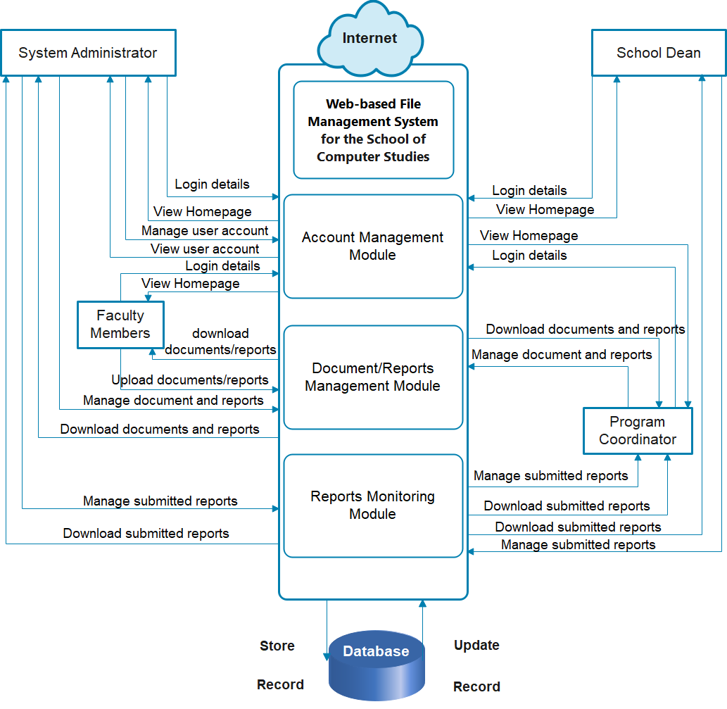

Figure 1. Theoretical Framework of Web-Based File Management System

for the School of Computer Studies

Below are the discussion of the process/flow of the study through every entity/user:

System Administrator has complete control over the entire system. To access the system's homepage, users must enter a valid username and password on the login page. The system administrator's homepage allows them to manage and view the accounts of various users. It allows them to arrange and monitor the status of the user's account.

Program Coordinator must also input a valid username and password to obtain secure access to the system. Once they get to the dashboard, they can view and read the reports that the faculty will submit. The program coordinator is also capable of managing the reports that will be submitted by faculty members based on the program they are assigned to.

School Dean. To gain access to anything they need, all users must begin at the login page and enter the correct username and password. The School Dean, like the Program Coordinator, can monitor and oversee the reports in an organized manner. Their accessibility is broader than the Program Coordinators as he's the only one who has control over the entire department.

Faculty Members has restricted system access. The Faculty Members will also submit a username and password in order to login to the system. Uploading papers and reports is one of the options presented on the homepage. Users can also modify and delete files that have been mistakenly uploaded to their accounts.

**Conceptual Model of the Study**

A conceptual model is built based on the above concepts, theories, and findings of associated literature, studies, and insights drawn from them, as illustrated below.

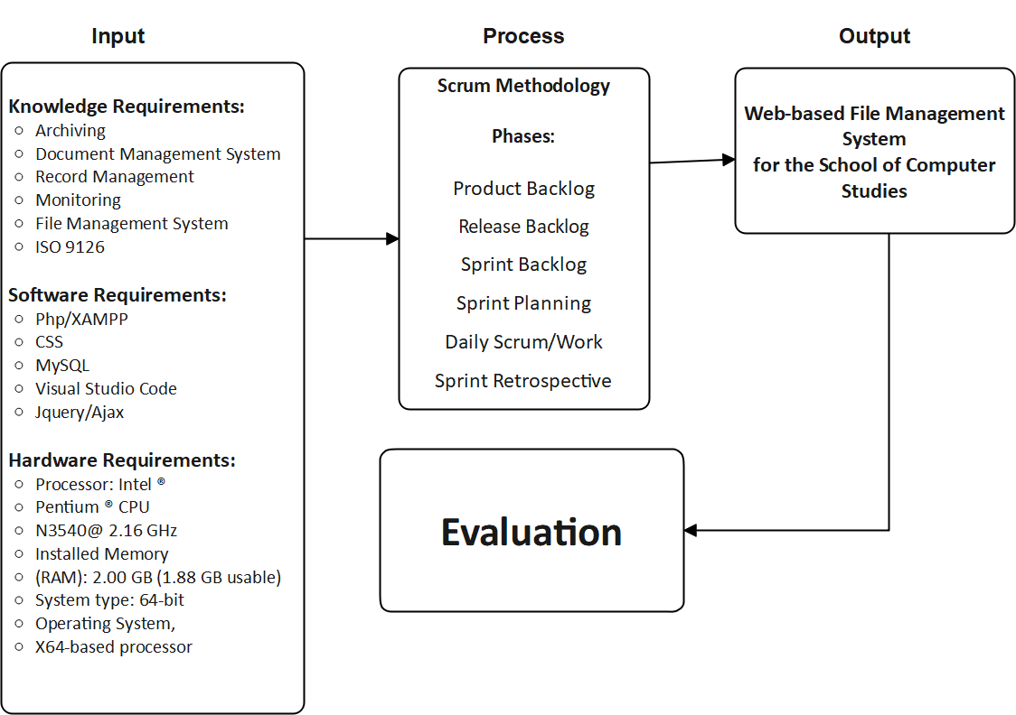

Figure 2. Conceptual Model of Web-Based File Management System for the School of Computer Studies

The conceptual model, as shown in Figure 2, depicts the various stages of the processes involved in achieving the study's objectives.

Input Stage. This stage identifies the various requirements that will need to begin creating the system. The components on this list are necessary to carry out the process effectively. It is impossible to develop a system that meets the knowledge requirement without first establishing a foundation for the system. The topics on the list will serve as a starting point for progressing on to the next stage of the process. The software requirements, such as various computer applications, will be utilized to quickly apply the proponents' knowledge of the many programs that the proposed system needs.

Process Stage. This stage includes the methodology that will be used. The different phases of the scrum will be performed in order to determine the system's advantages and disadvantages. The Product backlog is about a set of user stories collected for a scrum product. The Release backlog will be the period of time during which the number of iterations is completed. The Sprint backlog will be the time frame for completing the user stories, typically 2-4 weeks. The Sprint planning starts with the team importing stories from the release backlog into the sprint backlog and the sprint is will be hosted by the scrum master. The Daily scrum will discuss by the members to talk about the work they did the day before, the work they plan to do the next day, and any difficulties they will encounter on the sprint. The team's progress will be tracked during the daily stand-up meeting. Lastly, the Sprint retrospective will analyze what the team will accomplish in the previous sprint including the lessons learned.

Output Stage. Consists of the deliverables created by the proponents, “Web-Based File Management System for School of Computer Studies”. This stage will represent the final outcome of the project, which began with the input stage and continued via the scrum methodology to the desired output. The completed system must be functional by the entire department, particularly the system's intended beneficiary.

Evaluation Stage. This stage is essential since it will act as an assessment of whether or not the current project is effective. Different challenges will arise as a result of the evaluation, depending on how the team members resolve the problem.

**Operational Definition of Terms**

The terms defined below are used in the developing system:

**Faculty Members.** People in charge of document storage and report submission to the system.

**Program Coordinator (BSIT and BSCS Chairpersons).** Persons in charge of gathering and organizing the faculty member's submitted reports under the program handled.

**School Dean.** The person in charge of monitoring the BSIT and BSCS Department's filed reports.

**System Administrator.** Person in charge of accessing the entire system excluding the submission part.

**Chapter II**

**REVIEW OF RELATED LITERATURE AND STUDIES**

The review of related literature and studies relevant to the current topic is presented in this chapter.

**Related Literature**

**Archiving**

The practice of relocating data that is no longer actively used to a separate data storage device for long-term keeping is known as data archiving. Older data that is still useful and necessary for future reference, as well as data that must be kept for regulatory compliance, are stored in data archives. Files and sections of files can be quickly identified and retrieved since data archives are indexed and include search capabilities, Rouge (2010).

As stated byKoopman and De Jager (2016) and Renaut et al. (2018), concentrated on studying the approaches to archiving digital research-related data, and they found that many researchers do not use proposed repositories for archiving their materials, and moreover, many educational institutions have no effective research data management systems. As a result, there is a risk that, in many cases, documents and research-related data are stored and managed inappropriately, without being accurately and securely archived. In this case, the authors of the studies discussed the problem of archiving from the perspectives of both research and educational initiations and academic journals.

As stated by Esser (2013), he archived data by extracting information from documents that had been scanned and converted into digital format. The contents of the majority of the documents evaluated have a specific format or common fields. Because of the similar fields in each document, these documents can be simply categorized according to their function. As a result, document indexing and categorization became much easier. This automatic configuration will only work if all papers have the same format; small offices and home offices, on the other hand, will be unable to use this type of configuration due to the numerous formats used in their day-to-day documents.

**Document Management System**

According to Winterberg (2013), financial advisors have been hesitant to adopt document management technologies as part of the digital revolution. Many people have misconceptions about document management, which leads to inefficient and time-consuming paper-based solutions being used in their firms.

Regarding all of CHED's issues with handling, tracking, and managing all of their documents, the most likely Information System that would best meet their demands would be the Document management system. A Document Management System (DMS), as defined by the IT community (TopBits.com), is "an integrated network of compatible programs or computer systems that reliably handle information for accurate records and usability”, Zurc (2011).

Storage, scanning, indexing, retrieval, dissemination, and control of relevant documents are all included in document management. The System replaces paper-based workflows with automated processes in order to completely eliminate printouts and human document sorting, resulting in cost savings for the user organization or person. This technique is unquestionably effective and simple to use, Skynet Digital (2014).

**Record Management**

As stated by Mukrad et al. (2019), when it comes to deploying computer-based information management systems, higher professional education (HPE) institutions encounter specific problems. Electronic records management systems (ERMSs) aid in the organization of the vast amounts of data required to plan and make well-informed decisions. Organizations are still learning how to employ ERMS effectively because they are a relatively recent feature.

The storage of records has long been a primary goal of information systems, but in the last decade, managing sensitive data throughout its life cycle, from production to disposal (or archiving), has become increasingly important. The growing awareness of the influence of technology on privacy has accelerated the demand for stronger record retention policy enforcement. Today's businesses must not only adhere to legislation, but also strike a balance between operational record-keeping obligations, the risk of strong private information, and customer privacy preferences, Dandeleon (2012).

This system can handle and print copies of the registrar's primary reports issued to the CHED and CHMSC main campuses. Furthermore, this system is only capable of storing and producing student grades and registrar reports. As a result, reports that aren't frequently or ordinarily required of the Registrar aren't included in the system. By keeping files of students' records in a computer system, the student information and record system may save and provide needed information in a faster and more convenient manner, Moguies L. (2012).

**ISO 9126**

In 1992, the ISO 9126 quality model was proposed as an international standard for measuring software quality. It is the most widely used model of quality control. However, there are a few others, such as IEEE 1061. Quality traits, sub-characteristics, and attributes are divided into three levels. ISO 9126 identifies 21 characteristics that must be present in a high-quality software product. Functionality, reliability, usability, efficiency, maintainability, and portability are the six categories in which the 21 qualities are organized. Finally, ISO 9126 distinguishes three types of software quality (internal quality, external quality and quality in use).

ISO 9126 has also been compared to other quality models (MaCall, FURP and Dromey). This model's key advantage is that it may be applied to a wide range of systems, including those in the academic sector, such as e-learning systems. ISO 9126 has been used to review e-learning systems for instructors and educational administrators, to choose generic external system quality characteristics and sub characteristics for user evaluation of course management system (CMS) (Course management systems), to evaluate Computer-Based Systems, and to study technological, administrative, and economic elements in e-learning systems.It may be concluded that the ISO 9126 is appropriate for use in e-learning assessment since it is extensively used in the software engineering community, has been adapted to various domains and situations, and is simple to use and comprehend by its users.

**XAMPP**

XAMPP is one of the widely used cross-platform web servers, which helps developers to create and test their programs on a local webserver. It consists of Apache HTTP Server, MariaDB, and interpreter for the different programming languages like PHP and Perl. XAMPP helps a local host or server to test its website and clients via computers and laptops before releasing it to the main server. It is a platform that furnishes a suitable environment to test and verify the working of projects based on Apache, Perl, MySQL database, and PHP through the system of the host itself. Among these technologies, [Perl](https://www.javatpoint.com/perl-tutorial) is a programming language used for web development, PHP is a backend scripting language, and MariaDB is the most vividly used database developed by MySQL. XAMPP is used to symbolize the classification of solutions for different technologies. It provides a base for testing of projects based on different technologies through a personal server. XAMPP is an abbreviated form of each alphabet representing each of its major components. This collection of software contains a web server named Apache, a database management system named MariaDB and scripting/ programming languages such as PHP and Perl. X denotes Cross-platform, which means that it can work on different platforms such as [Windows](https://www.javatpoint.com/windows), [Linux](https://www.javatpoint.com/linux-tutorial), and macOS.

**PHP**

PHP is a programming language. It’s a pretty widely used language and can be embedded into HTML, which is the big draw for anyone interested in web development. Where HTML can be long, with lots of commands, PHP pages contain HTML with embedded code, making it much easier to manage. PHP stands for Hypertext Preprocessor which, in itself is confusing. It’s not actually as complicated as it seems though – if you have a basic understanding of HTML, PHP is going to be pretty easy to learn. It allows you to collect, process and utilize data to create output – basically it allows you to interact with all your pages.

**My SQL**

MySQL is currently the most popular database management system software used for managing the relational database. It is open-source database software, which is supported by Oracle Company. It is fast, scalable, and easy to use database management system in comparison with Microsoft SQL Server and Oracle Database. It is commonly used in conjunction with [PHP](https://www.javatpoint.com/php-tutorial) scripts for creating powerful and dynamic server-side or web-based enterprise applications.

**CSS**

CSS stands for Cascading Style Sheets. It is the coding language that gives a website its look and layout. Along with HTML, CSS is fundamental to web design. Without it, websites would still be plain text on white backgrounds. Before the development of CSS in 1996 by the World Wide Web Consortium (W3C), Web pages were extremely limited in both form and function. Early browsers presented a page as hypertext - plain text, images and links to other hypertext pages. There was no layout at all to speak of, merely paragraphs running across the page in a single column.

**Visual Studio Code**

Visual Studio Code (famously known as VS Code) is a free open source text editor by Microsoft. VS Code is available for Windows, Linux, and macOS. Although the editor is relatively lightweight, it includes some powerful features that have made VS Code one of the most popular development environment tools in recent times. VS Code supports a wide array of programming languages from Java, C++, and Python to CSS, Go, and Dockerfile. Moreover, VS Code allows you to add on and even creating new extensions including code linters, debuggers, and cloud and web development support.

**jQuery/ Ajax**

jQuery is a lightweight, open-source JavaScript library that helps us build interactive web pages with animations, visual effects, and advanced functionality. It is the most popular JavaScript library, used by around 70 million websites worldwide. jQuery makes web development easier by overcoming all the “stuff” that makes JavaScript difficult to use. With jQuery, you can call simple methods instead rewriting task blocks. The jQuery motto is “write less, do more”, because it reduces many lines of raw JavaScript code into a single line with its simple interface.

AJAX is an acronym that stands for Asynchronous JavaScript and XML, and it describes a set of development techniques used for building websites and web applications. According to web developer and Skillcrush WordPress instructor Ann Cascarano, the best way to understand AJAX is to start with identifying its specific purpose in the web development process. AJAX’s core function is to update web content asynchronously (the “A” of AJAX), meaning a user’s web browser doesn’t need to reload an entire web page when only a small portion of content on the page needs to change.

**Related Studies**

**Local Studies**

1. **memo Archiving for City College of Tagaytay**

The study entitled “E-memo Archiving for City College of Tagaytay” was developed to provide an electronic sending memorandum and archiving everytime a memo is sent to schools and offices. The system was developed using Php/Xampp that followed the guidelines of the World Wide Web Consortium. The system can be browsed using any available desktop.

The system is capable of creating, sending and deleting memorandum as well as sending message that serve as communication to users. There are three (3) users namely the Administrator, the Vice President for Academic Affairs, Registrar and Dean, and the users. The Administrator is capable of creating, sending and deleting memorandum as well as creating new user accounts and new office. He approves the memorandum submitted by the VPAA, registrar and dean. Only admin can delete user and reset the password of the user if needed. The second group which is consist of Vice President for Academic Affairs (VPAA), Registrar and Dean can create, send and receive memorandum. They can also change their password if they want and they can print memorandum as well. The last are the Users, who receive the memorandum from the Admin, VPAA, Registrar and Dean. The user can receive and send message to the other user, can print the memorandum and can change their password. (Kevin Daculla et al., 2017).

The capacity to send and receive vital documents from their respective departments was improved thanks to this system. It also acted as a means of communication for all users, particularly when conveying significant notifications to all.

**Development of Thesis Archive for School of Computer Studies (TARSCS)**

Data archiving is most suitable for storing the data that must be retained for operational or regulatory requirements such as document files, a process of moving data which is no longer actively used to a separate storage device for long-term retention. Data archiving consists of older data that is still important to the organization and may be needed for future reference. New plans developed by the organization are results of constant evaluation of their programs. The organizations are enabled to utilize their resources more efficiently to provide the needs of their clients. City College of Tagaytay has no system for thesis archiving so we made a system for archiving data to have search capabilities so the thesis documents can be easily located. The Administrator Department took a lot of work just to accomplish the task of collecting and storing thesis projects. The advancement of technology in the automated thesis archiving can aid the proponents in gathering more accurate data in the fastest possible manner. The results of the thesis archive conducted have met the objectives of the researchers and therefore worthy enough to be continued and developed. (Numuel Lim et al., 2016)

The goal of this system was to reduce the time spent searching for and retrieving various theses completed by students in the department. Because the files are stored in a secure location, they can be found on the completed system anytime they are required.

**Development of a Web Application System for the Archiving of Learning Module for the Program Offered by the School of Computer Studies**

The study entitled “Development of a Web Application System for the Archiving of Learning Module for the Program Offered by the School of Computer Studies” was developed to provide a way of archiving learning module in an electronic manner. The system was developed using PHP for the web development and followed the guidelines of the World Wide Web. The system can be browsed using any browser available on desktop and even in mobile devices.

The study is capable of viewing and downloading learning module. There are two (2) users namely the Admin which can add the user, list of teachers, who can view the subjects and learning modules uploaded, second is the teacher, by which they can upload and view learning modules.

During the development of the system, the guidelines that the researchers utilized were the Iterative Methodology. It has six (6) phases; (1) planning, (2) requirements, (3) analysis and design, (4) implementation, (5) testing and (6) evaluation.

The system was developed using Notepad++ for editor and MySQL for backend. The device system was presented to thirty (30) respondents and was rated “Very Good”. The project features and characteristics were evaluated as well as suggestions were considered (Erwin Desingaño et al., 2017)

This system meets the department's demand for digitally storing learning modules. It aided users in organizing files that would be utilized for a long time, as the number of students grows every year.

**Online Thesis Archiving System for University of Makati**

The study aimed to develop Online Thesis Archiving System for UMAK that would help the students, faculty or whoever are in need to easily access theses. Users can access the system even if they are off of the school since it is an online system. Users will register by filling up the registration form. Upon registering the system will send email verification to the user for security purposes. The system has the features of searching, previewing of full theses and abstract, users can also download thesis. The searching has filter by title, author, subject matter, year submitted, and program title. Users will be able to know what the most viewed thesis is. They can also save a particular thesis offline by adding it on their profile. The system will be managed by the admin which is the librarian. Admin can update, delete, and upload thesis. The system has the dashboard which displays the numbers of users registered, number of thesis per college, number of views per thesis and number of abstract viewed.The project requires Sublime Text 3 for the front-end tool using PHP, HTML, CSS, JavaScript while for the back-end tool are the XAMPP and MySQL. XAMPP is use only as a development tool, to allow website designers and programmers to test their work on their own computers without any access to the Internet. MS Office 2016 is required in Software for documentation purposes. Adobe Photoshop is use for editing pictures that will be used for the system. Domain is will be used for maintaining the website since it is an Online System. The researcher used CamScanner for scanning the documents. Aer capturing sample hardcopy of thesis the researcher imports the picture in CamScanner and edit, aer editing the pictures it will be saved as PDF form. This will be saved in the database of the system. CamScanner helps the researchers to be digitalized the theses that are in the library. The System need a browser since it is an online system. Google Chrome is the browser that the researcher used. (Aljane Gilles, 2019).

This system includes a lot of capability when it comes to saving theses for later use. The scope of this system's concept was broad, and its usability was well-developed. It will be accessible from anywhere via web systems. In order to design and complete a project successfully, standard development tools are required.

**Online Document Management System**

With storage prices falling and capacity ever increasing, the problem of how or where to store files and documents have pretty much been solved for normal users. Indeed, with the increasing number of files a user stores, the main problem now is the efficient and effective management of files the user has. By “management”, this refers to a system which enables easy access, organization and retrieval of files the user keeps, and the ability to perform certain functionalities automatically. The authors aim to build a prototype of such a document management system, ThesisFS. ThesisFS will present all the basic functionalities of a web-based file system, and will have additional document management features such as intelligent document searching called Search Folders, automated indexing and tagging called Smart Indexing, and automated user-defined actions called Action Folders. (Joseph Christian G. Noel, 2019)

With the help of this system, you will be able to solve the problem of file management. It differs from the traditional format of a document management system in that it is more advanced. The operation will take less time to complete thanks to automation, compared to the previous technique for saving files.

**The Monitoring and Evaluation Tool of the Department of Education**

Monitoring and evaluation tools are critical for determining the cause and effect of obtaining a high-quality education. It determines both administrators' and instructors' performance in delivering knowledge and skills to our pupils. In the case of Iligan City Division Philippines, the study described and assessed the Department of Education's monitoring and assessment mechanism. The descriptive – evaluative method was utilized to analyze both descriptive and inferential data in this study. The general findings suggested that the monitoring and evaluation instrument was not piloted in the field, and the teachers were unaware of the performance indicators. For the last (4) four years, the teacher's overall very acceptable (VS) rating does not correspond to the National Achievement Test (NAT) rating. Following that, a localized Monitoring and Evaluation instrument is developed, complete with suitable information dissemination and piloting, so that teachers know what to perform during the class observation. Furthermore, monitoring and evaluation must establish skills indicators that evaluate skill transfer in order to ensure that students' performance develops to the point where they can compete worldwide (Salvador, J. E. & Canencia, O. P., 2015).

**Developing an Application for Monitoring Student Academic Records**

One of the responsibilities of the teachers is to monitor the performances of the students based on their scholastic achievements. However, there are some issues encountered by teachers that need to be addressed such as, having a hard time on some activities including: grouping his/her students due to its large number, recording class participation during class discussion and monitoring their students’ individual performance. To somehow help the teachers solve this problem, the researchers decided to make an application to monitor student academic records by automating the method of recording class participation, applying a class record feature to determine the grades of students and classify them as to who are the fast or slow learners. Experimental research method and Spiral process model were used throughout the study. This method is done by comparing two variables in relation to the changes of the other. The researchers conducted a survey in UIC ITE faculty to assess how the application affected their way of monitoring students’ records. Researchers concluded that application for monitoring student academic records is an effective tool for monitoring students in a certain class, (Belarmino, J. B., Fetalvero, L. G., Javier, J. C. & Barrios, E. T., 2014).

**Web-Based Information and Monitoring System of Cagayan de Oro City Academy for International Education**

The study aimed at providing the Cagayan de Oro Academy for International Education with a web-based information and monitoring system capable of carrying out school transactions of the Cagayan de Oro Academy for International Education. An online information and monitoring system is complex and flexible and is designed to meet distinct needs. In developing the proposed system, the researchers used the Prototyping Life Cycle Model These applications improved the traditional transaction processing systems. Staff finds it tedious in searching and preparing reports on student’s information and also laborious due to repetition of processes done in filling and updating of records. The proposed system caters posting and viewing of grades, class schedules, students, guardians and staff profiling and other important data needed in the system. The Web-based Information and Monitoring System is an expansion of a basic information system achieved through system design of an improved or broader capability by functionally or technically relating two or more information systems. With this, the academy will be able to provide quality service to its students. This thesis study offers important implication for monitoring and information of the school and lessen the workload of school management and save time, (Tubongbanua, J. P., Dahilan, K. V., Sagun , K. A. & Ruiz, J. L., 2017)

**Records Management Information System with SMS Notification System**

Great Domestic Insurance Company of the Philippines is one of the country’s leading and oldest Non-Life Insurance Company. It was formerly known as Domestic Insurance Company of the Philippines and was incorporated on July 3, 1946. For how many years of service, more and more people have become their clients and for that reason the business transactions became slow to accommodate every client they have. At the present, they would still rely on the Microsoft Excel Applications for the storage of their data. In addition, for every client that the agencies have, that particular agency would send all those records of policies of their clients to the main office; all those records are re-encoded by their underwriter. At this case, they are having problem of sending their reports on time due to this. It took them two months to submit their reports to Manila branch. Due to these problems, the proponents were challenged to develop their Records Management System and Online Inquiry. Through the use of Web Engineering process model, the system was able to generate monthly reports on time. The proponents recommended that the system to be implemented not only in the Mindanao offices but also to Visayas and Luzon operations, (Claro, D. , Libron, K. , Songcayauon, K. & Masillones, J., 2013).

**Computerized Medical Record and Monitoring System of Saint Michael College of Caraga, Philippines**

Life in the digital age raises the need for computerized medical records. This study was conducted to determine the advantages that the system brings to the school clinic and ease managing the students’ medical records and personnel of Saint Michael College of Caraga (SMCC). The current CPD framework, while superior to paper in general, frequently doesn’t address the client’s issues halfway because they depend on an obsolete paper-outline’ worldview (Gad & Ramadan, 2013). The study revealed that the system was necessary for managing the medical records and that it is very beneficial for the school. In addition, this system stores files with security and adds information to both students and personnel, including their consultation with the clinic. Moreover, the system updates the information whenever there are changes in the patient - fast-tracking data that can be convenient for the clinic attendant. The system also prints three classes of reports that are easy to manipulate. It was recommended that applying the system to the school clinic to boost the performance in managing the medical records, and improve the security standards, maintain privacy and confidentiality of patient data, (Bergado, T. G., Esclamado, J. , Godinez, M. M., Isaga, R. E. & Magallen, K. D., 2020).

**Foreign Studies**

**The Design and Implementation of Student Academic Record Management System**

A number of problems associated with student academic record management include improper course registration, late release of students’ results, inaccuracy due to manual and tedious calculation and retrieval difficulties/inefficiency. In most cases the data generated by academic institutions are usually created in non-delineated files for use by different departments/units within the institutions with the same data appearing on several of these files. This means that a simple change of address would have to be processed in two and probably three or four places, depending on the number of other files on which these data appears. The development of database concept is the answer to these problems where the amount of redundant data is reduced and the possibility that data contained on a file might be inaccurate because they were never updated. This paper discusses the design and implementation of a student registration and course management database application with Microsoft Access 2003. It also discusses the issues of selecting appropriate database model, interface design, system deployment and maintenance. A projection of record growth in relation to student population and system requirement was carried out in the study. Finally it discusses the applicability of the system in academic institutions, (A.A. Eludire, Ikeji Arakeji, 2011).

**ARCHIVER - Data archiving and preservation for research environments**

Over the last decades, several data preservation efforts have been undertaken by the HEP community, as experiments are not repeatable and consequently their data considered unique. ARCHIVER is a European Commission (EC) co-funded Horizon 2020 pre-commercial procurement project procuring R&D combining multiple ICT technologies including data-intensive scalability, network, service interoperability and business models, in a hybrid cloud environment. The results will provide the European Open Science Cloud (EOSC) with archival and preservation services covering the full research lifecycle. The services are co-designed in partnership with four research organisations (CERN, DESY, EMBL-EBI and PIC/IFAE) deploying use cases from Astrophysics, HEP, Life Sciences and Photon-Neutron Sciences creating an innovation ecosystem for specialist data archiving and preservation companies willing to introduce new services capable of supporting the expanding needs of research. The HEP use cases being deployed include the CERN Opendata portal, preserving a second copy of the completed BaBar experiment and the CERN Digital Memory digitising CERN’s multimedia archive of the 20th century. In parallel, ARCHIVER has established an Early Adopter programme whereby additional use cases can be incorporated at each of the project phases thereby expanding services to multiple research domains and countries. (Devouassoux M., Fernandes J., Jones B., Lozada I., 2021)

**Chapter III**

**METHODOLOGY**

This chapter describes the research strategy as well as the procedures for determining how the system works and its phases.

**Project Design**

The "Web-based File Management System for School of Computer Studies" will be designed to improve the department's ability to keep track of important files. The system will be built using PHP as a server-side scripting language, CSS to design and layout webpages, jQuery to write JavaScript more easily, Ajax to make the webpage load quicker by updating the page contents without refreshing the page, and XAMPP to test the system on a local web server.

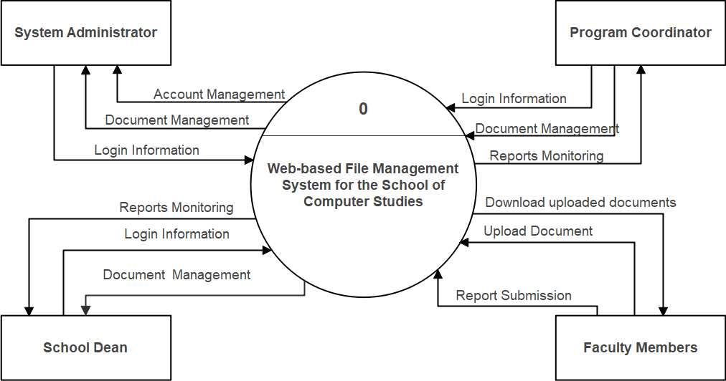

Figure 3. Context Diagram of Web-based File Management System

for School of Computer Studies

Figure 3 illustrates the context diagram. The context diagram is used to define the context and boundaries of the system to be developed. The flow of information between the systems and external entities is also represented in this diagram. System Administrator, School Dean, Program Coordinator, and Faculty Members are the four entities depicted in this figure.

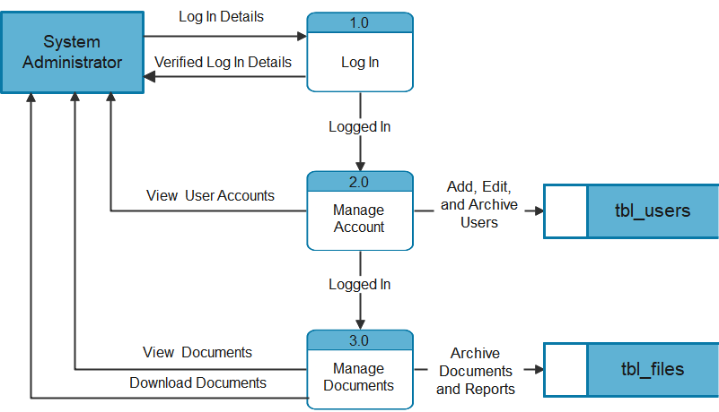

Figure 4. Data Flow Diagram of System Administrator Entity

Figure 4 represents the way in which the system administrator interacts with the system. As part of account administration, the System Administrator can view, add, edit, and archive user accounts after logging into the system. In addition, the System Administrator can view and archive reports for document management. During the process, the database will handle all of the data.

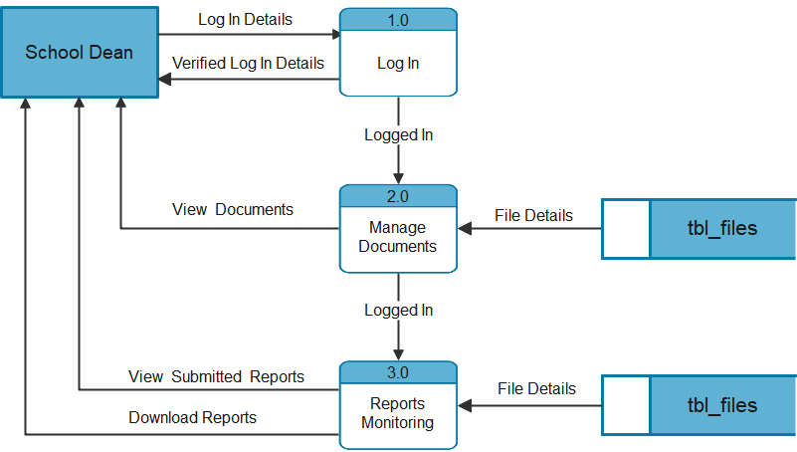

Figure 5. Data Flow Diagram of School Dean Entity

Figure 5 illustrates how the School Dean works within the system; the School Dean will be in charge of all documents, as well as the monitoring of reports submitted through the system. The reports that have been filed can also be managed and downloaded by the dean.

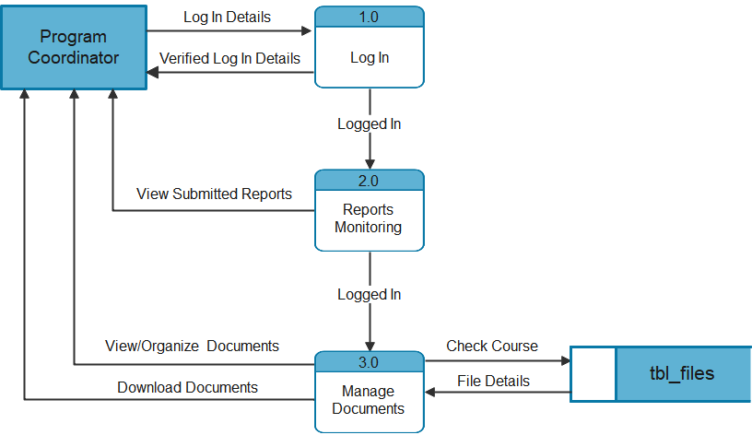

Figure 6. Data Flow Diagram of Program Coordinator Entity

Figure 6 represents the Program Coordinator's role in the system. The BSIT and BSCS departments have their own program coordinator. After logging into the system, the Program Coordinator can manage papers and monitor submitted reports based on the course they are responsible for.

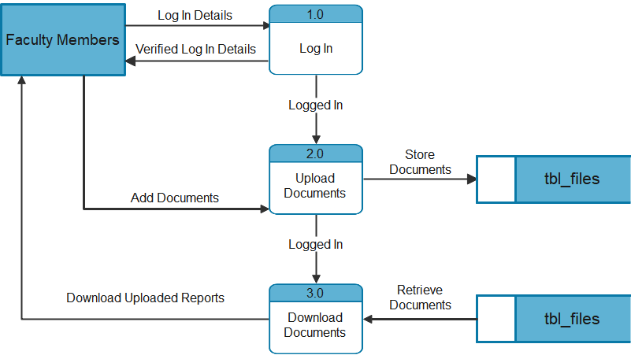

Figure 7. Data Flow Diagram of Faculty Members Entity

Figure 7 depicts how faculty members engage with one another throughout the system. Faculty members have the ability to upload and download materials. The uploading of documents includes the submission of all the reports.

**Project Methodology**

The Scrum Methodology will be utilized to conduct the research. It provides simple ways for completing difficult jobs. Because there will be a daily update, this is the most appropriate method for the study.

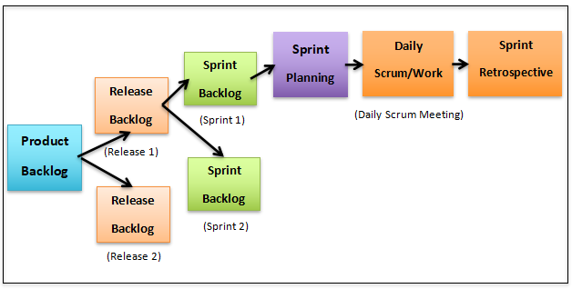

Figure 8. Scrum Processes (Hamilton, T., 2021)

**Product Backlog**

During this phase, the proponents will begin to consider what tasks the system could be able to provide for the School of Computer Studies. There will be a discussion of thoughts on the system's visualization at the meetings.

**Release Backlog**

In this phase, after the discussion on the plans for the system, each user story will be assessed to determine if it is appropriate for the proponent's current system.

**Sprint Backlog**

In this phase, the selected tasks from the system's Release Backlog will be listed in the order to move on to Sprint Planning. This will be the last step in identifying the system's appropriate features.

**Sprint Planning**

During this phase, the proponents will evaluate how everyone can contribute to the system and what activities they can complete in a given amount of time. It will be the stage when the entire team will combine their completed work on the tasks they were assigned.

**Daily Scrum/Work**

This phase will feature daily meetings where each proponent will give an update on their work after all of the planning. The entire team will also explain the difficulties they encountered while completing the work. Lastly, they will need to apply the concepts they learned in order to enhance the system, and they will review it at the next meeting.

**Sprint Retrospective**

In the final phase, the team leader will host a meeting and summarize what tasks everyone completed over the previous sprint. They'll also discuss the insights they gained after completing the entire process.

**System Operation and Testing Procedure**

The proposed system will be accessed via a web browser; once on the website, the authorized account given by the system administrator will be acceptable for access. Different actions can be taken depending on the user who logged in and what activity they are assigned to do.

**Testing Procedure**

The various kinds of testing procedures listed below will determine whether the current system is capable of meeting the needs of the intended users. To assure the system's quality, it must be tested. This must also be done in a methodical and sequential manner. The following types of testing will be performed for the checking of the developed system and is discussed as follows:

**Unit Testing**

This test will determine whether the system can be accessible from any platform. Since it will be built to be available on any device, the system will be capable of browsing through a Personal computer or a mobile phone.

**Integration Testing**

Each module will be tested in accordance with its intended function. Modules will be integrated after they have been evaluated to see if the system can do the functions that the proponents desire.

**Acceptance Testing**

In this test, the proponents will present the system to an individual user in order to know about his or her impressions of the system. Because this is part of the software testing process, problems may arise, and the user can offer suggestions to improve the system's capabilities.

**Performance Testing**

This test will verify whether the system is responsive and capable of meeting the requirements. This will assist the proponents in determining to see if the system will perform in a short amount of time, as well as the system's scalability and stability.

**System Testing**

Following all separate tests conducted, the system will be evaluated as a whole to see if each module will function properly as well as to avoid problems once the system is used by the specified number of users.

**Evaluation Procedure**

The proponents will review all of the necessary things/factors that will be required in the completion of the system based on the preliminary evaluation. The results will be analyzed to see if the target output can be achieved with the current input. Respondents will be provided the final evaluation sheet. The system is improved and enhanced as a result of the comments, suggestions, and recommendations.

The Slovin’s Formula will be used to calculate the sample size given the population (N) and a margin of error (e). It is a random sampling technique formula to estimate sampling size.

Slovin’s formula will be used in determining the number of respondents and the formula that will be used is written below:

N N = population size

n = ----------------

1 + Ne2  e = margin of error

Table 1 shows the numeric rating and its equivalent interpretation to scale the results of project evaluation.

Table 1. System Evaluation Sheet Numerical and Descriptive Scale

|  |  |  |
| --- | --- | --- |
| **NUMERICAL**  **RATING** | **INTERPRETATION** | **DEFINITION** |
| 4.21 - 5.00 | Excellent | The system fully meets and far exceeds  the most expectations. |
| 3.41 - 4.20 | Very Good | The system fully meets all and exceeds  several expectations. |
| 2.61 - 3.40 | Good | The system fully meets all expectations. |
| 1.81 - 2.60 | Fair | The system does not fully meet all  expectations. |
| 1.00 - 1.80 | Poor | The system fails to meet expectation to a  significant degree in several areas |

**REFERENCES**

Alokluk, Jamilah. (2019). Archiving and Document Management at Taibah University: A Case Study. Computer and Information Science. 12. 11. 10.5539/cis.v12n4p11.

Belarmino, J. B., Fetalvero, L. G., Javier, J. C. & Barrios, E. T.. (2014). DEVELOPING AN APPLICATION FOR MONITORING STUDENT ACADEMIC RECORDS. CLOUD, 2(1). Retrieved from http://ejournals.ph/form/cite.php?id=12626

Bergado, T. G., Esclamado, J. , Godinez, M. M., Isaga, R. E. & Magallen, K. D.. (2020). Computerized Medical Record and Monitoring System of Saint Michael College of Caraga, Philippines. SMCC INTERDISCIPLINARY JOURNAL, 1(1). Retrieved from http://ejournals.ph/form/cite.php?id=15869

Bill Winterberg., 2013. Five misconceptions about document management.www.fpanet.org/journal/ .../56 – 97.

Caswell, Michelle. (2010). Khmer Rouge archives: Accountability, truth, and memory in Cambodia. Archival Science. 10. 25-44. 10.1007/s10502-010-9114-1.

Claro, D. , Libron, K. , Songcayauon, K. & Masillones, J. . (2013). Records Management Information System with SMS Notification System. CLOUD, 1(1). Retrieved from http://ejournals.ph/form/cite.php?id=6114

Daculla K., Digo M. C., Javier E. A., Mojica J. M., Noche J. C., E-memo Archiving for City College of Tagaytay, 2017.

Desingaño E., Desingaño S. D., Valentino A., Development of a Web Application System for the Archiving of Learning Module for the Program Offered by the School of Computer Studies, 2017.

Esser, D. (2013, January). Cooperative and Fast-Learning Information Extraction from Business Documents for Document Archiving. In On the Move to Meaningful Internet Systems: OTM 2013 Workshops (pp. 22-31). Springer Berlin Heidelberg.

Fahmy, N. Haslinda, W. Roslina, and Z. Fariha, “Evaluating the quality of software in e-book using the ISO 9126 model,” International Journal of Control and Automation, vol. 5, no. 2, 2012.

Lim N., Erce R. M., Sicap E. J., Ambat C. V., Development of Thesis Archive for School of Computer Studies (TARSCS), 2016.

1. Bari and R. Djouab, “Software quality and e-learning,” presented at International Conference on e-Education, Mostar, Bosnia and Herzegovina, September 26-27, 2014

Marion Devouassoux, João Fernandes, Bob Jones, Ignacio Peluaga Lozada, ARCHIVER - Data archiving and preservation for research environments. Jakub Urban. EPJ Web Conf. 251 02044 (2021). DOI: 10.1051/epjconf/202125102044

Mukred, Z. M. Yusof, F. M. Alotaibi, U. A. Mokhtar and F. Fauzi, "The Key Factors in Adopting an Electronic Records Management System (ERMS) in the Educational Sector: A UTAUT-Based Framework," in IEEE Access, vol. 7, pp. 35963-35980, 2019, doi: 10.1109/ACCESS.2019.2904617.

1. P. Kotze et al., “ISO 9126 external systems quality characteristics, sub-characteristics and domain specific criteria for evaluating e-learning systems,” presented at SACLA Conference, 2010.

Salvador, J. E. & Canencia, O. P.. (2015). The Monitoring and Evaluation Tool of the Department of Education. IAMURE International Journal of Education, 13(1). Retrieved from http://ejournals.ph/form/cite.php?id=3445

Tubongbanua, J. P., Dahilan, K. V., Sagun , K. A. & Ruiz, J. L.. (2017). Web- Based Information and Monitoring System of Cagayan de Oro City Academy for International Education. SMCC Higher Education Research Journal, 5(1). Retrieved from http://ejournals.ph/form/cite.php?id=13825

**E-Sources**

<https://www.scribd.com/document/360761818/Abstract-of-Online-Thesis-Archiving-System-for-University-of-Makati>

<https://www.academia.edu/2601142/ThesisFS_Online_Document_Management_System>

https://www.academia.edu/29216348/CHAPTER_II_Review_of_Related_Literature_and_System

<https://www.skynet-digital.com/isvo-oracle-systems/document-filing-monitoring-system>

https://capstoneguide.com/school-management-system-capstone-project-document/

https://citeseerx.ist.psu.edu/viewdoc/download?doi=10.1.1.1076.8366&rep=rep1 &type=pdf

<https://www.javatpoint.com/xampp>

<https://codeinstitute.net/blog/what-is-php-programming/>

<https://www.javatpoint.com/mysql-tutorial>

[https://www.bigcommerce.com/ecommerce-answers/what-css-and-why-it- important/](https://www.bigcommerce.com/ecommerce-answers/what-css-and-why-it-important/)

<https://www.educative.io/edpresso/what-is-visual-studio-code>

<https://www.educative.io/blog/what-is-jquery-javascript-library>

<https://skillcrush.com/blog/what-is-ajax/>