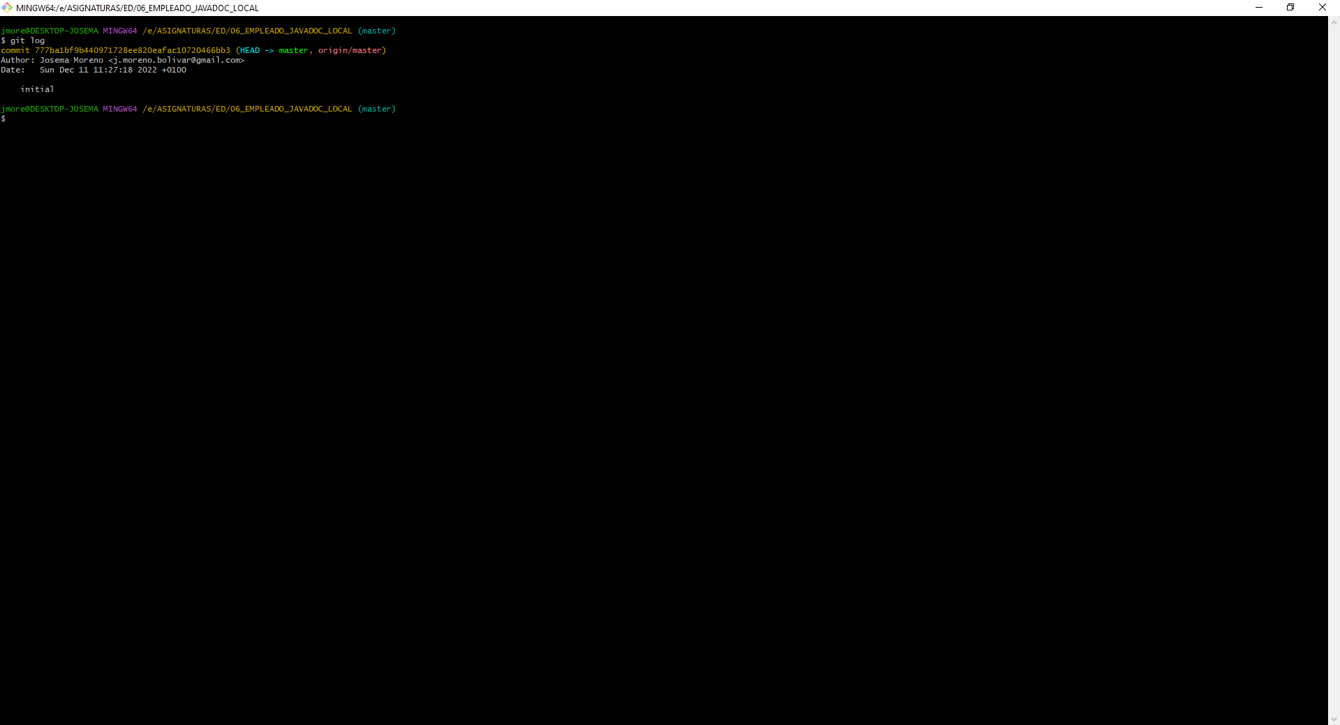
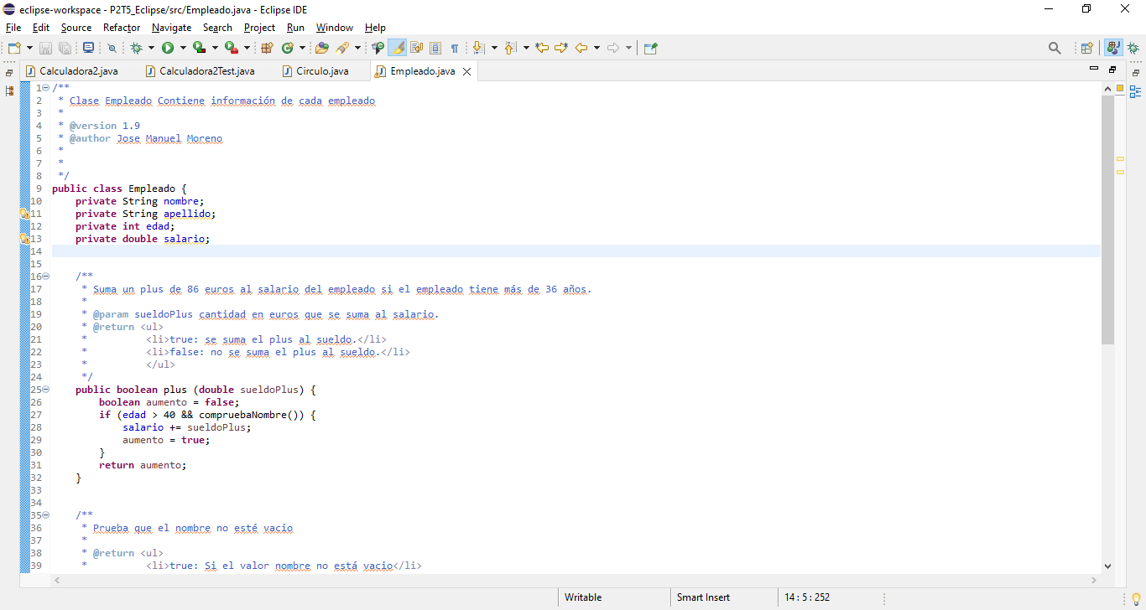 | 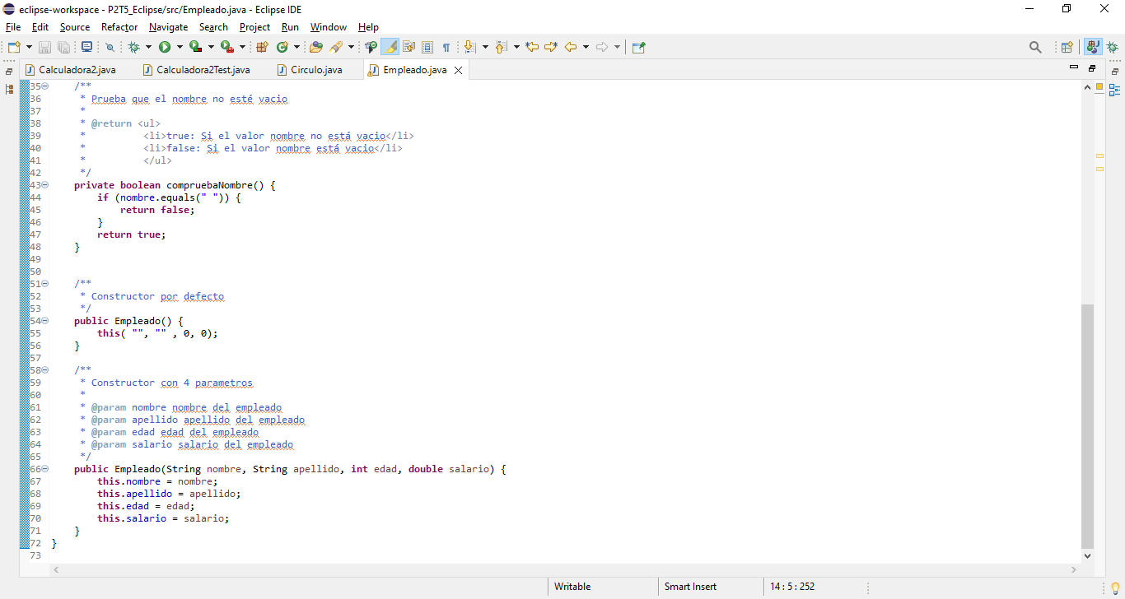
- https://github.com/JosemaVlc/06_EMPLEADO_JAVADOC
- https://josemanuelmorenojavadoc.netlify.app/

