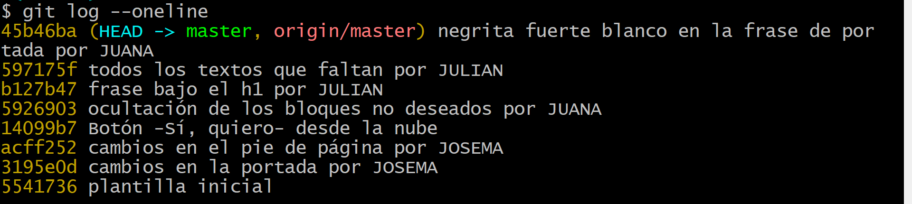
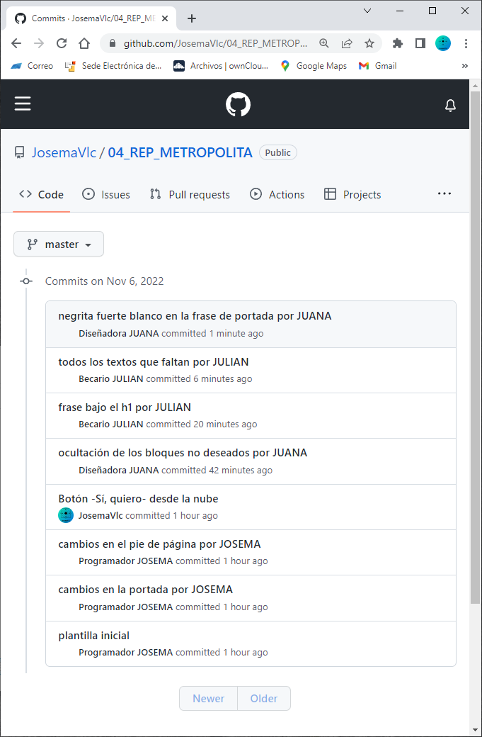 | 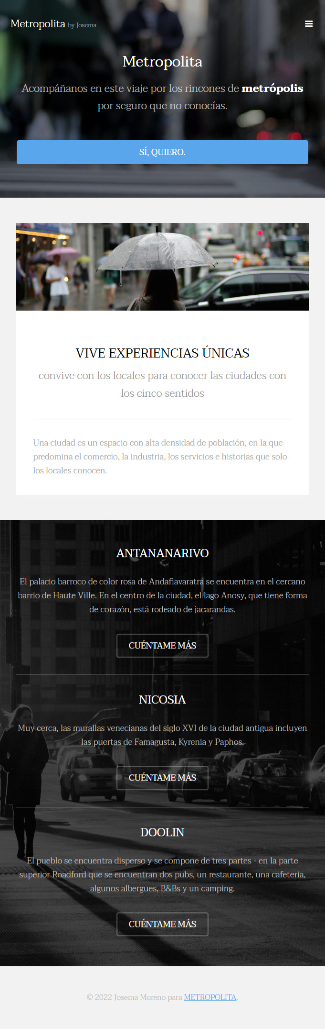
- https://github.com/JosemaVlc/04_REP_METROPOLITA
- https://metropolita-josemamoreno.netlify.app/

