SQLite is a **server-less** database and it is a light **file storage** database.

For C++ development, need to get the header file and generate the lib manually. Following is the steps.

* Header file

need to download the source code(sqlite-amalgamation-****.zip) through official web: <https://www.sqlite.org/download.html>

The zip file contains 4 files: shell.c, sqlite3.c, sqlite3.h, sqlit3ext.h

* Library

Use visual studio tools to generate the library.

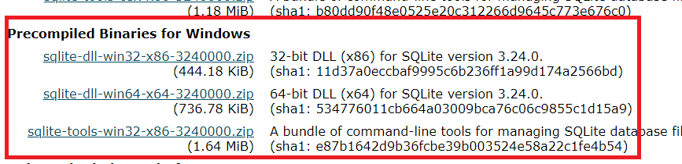

* Download the dll(take windows as a example: download sqlite-dll-win32-x86-****.zip). That zip file contains 2 files: sqlite3.dll and sqlite3.def
* Unzip the folder and copy the VS tools to the unzip folder(lib.exe, link.exe, mspdb140.dll which are located in %visual Studio%\VC\Tools\MSVC\14.10.25017\bin\HostX86\x86)
* Execute “lib.exe   /MACHINE:IX86    /DEF:sqlite3.def     /OUT:sqlite3.lib”. 2 files are generated - sqlite3.exp and sqlite3.lib