1. Download and install VS Code

<https://code.visualstudio.com/Download>

1. Install c/c++ extensions

* Open VS Code
* Select C++ extensions and install them.

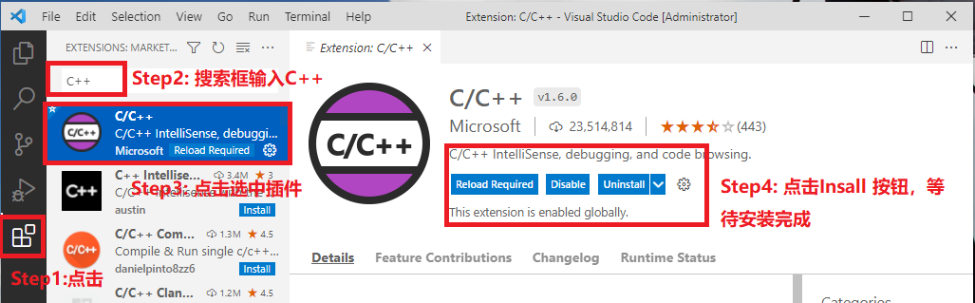

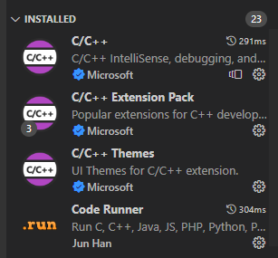

1. Download MSYS2 to install gcc.exe, g++.exe and gdb.exe

<https://www.msys2.org/>

Follow above instruction to install all three of them(gcc, g++, gdb).

1. Setup system environments

Path：

32bit：C:\msys64\mingw32\bin

64bit：C:\msys64\mingw64\bin

Add new environment variables for mingw:

MINGW_HOME ：C:\msys64\mingw64

C_INCLUDE_PATH ：%MINGW_HOME%\include

LIBRARY_PATH ：%MINGW_HOME%\lib

Use below command to check if they are installed correctly.

gcc --version

g++ --version

gdb --version

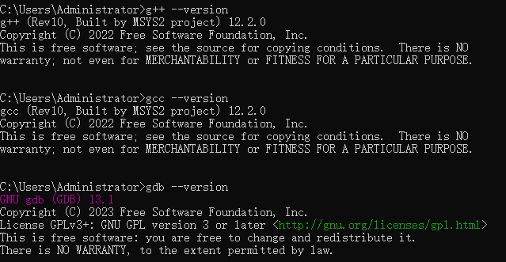

Note: The version of gdb, gcc and g++ need to be consistent. Otherwise, it may have some issues when use gdb.

1. Add a new file and add code as below.

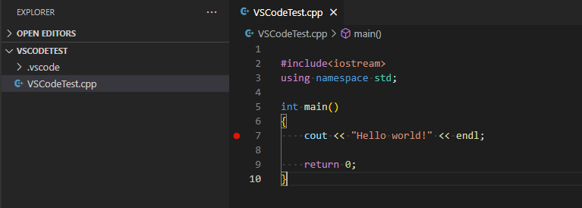

1. Build cpp file

Select a active cpp file -> Ctrl + Shift + P -> Run build task -> select g++.exe as compiler

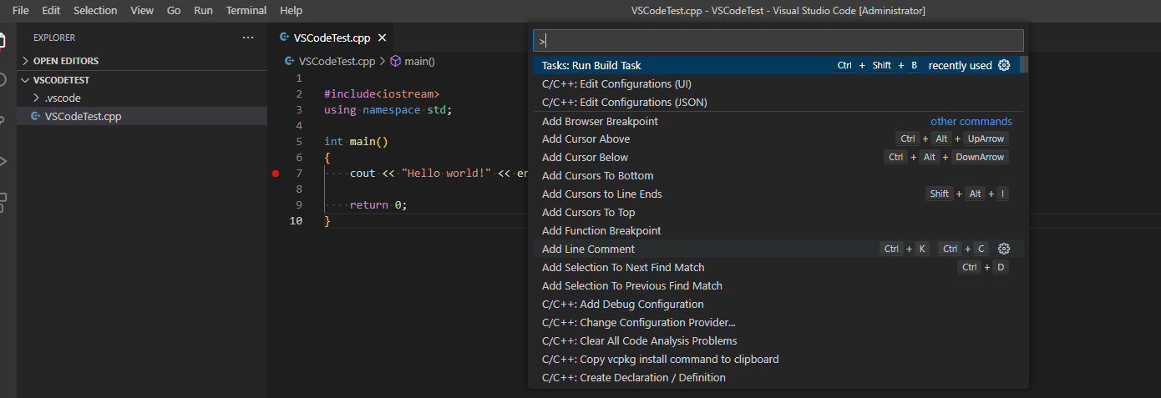

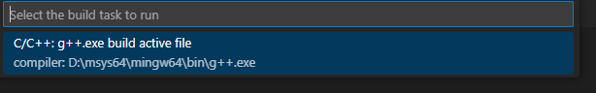



1. Debug

Select c++ code file(cpp file) -> F5 -> select g++.exe build and debug active file.

