|  |
| --- |
|  |

|  |
| --- |
|  |





User Requirements Specifications

By Atomic Peanuts ©

Date: 21-February-2020

Location: Fontys, Eindhoven

Tutor: Qin Q. Zhao

Louis Kareem Cocks (Project Leader & Developer) S.N: 3954358

Jose Navarrete Carbonell (Developer) S.N: 3917533

Alexander Vartic (Developer) S.N: 4030435

Menderes Saçli (Developer) S.N: 3838439

Table of Contents

Agreements with client 2

Functional Requirements 3

Use Cases 4

Use Cases 5

[GUI One 6](https://stichtingfontys-my.sharepoint.com/personal/440569_student_fontys_nl/Documents/semester_2_project/URS_document.docx#_Toc34084807)

[GUI Two 7](https://stichtingfontys-my.sharepoint.com/personal/440569_student_fontys_nl/Documents/semester_2_project/URS_document.docx#_Toc34084808)

[GUI Three 8](https://stichtingfontys-my.sharepoint.com/personal/440569_student_fontys_nl/Documents/semester_2_project/URS_document.docx#_Toc34084809)

[GUI Four 9](https://stichtingfontys-my.sharepoint.com/personal/440569_student_fontys_nl/Documents/semester_2_project/URS_document.docx#_Toc34084810)

[GUI Five 10](https://stichtingfontys-my.sharepoint.com/personal/440569_student_fontys_nl/Documents/semester_2_project/URS_document.docx#_Toc34084812)

Some of the agreements we have with our client is that we are going to deliver a desktop application by the 27th of March and the website by 8th of May 2020.

# Agreements with client

1. The app should provide a user-friendly interface to let a user easily view statistics and the work schedule.
2. A user should be able to view and update their personal information.
3. A user should be able to add an employee to the system.
4. A user should be able to edit an employee in the system.
5. A user should be able to delete an employee from the system.
6. A user should be able to view an employee in the system.
7. A user should be able to assign an employee to a shift.
8. A user should be able to send a complaint to the manager.
9. The app should notify the user if an employee is not available for a shift.
10. A user should be able to login with their email and password.
11. A user should be able to logout from the application.

# Functional Requirements

Use case: Assigning employees to shifts

# Use Cases

Actor: Manager

Main Success Scenario:

1. A manager clicks on an employee from the table.
2. Manager gets a message.
3. System opens a new form with employee information.
4. Manager selects time and date to from the dropdown list and calendar.
5. The system confirms that employee is assigned to shift.

Extensions:

2a. Question to assign an employee

1. Manager choose to assign an employee
2. Continue to MSS step 4.
3. Manager choose to cancel the action.
4. Return to MSS step 1.

4a. Form to assign employee

1. If there’s no data, the system will give an error.
2. If the employee is not available, the system will suggest a reserved employee.
3. If data is available and employee is assigned to a shift, the system will display message indicating success of the action.
4. End of use case.

Use case: Viewing employees

Actor: User

Main Success Scenario:

1. User selects a date from the date calendar.
2. The table displays all shifts.

Use case: Deleting an employee

Actor: Manager

Main Success Scenario:

1. Manager selects an employee from the display.
2. Manager clicks on the fire an employee button.
3. System displays a pop-up window.
4. System displays a message that user is successfully removed from the system.

Extensions:

3a. Pop-up window asking the manager to confirm decision

1. Manager clicks yes
2. Continue to MSS step 4.
3. Manager clicks no
4. Return to MSS step 2

Use case: Updating an employee’s information

Actor: Manager

Main Success Scenario:

1. Manager selects an employee from the display.
2. Manager clicks on the update an employee button.
3. System opens a new page with employee’s information.
4. Manager fills input with relevant information.
5. Manager clicks on the done button.
6. System displays a successful message.

Use case: Adding an employee to the system

Actor: Manager

Main Success Scenario:

1. Manager clicks on the add an employee button.
2. System opens a new page with empty fields.
3. Manger fills input with relevant information.
4. Manager clicks on the ‘done’ button.
5. System displays a successful message

# Use Cases

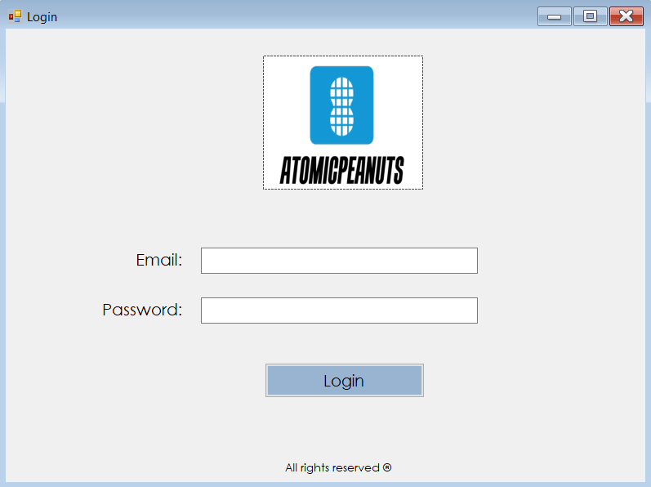

# GUI One

* Login page. User logs into the application with his/her credentials.

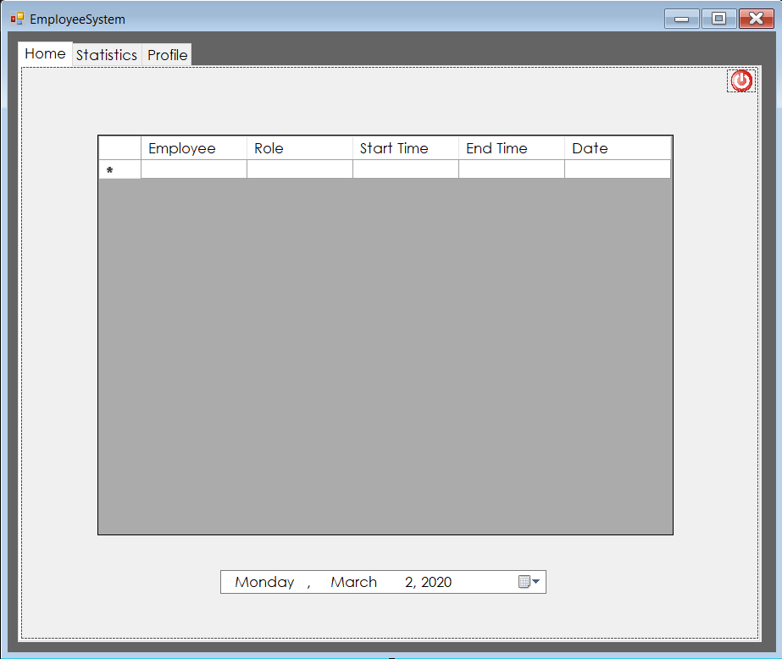

* After logging in, the user will get a schedule overview where they can view all work shifts. In this case, the user is an employee.

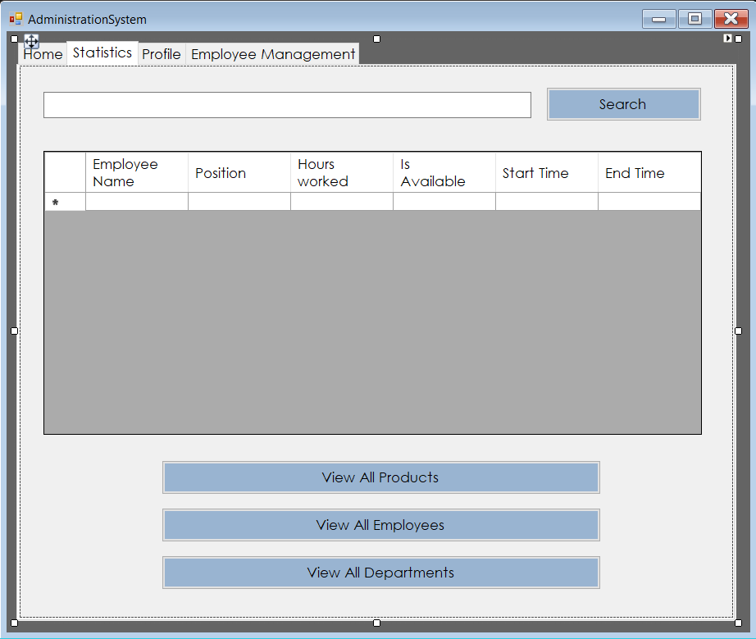

# GUI Two

* The user (Employee or Manager) can choose to view the statistics by clicking the statistics tab.

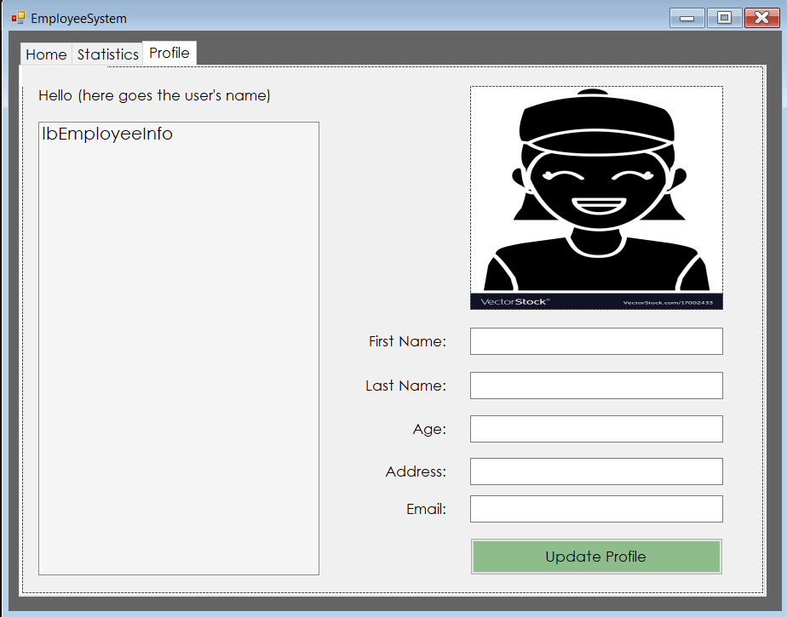

* The user (Employee or Manager) can view their profile or choose to update personal information by filling in the textboxes and clicking update profile.

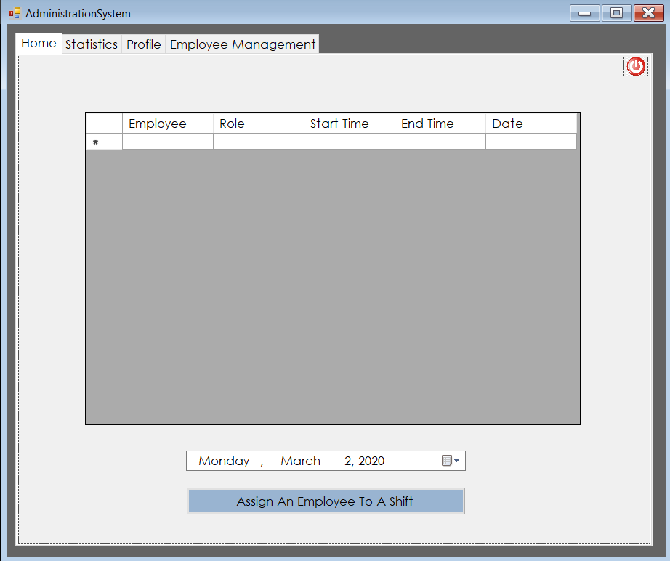

# GUI Three

* After the manager logs in, they will get an overview of the schedule.   
  As manager, they would be able to view all work shifts or assign an employee to a shift.

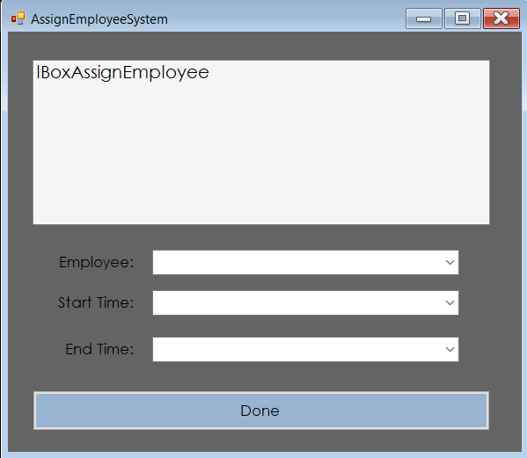

* When manager clicks on the ‘Assign an employee to a shift’ button. This page will open, where the manager can assign an employee.

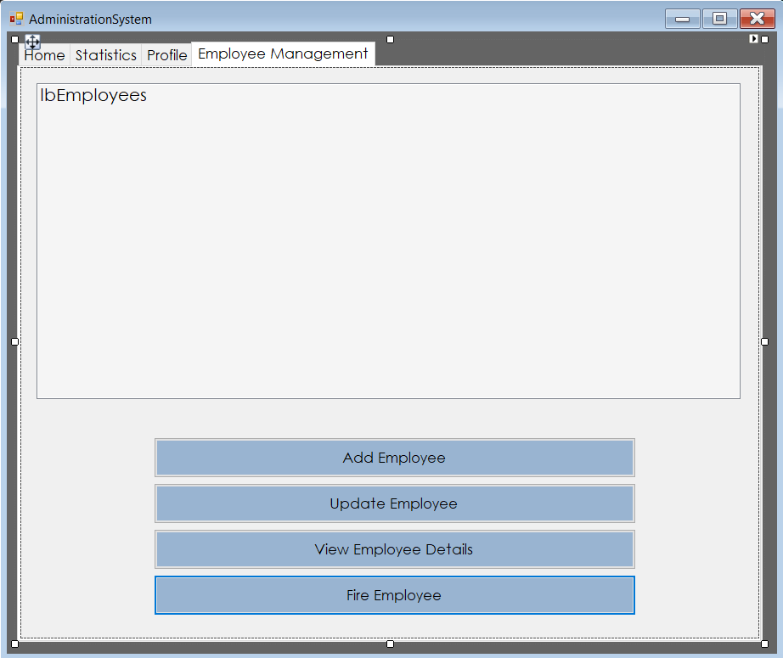

# GUI Four

* On the employee management page, the Manager can add, update, view or remove an employee.

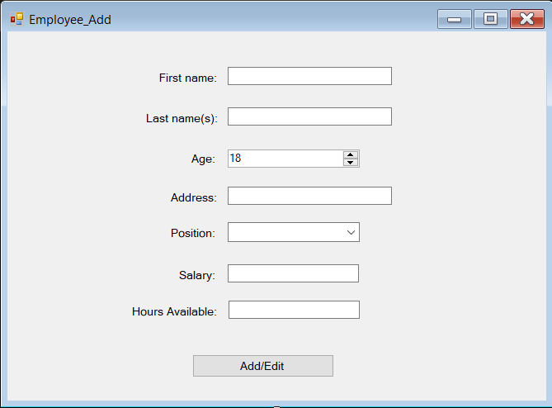

* After manager clicks on the ‘Add employee’ button. The system will open this page, where the manager can add an employee to the system.

# 

# GUI Five

* After manager selects an employee from the display and clicks on the ‘View employee details’ button. The system will open this details page.