

Demo Company

Security Assessment Findings Report

Date: November 19th, 2022

# Contact Information

|  |  |
| --- | --- |
|  |  |

|  |  |  |
| --- | --- | --- |
| Name | Title | Contact Information |
| **NUWE x Schneider Electric** | | |
| Josep Añó Gosp | Josep_glic | Email: josepengineer@gmail.com  Github: |
| Alos | CallMeR00t | Email: carlosalos1995@gmail.com  Github: |
| Sonia | Soni | Email: so.peinadoasensi@gmail.com  Github: |

# Finding Severity Ratings

The following table defines levels of severity and corresponding CVSS score range that are used throughout the document to assess vulnerability and risk impact.

| Severity | CVSS V3 Score Range | Definition |
| --- | --- | --- |
| Critical | 9.0-10.0 | Exploitation is straightforward and usually results in system-level compromise. It is advised to form a plan of action and patch immediately. |
| High | 7.0-8.9 | Exploitation is more difficult but could cause elevated privileges and potentially a loss of data or downtime. It is advised to form a plan of action and patch as soon as possible. |
| Moderate | 4.0-6.9 | Vulnerabilities exist but are not exploitable or require extra steps such as social engineering. It is advised to form a plan of action and patch after high-priority issues have been resolved. |
| Low | 0.1-3.9 | Vulnerabilities are non-exploitable but would reduce an organization’s attack surface. It is advised to form a plan of action and patch during the next maintenance window. |
| Informational | N/A | No vulnerability exists. Additional information is provided regarding items noticed during testing, strong controls, and additional documentation. |

# Scope

|  |  |
| --- | --- |
| Assessment | Details |
| Security Audit | 18.170.119.133 |

## **Security Audit Findings**

Python script with privileges–switch.py(Severity)

|  |  |
| --- | --- |
| Description: | Vulnerable script in switch.py |
| Impact: | **High** |

**Exploitation Proof of Concept.**

**Python script has root permissions, and it can execute commands.**

**Remediation**

|  |  |
| --- | --- |
| Who: | IT Team |
| Vector: | Remote, Physical… |
| Action | Item 1: Deny root permisions  Item 2: Encrypt data in plain text, as it poses a high risk. |

## **Security Audit Findings**

Python code injection with root permissions – pseudo-terminal/switch.py (Critical)

|  |  |
| --- | --- |
| Description: | Python vulnerability code injection. The script contains commands that use the python library popen, this library allows using execute commands, just using this variable “banner_text” in Telnet connecting to 127.0.0.1:6969. Moreover, this script has root permissions. |
| Impact: | Critical |

**Exploitation Proof of Concept.**

**switch.py file is studied.**

**1-Python script has root permissions.**

**2- Studying the code the library uses the library popen. This allows to execute commands.**

**3- The place where the popen is executed inside the script is filled with variable strings to create a banner.**

**4- Using telnet following how the script works, the banner is changed using “banner -s”**

**5- Adding “string” && “command” to banner, it creates an injection of commands. Allowing using other commands and the root permissions creating an exploit.**

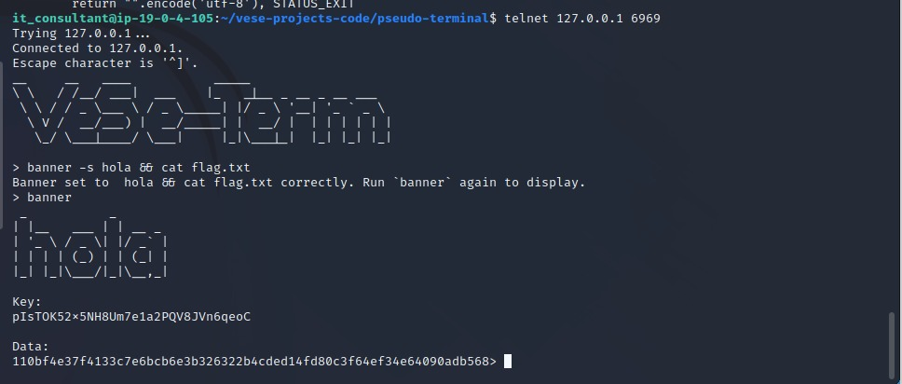

**Remediation**

|  |  |
| --- | --- |
| Who: | IT Team |
| Vector: | Remote, Physical… |
| Action: | Item 1: Deny root permisions  Item 2: Deleting return condition  Item 3: Deny telnet connection  Item 4: Put **cmd = False** to avoid execute more commands on the system  Additional Recommendations: Block the IP that tries to do the telnet |

## **Security Audit Findings**

Lick information – websites/internals/index.html (Severity)

|  |  |
| --- | --- |
| Description: | Licked data in login.php, main index.html. |
| Impact: | Low |

**Exploitation Proof of Concept.**

**1-Index.html inside /websites/internal/ has a form type, it calls a login.php action.**

**2- Login.php may be vulnerable to brute force attacks doing SQL injection on the login form.**

**Remediation**

|  |  |
| --- | --- |
| Who: | IT Team |
| Vector: | Remote, Physical… |
| Action: | Item 1: Deny root permisions  Item 2: Add lock after several attempts. For example: after X failures, lock the account for X minutes.  Item 3: Encrypt data in plain text, as it poses a high risk. |

## **Security Audit Findings**

Pcap command– dump_2022_11_19, tcpdump.pcap (Severity)

|  |  |
| --- | --- |
| Description: | Pcap, analyzes the traffic of the entire attack |
| Impact: | Informational |

**Exploitation Proof of Concept.**

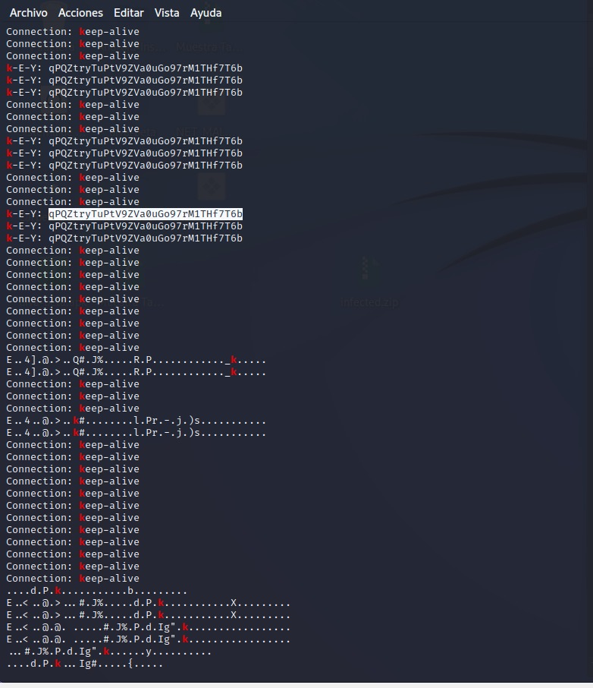

**Remediation**

|  |  |
| --- | --- |
| Who: | IT Team |
| Vector: | Remote, Physical… |
| Action: | Item 1: Deny root permisions  Item 2: Encrypt data in plain text, as it poses a high risk. |

## **Security Audit Findings**

SQL injection–http://internal.vese.com(Severity)

|  |  |
| --- | --- |
| Description: | Maridb database is vulnerable to SQL injection in login in the website http://internal.vese.com |
| Impact: | Critical |

**Exploitation Proof of Concept.**

1. **Login as admin’) OR (‘1’=’1 creates SQL Injection**
2. **This allows to introduce any kind of SQL command to obtain information needed**

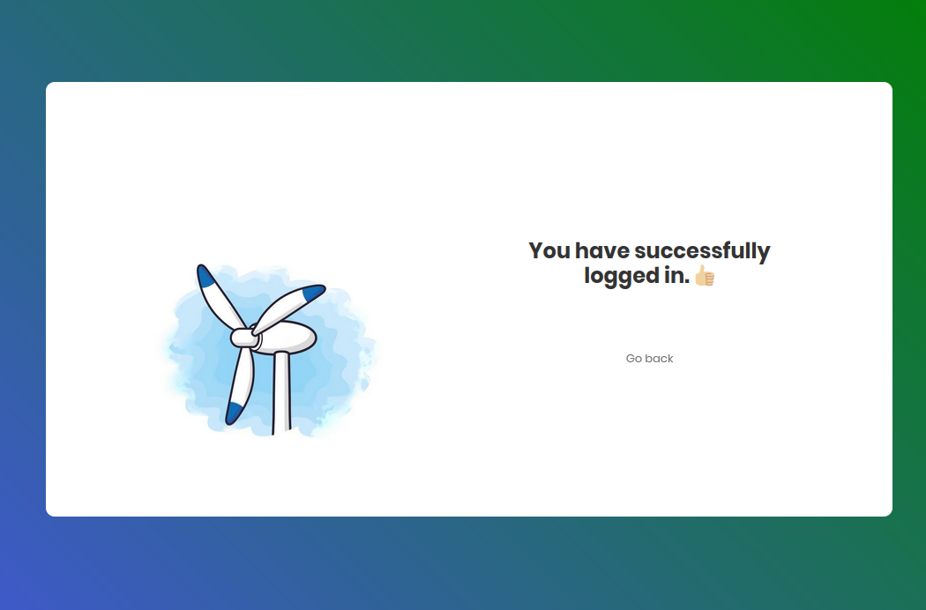

**Remediation**

|  |  |
| --- | --- |
| Who: | IT Team |
| Vector: | Remote, Physical… |
| Action: | Item 1: Update security version of Mariadb  Item 2: Not allow multiple login tries  Item 3: Block Ips who tries to login multiple time  Item 4: Block Ips by regex which try to SQL injection |

# Exploitation Paths

1. **Attackers get initial access via API web using SQL Injection in http://internal.vese.com**
2. **Obtain persistence inside the script test_comment.php, wih a shell reverse when parameters are introduced as fields name, mail, and comment in contact field in http://vese.com**
3. **They can execute commands with root privileges using a vulnerability in python code injection using the function “popen”, which allows executing code in OS. The script terminal.py had root privileges and was running.**