How to use our own MCP servers with Claude Desktop

First steps
- Download Claude desktop:
Download Claude
- Install, create an account and follow the steps from the program.

Create our first Local MCP Server
From the top-left menu select File, then select Settings, there you should see a setting with the name Developer, click on it and there you have the list of the Local MCP servers, for now it’s empty, but let’s create our first MCP server.
- Top-Left Menu -> File -> Settings -> Developer
Select Edit Config, you should be now on the Claude folder with the file claude_desktop_config selected, open it.
On this config file we’ll manage the different scripts that we want to run, for example here we’ll run 2 scripts when executing the Cloude app.
Change the folder line for whatever folder you want.
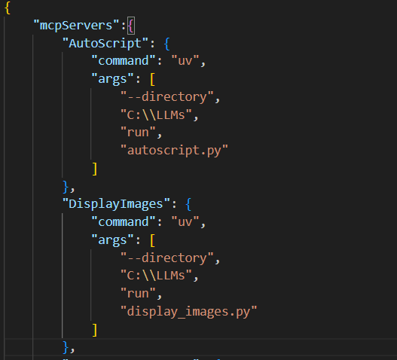
Now let’s see the configuration of the scripts in a general way.
First, we’ll have the dependences that are necessary to open the script.
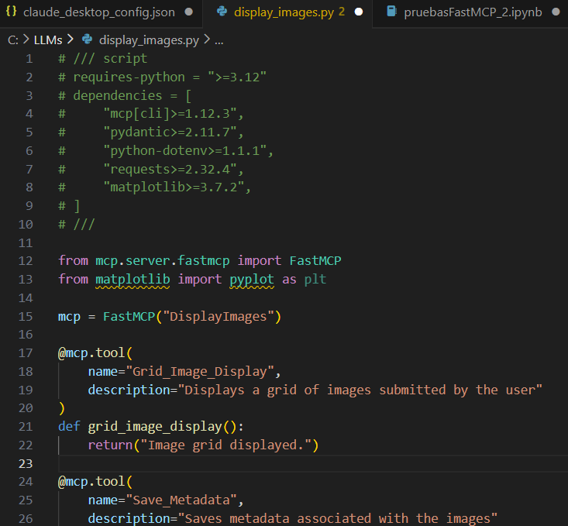
Then import the packages that are necessary for our code
Finally, the key of the mcp servers are the tools. For each function we’ll have a separate tool with his name and description in order to make the life easy for our ChatBot.
Here are some basic examples:
Be careful with the naming of the tools!!
From this repository we have some rules that we must follow when naming the tools:
- Tool names SHOULD be between 1 and 64 characters in length (inclusive).
- Tool names are case-sensitive.
- Allowed characters: uppercase and lowercase ASCII letters (A-Z, a-z), digits
(0-9), underscore (_), dash (-), dot (.), and forward slash (/).
- Tool names SHOULD NOT contain spaces, commas, or other special characters.
- Tool names SHOULD be unique within their namespace.
- Example valid tool names:
  - getUser
  - user-profile/update
  - DATA_EXPORT_v2
  - admin.tools.list

The only thing left to do is to change the functions for our own functions

