**1.Acquire the top 200,000 posts by viewcount**

Queries

1.select DISTINCT top 50000 * from posts where posts.ViewCount > 1000000 ORDER BY posts.ViewCount

Results are stored in QueryResults.csv

2.select DISTINCT top 50000 * from posts where posts.ViewCount > 100000 ORDER BY posts.ViewCount

Results are stored in QueryResults1.csv

3. select DISTINCT top 50000 * from posts where posts.ViewCount>58000 and posts.ViewCount <= 100000 ORDER BY posts.ViewCount

Results are stored in QueryResults2.csv

4. select count(*) from posts where posts.ViewCount>=31718 and posts.ViewCount <= 58000

5.select count(*) from posts where posts.ViewCount>41500 and posts.ViewCount <= 58000

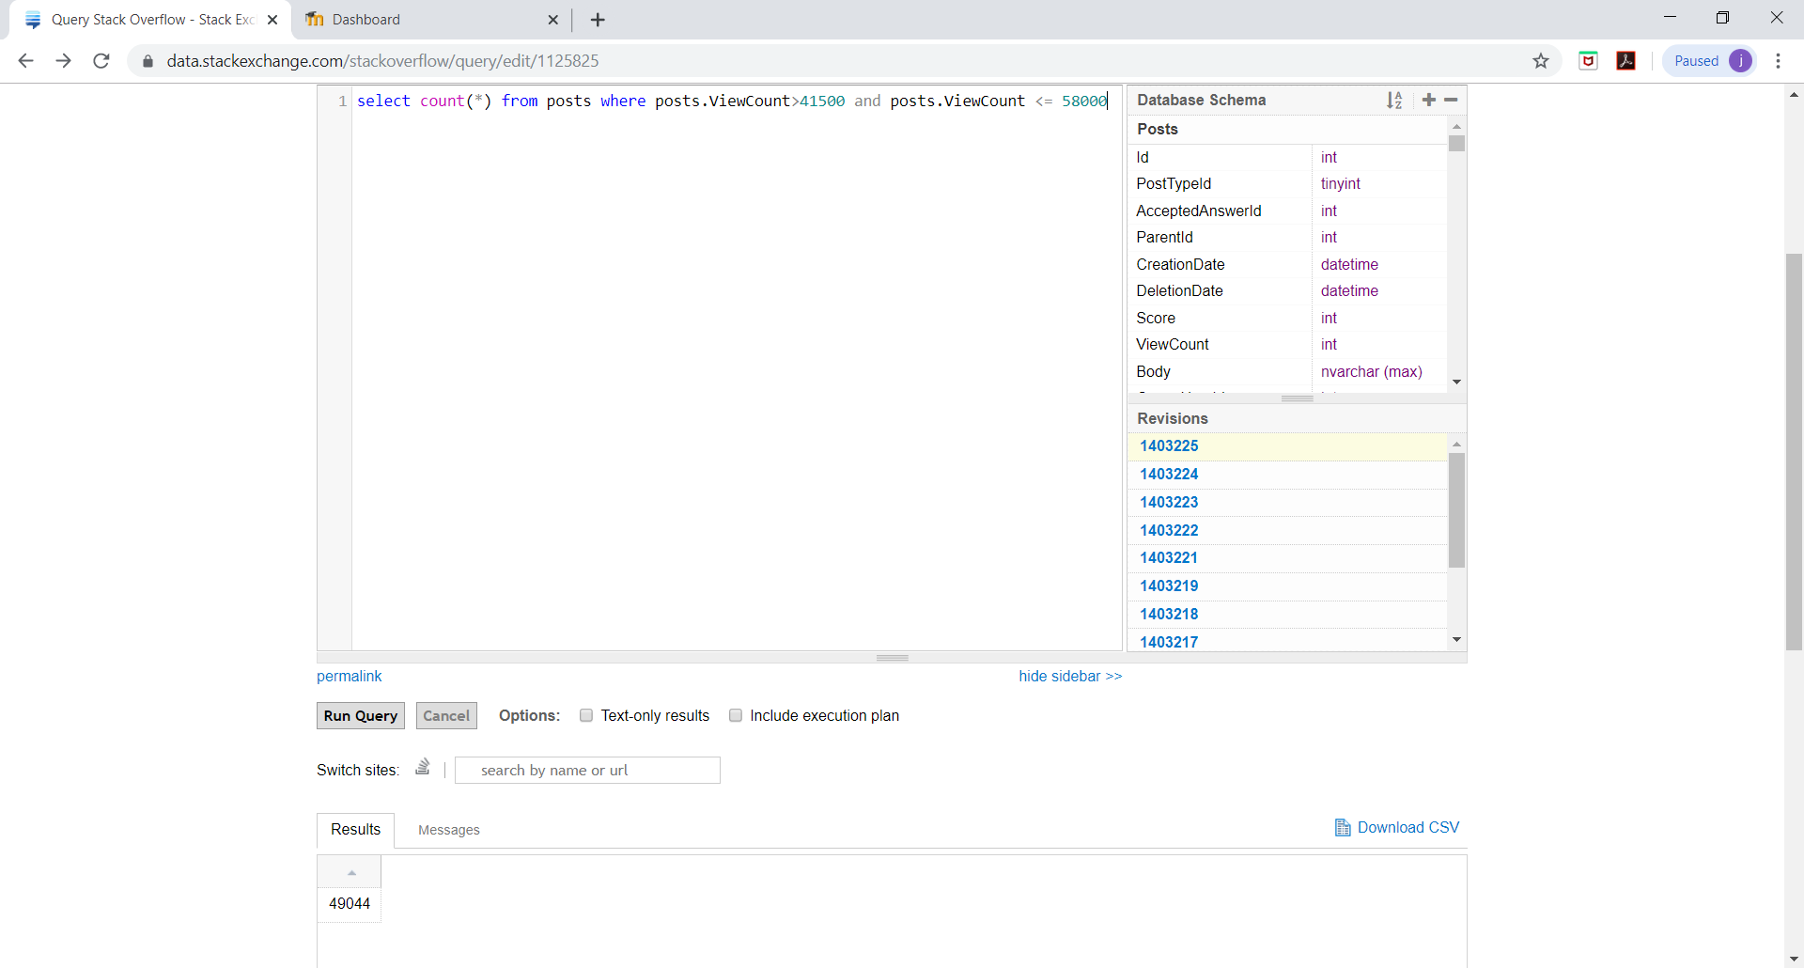

6. select DISTINCT top 50000 * from posts where posts.ViewCount>41500 and posts.ViewCount<= 58000 ORDER BY posts.ViewCount

Results are stored in QueryResults3.csv

7. select DISTINCT top 50000 * from posts where posts.ViewCount>33500 and posts.ViewCount<= 41500 ORDER BY posts.ViewCount

Results are stored in QueryResults4.csv

8. select count(*) from posts where posts.ViewCount>31747 and posts.ViewCount<=33500

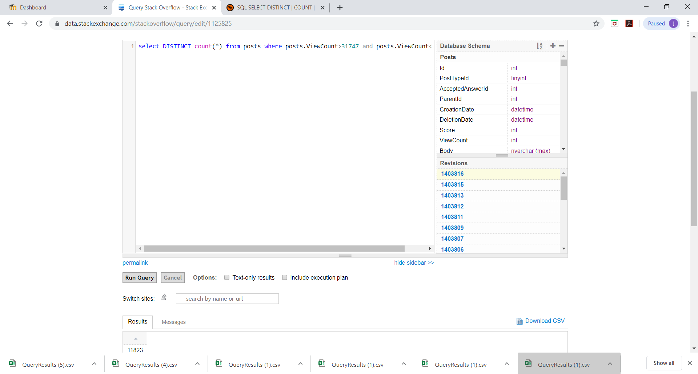

9.select DISTINCT top 50000 * from posts where posts.ViewCount>31747 and posts.ViewCount<=33500 ORDER BY posts.ViewCount

Results are stored in QueryResults5.csv

**TASK2**

Upload all the 5 csv files obtained from Stack Exchange into the local file system

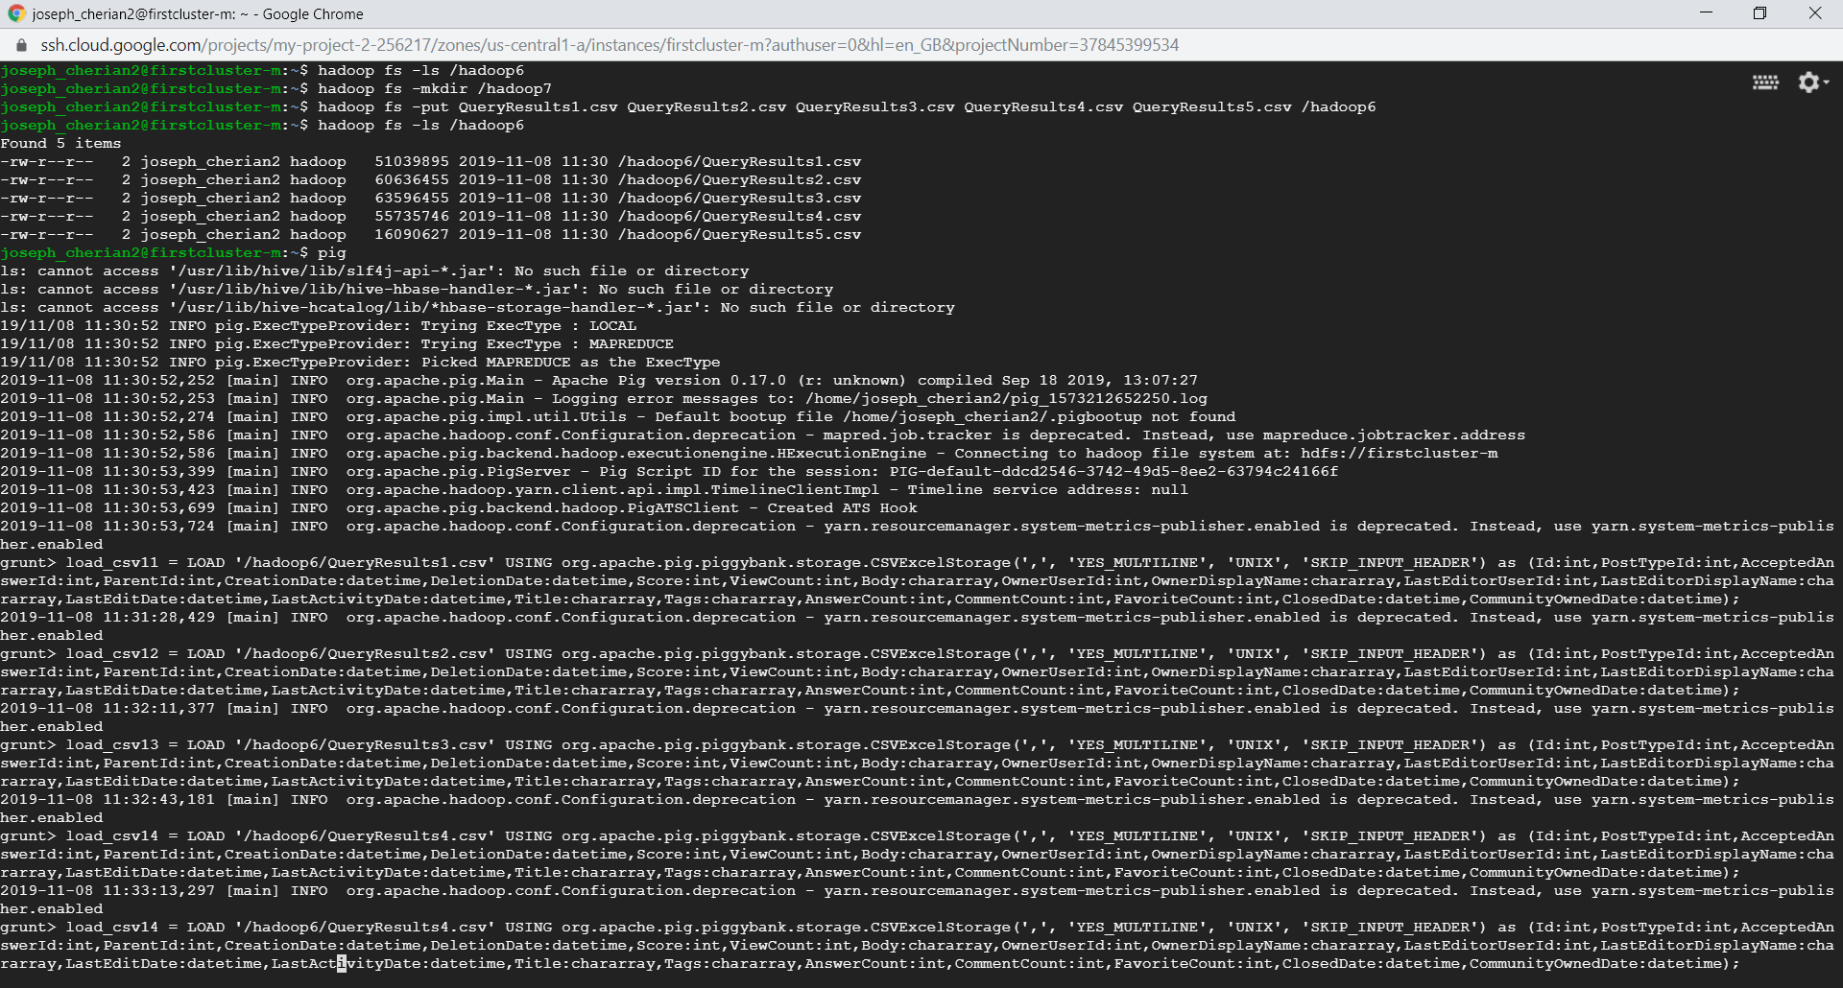

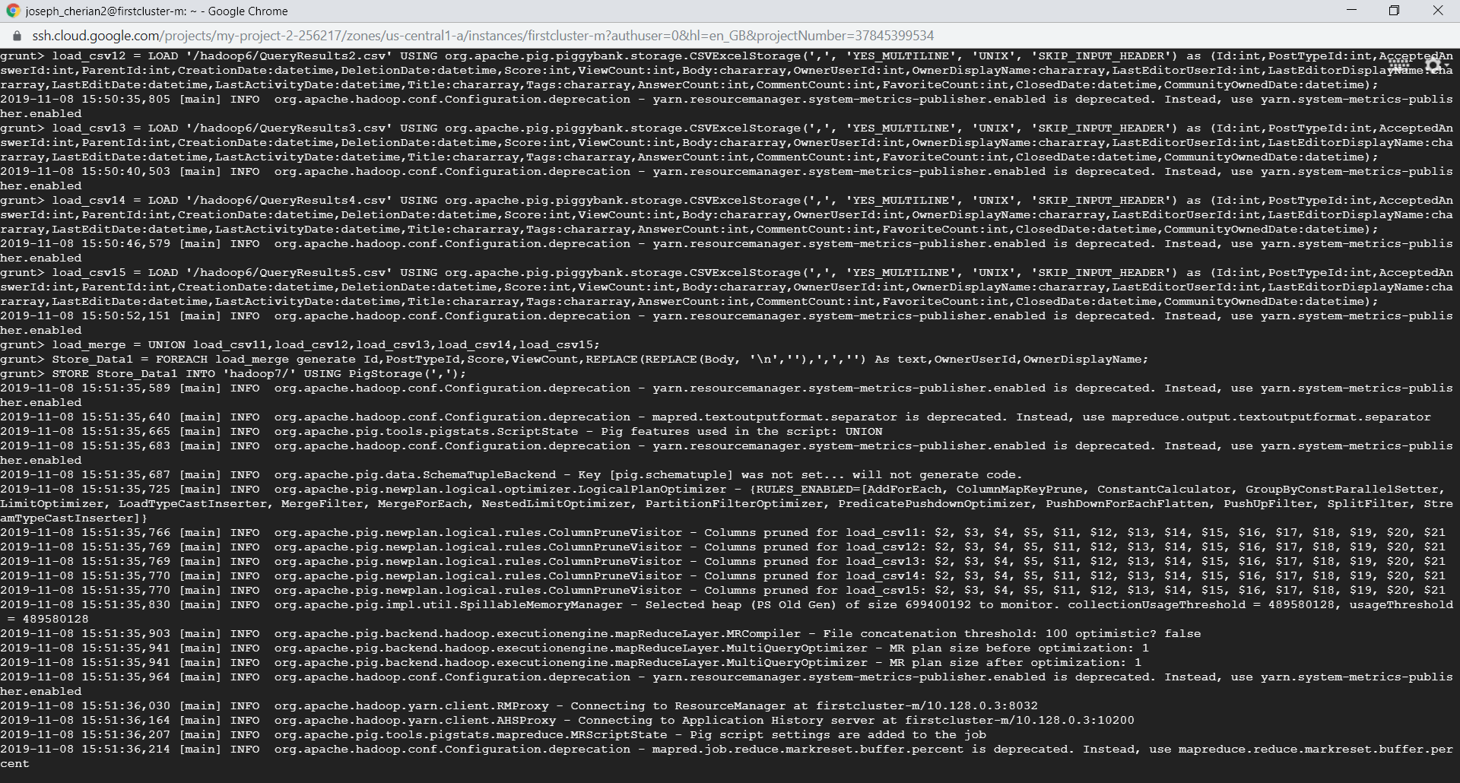

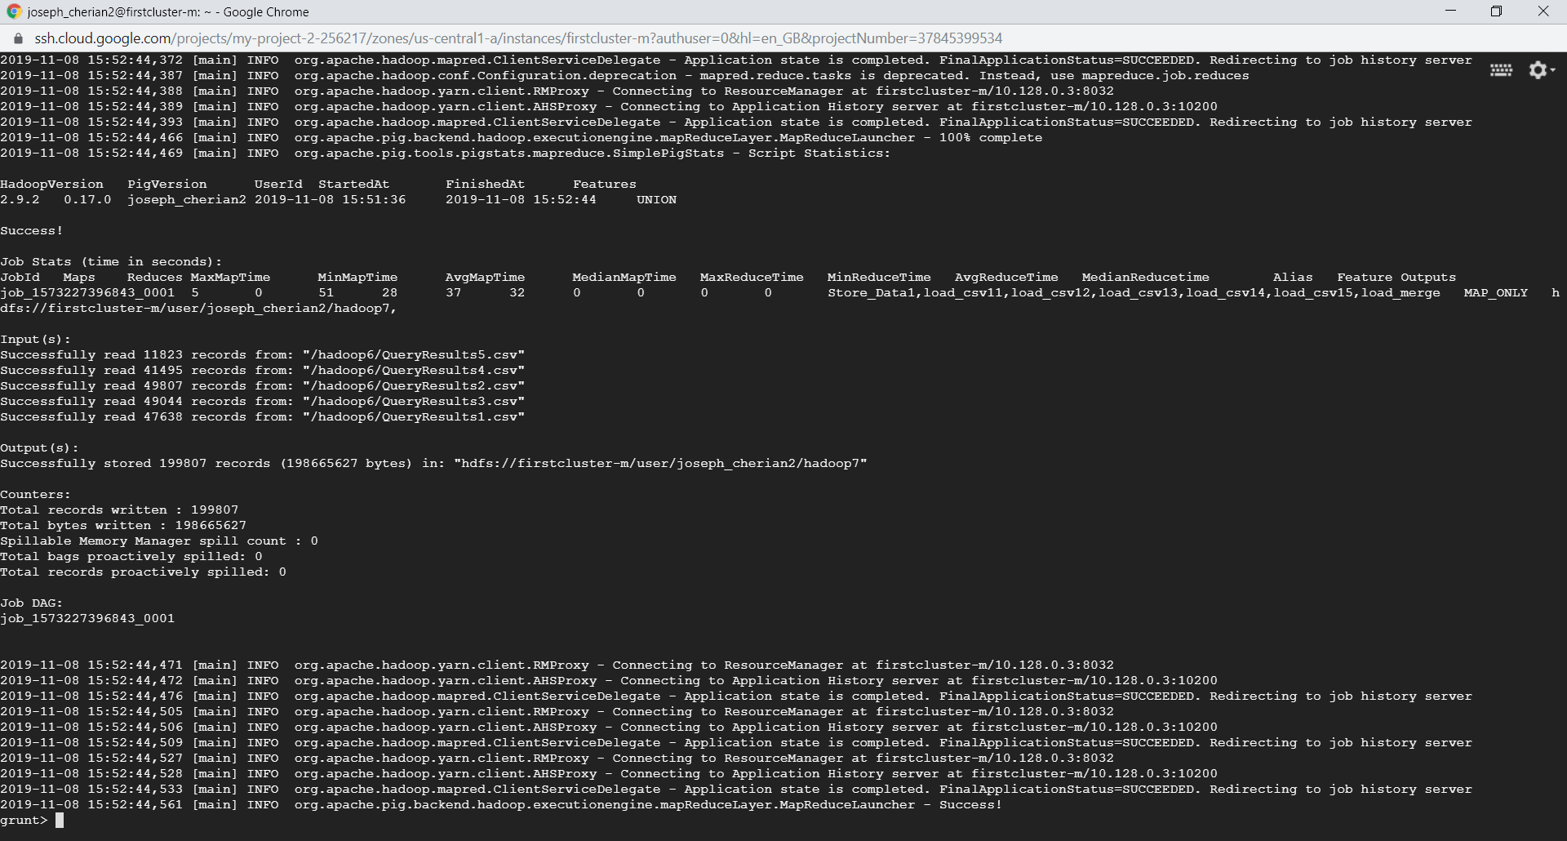

TASK3

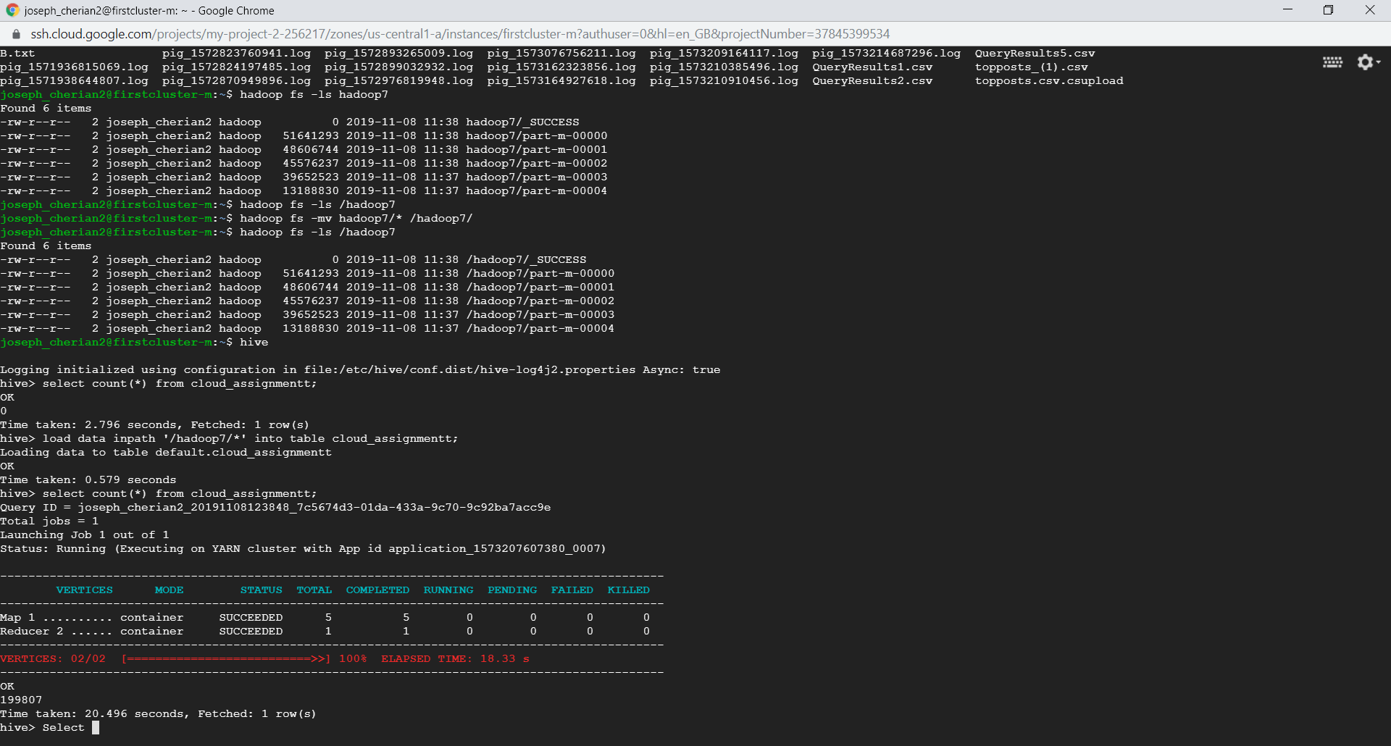

3.I.

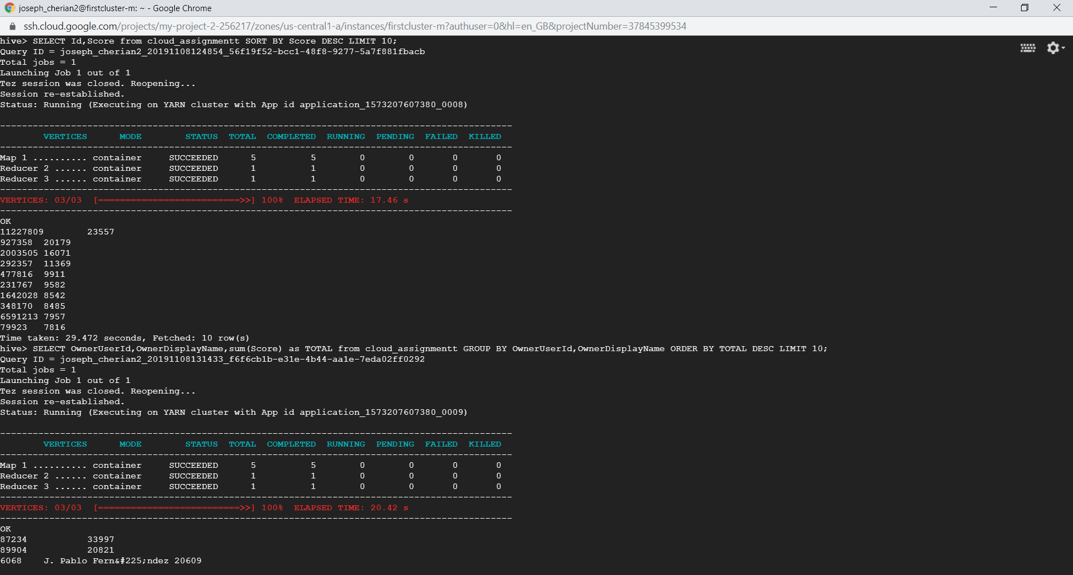

3.II.

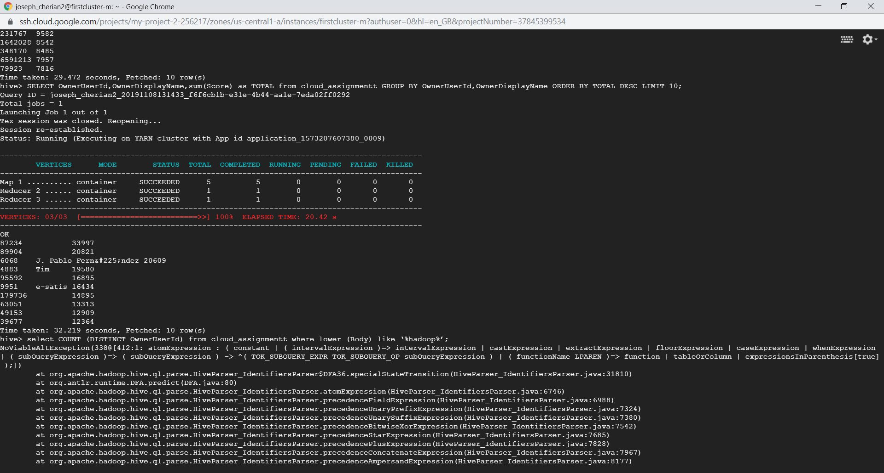

3.III.

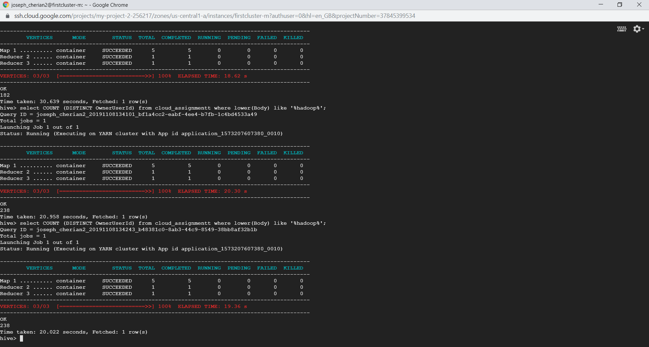

3.I.OUTPUT

11227809 23557

927358 20179

2003505 16071

292357 11369

477816 9911

231767 9582

1642028 8542

348170 8485

6591213 7957

79923 7816

3.II. OUTPUT

87234 33997

89904 20821

6068 J. Pablo Fern&#225;ndez 20609

4883 Tim 19580

95592 16895

9951 e-satis 16434

179736 14895

63051 13313

49153 12909

39677 12364

3.III.OUTPUT

238