Program Name
PawState:Real-Time Canine Emotion & Activity Monitoring via Collar IMU

Summary
Purpose and Overview:
Dogs are non-verbal. When a dog is anxious, stressed, or entering an alert-freeze state, the only signal is their body language—postural shifts, pacing, sudden stillness. PawState is a collar-mounted embedded application that reads these signals in real time to monitor a canine's emotional and behavioral state.
Features Summary:
A three-axis accelerometer and gyroscope (IMU) mounted in the collar samples data at 50 Hz. Using the μT-Kernel 3.0 RTOS, the system schedules four prioritized tasks: raw IMU sampling, sliding-window feature extraction, TinyML classification into one of five behavioral states (Resting, Walking, Playing, Anxious Pacing, Alert Freeze), and BLE-based event logging to a smartphone. The RTOS provides hard real-time guarantees, crucial for a 200 ms postural-event detection window and an instant high-priority interrupt path for anxiety spikes, which bare-loop approaches would miss.

Team and Division of Responsibilities
We are a development team consisting of 3 members. Our planned division of responsibilities is as follows:
- Member 1 -Joseph P George (Team Lead & RTOS Firmware): Responsible for the core μT-Kernel 3.0 configuration, priority-based task scheduling, preemptive interrupt handling, and BLE communication layer.
- Member 2 - Kasinath Salim (Machine Learning & Signal Processing): Responsible for offline Python-based training of the neural network using labeled veterinary datasets, TensorFlow Lite Micro model quantization, and C-based sliding-window feature extraction.
- Member 3 - Evan George Varghese (Hardware Integration & Mobile App): Responsible for the IMU sensor interfacing/DMA, the physical collar prototyping, and developing the smartphone companion application to receive BLE alerts.

Development Environment
- Target RTOS: μT-Kernel 3.0 (IEEE Std 2050-2018)
- Primary Target Board: micro:bit v2 (BBC micro:bit, nRF52833)
- PC OS (Dev): Windows 11 / Linux (Ubuntu 22.04)
- IDE: Visual Studio Code + GNU Arm Embedded Toolchain
- Programming Language: C (for embedded firmware), Python (for offline model training)

Scale of Development
- Firmware Size: Estimated ~2,000–3,500 lines of C code.
- Machine Learning Model: Pre-trained TF-Lite Micro model (approx. 2 KB of weights quantized to INT8).
- Estimated Schedule: 8 weeks from the receipt of the board to final submission.

Description of Features
1. RTOS Task Architecture
The system uses four tasks running under μT-Kernel 3.0's priority-based preemptive scheduler:
- Task 1 (IMU Sampler) - Highest Priority: Hard real-time, 50 Hz interrupt-driven. Writes 6-axis data to a lock-free circular buffer. Preempts all other tasks.
- Task 2 (Feature Extractor) - Medium-High Priority: Wakes every 2.5s. Reads a 125-sample window to compute acceleration variance, gyro RMS, tilt angle delta, and activity bout duration.
- Task 3 (TinyML Classifier) - Medium Priority: Wakes every 5s. Runs TF-Lite Micro inference on the extracted 6-dimensional feature vector to output one of 5 behavioral labels.
- Task 4 (BLE Event Logger) - Lower Priority: Sends state-change events to the phone app.
2. High-Priority Interrupt Path (Anxiety Spikes)
Normally, BLE logging is low priority. However, if the classifier detects an 'anxiety spike' (e.g., transition to Anxious Pacing or Alert Freeze), a high-priority interrupt is raised. This instantly preempts the classifier task for an immediate BLE push, ensuring the alert reaches the phone within one BLE connection interval (~30 ms).
3. System Architecture Diagram
The diagram below shows the data flow from the sensor through RTOS tasks to the phone app. The critical
interrupt path (anxiety spike alert) is highlighted
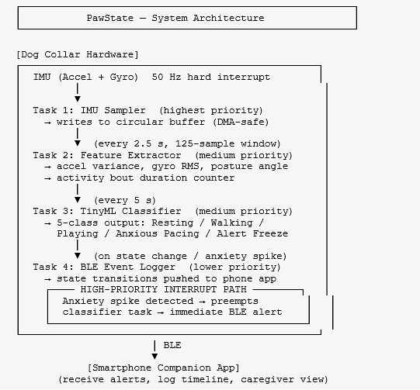
Feasibility Check - Multi-Angle Analysis
Before settling on this project, I went through a systematic feasibility review. The table below captures the
key dimensions:
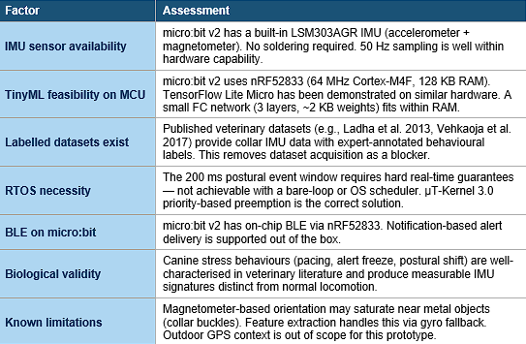

Appeal Points for the Application Program
- Originality (Beyond the Standard Tropes): Embedded systems contests frequently focus on smart homes, industrial monitors, or drones. A real-time canine emotion classifier running on an RTOS is highly original. It is scientifically grounded, drawing on peer-reviewed veterinary literature (e.g., Ladha et al. 2013) rather than functioning as a gimmick.
- Better than Previous/Prior Art: Existing commercial dog collars (Whistle, Fi, Tractive) focus exclusively on GPS and daily step counting. None attempt to classify real-time emotional states, and none utilize an RTOS for hard real-time alert paths. PawState solves a completely different, qualitative problem.
- What We Are Trying This Time (Architectural Necessity): We are out to prove that an RTOS is necessary for this problem, not just cosmetic. The strict 200 ms postural event window and the preemptive alert path for anxiety spikes cannot be replicated safely by a conventional bare-metal polling loop. The use of μT-Kernel 3.0's priority-based preemption is the core of this system's reliability.

Applicant Appeal Points
- Motivation and Approach to RTOS: We came to this project because our team genuinely wanted to understand what an RTOS provides that a bare-metal loop does not. The answer is guaranteed preemption timing. We didn't start with "what can we build for a contest?" We started with "what problem actually requires an RTOS?" and the answer led us to PawState.
- Experience & Enthusiasm: Our team has a strong background in software development and practical experience with FreeRTOS. While μT-Kernel 3.0 is new to us, its IEEE standardization and documentation make us incredibly enthusiastic to learn, master, and implement it in a real-world scenario.
- Real-World Testing Capabilities: One of our team members owns a dog, which gives us a massive advantage. We aren't relying purely on abstract data; we can gather our own labeled training data from a real animal wearing a collar. Given the micro:bit's compact form factor, built-in IMU, and BLE, we will be testing on a live subject within the first week of receiving the board.
- Commitment to the Community: If selected, our team commits to documenting the entire journey publicly—from μT-Kernel 3.0 task configuration and feature engineering, to model quantization and real-dog testing. We believe a well-documented, highly unusual application domain is extremely valuable to the TRON community.

