Section 10 – Undoing changes & Time Traveling

What Matters?

* Critical:
  + Checking Out Commits
  + “Escaping” Detached HEAD
* Important:
  + Discarding changes with checkout
  + Git Restore
  + Git Reset
  + Git Revert

**git log --oneline** cmd to view commit hashes.

* + Need first 7 digits

Detached HEAD???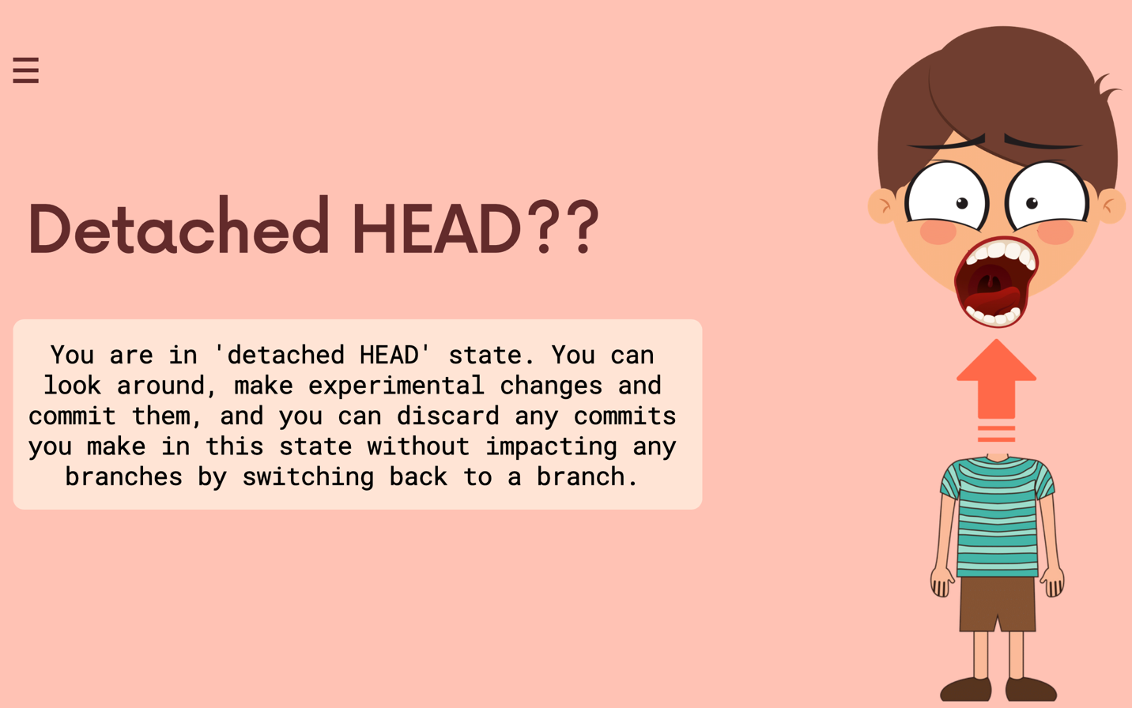

Re-attaching detached HEAD

git switch master takes you too previous HEAD position

When we reset it moves the commit back into the working directory.

Removes from commit area & working directory

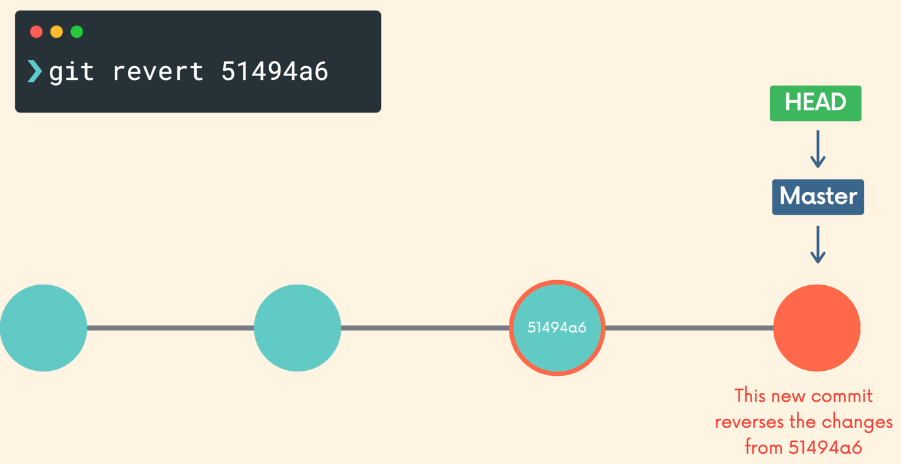

If you want to reverse commits that other people already have on their machines, use revert

If you want to reverse commits that you haven’t shared with others, use reset

* No one will ever know.