Section 12 Fetching & Pulling

What’s Important

Critical:

* Remote Tracking Branches
* Git Fetch
* Git Pull

Remote Tacking Branches

Checking out Remote Tracking Branches

Working with Remote Branches

Git Fetch: The Basics

Git Pull: The Basics

Git Pull & Merge Conflicts

Pull down first -> Merge -> Push up

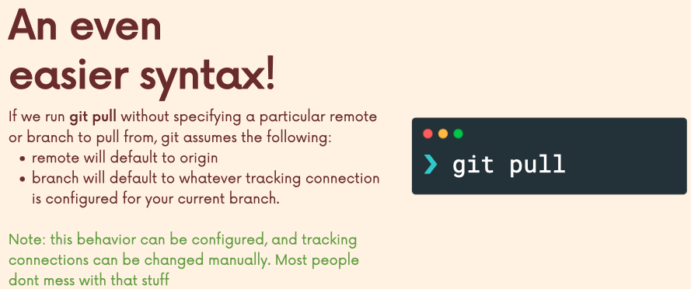Shorter Syntax for git pull

