Section 14 GitHub Collaboration Workflows

What Matters?

Critical:

* Problems with working on a single branch
* Feature Branch Workflow
* Pull Requests
* Forking
* Fork-And-Clone Workflow

Important:

* Branch Protection Rules

The Pitfalls of a Centralized Workflow

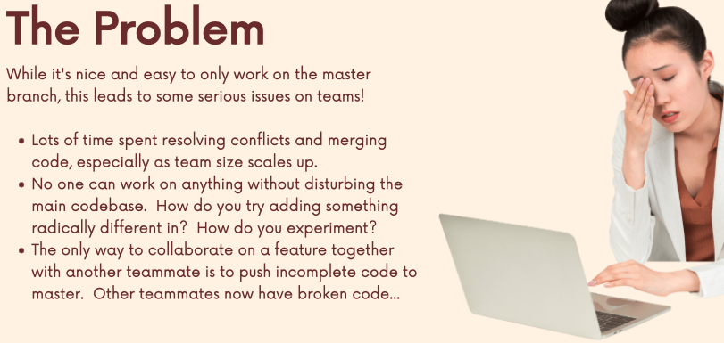

The All-Important Feature Branch Workflow

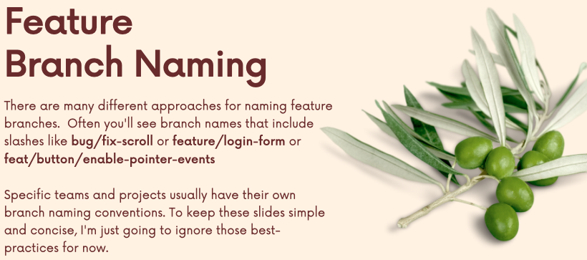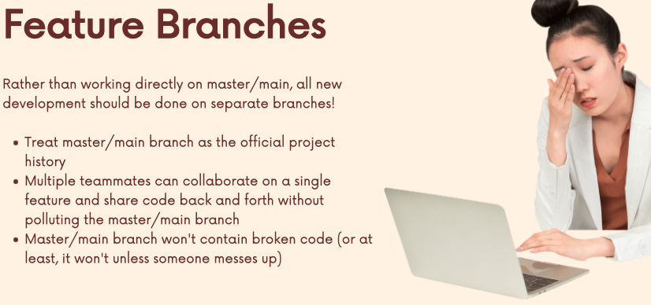

Merging Pull Requests with conflicts

Configuring Branch Protection Rules

On GitHub in settings under the branch tab, you can protect branches.

* Feedback process
* Quality control check

Intro Forking

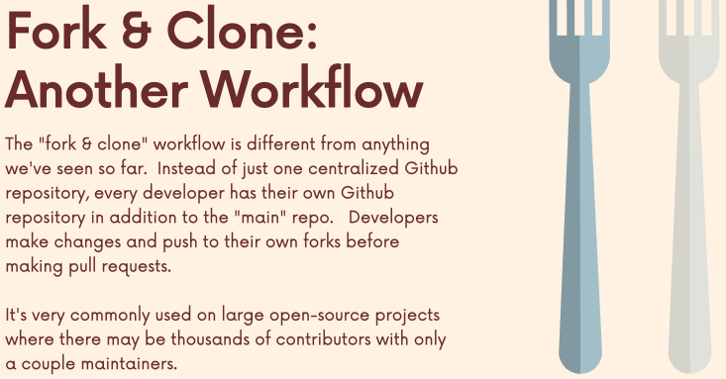

The Fork & Clone Workflow

