Section 17 – Git Tags: Marking Important Moments in History

What Matters?

Important:

* Understanding Git Tags
* Viewing Tags
* Lightweight vs Annotated tags
* Pushing Tags

Nice to Have:

* Semantic Versioning
* Moving Tags
* Deleting Tags
* Diffing Tags

The idea behind Tags

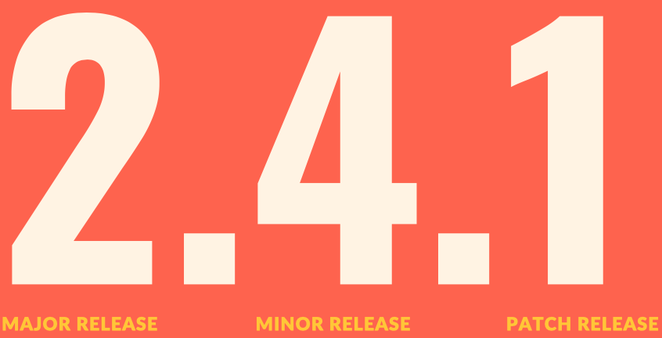

Viewing & Searching Tags

Comparing tags with Git Diff

Creating Lightweight Tags

Creating Annotated Tags

git show <tag name> to see all that metadata.

Tagging Previous Commits

Replacing tags with Force Not often used

Deleting Tags

IMPORTANT: Pushing Tags

