Section 18 Git Behind the Scenes: Hashing & Objects

What matters?

Important:

* The Local Config File

Nice to Have:

* The Refs Directory
* The HEAD File
* Hashing Functions Basics
* Git Objects: Blobs, Trees, and More

Working with the Local Config File

Inside Git: The Refs Directory

Inside Git: The HEAD File

Inside Git: The Objects Folder

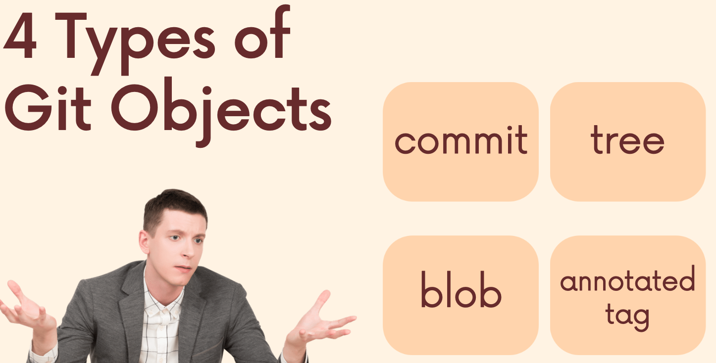

A Crash Course on Hashing Functions

Git as a Key-Value Datastore

Hashing with Git Hash-Object

Retrieving Data with Git Cat-File

Git Objects: Blobs

Git Objects: Trees

Git Objects: Commits

