Section 7 Merging Branches

What Matters?

Critical:

* Fast Forward Merges
* Git Merge & Merge Commits
* Resolving Merge Conflicts

Nice To Have:

* Using VSCode To Resolve Conflicts

Intro to Merges

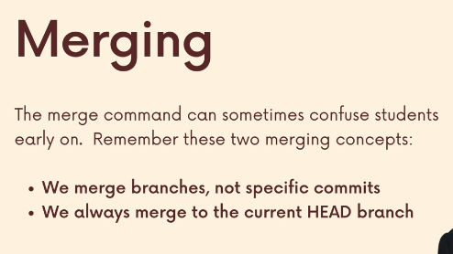

Merge Conflicts

AI Voice control. Will input commands based on vocal instructions