Section 8 Comparing Changes with Git Diff

What’s important?

Critical:

* Reading Diffs
* Git Diff Basics

Important:

* Diffing Branches
* Diffing Commits
* Diffing specific Files
* Git diff –staged

The Git Diff Command

Guide to Reading Diffs

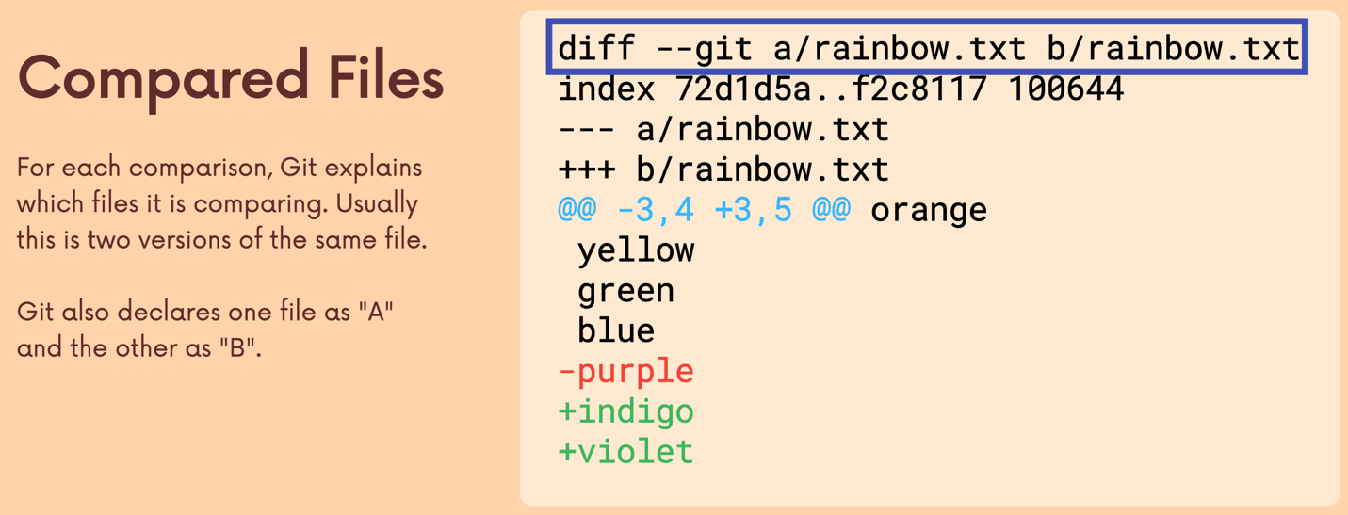

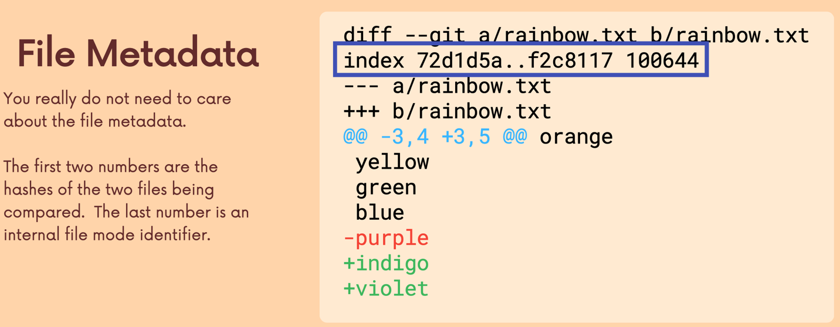

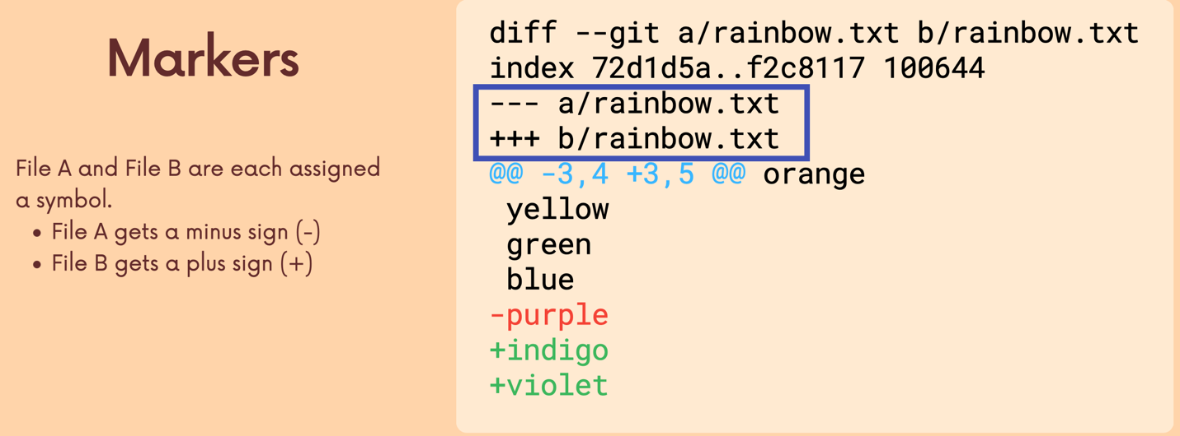

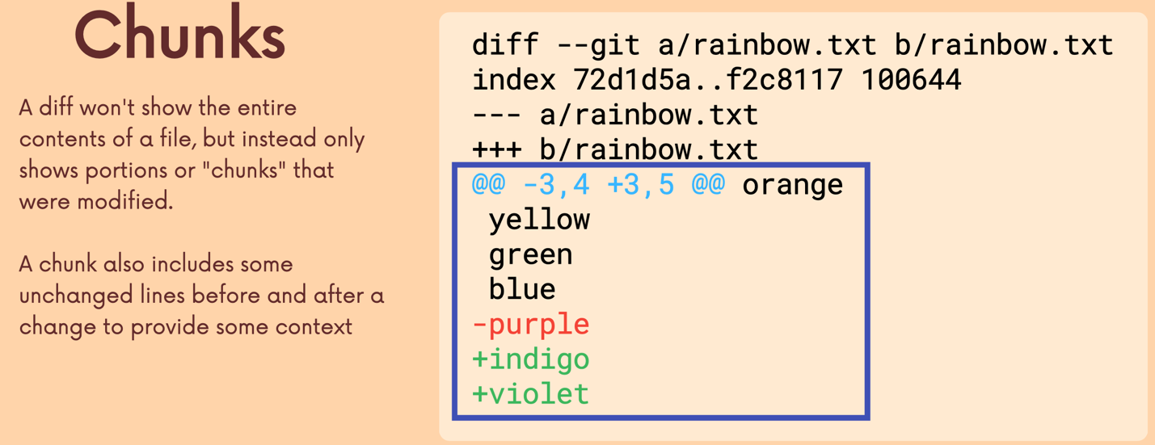

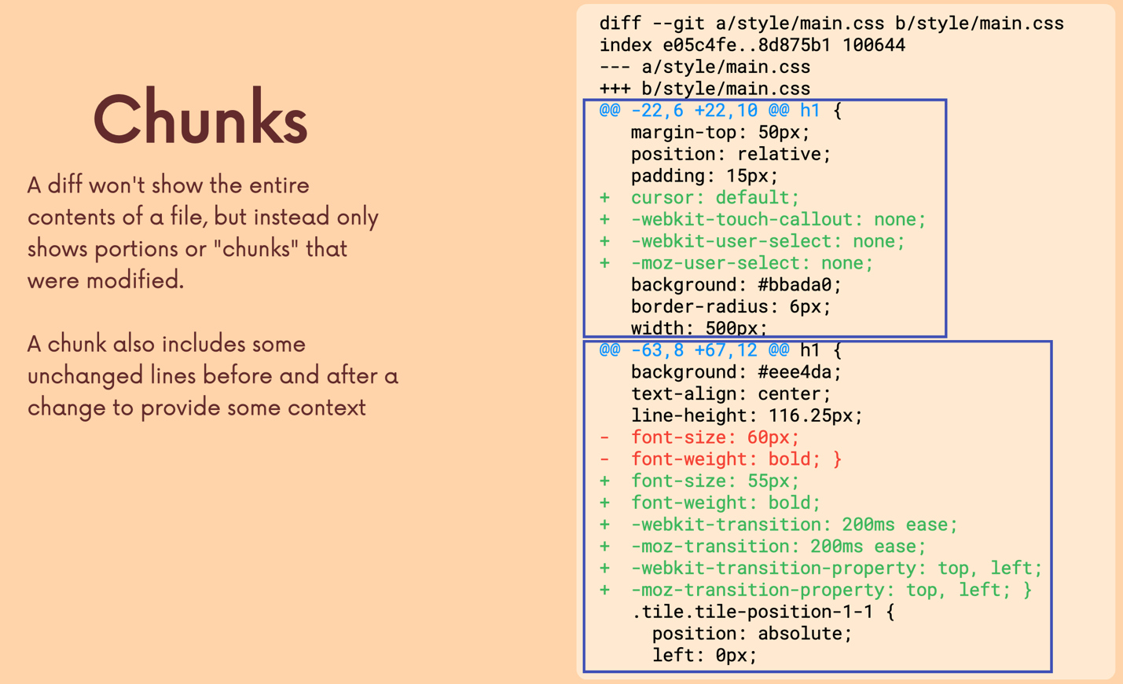

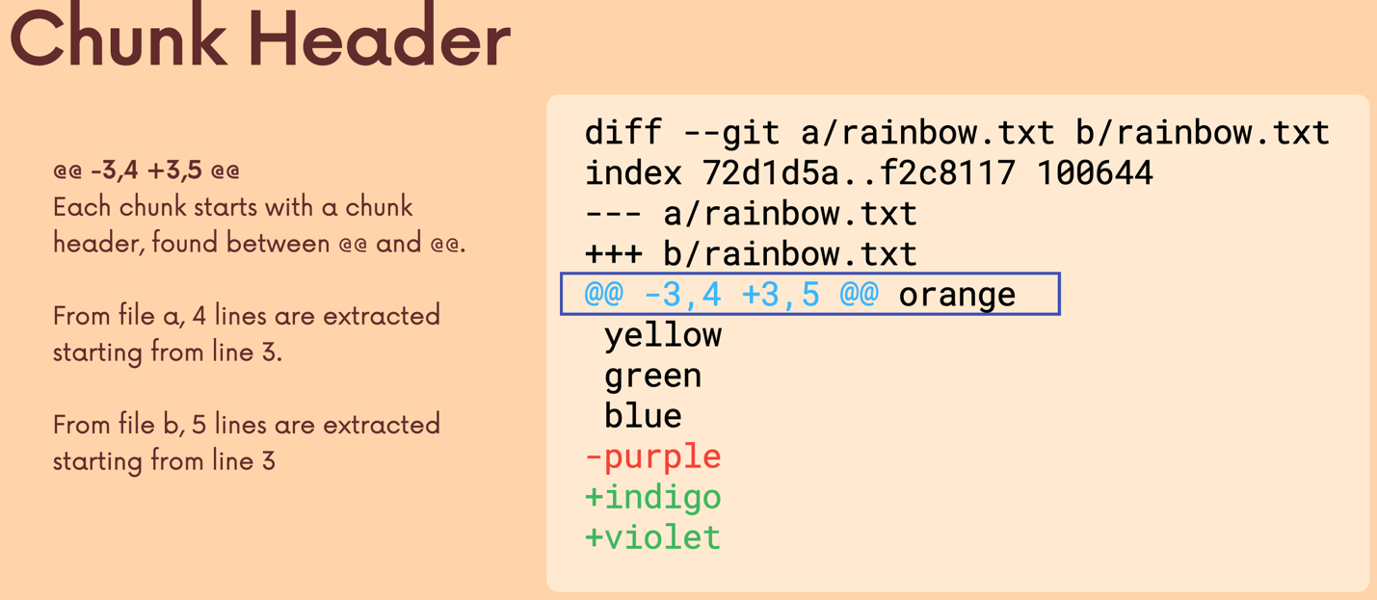

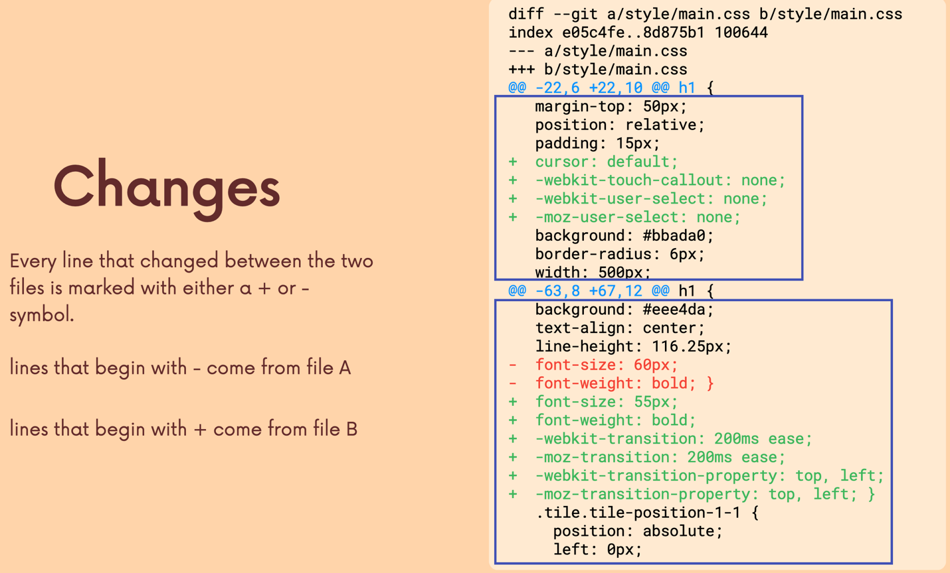

Example

Diff –git a/rainbow.txt b/rainbow.txt (Compare Files)

Index 72d1d5a..f2c8117 100644 (Metadata)

--- a/rainbow.txt (Markers)

+++ b/rainbow.txt (Markers)

@@ -3,4 +3,5 @@ orange (Chunks)

Yellow (Chunks)

Green (Chunks)

Blue (Chunks)

-purple (Chunks)

+indigo (Chunks)

+violet (Chunks)

Viewing Working Directory Changes

Viewing Staged Changes

Diffing Specific Files

Comparing Changes Across Branches

Comparing Changes Across Commits

