Client Response to Initial Proposal
The following document details the list of requirements given in the client’s response to the initial proposal document.

  - Additional features
- A page listing who is able to foot steer [captains must add this attribute to an account]
- Single login for admins
- Who you are out with [additional_people] for either crew members or anyone else out if you are in a single
- Individual erg numbers [1-8] included in equipment name of ergs
- equipment_status [i.e. under maintenance or functional]. Only functional equipment can be booked
- 2 week visual for boat schedule [can be scrollable page so each day is below the previous]
- 1 week visual for ergs
- 3 month history of bookings
- Admin page should also allow changing status of equipment
- A toggle lock on equipment preventing them from being booked out

  - Booking form
- Blades should be booked also from the list of blades assigned to that boat
- All users can see who has booked a boat
- A ‘smart dropdown’ system for selecting the boat and blades in a booking. The following screenshots have been approved by the client. The drawings in these images can be found in UI_mock_ups.drawio. The drop down system implements categories into the drop down to avoid having a list of all possible equipment. It is then a 2 or 3 step process to select a piece of equipment by selecting category options.
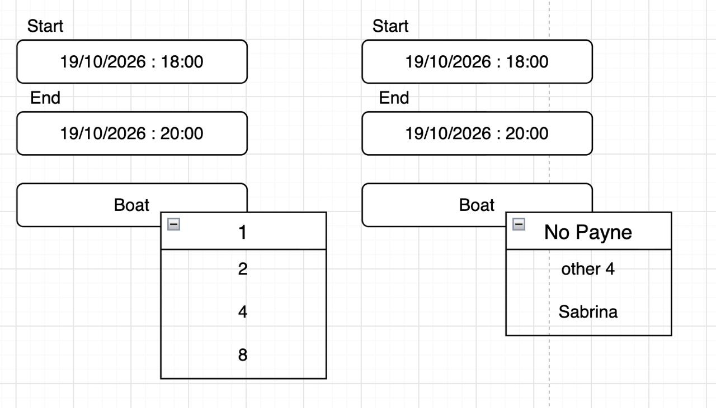
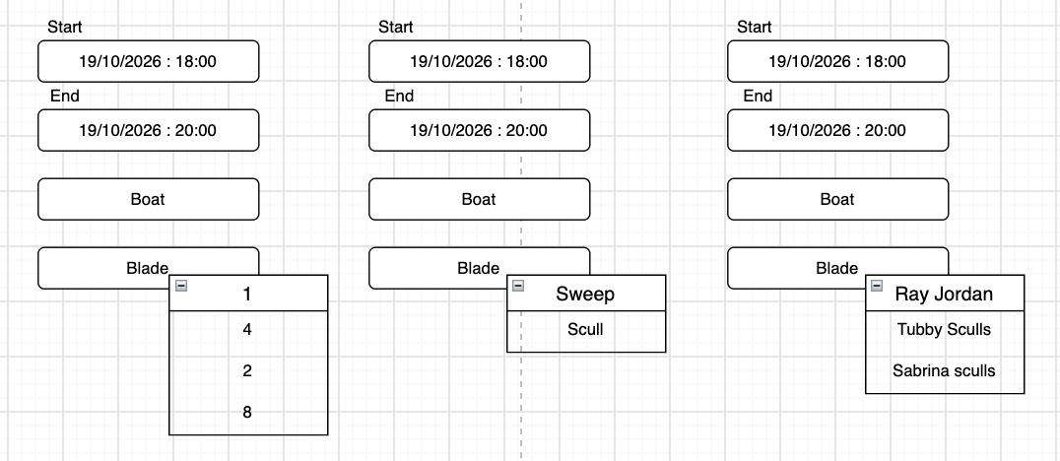

  - Visual requirements
- Bridgnorth boat club colours
- Dyslexia friendly formatting
  - Information still required
- Complete list of all public boats and blades at the club and associated information.
- List of all gym equipment/ergs and current status of this equipment
- Decision about having a regular-user facing list of all equipment for reference.
- Decision on exact URL and hosting arrangement.

