Bridgnorth Rowing Club Booking System Proposal
  - Proposed Solution
Online live booking system with multiple user access levels. Each member of the club who wishes to use either the club boats or ergs will be given login details with which to access the system. All users can see bookings made, clashing bookings will be prevented. Admins can see and edit all bookings and other information contained within the system. An information page will be included for further information about boats such as the average crew weight and accompanying blades.
  - User hierarchy and privileges:
- Admin – can add/edit/remove boats, blades, bookings, equipment and users from the system
- User – can make bookings and can edit/delete bookings they own
  - Suggested pages:
- Login
- Select booking type (boat or erg)
- Book a boat
- Book an erg
- Manage my bookings
- View schedule
- Boat list
- Boat information
- Manage all bookings (admin only)
- Manage equipment (admin only)
  - Boats
  - Blades
  - Other equipment

What other pages are desired?

Login details:
Login details for regular users will comprise of a unique username generated from their name and other information. In addition to this mandatory passwords is an option for a more secure system but this will require all users to supply both a username and password each time they wish to access the system.
Admin users can be required to have both a username and password without the same requirement for other users.

  - System information:
The following is the information the system may store:
Boats:
- Name
- Number of seats
- Average crew weight
- Last rigged as
- Steering
- Additional info
- Number of times this boat has been booked
- Number of times a booking of this boat has been cancelled (used with the above data to calculate the number of sessions this boat has had)
- Boat weight
- Which blades are suitable for this boat

Blades:
- Name
- Blade type
- Additional info
User:
- Name
- Username
- Password
- Access level
Bookings:
- Booking date and time
- Boat/equipment booked
- Booking duration
- Booked by

Is there any other information that should be included?
  - User experience timeline:
The following image is the suggested path a user may take through the system.

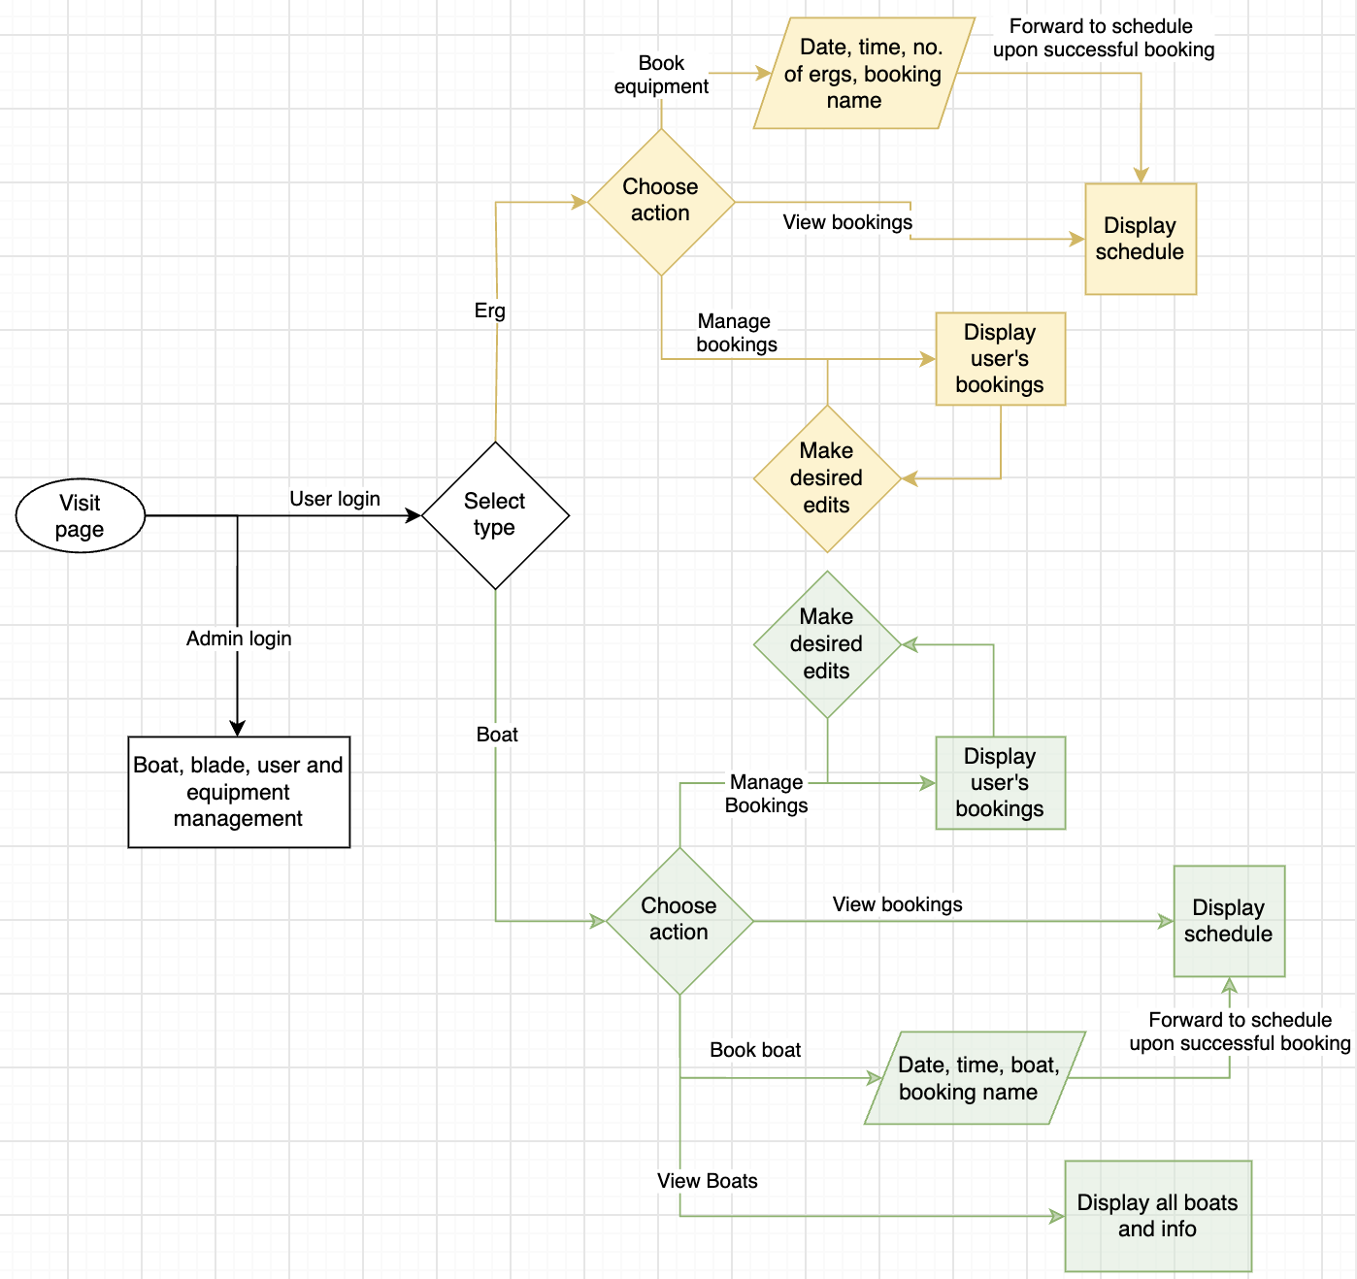

  - Clarification required:
- Would users need to select blades to go with a boat when booking to prevent clashes (if there are some blades used by more than one boat) or can the list of blades for each boat be purely informational?
- Will the non-boat booking section include only the ergs or the other gym equipment? If so, what other equipment?
- What information needs to be stored about the ergs and or other equipment in the gym?
- Should admin logins also work for boat booking or should each admin have a separate login for when they make bookings?
- When viewing the schedule of bookings, what timelines are desirable (1-day, 3-day, week)?
- Should all users be able to see who has made a booking or just the booking time and boat/equipment?
- Are there some boats that are for public use but only with permission from captains? If so, should these bookings be approved with an email notification sent to the captains?
- What should the name of the booking system be and where should it be accessed from?
- How long should past bookings be kept for?
What other features are expected of the system?

  - User Interface
- What requirements can be placed on the visual aspects of the system?
- How should the system look?

